a
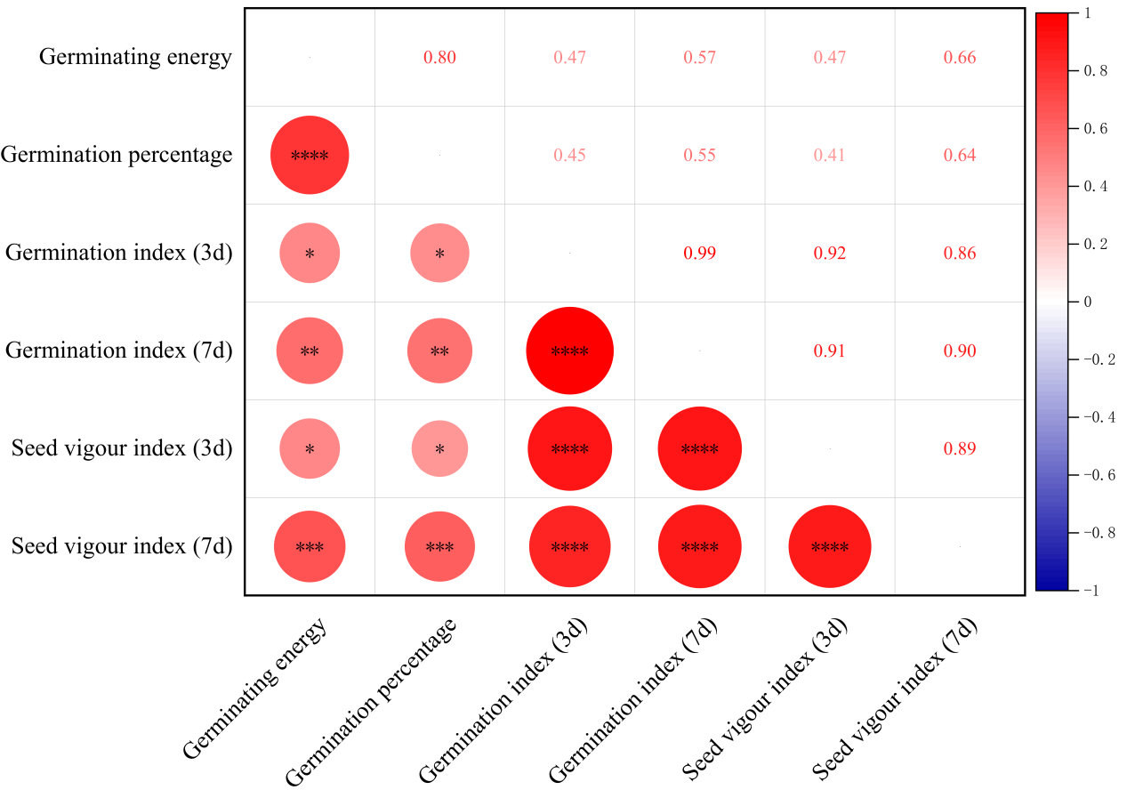
b
Figure S1. Germination characteristics and correlation of different seed size varieties. a, Kenfeng 16 (KF16); b, Heinong 84 (HN84), c, correlation analysis. L, large; M, medium; S, small; VS, very small. *p < 0.05; **p < 0.01; ***p < 0.001; ****p < 0.0001

