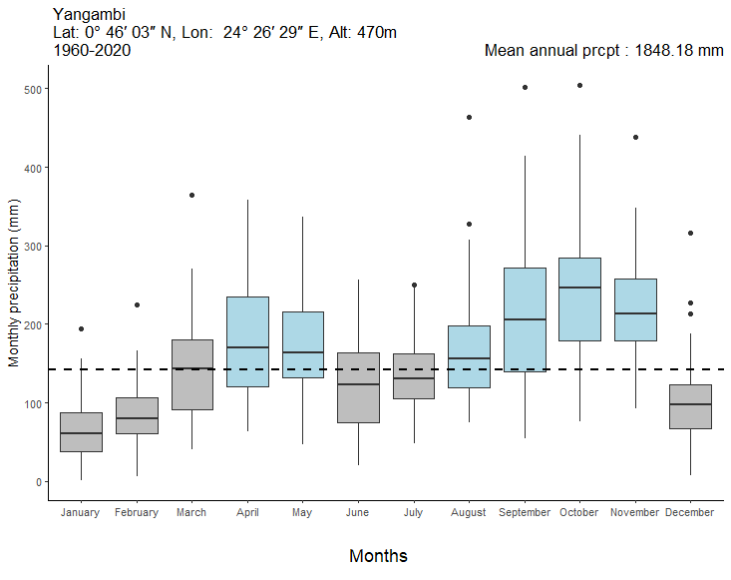
Supplementary Figure 1: Variation in monthly precipitation in Yangambi from 1960 to 2020, adapted from Kasongo (23). Grey and light blue boxes represent dry and wet season months respectively. The horizontal dashed line represents the overall median precipitation (142 mm month-1).
Supplementary Table 1: Overview of the 18 selected trees for monitoring foliar phenology and cambial activity in Yangambi. The cambial activity stage was monitored four times and is determined by the number of xylogenesis phases present. Cambial activity stage 0 corresponds to the absence of any xylogenesis phase (=cambial dormancy); cambial activity stage 1 corresponds to the presence of cells in DP (division phase); cambial activity stage 2 corresponds to the presence of cells in DP and EP (enlarging phase); cambial activity stage 3 corresponds to the presence of cells in DP, EP and TP (thickening phase); cambial activity stage 4 corresponds to the presence of cells in DP, EP, TP and MX (mature xylem). Foliar phenology was monitored twice and is expressed as a percentage of the canopy covered by old, new or no leaves. Each dot indicates an individual tree, and colours refer to species. DBH=diameter at breast height; CII=Crown Illumination Index.
Species | ID | DBH | CII |  | Cambial phenology |  |  |  |  | Leaf phenology (% of canopy)
 |  |  |  |  | 05/03/2022 | 18/03/2022 | 01/04/2022 | 22/04/2022 |  | Just after dry season (18/03/2022) |  |  |  | During the rainy season (15/04/2022)
 |  |  |  |  |  |  |  |  |  | Old leaves | New leaves | No leaves |  | Old leaves | New leaves | No leaves
L. thompsonii | 1 | 30.4 | 3 |  | 1 | 1 | 1 | 1 |  | 90 | 5 | 5 |  | 50 | 45 | 5
L. thompsonii | 2 | 40 | 3 |  | 1 | 1 | 1 | 1 |  | 60 | 35 | 5 |  | 95 | 0 | 5
L. thompsonii | 3 | 30.9 | 3 |  | 1 | 1 | 1 | 1 |  | 95 | 0 | 5 |  | 70 | 25 | 5
P. macrocarpus | 1 | 37.6 | 5 |  | 0 | 0 | 0 | 0 |  | 85 | 0 | 15 |  | 90 | 5 | 5
P. macrocarpus | 2 | 50.1 | 5 |  | 0 | 0 | 0 | 0 |  | 90 | 0 | 10 |  | 95 | 0 | 5
P. macrocarpus | 3 | 40.4 | 5 |  | 0 | 0 | 0 | 0 |  | 90 | 0 | 10 |  | 90 | 0 | 10
S. subcordatum | 1 | 34.2 | 5 |  | 0 | 0 | 0 | 0 |  | 85 | 0 | 15 |  | 95 | 0 | 5
S. subcordatum | 2 | 58.2 | 3 |  | 0 | 0 | 0 | 0 |  | 80 | 15 | 5 |  | 85 | 5 | 10
S. subcordatum | 3 | 25 | 2 |  | 0 | 0 | 0 | 0 |  | 80 | 15 | 5 |  | 80 | 5 | 15
P. oleosa | 1 | 47.2 | 3 |  | 4 | 4 | 4 | 4 |  | 80 | 15 | 5 |  | 90 | 5 | 5
P. oleosa | 2 | 59 | 2 |  | 1 | 1 | 0 | 1 |  | 65 | 30 | 5 |  | 90 | 5 | 5
P. oleosa | 3 | 32.8 | 4 |  | 0 | 0 | 0 | 0 |  | 65 | 25 | 10 |  | 90 | 0 | 10
S. zenkeri | 1 | 33.7 | 5 |  | 0 | 0 | 0 | 0 |  | 85 | 10 | 5 |  | 90 | 0 | 10
S. zenkeri | 2 | 50.1 | 3 |  | 4 | 4 | 4 | 4 |  | 85 | 5 | 10 |  | 80 | 0 | 20
S. zenkeri | 3 | 33.3 | 5 |  | 0 | 0 | 0 | 0 |  | 80 | 10 | 10 |  | 70 | 0 | 30
T. madagascariense | 1 | 51.4 | 5 |  | 2 | 2 | 2 | 3 |  | 95 | 0 | 5 |  | 90 | 0 | 10
T. madagascariense | 2 | 44.8 | 5 |  | 2 | 2 | 2 | 2 |  | 95 | 0 | 5 |  | 90 | 0 | 10
T. madagascariense | 3 | 46.3 | 5 |  | 2 | 2 | 2 | 2 |  | 90 | 0 | 10 |  | 90 | 0 | 10

Supplementary Table 2: Average measurements and respective standard deviations of the radial widths of the different xylogenesis phases. When the quality of the sections is sufficient, the mean value totals the 3 repeated radial measurements for all 3 individuals monitored for each species and for the 4 sample collections between 5 March and 16 April 2022. Total measurement considers all phases of xylogenesis without distinction.
Species | CZ | DP | EP | TP | Total
L. thompsoniii |  | 76.88 ± 11.98 |  |  | 76.88 ± 11.98
P. oleosa | 79.29 ± 16.87 | 76.88 ± 47.71 | 76.88 ± 57.85 | 76.88 ± 176.49 | 163.27 ± 148.26
P. macrocarpus | 72.96 ± 12.20 |  |  |  | 72.96 ± 12.20
S. zenkerei | 34.36 ± 9.38 | 73.64 ± 10.30 | 83.61 ± 36.32 | 101.10 ± 32.57 | 62.80 ± 35.71
S.subcordatum | 51.78 ± 13.15 |  |  |  | 51.78 ± 13.15
T. madagascariense |  | 62.26 ± 14.96 | 52.75 ± 24.47 |  | 57.51 ± 20.64

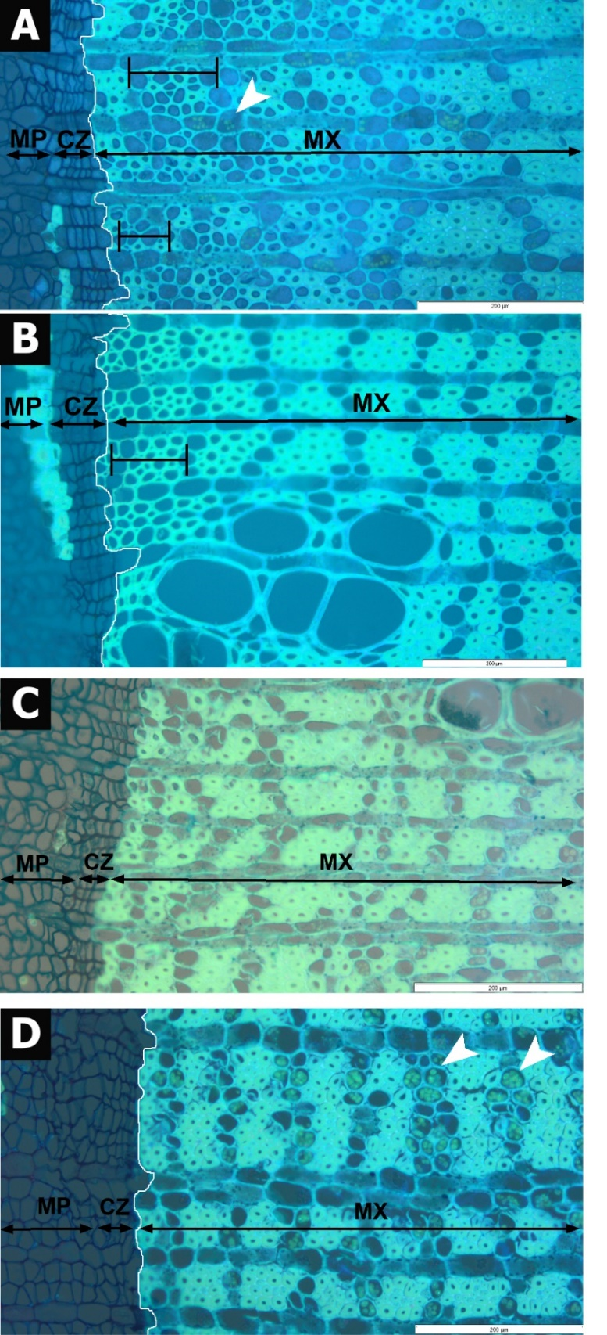
Supplementary Figure 2: Predominant cambial dormancy observed in Synsepalum subcordatum. (A) Cross section of the cambial zone (CZ) and the adjacent xylem (X) under UV light for individual 1 on 05/03/2022. (B) Cross section of individual 3 on 18/03/2022. (C) Cross section of individual 1 on 01/04/2022. (D) Cross section of individual 3 on 15/04/2022. In each image, the cambial zone consists of non-lignified cells (dark blue) and contrasts starkly with the fully lignified xylem cell walls (light blue). The cross-section of S. subcordatum typically shows fibres with thick walls surrounding vessels. It also presents axial, reticulated, parenchyma in 1-3 cells-wide bands. Large zones (>4 rows of fibres) of mature xylem can be deprived of axial parenchyma cells (C). Abundant starch deposits are detected within parenchyma cells confirming that the xylem is fully developed (white arrow heads). Growth zones appear in mature xylem (MX) and consist of unusually thin-walled fibres and hence less perceivable axial parenchyma (double black bars in images A, and B). Scale bars = 200µm.
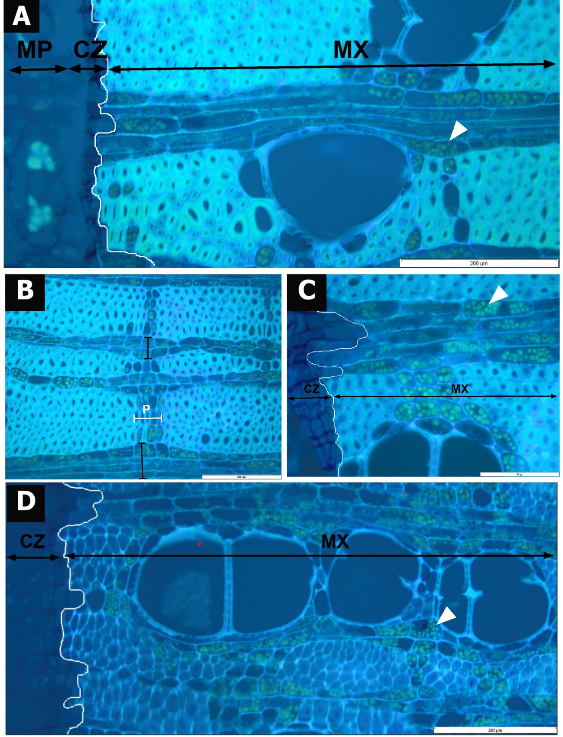
Supplementary Figure 3: Predominant cambial dormancy observed in Petersianthus macrocarpus. (A) Cross section of the cambial zone (CZ) and the adjacent xylem (X) under UV light for individual 1 on 05/03/2022. (B) D Cross section of individual 1 on 05/03/2022. (C) Cross section of individual 1 on 18/03/2022. (D) Cross section of individual 3 on 15/04/2022. The cross-section of P. macrocarpus typically shows apotracheal and paratracheal aliform axial parenchyma. In each image, the cambial zone consists of non-lignified cells (dark blue; not visible in image Bin image B) and contrasts starkly with the fully lignified xylem cell walls (light blue). Abundant starch deposits are detected within axial and ray parenchyma cells (white arrowheads), confirming that the xylem is fully developed. Petersianthus macrocarpus exhibits distinct growth rings within the mature xylem. Growth ring borders are defined by radial flattened fibres, and axial marginal parenchyma cells (horizontal white double bars in image B; indicated with P) and sometimes by distended rays (vertical black double bars in image B). In image D, the less pronounced lignification of the secondary walls of the fibres, characterized by the dark blue color of the secondary walls, indicates tension wood fibres. Scale bars = 200µm (A, B, and D). Scale bar = 100µm (C).
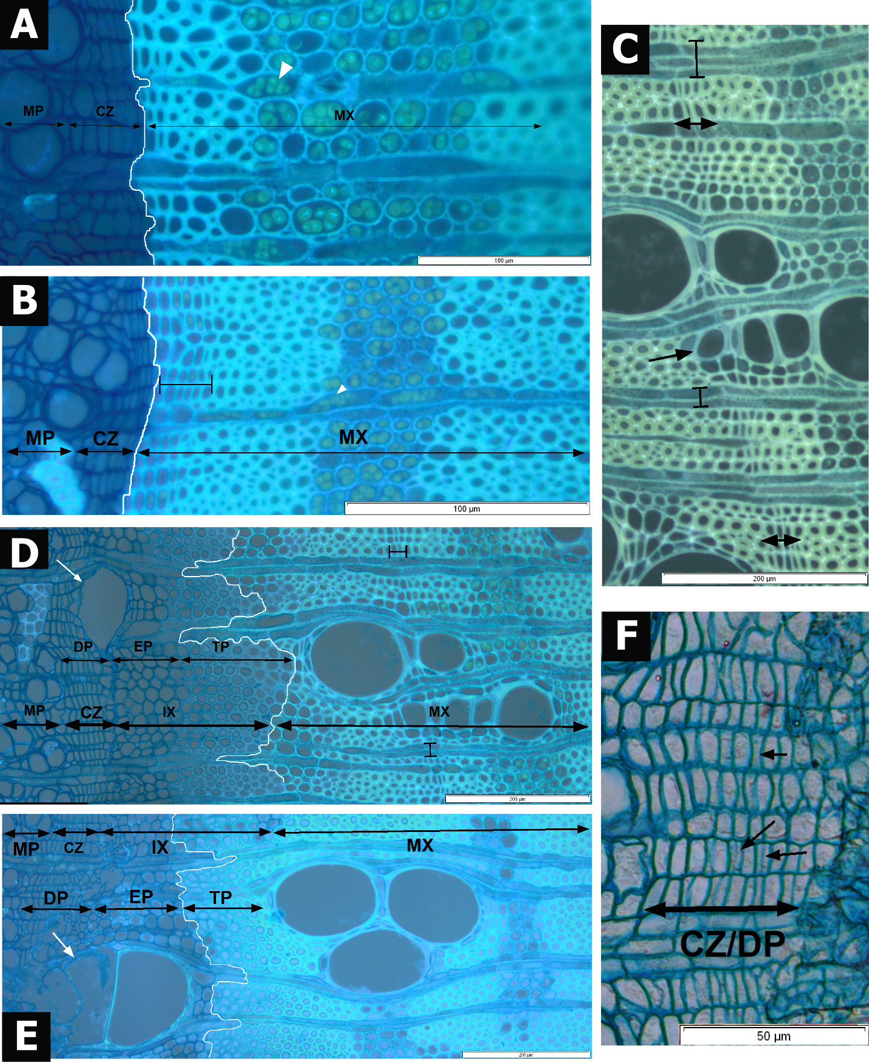
Supplementary Figure 4: Variability in cambial activity observed in Scorodophloeus zenkeri under UV and transmitted light. (A) Cross section of the cambial zone (CZ) and the adjacent xylem for individual 3 on 05/03/2022, showing cambial dormancy. (B) Cross section of individual 3 on 15/04/2022, showing cambial dormancy. (C) Cross section of individual 2 on 05/03/2022, showing cambial activity. (D) Cross section of individual 2 on 05/03/2022, showing cambial activity. (E) Cross section of individual 2 on 18/03/2022, showing cambial activity. (F) Cross section of individual 2 on 18/03/2022, showing cambial activity. The cross section of S. zenkeri typically shows diffuse-in-aggregates apotracheal axial parenchyma, and sparse vasicentric paratracheal axial parenchyma and scanty parenchyma. Banded parenchyma is present in bands of 3 cells and marginal bands with fibres cells with thick walls. Cells in the cambial zone (left) are non-lignified and appear dark blue under UV light. Cells in the mature xylem (right) are fully lignified and appear light blue. In each image, the lignification front is highlighted with a white line. The lignification front coincides with the cambium-xylem front in images A, and B, confirming that the cambium is dormant (i.e. there are no developing non-lignified cells between the cambial zone and the mature xylem). In contrast, the lignification and cambium-xylem fronts do not coincide in images D and E, as well as the division plates appear in CZ (black arrows in F), confirming that the cambium is active. In images D and E, all xylogenesis phases are observed: division phase (DP), enlarging phase (EP), cell-wall thickening phase (TP) and mature xylem phase (MX). Longitudinal growth of fibres is detected within the thickening phase (black arrowheads in D) and juvenile vessels are produced within the enlarging phase (white arrows). Lignification of juvenile vessels seems to appear before the thickening phase (deposition and lignification of a second cell wall) of fibres (E). Growth-ring boundaries are sometimes anatomically distinct either next to an inactive cambial cell or in a mature xylem. Growth-rings boundaries consist of 4-6 radially flattened fibres and tangentially distended ray parenchyma cells (horizontal black bars in B, C, F). These occur just adjacent to the cambium in individuals with cambial dormancy (B and C), but further away from the cambium in individuals with cambial activity (F). Vessel elements adjacent to the growth ring can have a smaller size (F). Numerous starch deposits are observed within mature xylem parenchyma cells in images A, B, C, D, and E (white arrow heads). Scale bar = 50µm (C), scale bar = 100µm (D), scale bars = 200µm (A, B, E, and F).
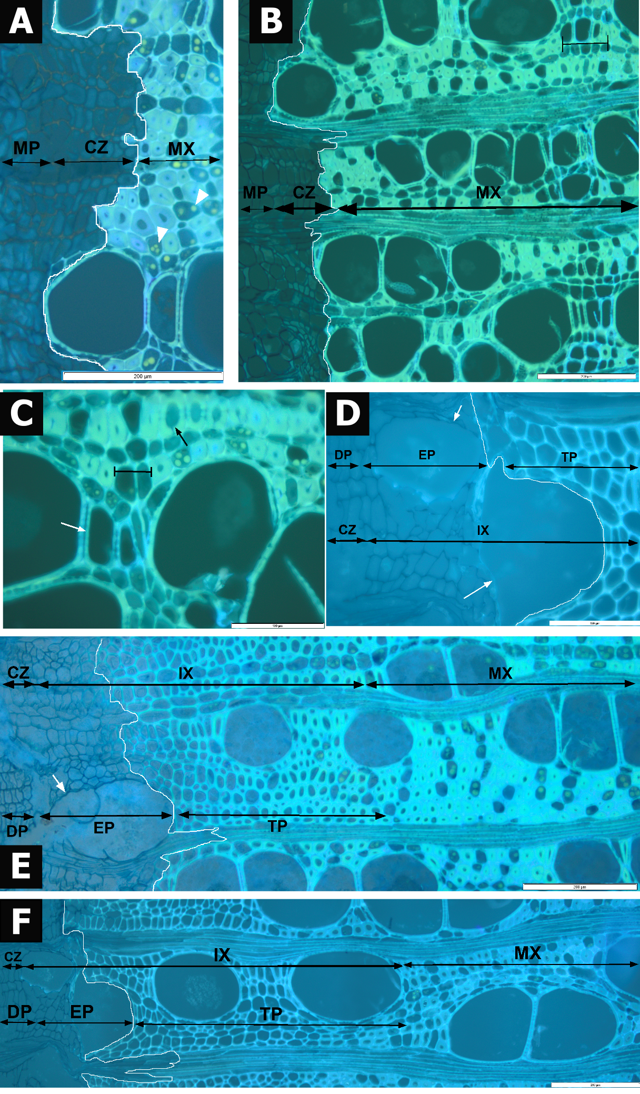
Supplementary Figure 5: Variability in cambial activity observed in Panda oleosa under UV light. (A) Cross section of the cambial zone (CZ) and the adjacent xylem for individual 2 on 05/03/2022, showing cambial dormancy. (B) Cross section of individual 2 on 05/03/2022, showing cambial dormancy. (C) Cross section of individual 2 on 18/03/2022, showing cambial dormancy. (D) Cross section of individual 1 on 15/04/2022, showing cambial activity. (E) Cross section of individual 1 on 15/04/2022, showing cambial activity. (F) Cross section of individual 1 on 15/04/2022, showing cambial activity. The cross-section of P. oleosa typically presents diffuse axial parenchyma along the vessels, but the axial parenchyma also forms narrow bands of 3 cells wide and is scalariform. Fibres have thick cell wall. Cells in the cambial zone (left) are non-lignified and appear dark blue under UV light. Cells in the mature xylem (right) are fully lignified and appear light blue. In each image, the lignification front is highlighted with a white line and the front. This shows that the lignification front coincides with the cambium-xylem front in images A and B, confirming that the cambium is dormant (i.e. there are no developing non-lignified cells between the cambial zone and the mature xylem). In contrast, the lignification and cambium-xylem fronts do not coincide in images E and F, confirming that the cambium is active. In images E and F, all xylogenesis phases are observed: division phase (DP), enlarging phase (EP), cell wall thickening phase (TP) and mature xylem (MX). The number of ray parenchyma cells is much lower in developing rays as compared to mature rays, with division still occurring over the enlargement and thickening of fibre walls. Longitudinal growth of fibres is detected within the thickening phase and new vessels are produced within the enlarging phase. Growth-rings borders (horizontal black double bars in images B and C) are characterized by marginal parenchyma cells, small vessels and fibres with thin lignified walls (B, and C). Numerous starch deposits are observed within mature xylem parenchyma cells in all images (white arrow heads). Scale bars = 200µm (A, B, E, and F), scale bars = 100µm (C, and D).
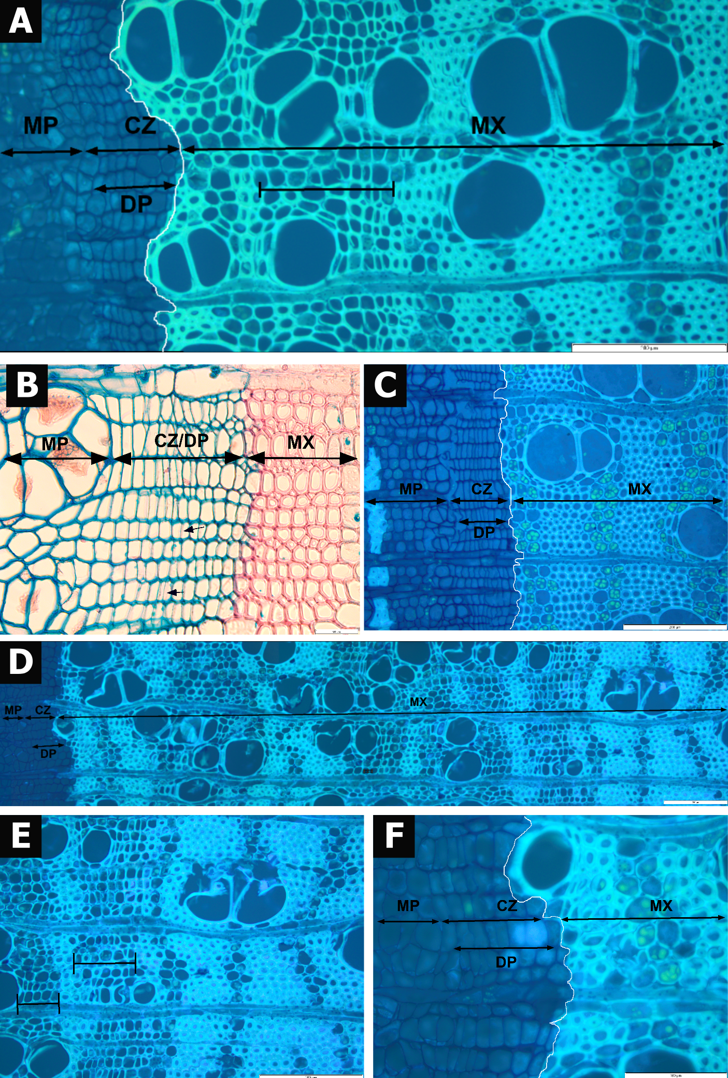
Supplementary Figure 6: Onset of cambial activity observed in Leplaea thompsonii under UV and transmitted light. (A) Cross section of the cambial zone (CZ) and the adjacent xylem (X) for individual 3 on 05/03/2022. (B) Cross section of individual 3 on 05/03/2022. (C) Cross section of individual 3 on 01/04/2022. (D) Cross section of individual 3 on 15/04/2022. (E) Cross section of individual 3 on 15/04/2022. (F) Cross section of individual 3 on 15/04/2022. The cross-section of L. thompsonii typically shows axial parenchyma in 2-3 cells narrow bands and confluent paratracheal axial parenchyma, with fibres of intermediate wall thickness and diffuse-porous of 100 to 200µm vessel’s diameter. In each image, the cambial zone consists of non-lignified cells (dark blue) and contrasts starkly with the fully lignified xylem cell walls (light blue). Individual 3 shows 2 to 3 rows of slightly enlarged cambial cells adjacent to the xylem with some division plates (black arrows in B) suggesting the first signs of nascent cambial activity. Growth zones in the mature xylem could be mistaken for zones of cell division and differentiation (black double bars in images A, and E). These zones are composed of unusually thin-walled and radially flattened fibres between uniseriate bands of radially flattened parenchyma. In these zones, vessel elements are smaller, distinctly aligned and sometimes axially accolated. Abundant starch deposits are detected within parenchyma cells confirming that the xylem is fully developed (white arrowheads). Scale bar = 50µm (B), scale bars = 200µm (A, D, and E), scale bars = 100µm (B, and F).
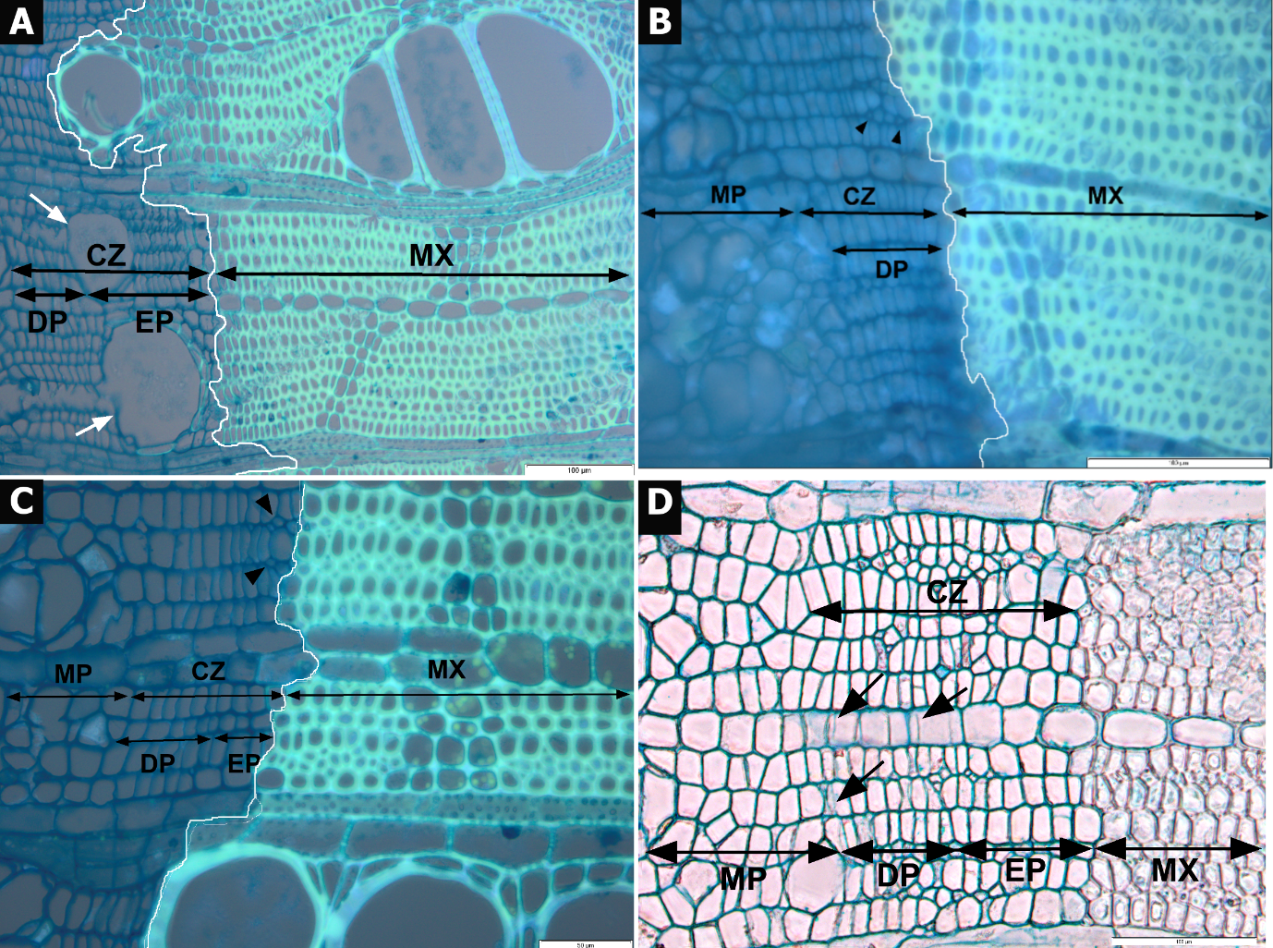
Supplementary Figure 7: Predominant cambial activity observed in Trilepisium madagascariense under UV light and transmitted light. (A) Cross section of the cambial zone (CZ) and the adjacent xylem for individual 2 on 18/03/2022. (B) Cross section of individual 2 on 01/04/2022. (C) Cross section of individual 3 on 15/04/2022. (D) Cross section of individual 3 on 15/04/2022. (D) cross section of individual 1 on 18/03/022. The cross section of T. madagascariense typically shows apotracheal and paratracheal axial parenchyma, scanty parenchyma and vasicentric parenchyma. They form 3cells wide bands and surround vessels. Fibres present a thin to thick cell wall. Cells in the cambial zone (left) are non-lignified and appear dark blue under UV light. Cells in the mature xylem (right) are fully lignified and appear light blue. In each image, the lignification front is highlighted with a white line and the front. The lignification and cambium-xylem fronts do not coincide, confirming that the cambium is active. Yet, only the first two stages of xylogenesis are observed: cell division (DP) and enlarging (EP) phases. Longitudinal division of fibres is detected within the cell division and enlarging phases (black arrowheads) and juvenile vessels are produced within the enlarging phase (white arrows). Numerous starch deposits are observed within mature xylem parenchyma cells (white arrowheads). Scale bars = 100µm (A, and B), scale bar = 50µm (C).

