Supplementary Figure
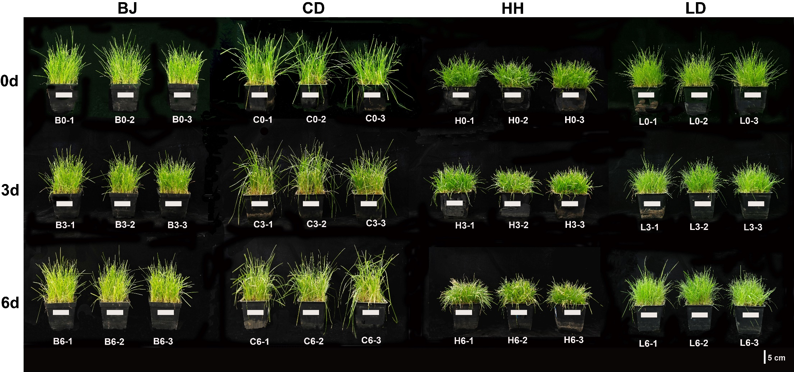
Fig. S1 Growth phenotypes of four Poa species under cold treatments at 4°C. BJ, P. pratensis var. anceps. CD, P. pratensis. HH, P. sinoglauca. LD, P. crymophila.
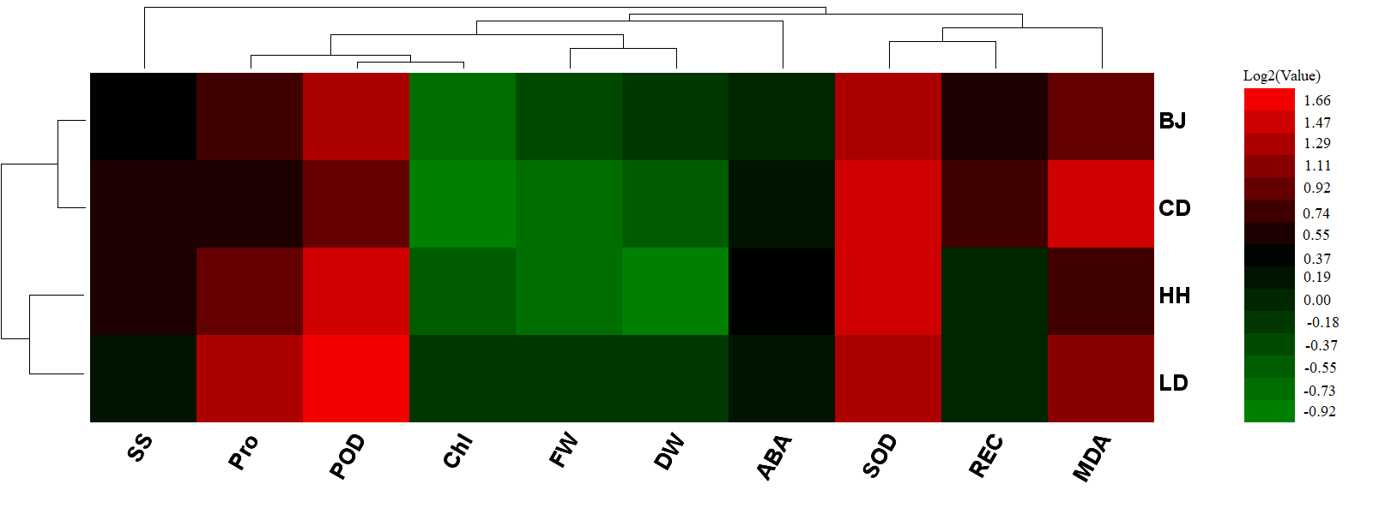
Fig. S2 The clustering analysis of seven physiological indicators of four Poa species. BJ, P. pratensis var. anceps; CD, P. pratensis; HH, P. botryoides; LD, P. crymophila; SS, Soluble sugar; Pro, Proline; SOD, Superoxide dismutase; POD, Peroxidase; FW, Fresh weight; Chl, Chlorophyll; ABA, Abscisic acid.
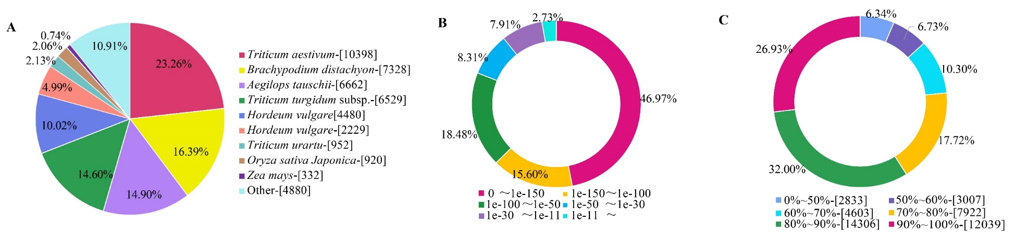
Fig. S3 The E-value distribution and similarity statistics of the annotated unigenes. (A) The species distribution of homologous based on Nr. (B) The E-value distribution of unigenes blasted to the Nr database. (C) The similarity distribution of unigenes blasted to the Nr database.
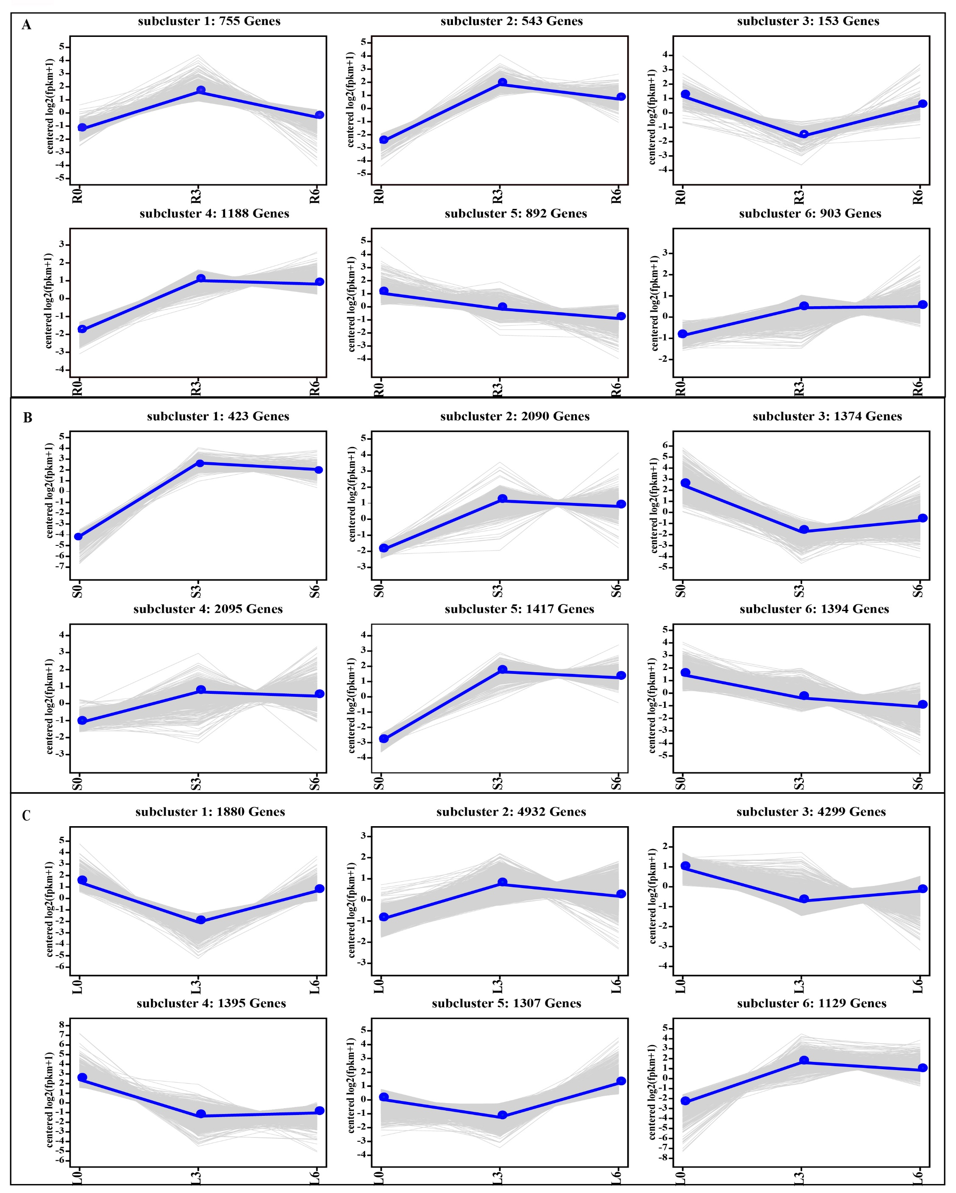
Fig. S4 Differentially expressed gene expression patterns in roots, stems and leaves across three time. A, roots. B, stems. C, leaves. The light grey lines represent the expression pattern of each gene, while the thick, blue lines represent the expression tendency of all the genes. In the roots, subclusters 2, 4, and 6 were three up-regulated patterns containing 543, 1118, and 903 DEGs, respectively (A); subcluster 5 was the down-regulated pattern, containing 892 DEGs (A). In the stems, subclusters 1, 2, 4 and 5 were three up-regulated patterns containing 423, 2090, 2095 and 1417 DEGs, respectively (B); Subclusters 3 and 5 were down-regulated patterns containing 1374 and 1394 DEGs, respectively (B). In the leaves, subclusters 2 and 6 were up-regulated patterns, containing 4932 and 1129 DEGs, respectively (C).
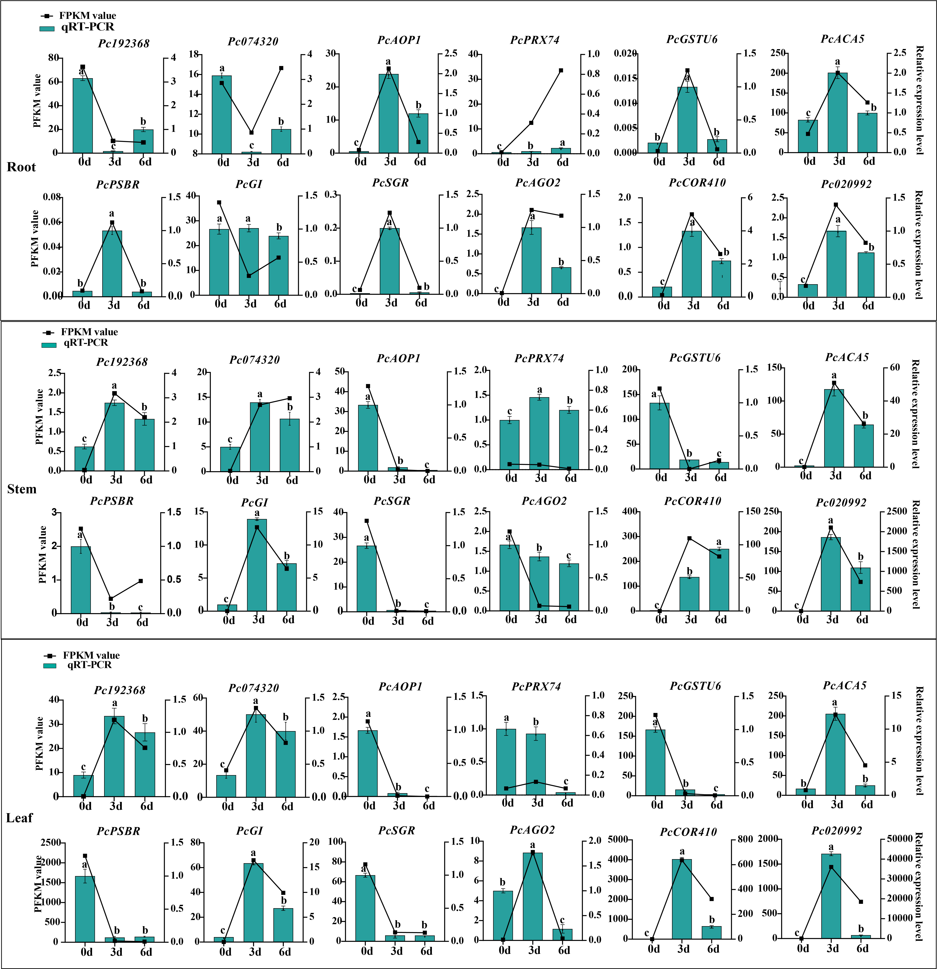
Fig. S5 Validation of the expression by qRT-PCR. Bar charts indicate values of qRT-PCR. All data are presented in the form of mean ± standard error (n = 3). Different lowercase letters indicate significant differences between treatments (P < 0.05). The same below. Line plots indicate values of FPKM value.

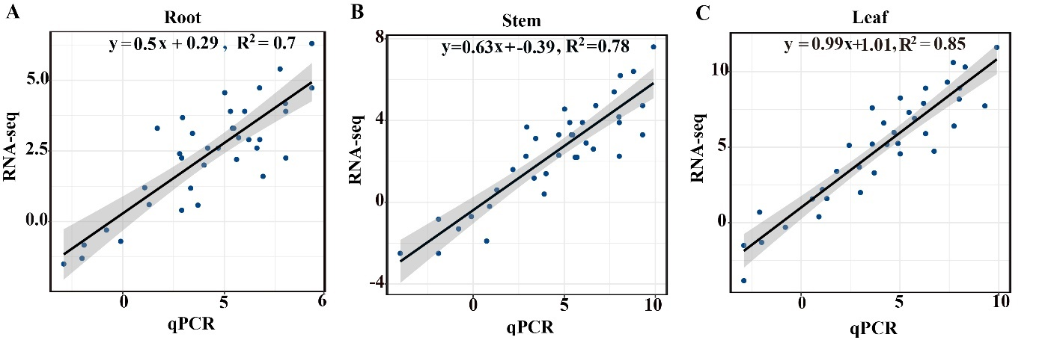
Fig. S6 Correlation analysis.
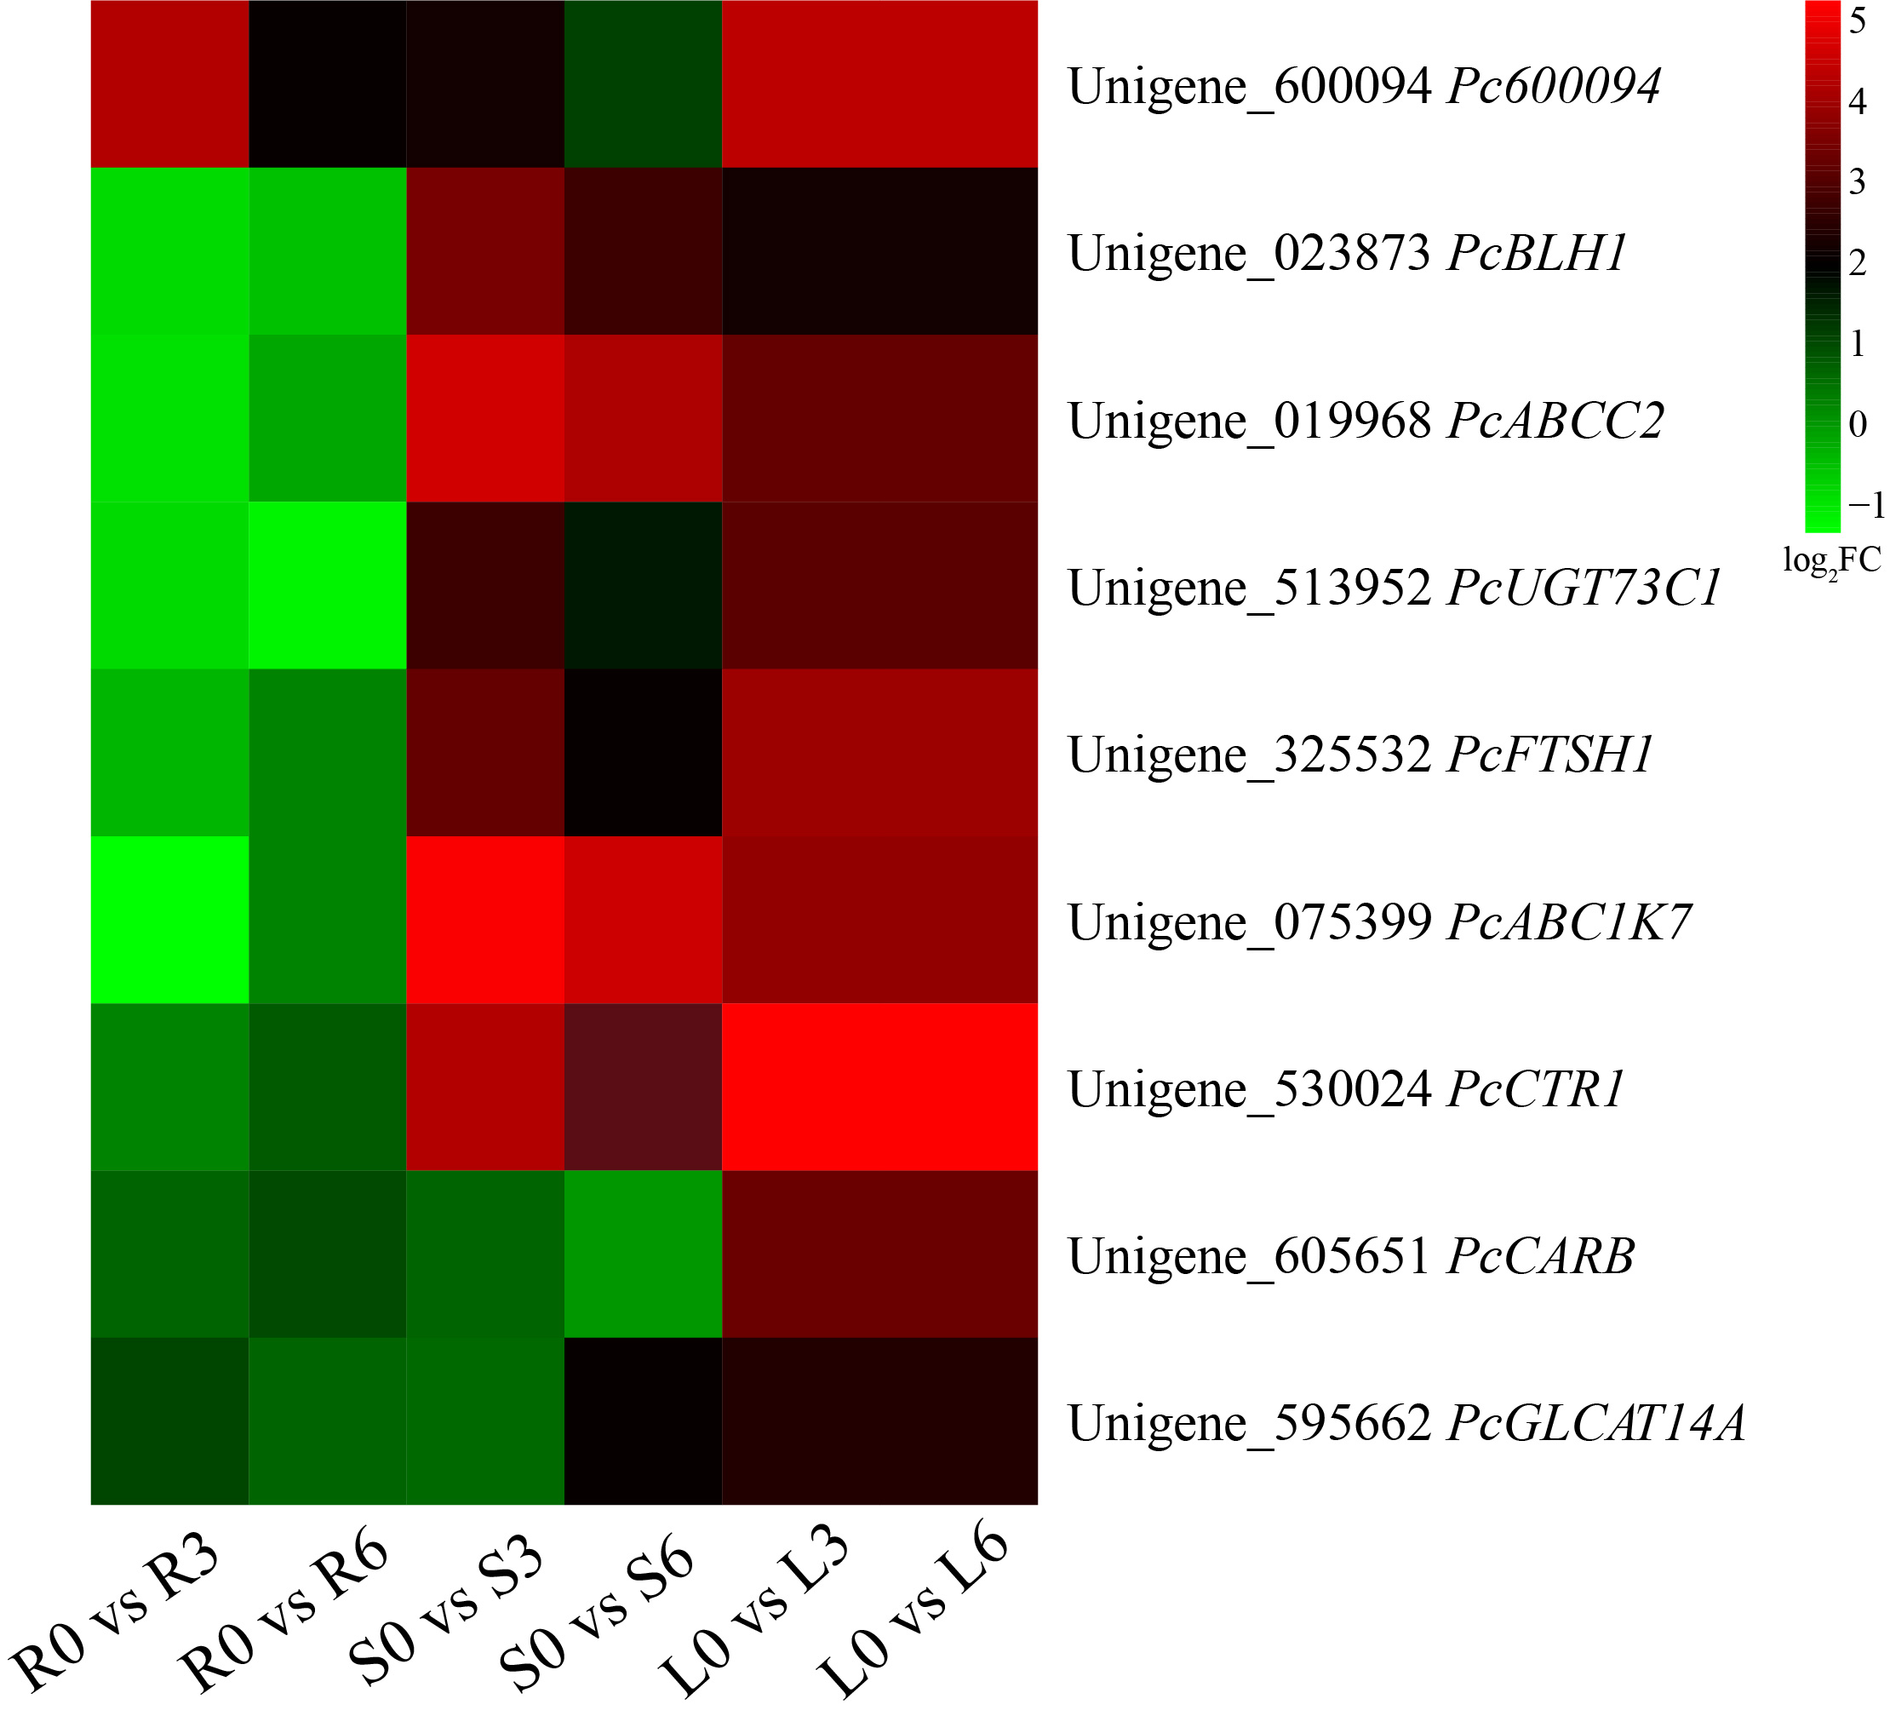
Fig. S7 Heat map of the expression of the nine selected Hub genes.

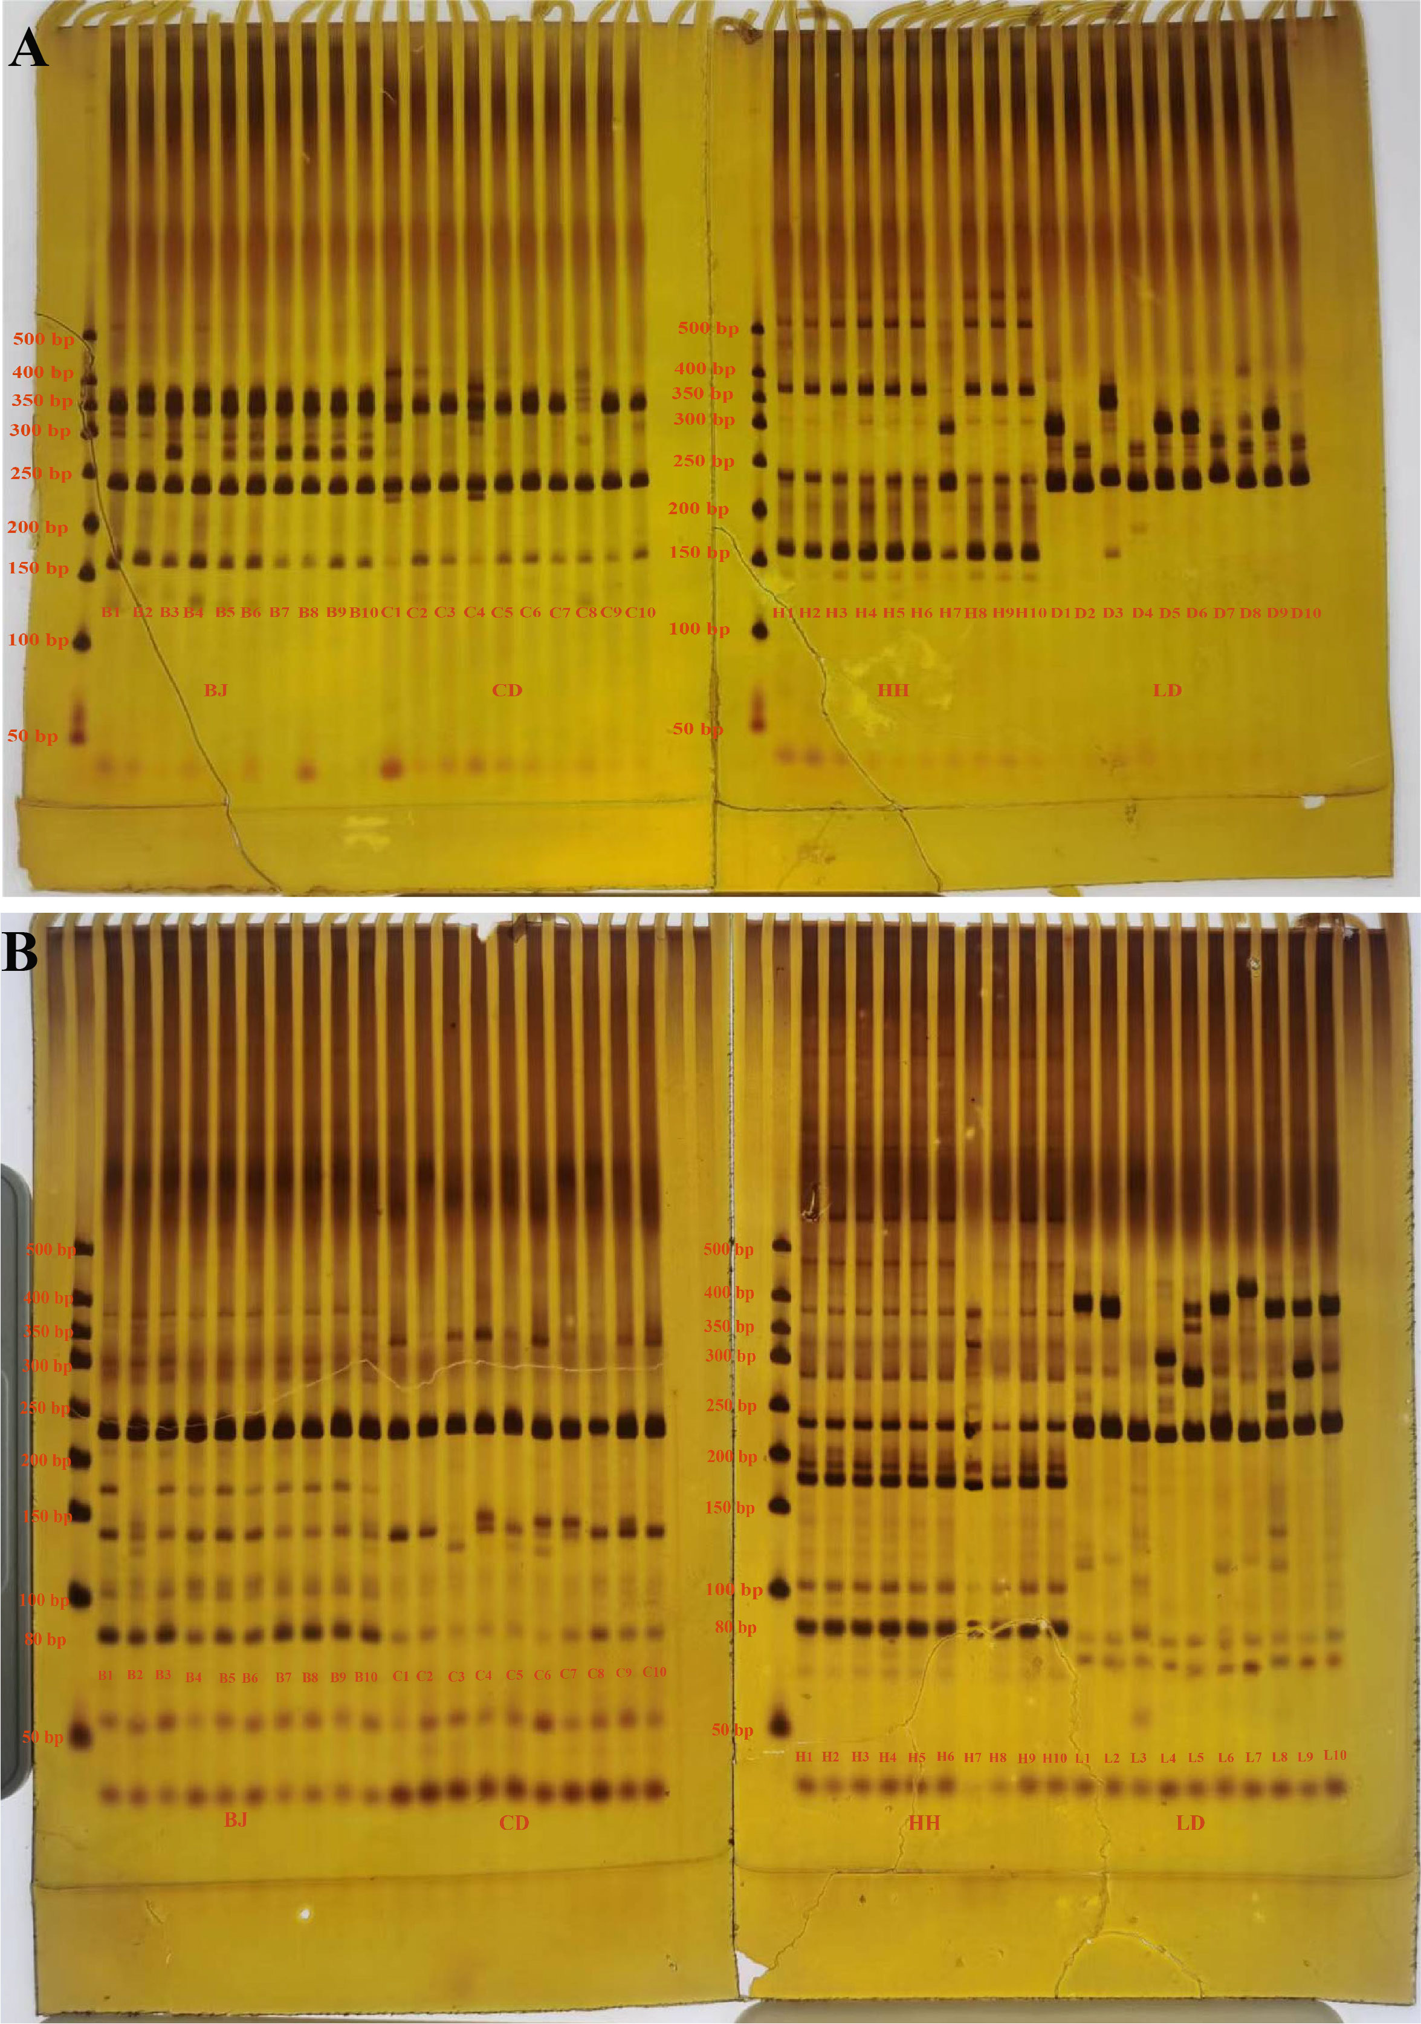
Fig. S8 Results of PCR amplification of primers P37(A) and P148(B) in 40 individual plants of four Poa species. The different codes represent the genotypes of the individuals, B1 to B10 for the 10 genotypes of BJ (P. pratensis var. anceps), C1 to C10 for the 10 genotypes of CD (P. pratensis), H1 to H10 for the 10 genotypes of HH (P. botryoides), L1 to L10 represent the 10 genotypes of LD (P. crymophila).

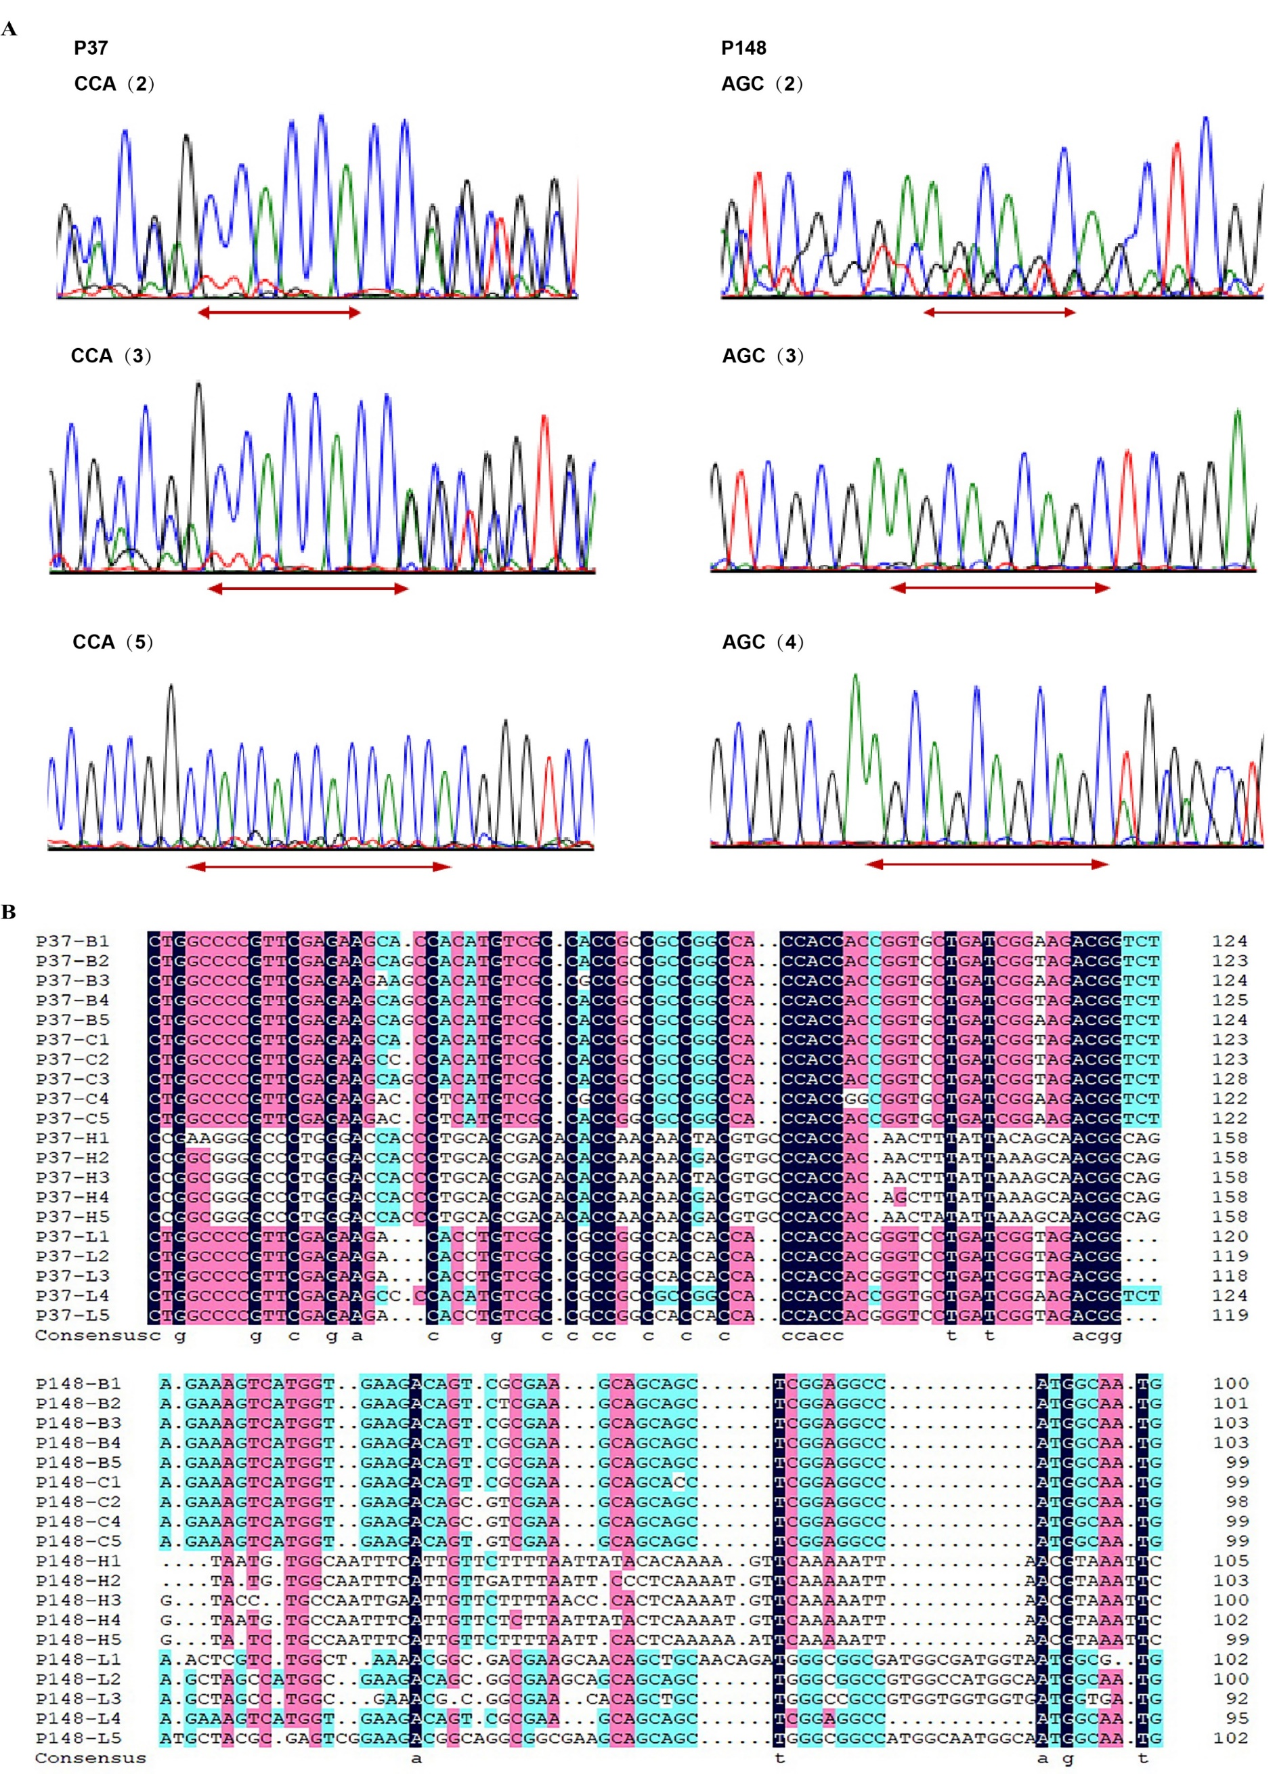
Fig. S9 Analysis of primer validation results. (A) Comparative electropherogram analysis of primers P37 and P148 EST-SSR loci among different species of Poa. (B) Alignment of sequences obtained from selected PCR bands amplified by primers P37 and P148. The different codes represent the genotypes of the individuals, B1 to B5 for the 5 genotypes of BJ (P. pratensis var. anceps), C1 to C5 for the 5 genotypes of CD (P. pratensis), H1 to H5 for the 5 genotypes of HH (P. botryoides), L1 to L5 represent the 5 genotypes of LD (P. crymophila).

