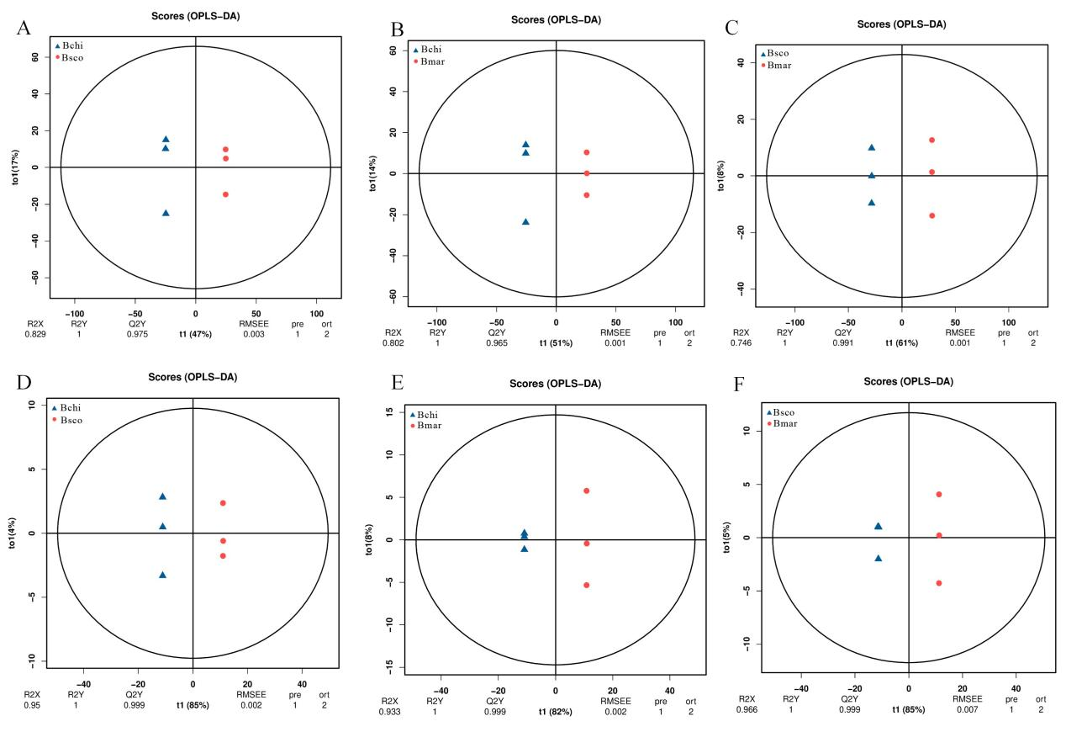Fig. S1. OPLS-DA model of differences in metabolite levels between Bchi, Bsco and Bmar. (A-C) The OPLS–DA score of LC-MS. (D-F) The OPLS–DA score of GC-MS. The three accessions (Bchi, Bsco and Bmar) exhibited significantly different metabolic characteristics.

