Supplementary Material S4.
(a) Example of seed scans of control barley and barley treated with ABA, drought and ABA+drought obtained using GrainScan.

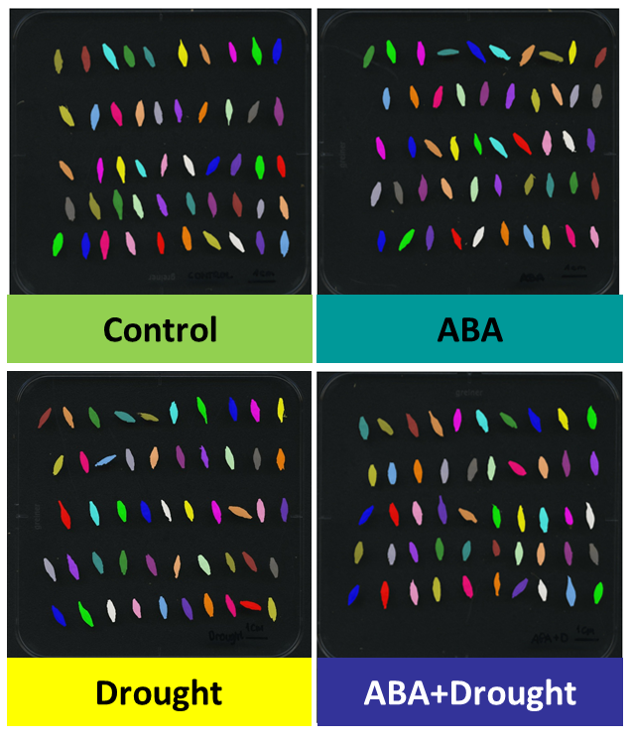

(b) Seed parameters of control plants and plants treated with ABA, drought and ABA+drought obtained using GrainScan.
(A) Seed area, (B) seed circuit, (C) seed length, (D) seed width, (E) lightness of the grain colour (0-100) - grain Ch1, (F) redness, green (negative values) or magenta (positive values) - grain Ch2 and (G) yellowness, blue (negative values) or yellow (positive values) - grain Ch3 (Whan et al. 2014). One-way ANOVA (P ≤ 0.05) followed by Tukey HSD test (P ≤ 0.05) was applied to identify differences between analysed variants of the experiment. Statistically significant differences (P ≤ 0.05) are indicated by different letters.
