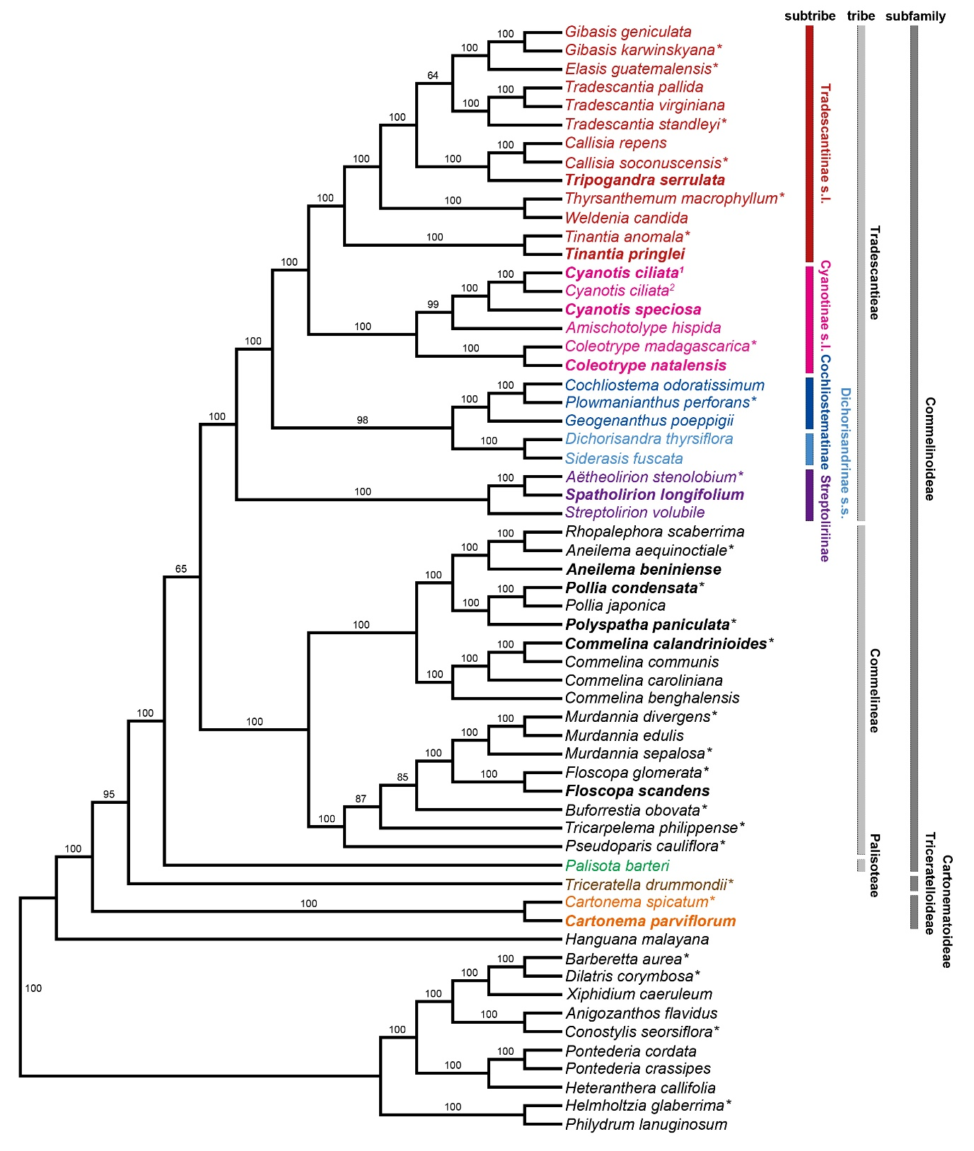
Fig. S1 The Maximum Parsimony bootstrap consensus tree of 60 taxa inferred from 79 plastid protein-coding genes. Numbers indicate maximum parsimony bootstrap percentages (PBP).

