Supplementary Figures and Legends

Figure S1 Changes of sand water content and leaf relative water content with time course of treatment.
Figure S2 Correlation analysis of gene expression value obtained from the RNA-seq and qRT-PCR.
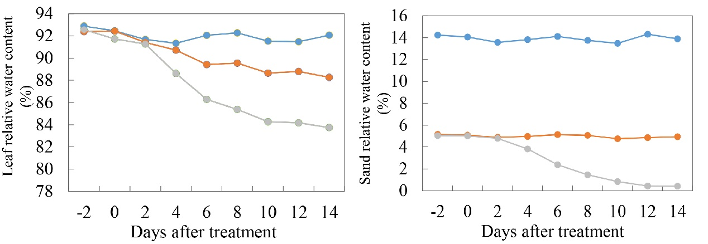
Fig. S1 Changes of sand water content and leaf relative water content with time course of treatment. At day 0, ten-day-old seedlings with one true leaf were transplanted in the same pot (three plants in each pot) filled by sand, and sand water-holding capacity is 14%. Well water supply (CK), moderate drought (MD), and severe drought (SD) treatments were indicated by blue, red, and gray line, respectively.

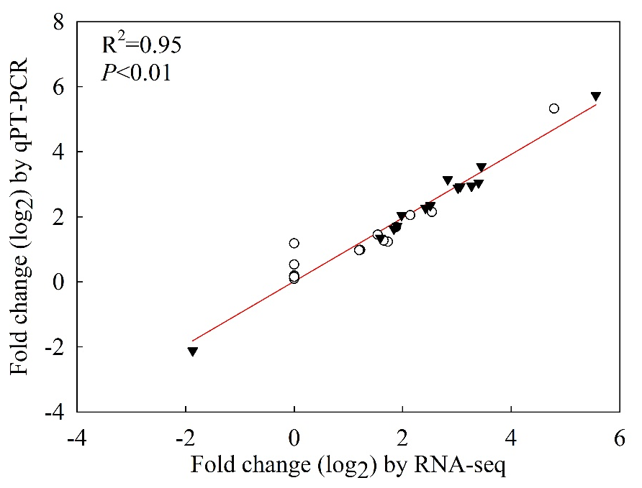
Fig. S2 Correlation analysis of gene expression value obtained from the RNA-seq and qRT-PCR. White circles and black triangles, respectively, represent correlation of SD and MD-treated results.

