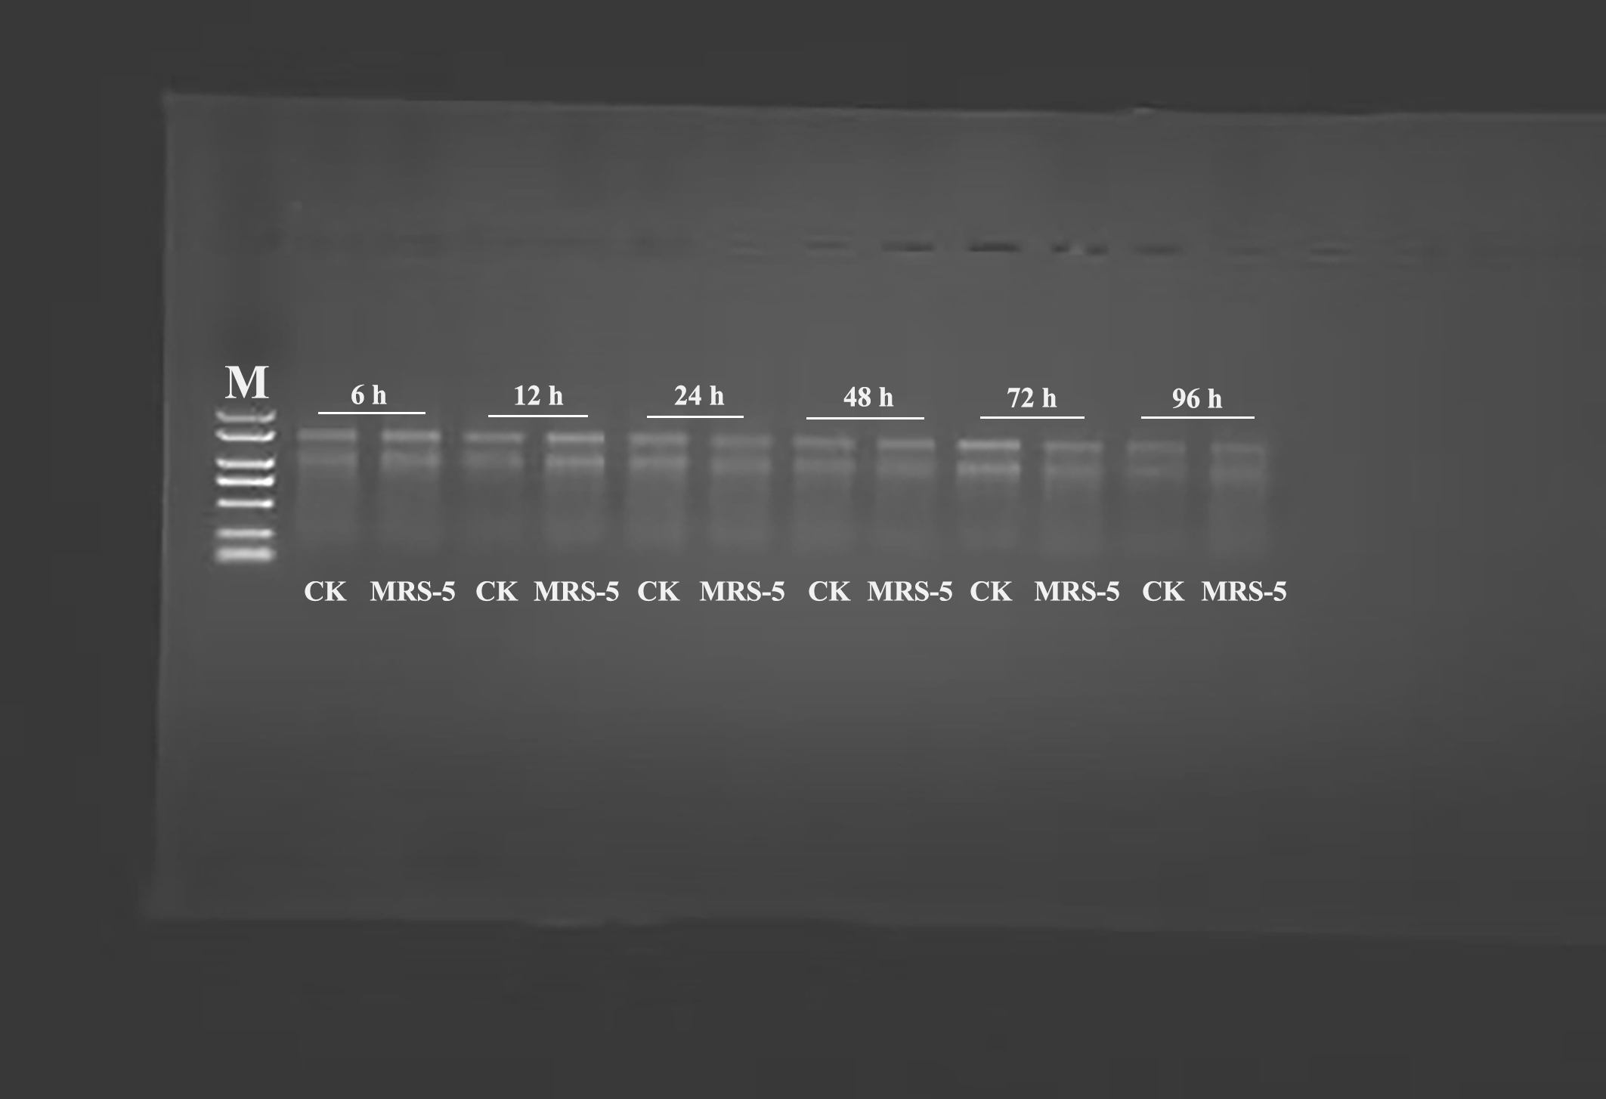
Fig.S2-1 The original gel image: RNA quality analysis in R. pseudosolanacearum-infected mulberry roots by 1.25% agarose gel electrophoresis. M: DNA Marker DL2000.
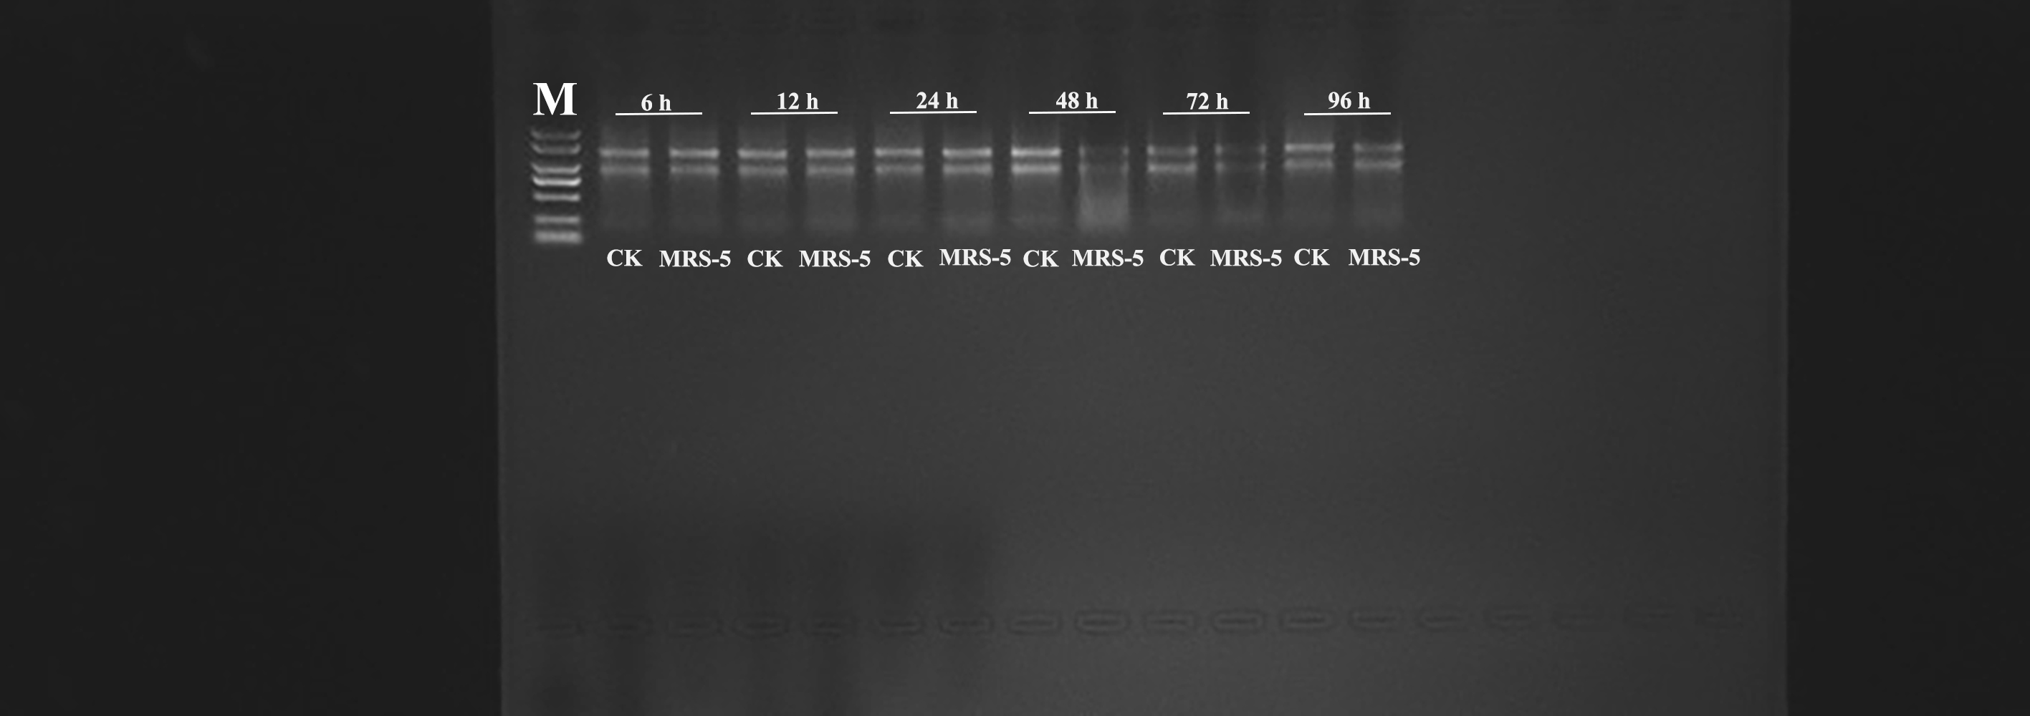
Fig.S2-2 The original gel image: RNA quality analysis in R. pseudosolanacearum-infected mulberry stems by 1.25% agarose gel electrophoresis. M: DNA Marker DL2000.
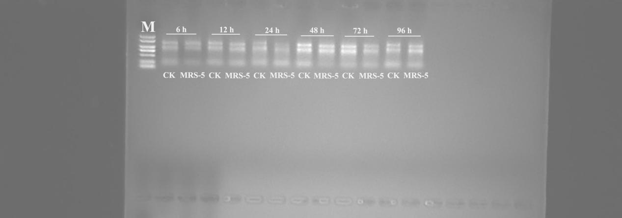
Fig.S2-3 The original gel image: RNA quality analysis in R. pseudosolanacearum-infected mulberry leaves by 1.25% agarose gel electrophoresis. M: DNA Marker DL2000.

