Bioinformatics analysis of the tomato methylesterase gene family
Jing Shang ^{1†}, Fujun Li ^{1†}, Xiangrong Kong ¹, Yue Ji ¹, Yanan Li ¹, Sarfaraz Hussain¹, Xiaoan Li¹, Ling Li³, Xinhua Zhang ^{1,}* and Zienab F.R. Ahmed ^{2,}*
¹ College of Agricultural Engineering and Food Science, Shandong University of Technology, Zibo, 255049, Shandong, PR China
² Integrative Agriculture Department, College of Agriculture and Veterinary Medicine, United Arab Emirates University, Al Ain 15551, United Arab Emirates (UAE)
³ College of Food and Biological Engineering, Beijing Vocational College of Agriculture, Fangshan District, Beijing 102442, PR China
*Correspondence: zxhl@sdut.edu.cn (X.H.Z); Zienab.ahmed@uaeu.ac.ae (Z.F.R.A)
† These authors contributed equally to this work.

∗ Correspondence:
Xinhua Zhang
zxh@sdut.edu.cn
Zienab F.R.Ahmed
ahmed@uaeu.ac.ae
Full list of author information is available at the end of the article
Jing Shang, Fujun Li these authors contributed equally to this work.
Fig. S1 Multiple sequence alignment and conserved motif analysis of SlMES. Amino acid residues were colored based on similarity levels: identical (100%, dark navy), conserved (75–99%, pink), and similar (50–74%, cyan). Consensus amino acids are denoted by lowercase abbreviations below each column, indicating identical or conserved residues. Horizontal lines in distinct colors below each column represent different conserved motifs. The catalytic triad residues are indicated by asterisks.
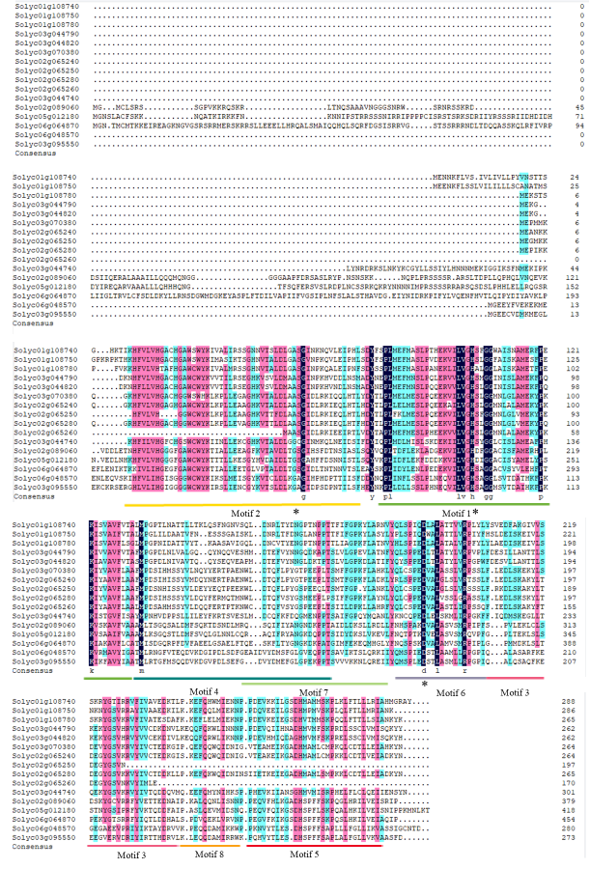

Fig. S2 SlMES family conserved motifs. The height of each letter corresponds to the frequency of the amino acid residue represented by that letter at that location.
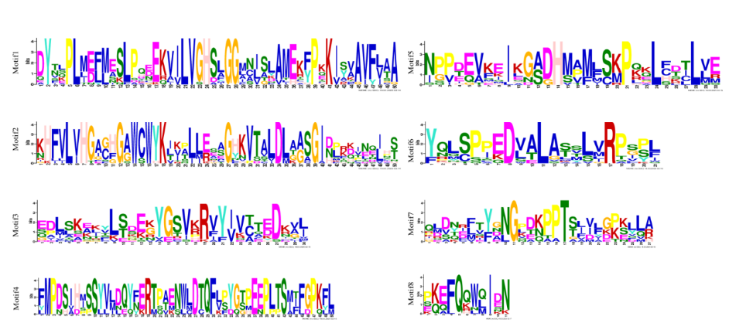

Table S1 Homology alignment parameters (E-value and identity%) between Solanum lycopersicum (Sl) and Arabidopsis thaliana (At) proteins
Protein | Query ID | E-value | Identity%
Solyc03g070380 | At2g23620 | 3.92E-93 | 57
Solyc02g065240 | At4g37140 | 5.47E-34 | 59
Solyc01g108740 | At4g37140 | 1.85E-25 | 51
Solyc02g065260 | At2g23620 | 5.13E-44 | 51
Solyc02g065250 | At2g23600 | 1.59E-53 | 49
Solyc01g108750 | At4g37140 | 1.79E-13 | 49
Solyc03g044790 | At2g23580 | 9.10E-38 | 47
Solyc03g044740 | At4g37140 | 1.18E-33 | 48
Solyc02g065280 | At2g23590 | 4.32E-75 | 47
Solyc03g044820 | At4g37140 | 5.09E-29 | 50
Solyc06g048570 | At3g10870 | 3.85E-101 | 60
Solyc03g095550 | At3g10870 | 1.86E-82 | 55
Solyc06g064870 | At4g09900 | 1.85E-138 | 75
Solyc02g089060 | At3g29770 | 4.45E-137 | 74
Solyc05g012180 | At1g26360 | 2.41E-107 | 62
Solyc01g108780 | At4g37140 | 8.78E-29 | 48

