Fig. S1 Density distributions of mapped reads on reference genome. A, B, and C are three samples of HN2026-4x, respectively; D, E, F are three samples of 9311-4x, respectively. The horizontal axis represents the chromosomal location; The vertical axis represents the log2 value of the coverage depth.

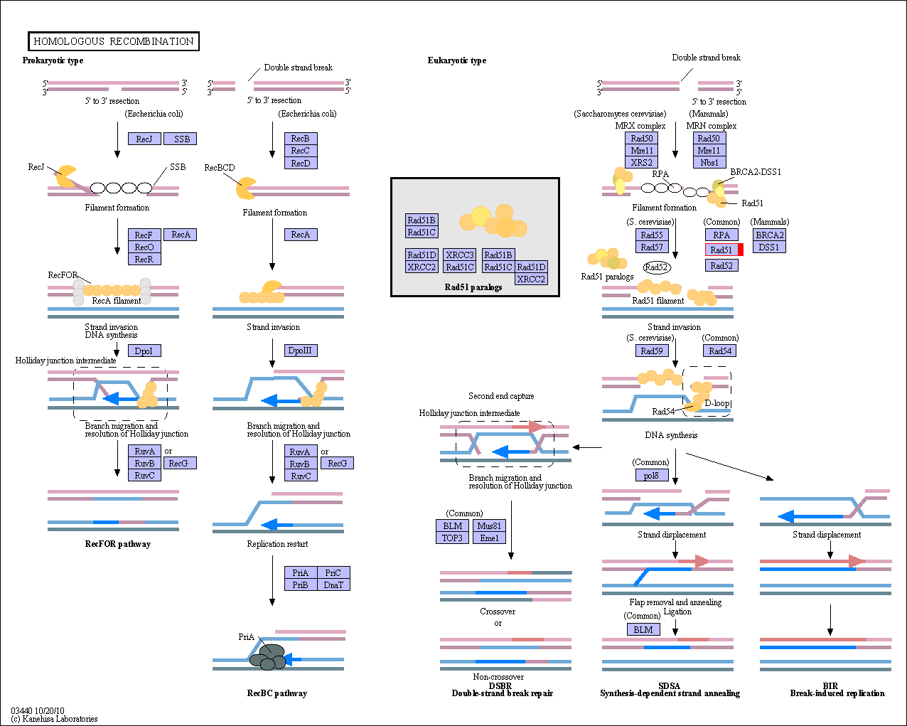
Fig. S2 RAD51 gene was annotated in homologous recombination pathway (ko03440) by Kyoto encyclopedia of genes and genomes (KEGG) analysis (indicated with a red border).

