Additional File 1: Supplemental Figures
(Fig. S1–S5）
The first complete mitochondrial genome of Eucommia ulmoides: a multi-chromosomal architecture and controversial phylogenetic relationship in asterids
Meng Li¹, Weijie Zhao¹, Jing Qiu²* and Changwei Bi¹*
*Correspondence: bichwei@njfu.edu.cn (CB); power_ko@126.com (JQ)
1 State Key Laboratory of Tree Genetics and Breeding, Co-Innovation Center for Sustainable Forestry in Southern China, Key Laboratory of Tree Genetics and Biotechnology of Educational Department of China, Key Laboratory of Tree Genetics and Silvicultural Sciences of Jiangsu Province, Nanjing Forestry University, Nanjing 210037, China
2 The First Affiliated Hospital of Naval Medical University, Information Department, Shanghai 200433, China

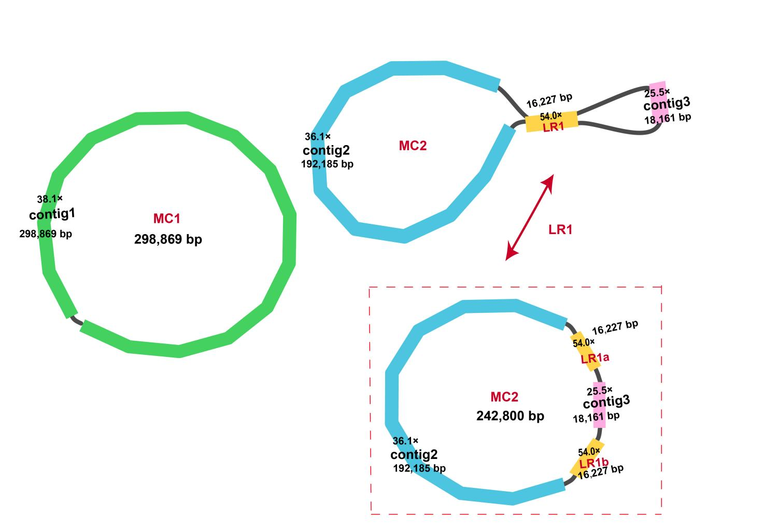
Fig. S1. The assembly graph of the E. ulmoides mitogenome. MC1 and MC2 refer to the two chromosomes in the E. ulmoides mitogenome. Different colors represent different DNA fragments sorted and labeled with LR1/contig1–3 according to length.
Fig. S2. Comparison of read coverage depth between nuclear genome (A), plastome (B), and mitogenome (C) of E. ulmoides.

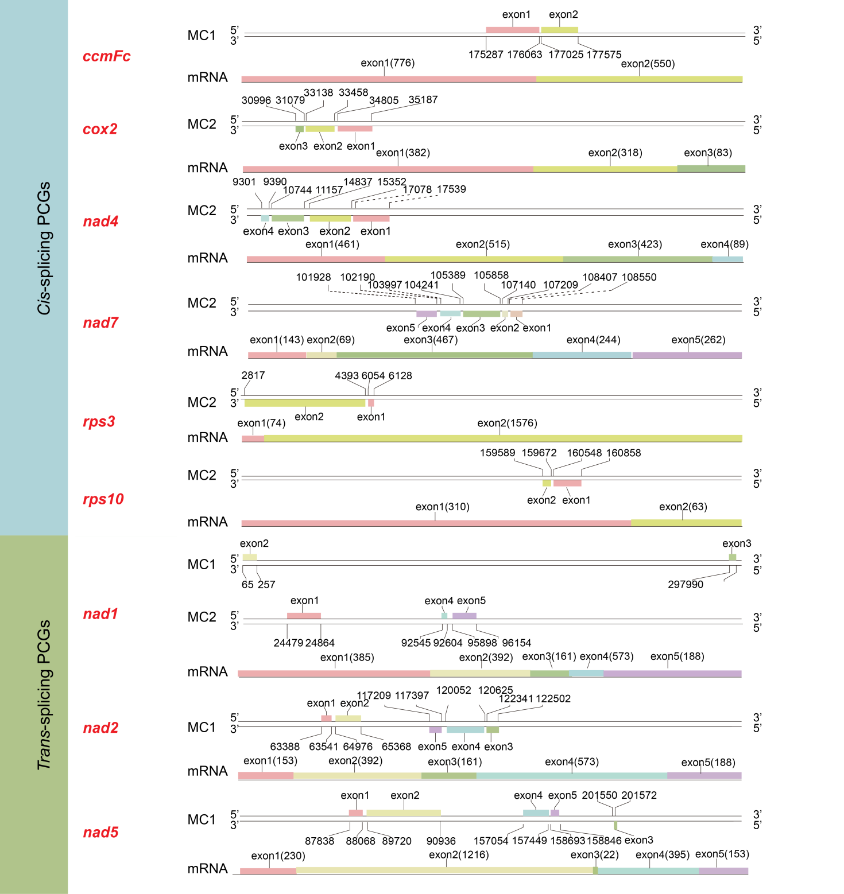Fig. S3. Cis-splicing PCGs and trans-splicing PCGs in the E. ulmoides mitogenome.

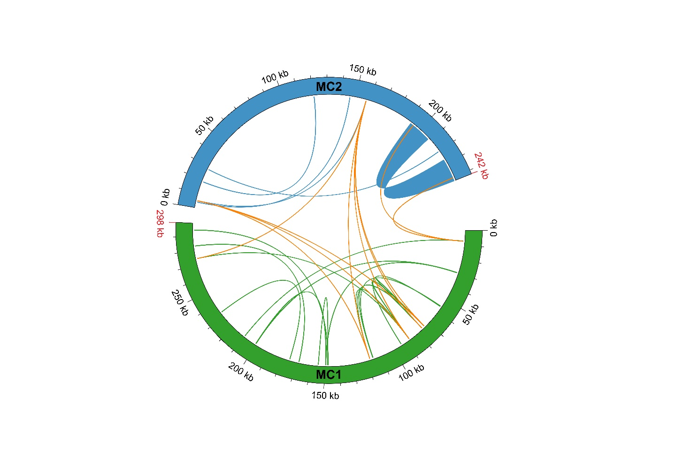Fig. S4. Dispersed repeats in the E. ulmoides mitogenome. Bars show the different chromosomes of E. ulmoides mitogenome. Lines in the circle demonstrate dispersed repeats (>150 bp). Green lines represent the dispersed repeats identified in MC1, blue lines show the repeats in MC2, and orange lines depict the repetitive sequences present in both chromosomes

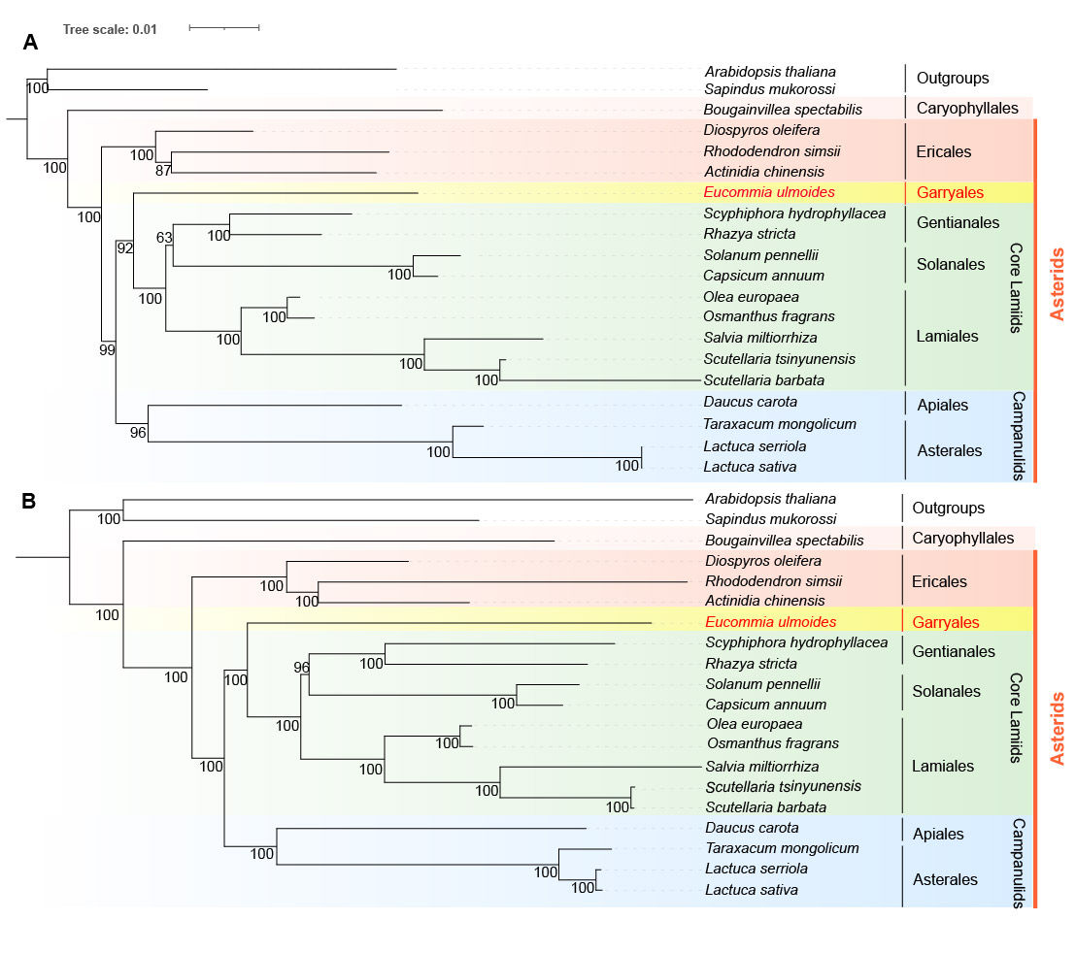
Fig. S5. Phylogenetic relationships of 7 orders of asterids based on mitogenomes (A) and plastomes (B). They present the branch lengths and bootstraps.

