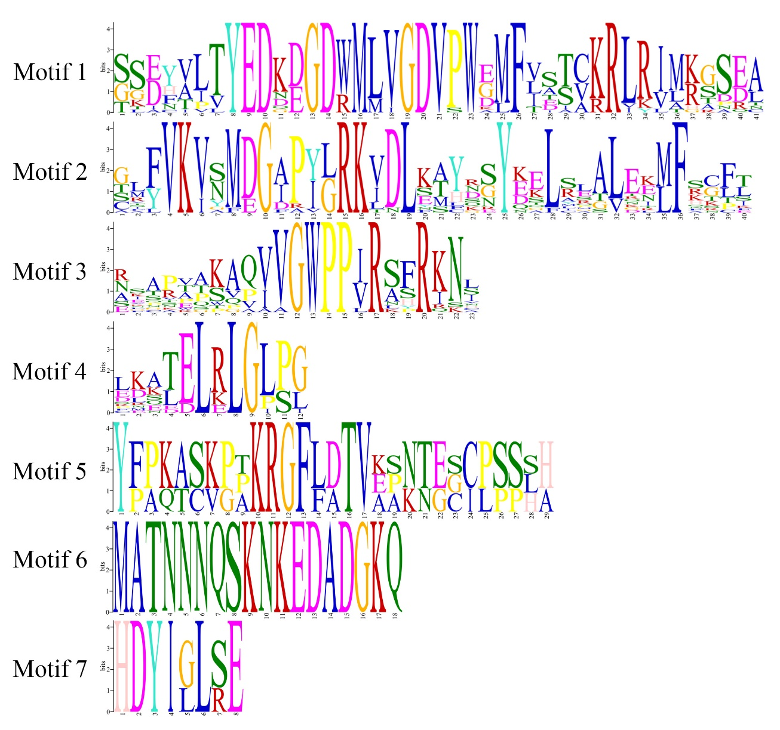
Fig. S1 Conserved motif of Aux/IAA proteins

