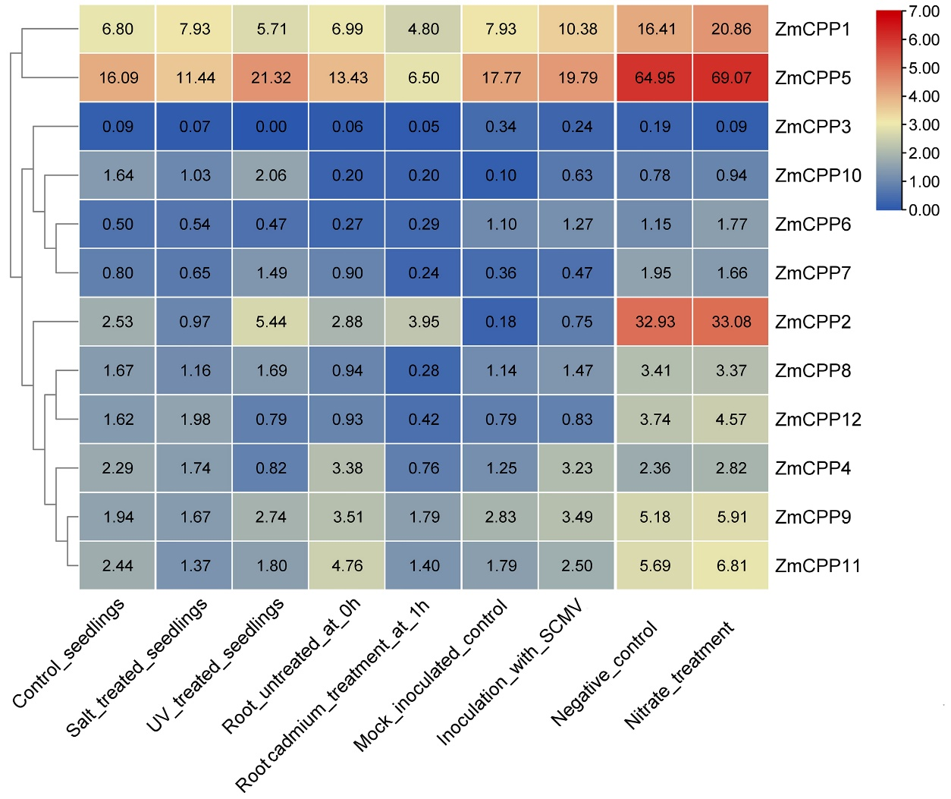
Figure S1. Heat map of the expression levels of ZmCPPs in different environmental stresses. Specific stress names are marked in the figure. Heatmap construction was based on the fragments per kilobase per million mapped reads (FPKM) values. Detailed FPKMs are listed in figure.

