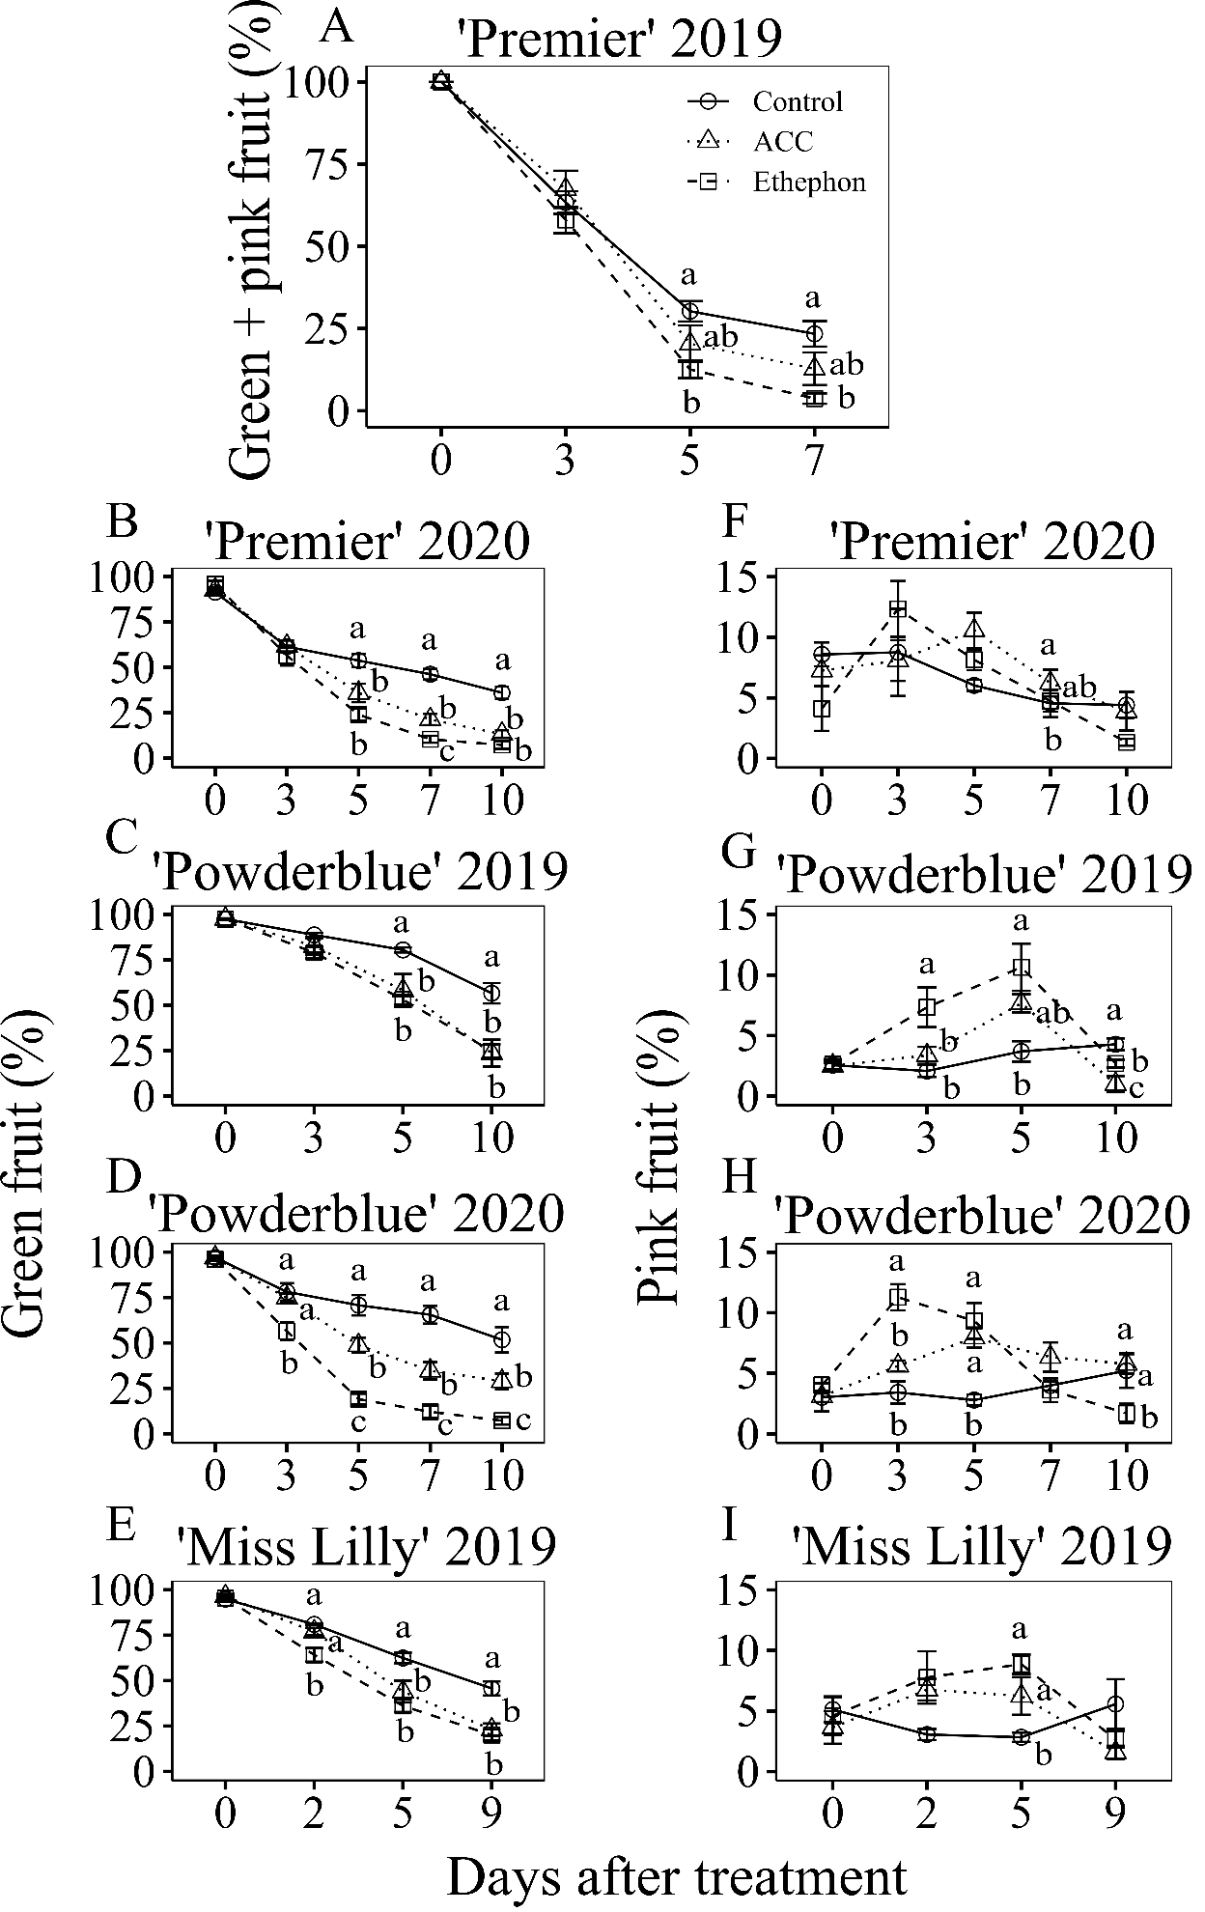
Supplementary Material 1: Figure S1: Effects of ethephon and 1-aminocyclopropane 1-carboxylic acid (ACC) treatments on the rate of ripening in blueberry fruit. Percentage of unripe fruit (green and pink fruit, A), green (B, C, D, E) and pink (F, G, H, I) fruit in control and in response to 1-aminocyclopropane 1-carboxylic acid (ACC) and ethephon treatments in three cultivars, Premier (A, B, F), Powderblue (C, D, G, H ) , and Miss Lilly (E, I), in 2019 (A, C, E, G, I) and 2020 (B, D, F, H). Mean ± S.E. (n = 4) are presented. Statistical analyses were performed using ANOVA followed by Fischer’s Least Significant Difference (LSD; α = 0.05). The same letter above the symbols indicates no statistically significant differences across treatments within a given day after treatment.

