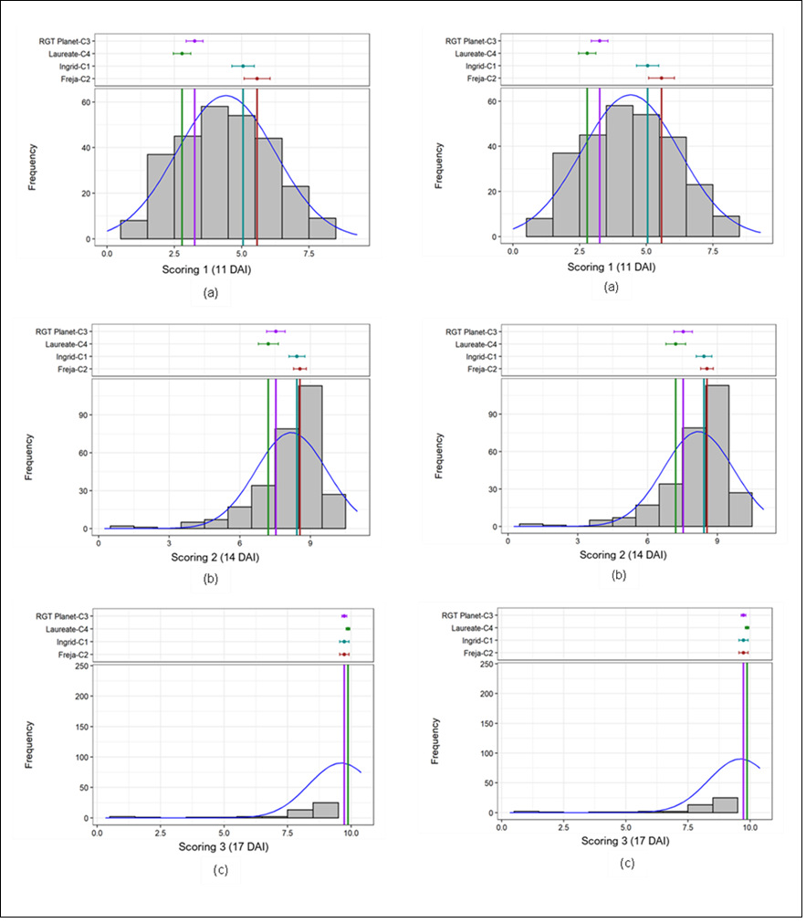
Supplementary Figure 1. Frequency distribution of the tested barley genotypes in trial set 1 (left panel) and trial set 2 (right panel). (A) first scoring at 11 DAI; (B) second scoring at 14 DAI; (C) third scoring at 17 DAI

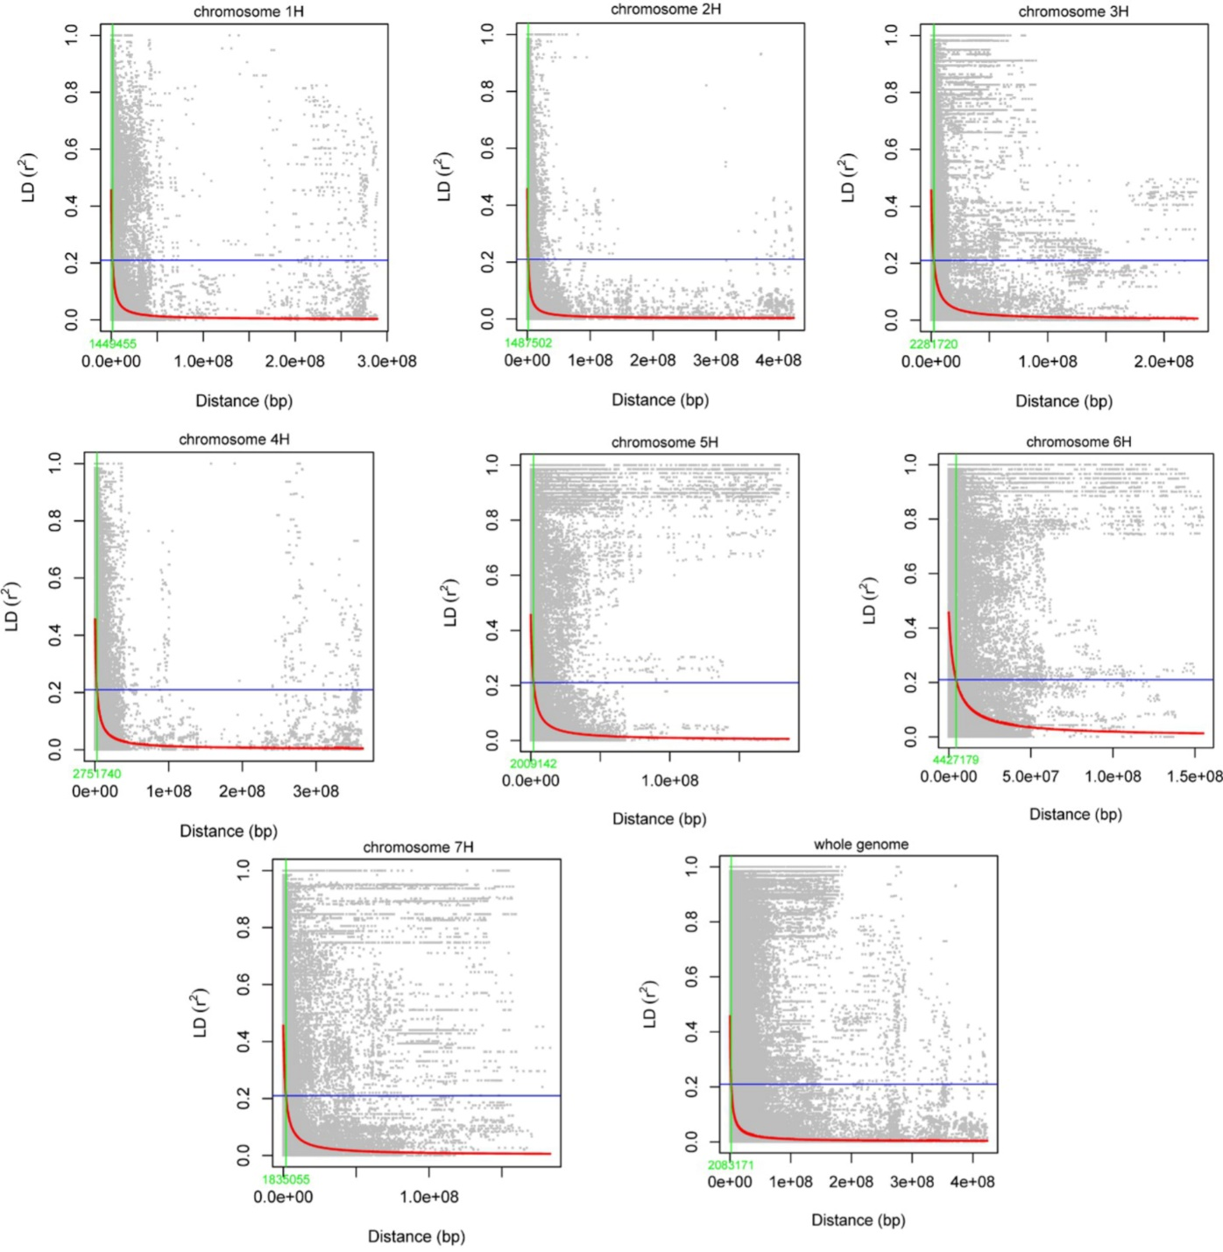
Supplementary Figure 2. Chromosome level LD decay curve fitted into a scatter plot with r² values against the physical distance (bp). The red curve line in each figure was the smoothing spline regression model fitted to LD decay for each chromosome. The AUDPC (BLUE) horizontal line showed the half decay r² value and the green vertical line represented the distance between the marker pairs where at the intersection between the half decay and the LD decay curve.

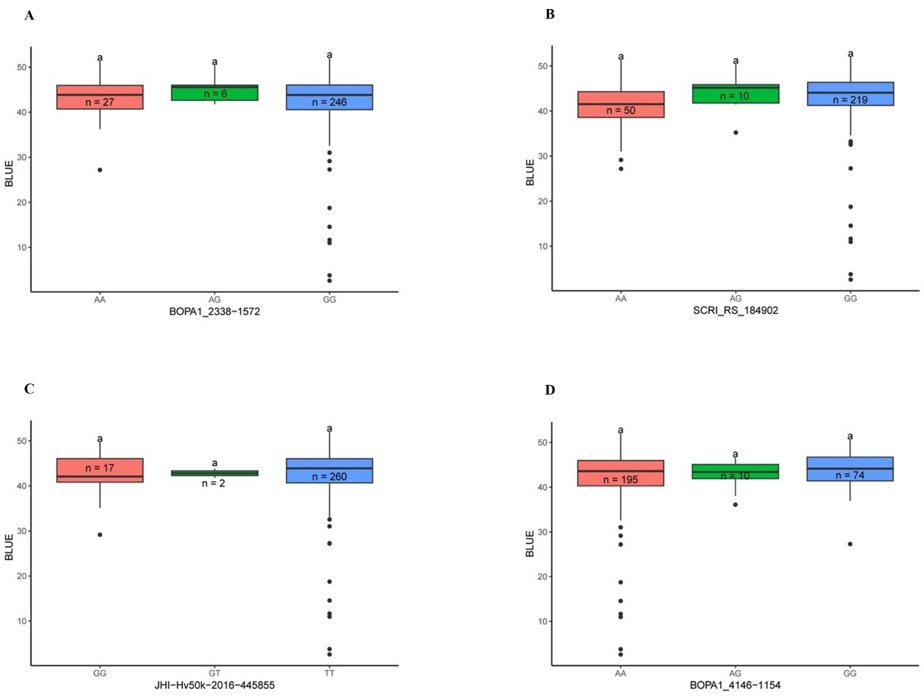
Supplementary Figure 3. Boxplots illustrating the allelic effect of SNPs detected from GWAS. BOPA1_2338-1572 (A), SCRI_RS_184902 (B), JHI-Hv50k-2016-445855 (C) and BOPA1_4146-1154 (D). Tukey's HSD (honestly significant difference) test was performed to check the significance level by comparing the allelic composition of the barley germplasms.

