 | Annotations | Gene Name | Primer Sequence 5’ to 3’
1. | Actin gene | TaActin-F  TaActin-R | GACCGTATGAGCAAGGAGAT  CAATCGCTGGACCTGACTC
2. | Chloride Channel B | TaCLCb-F  TaCLCb-R | CATGTTCGTGCTGCTCATCG  GACACCTTCTCGACCACCTG
3. | Guard cell Outward Rectifying K⁺ channel | TaGORK-F  TaGoRK-R | ATGAACGAGTGGCCACATTAC  TGGATCCGAACCATAAGCTAG
4. | Rubisco Activase | TaRca-F  TaRca-R | CCATACACACCCACCATCTCTTGC  TGTAAAGGCAGCTCCCGTCGT
5. | Stay-Green Regulator | TaSGR-F  TaSGR-R | CACTTCCTGCTCGACCTCAT  AAGTTGGGGTTGTTGGAGTG
6. | Lipoxygenase | TaLOX-F  TaLOX-R | TGCGGATTTCTTTGTTGGTTT  CGTTTTGTGAGAGCTGTTTCCA
7. | Heat Shock Transcription Factor A2 | TaHsfA2-13-f  TaHsfA2-13-r | TGAAGGAGGAGGAGGTGC  GTGTGGGTTACGCATTGC
8. | Heat Shock Transcription Factor A6f | TaHsfA6f -f  TaHsfA6f -r | ACGACTTCTGGGAGGAGCTG  TCTCCTCCTTTCCAGCTCTAAAATC
9. | Caleosin | Caleosin F  Caleosin R | TGTACGACGGCAGCCTCTTC  GCTCCGACCATGCGAGTTT
10. | Haeme Peroxidase | Haeme Peroxidase F  Haeme Peroxidase R | GGGATTCTTCAGTTGCCATTG  TTGTCGGTCAAGCCCATTC
11. | Pheophorbide a Oxygenase | TaPaO-F  TaPaO-R | TCGTATCACTGCAACTTTCG  GCTCCGACCATGCGAGTTT
Supplementary Table 1. List of the genes and their primer sequences.

Supplementary Table 2. Impact of treatments on postharvest traits. P values are shown ns = not significant * P < 0.05, ** P < 0.01, and ****P <<0.0001****

 | Traits | Control*Heat | Control*Heat & Drought | Heat* Heat & Drought
1. | Tiller/plant | 0.008** | 0.0085** | 0.9998^{ns}
2. | Spike/plant | 0.0033** | <0.0001**** | 0.1624^{ns}
3. | Plant height (cm) | <0.0001**** | <0.0001**** | 0.6588^{ns}
4. | Main tiller length (cm) | 0.0002*** | <0.0001**** | 0.2014^{ns}
5. | Spikelet/main spike | 0.0005*** | <0.0001**** | <0.0001****
6. | Grain/main spike | <0.0001**** | <0.0001**** | <0.0001****
7. | Spike wt (g) | 0.0003*** | <0.0001**** | <0.0001****
8. | Grain wt (g) | <0.0001**** | <0.0001**** | 0.6001^{ns}
9. | Biomass (g) | 0.1927^{ns} | <0.0001**** | <0.0001****
10. | 1000 seed wt(g) | <0.0001**** | <0.0001**** | <0.0001****
11. | Spike fertility index | <0.0001**** | <0.0001**** | <0.0001****
12. | Harvest index | 0.0197* | <0.0001**** | <0.0001****

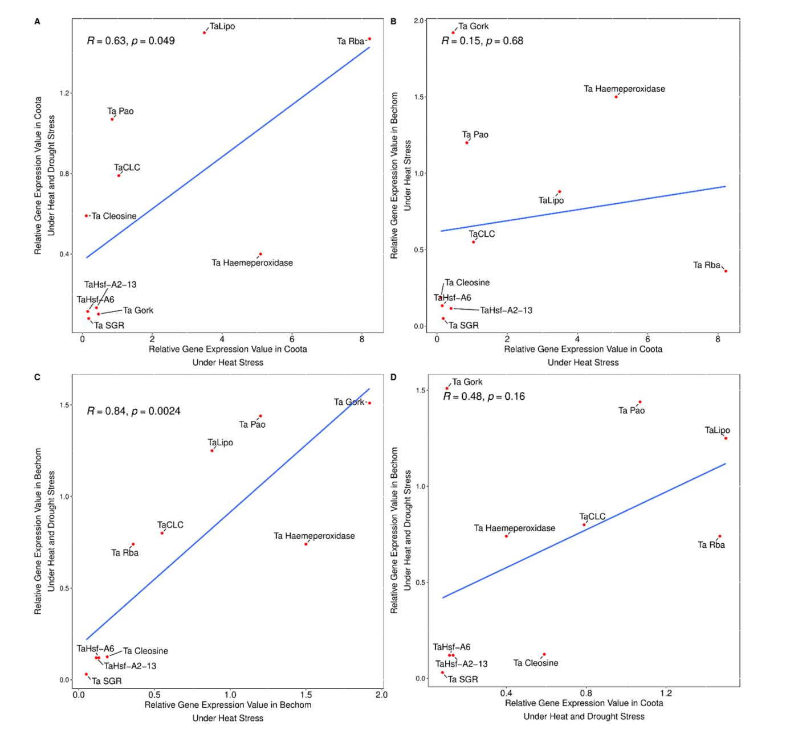

Supplementary Figure 1. Correlation analysis between key genes under heat and heat+drought stress in wheat.

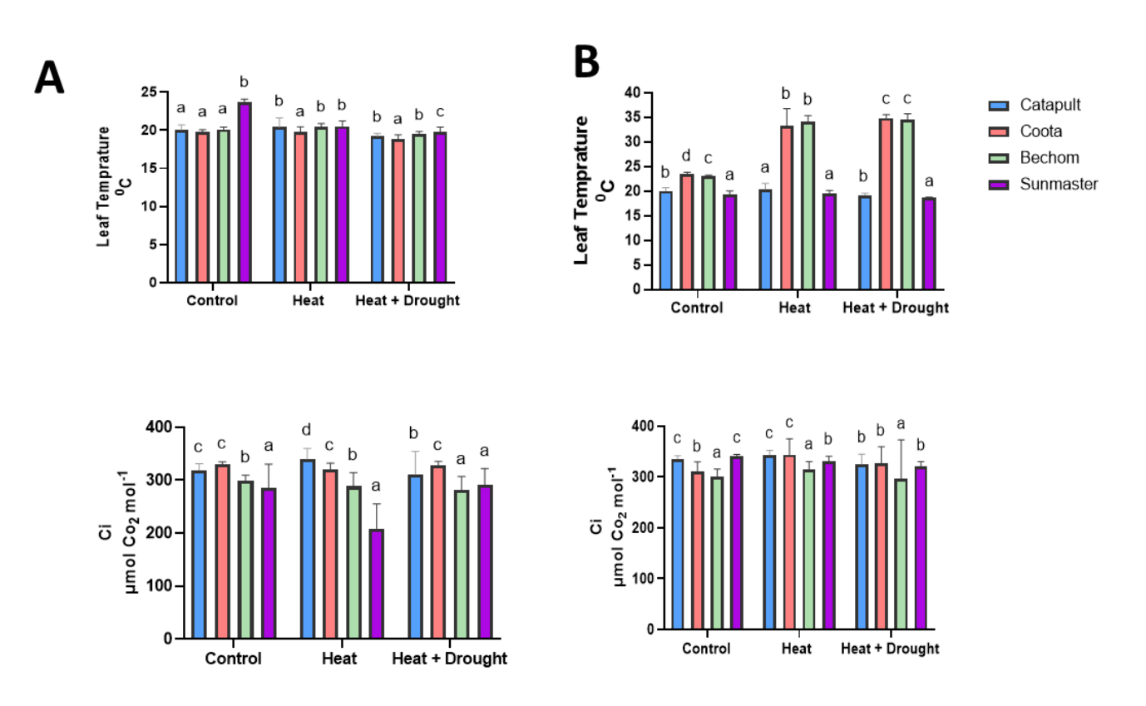
Supplementary Figure 2. Leaf gas exchange measurements during and after heat or heat+drought treatments in wheat. Leaf Temp is represented in (°C) and Ci is represented in (μmol CO₂ mol⁻¹). A) after treatment, B) During treatment. Data represent mean ± SE of N=25 *P<0.05.

