Supplementary information
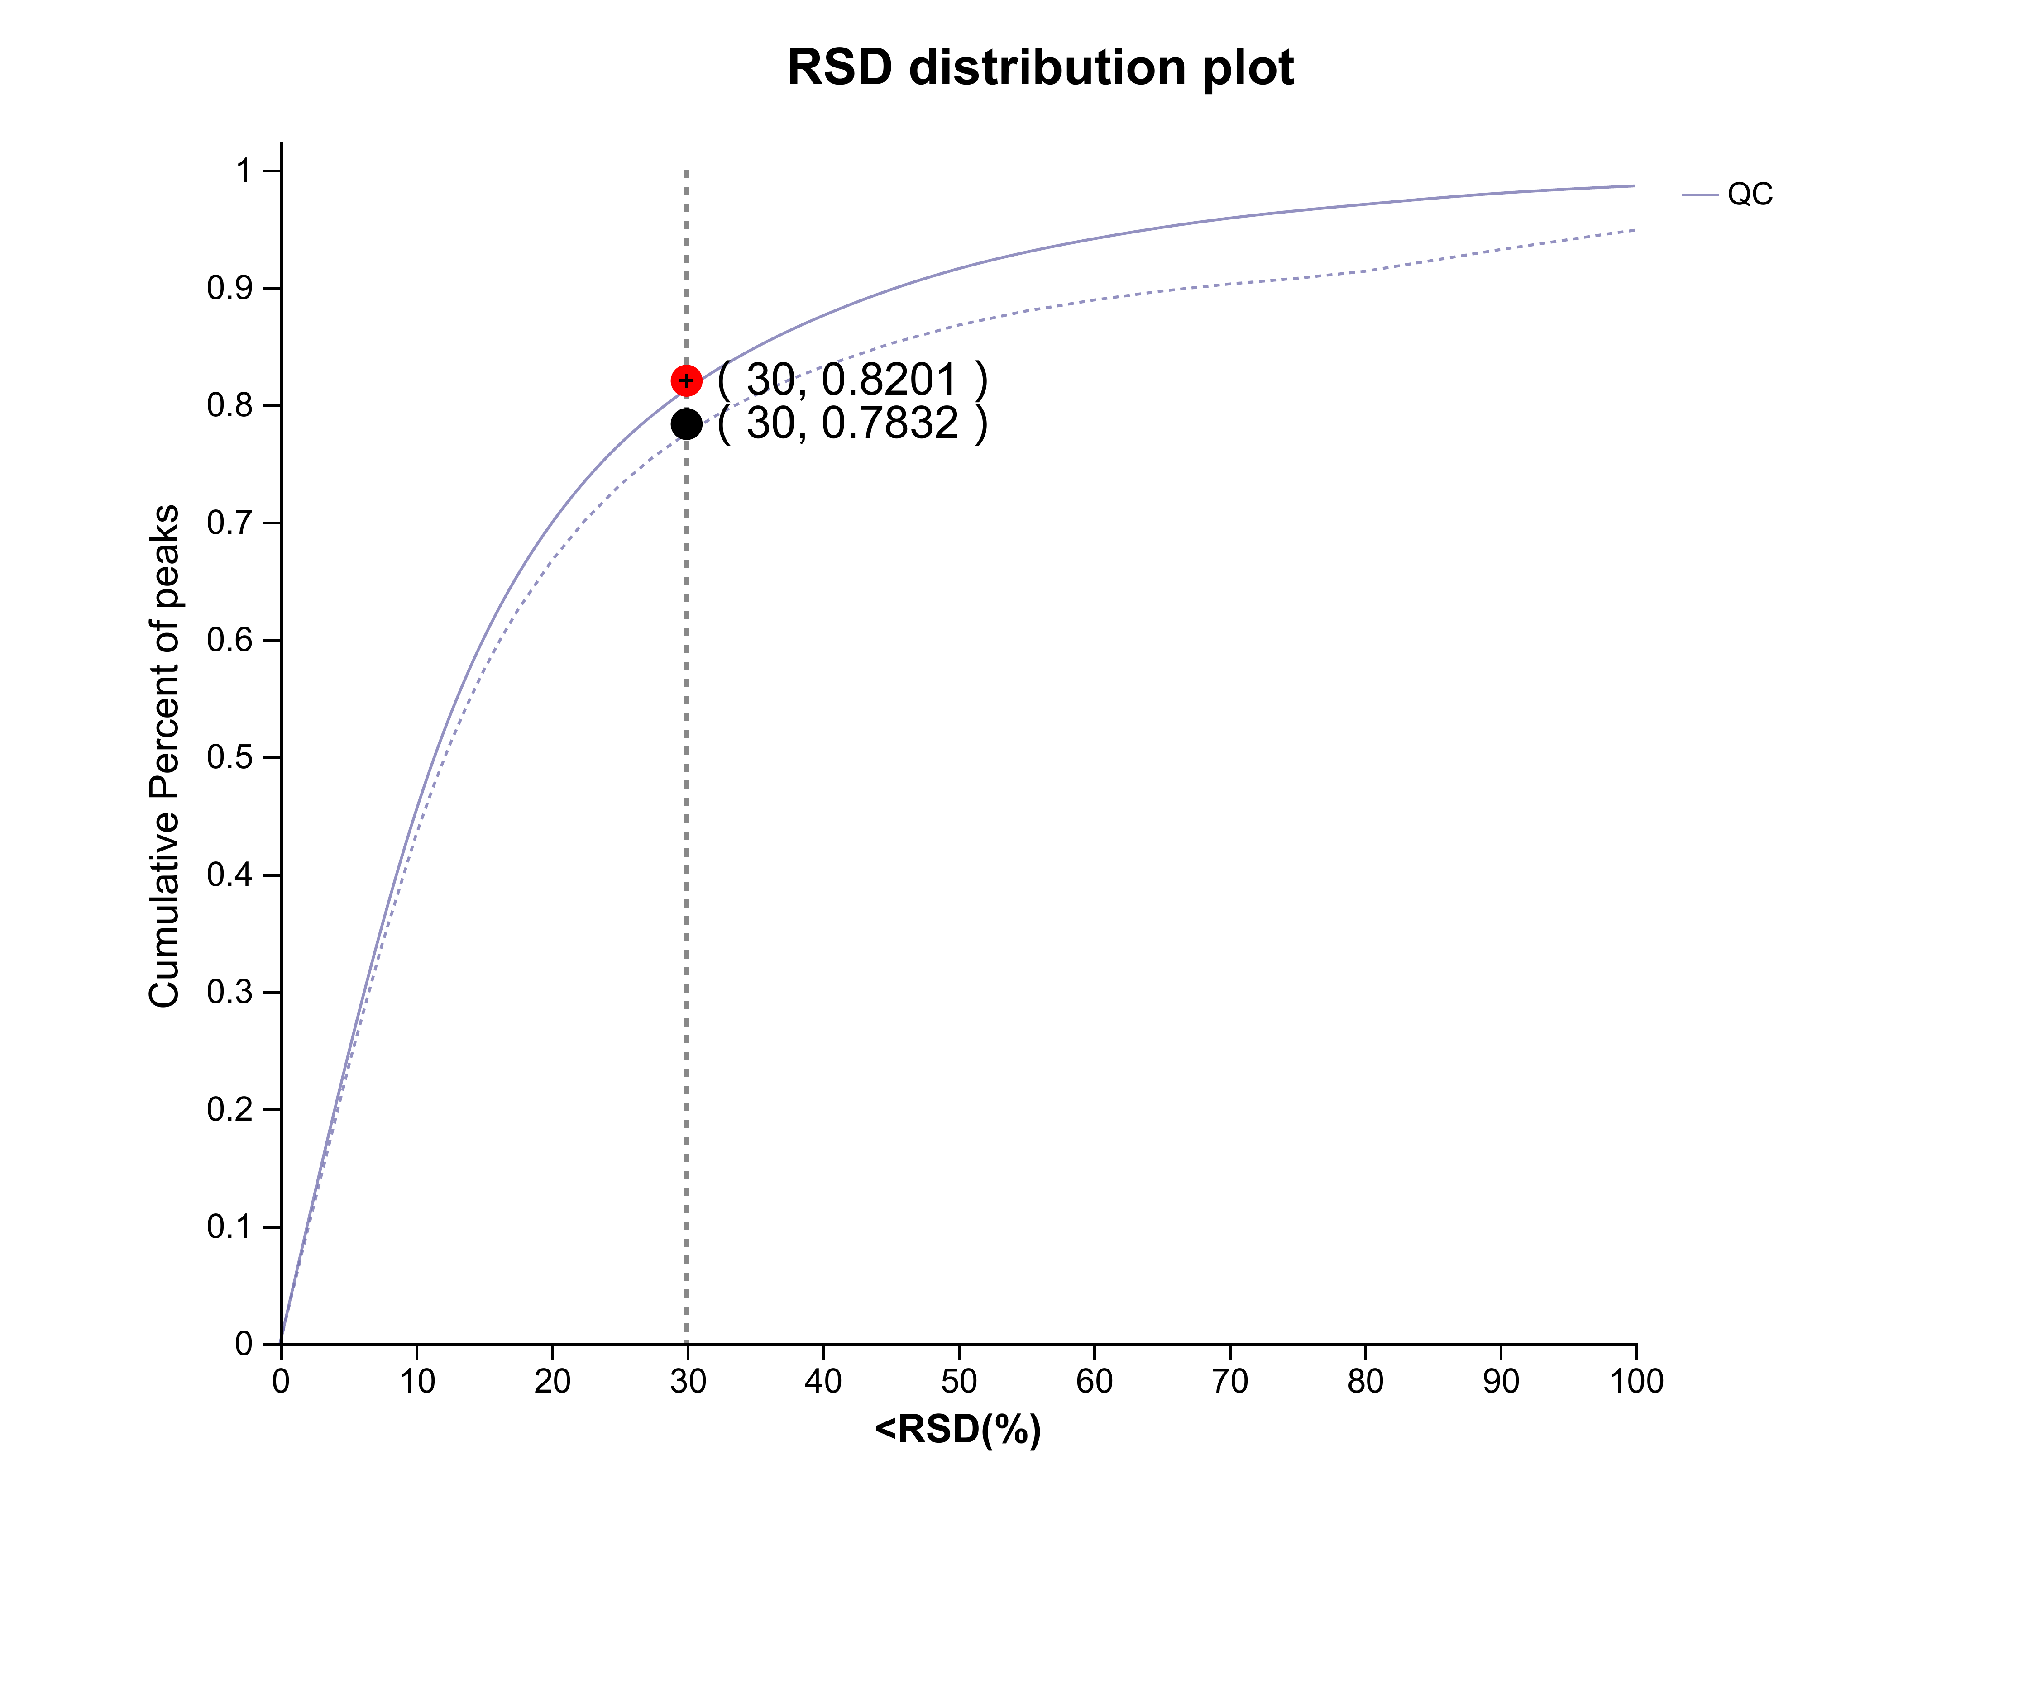
Fig. S1 QC sample RSD evaluation chart

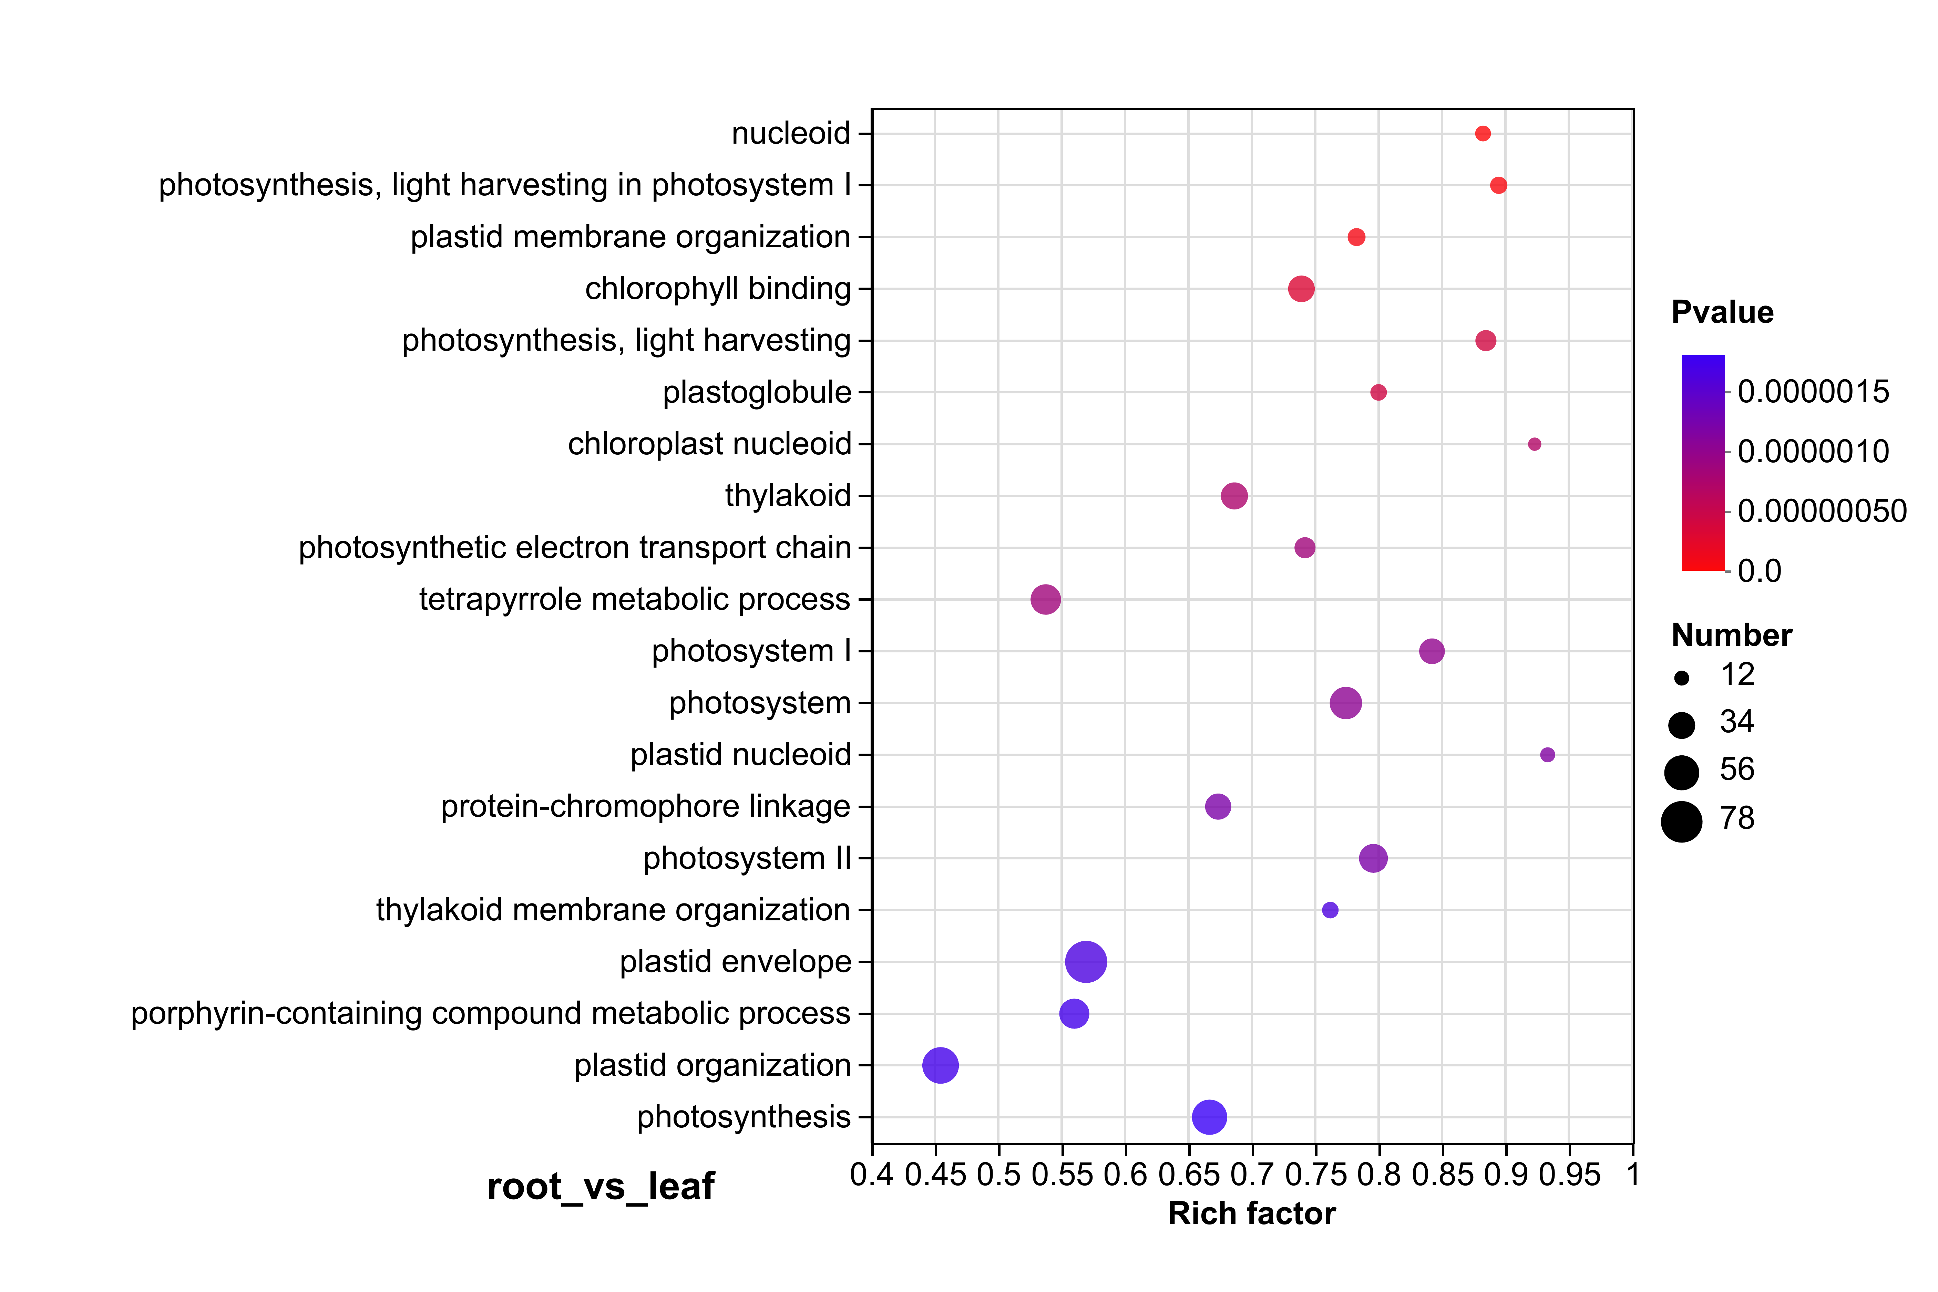

Fig. S2 The Gene Ontology (GO) enrichment analysis of DEGs among the different tissues .

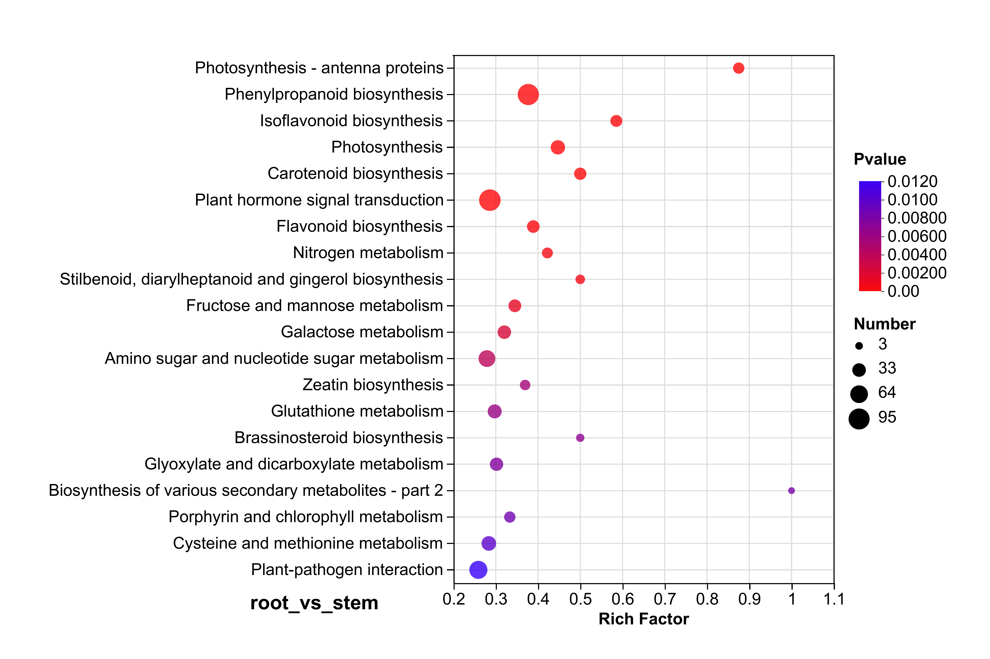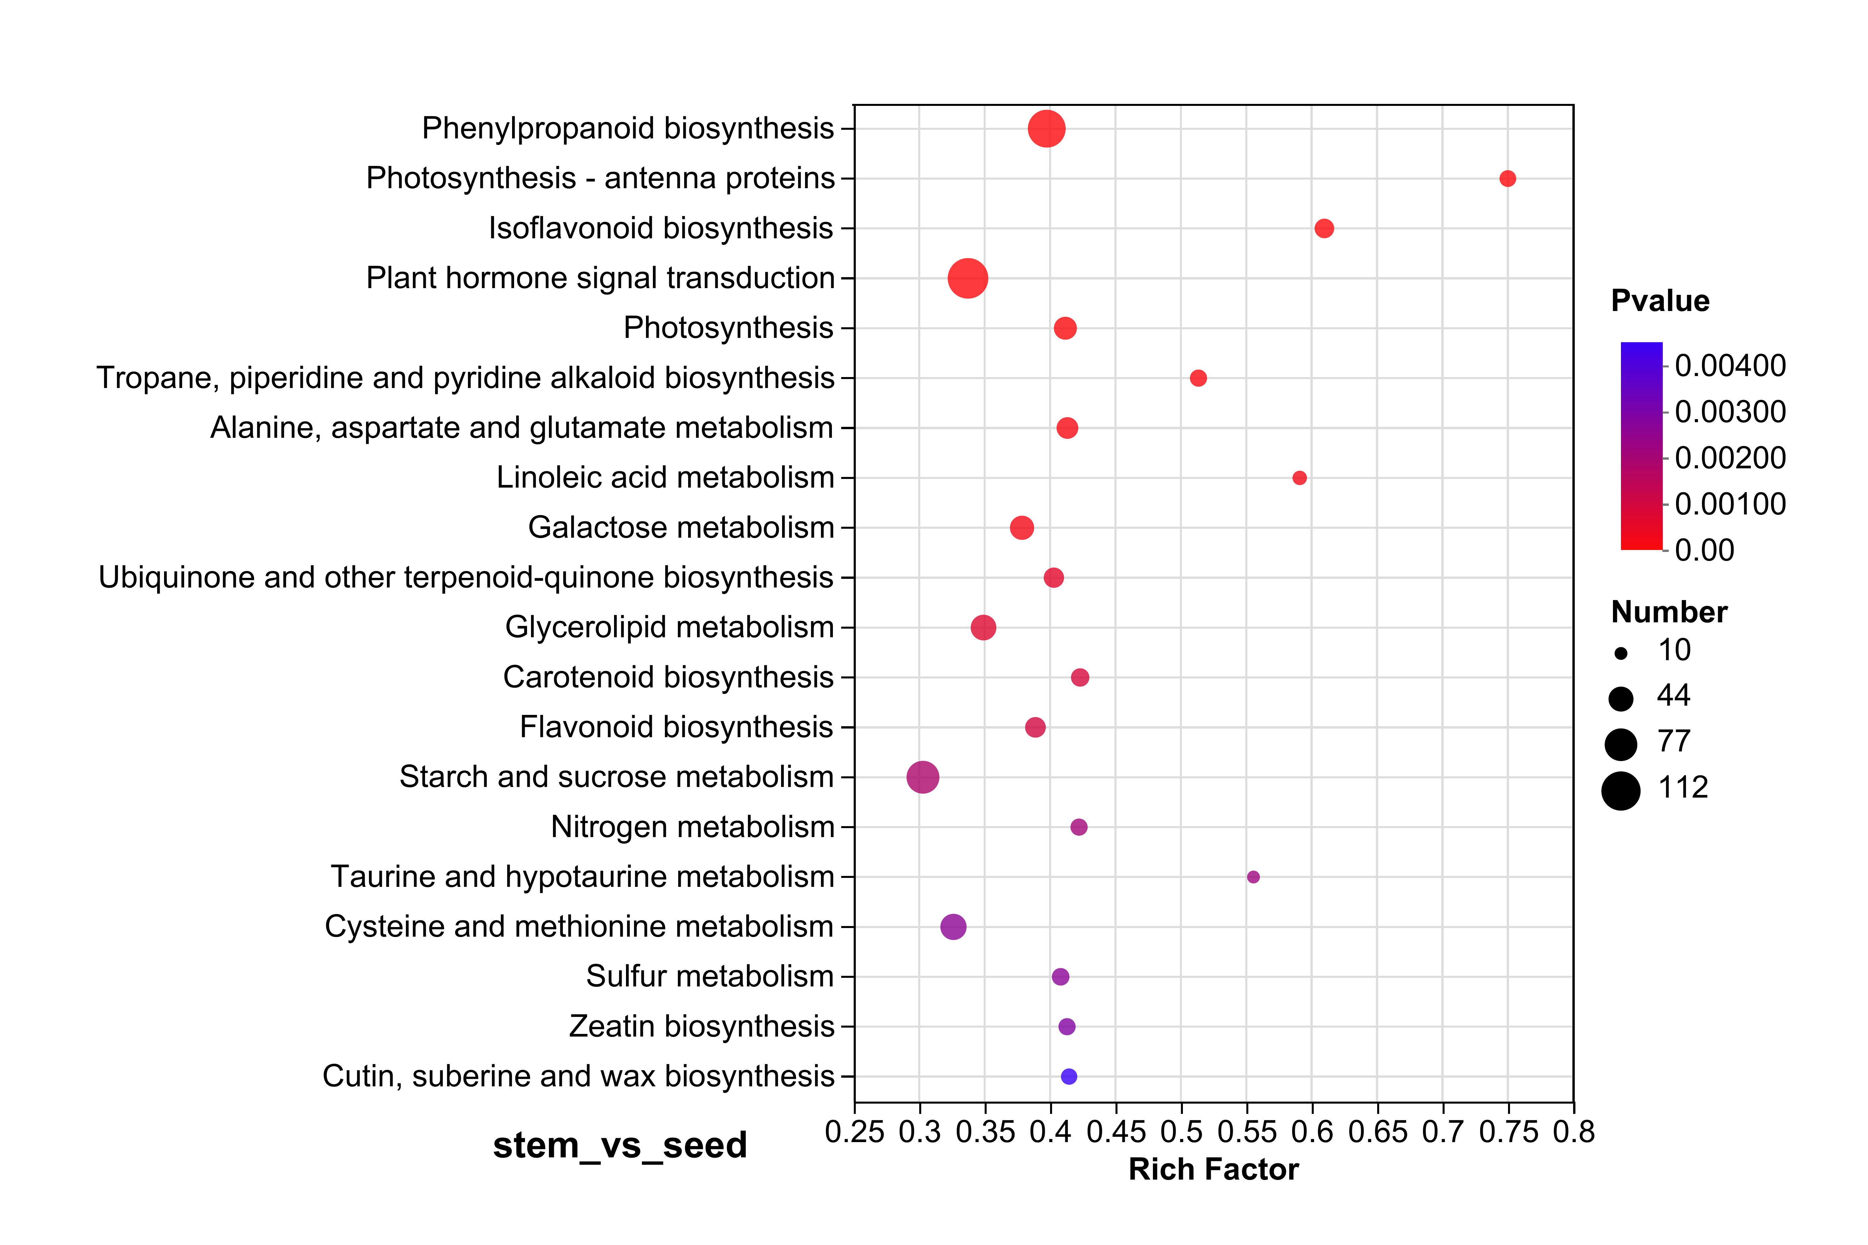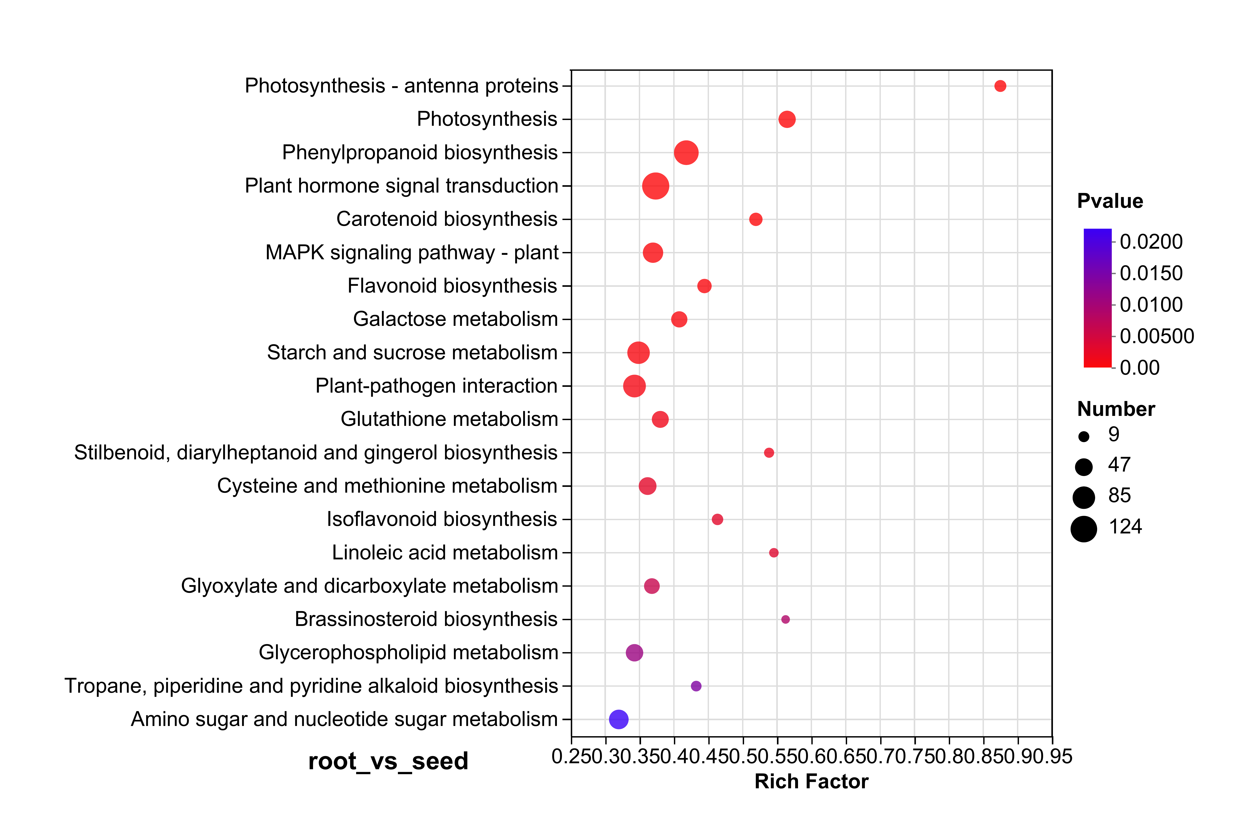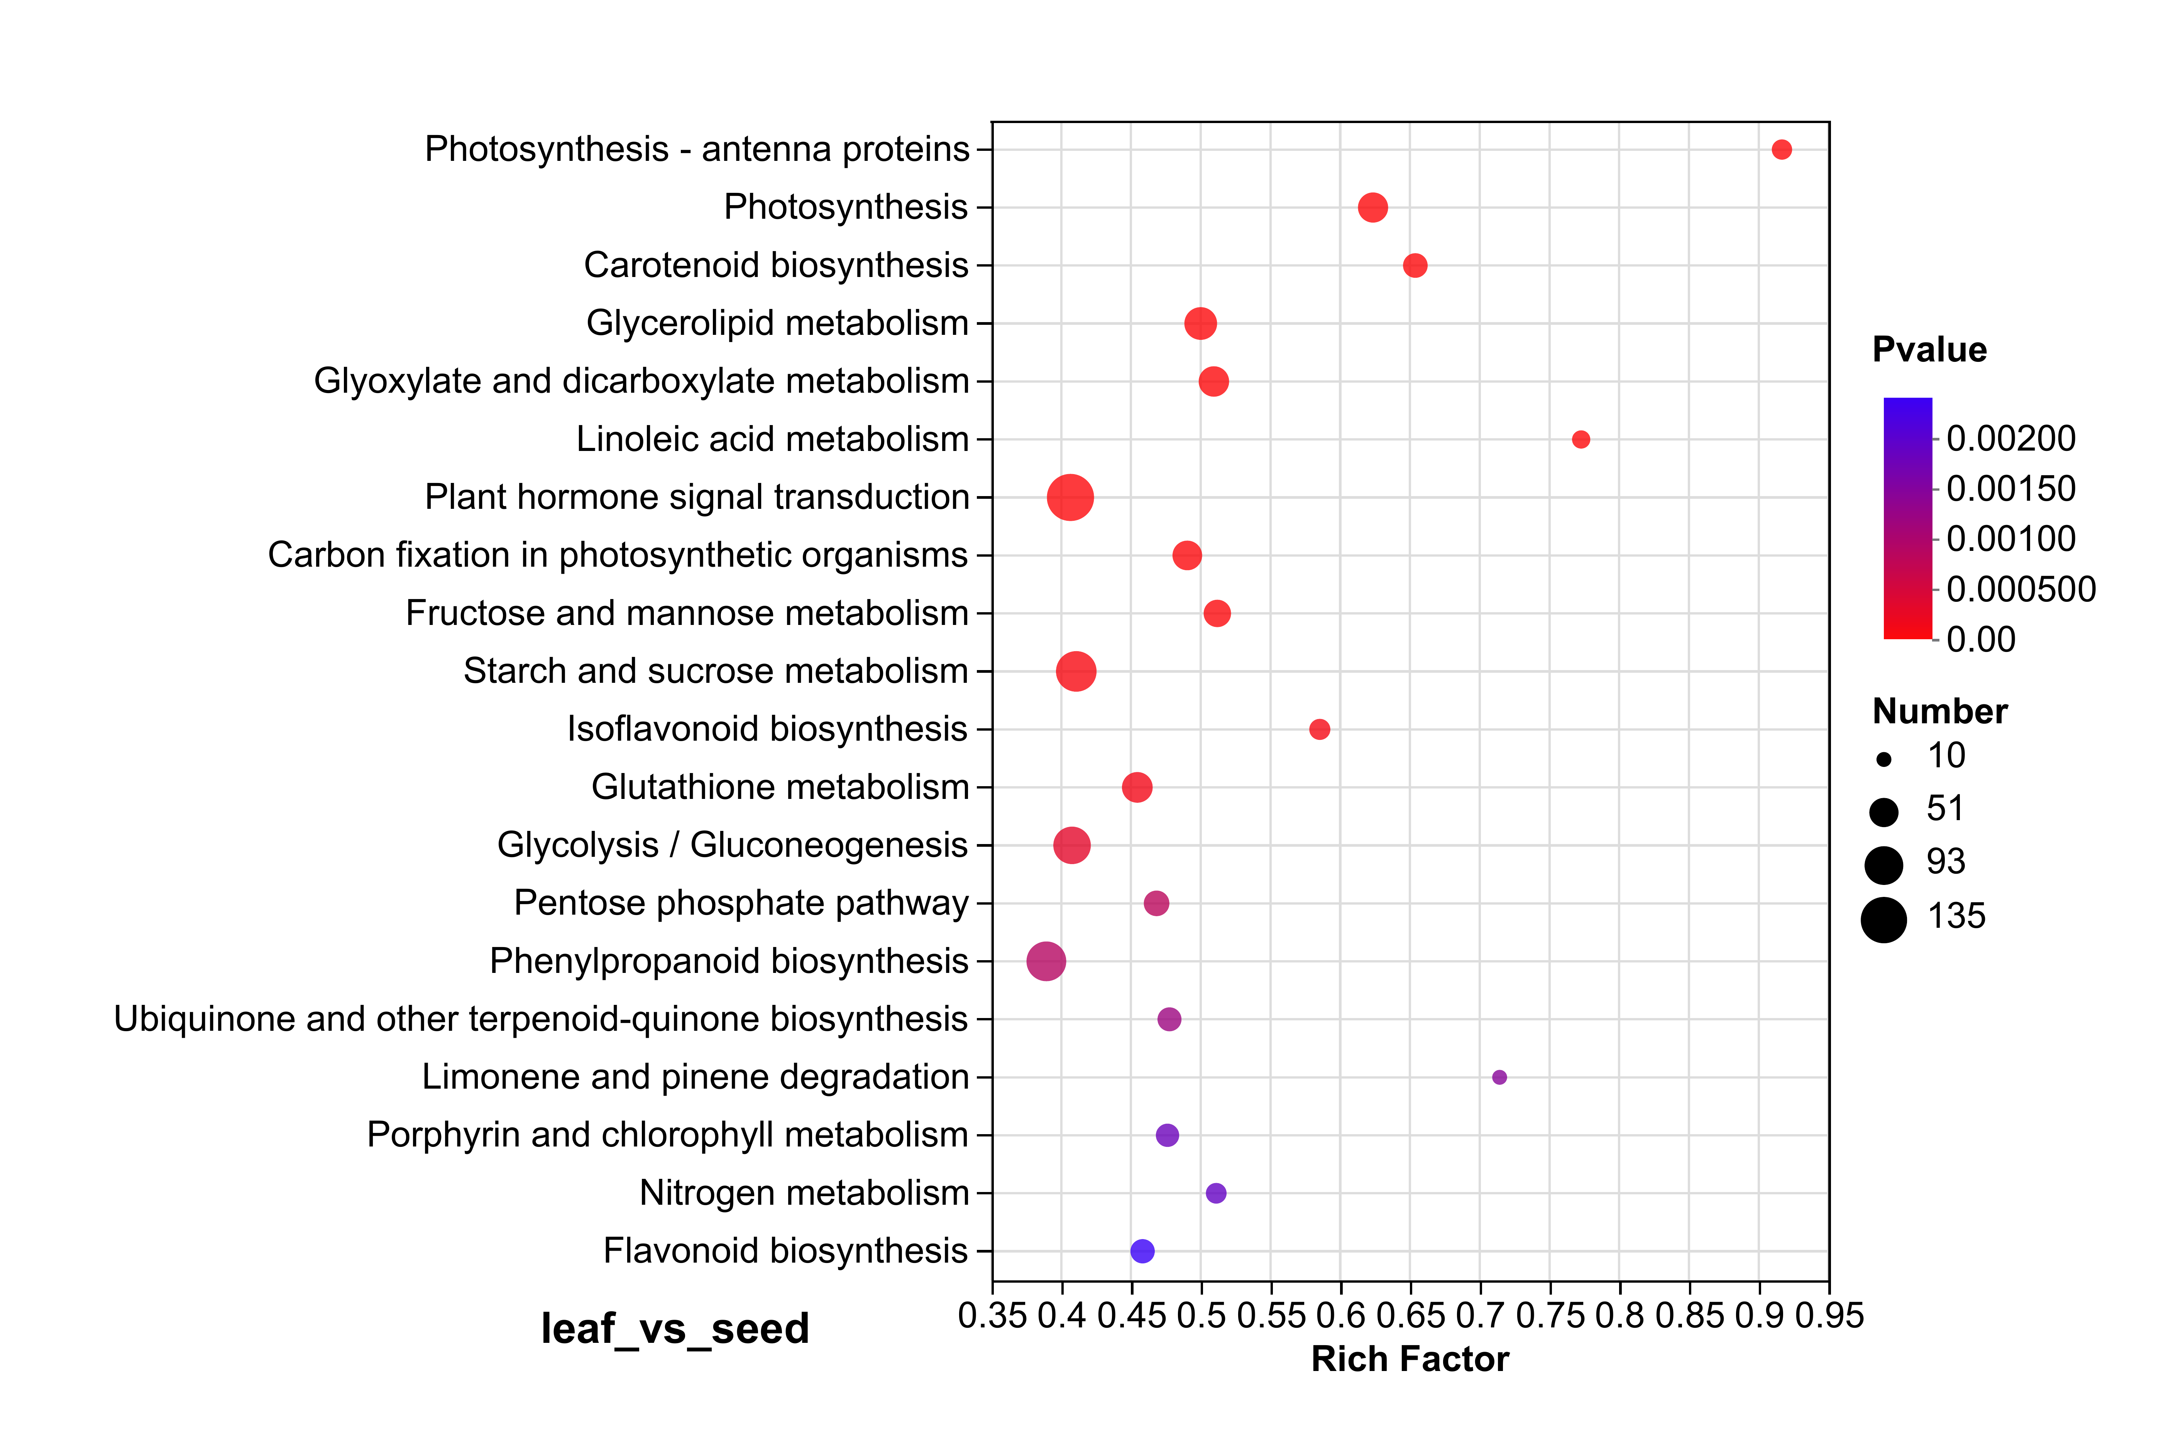
Fig. S3 The KEGG enrichment analysis of DEGs among the different tissues.

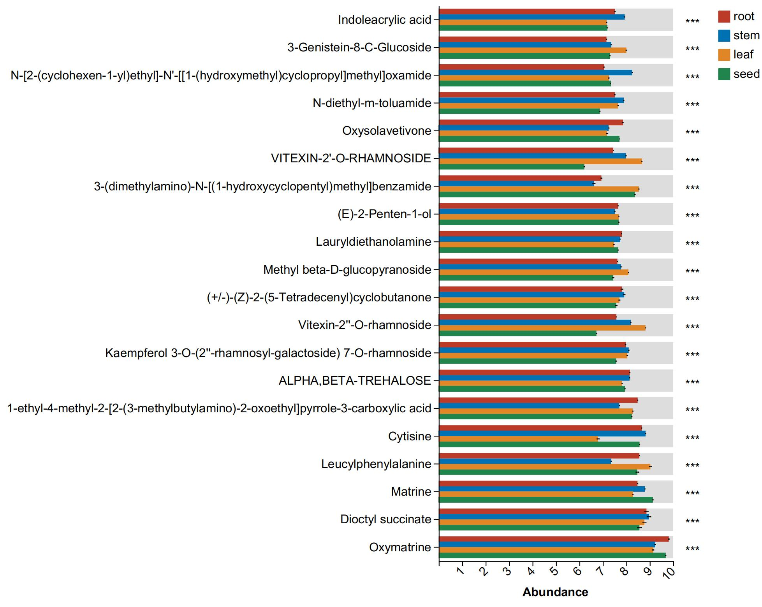
Fig. S4 The One-way ANOVA analysis of genes among the different tissues.

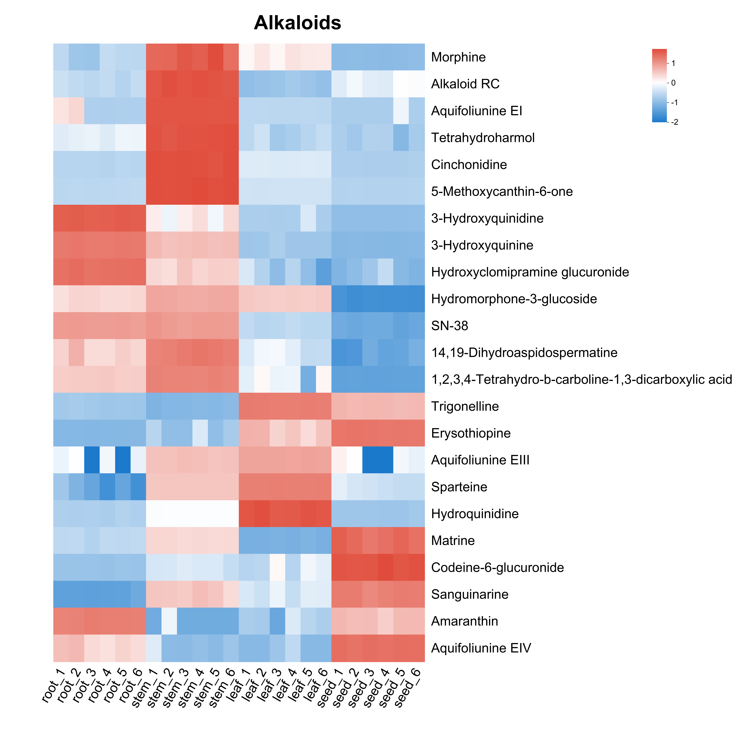
Fig. S5 DAMs related to the biosynthesis of alkaloids in different tissues of S. tonkinensis.
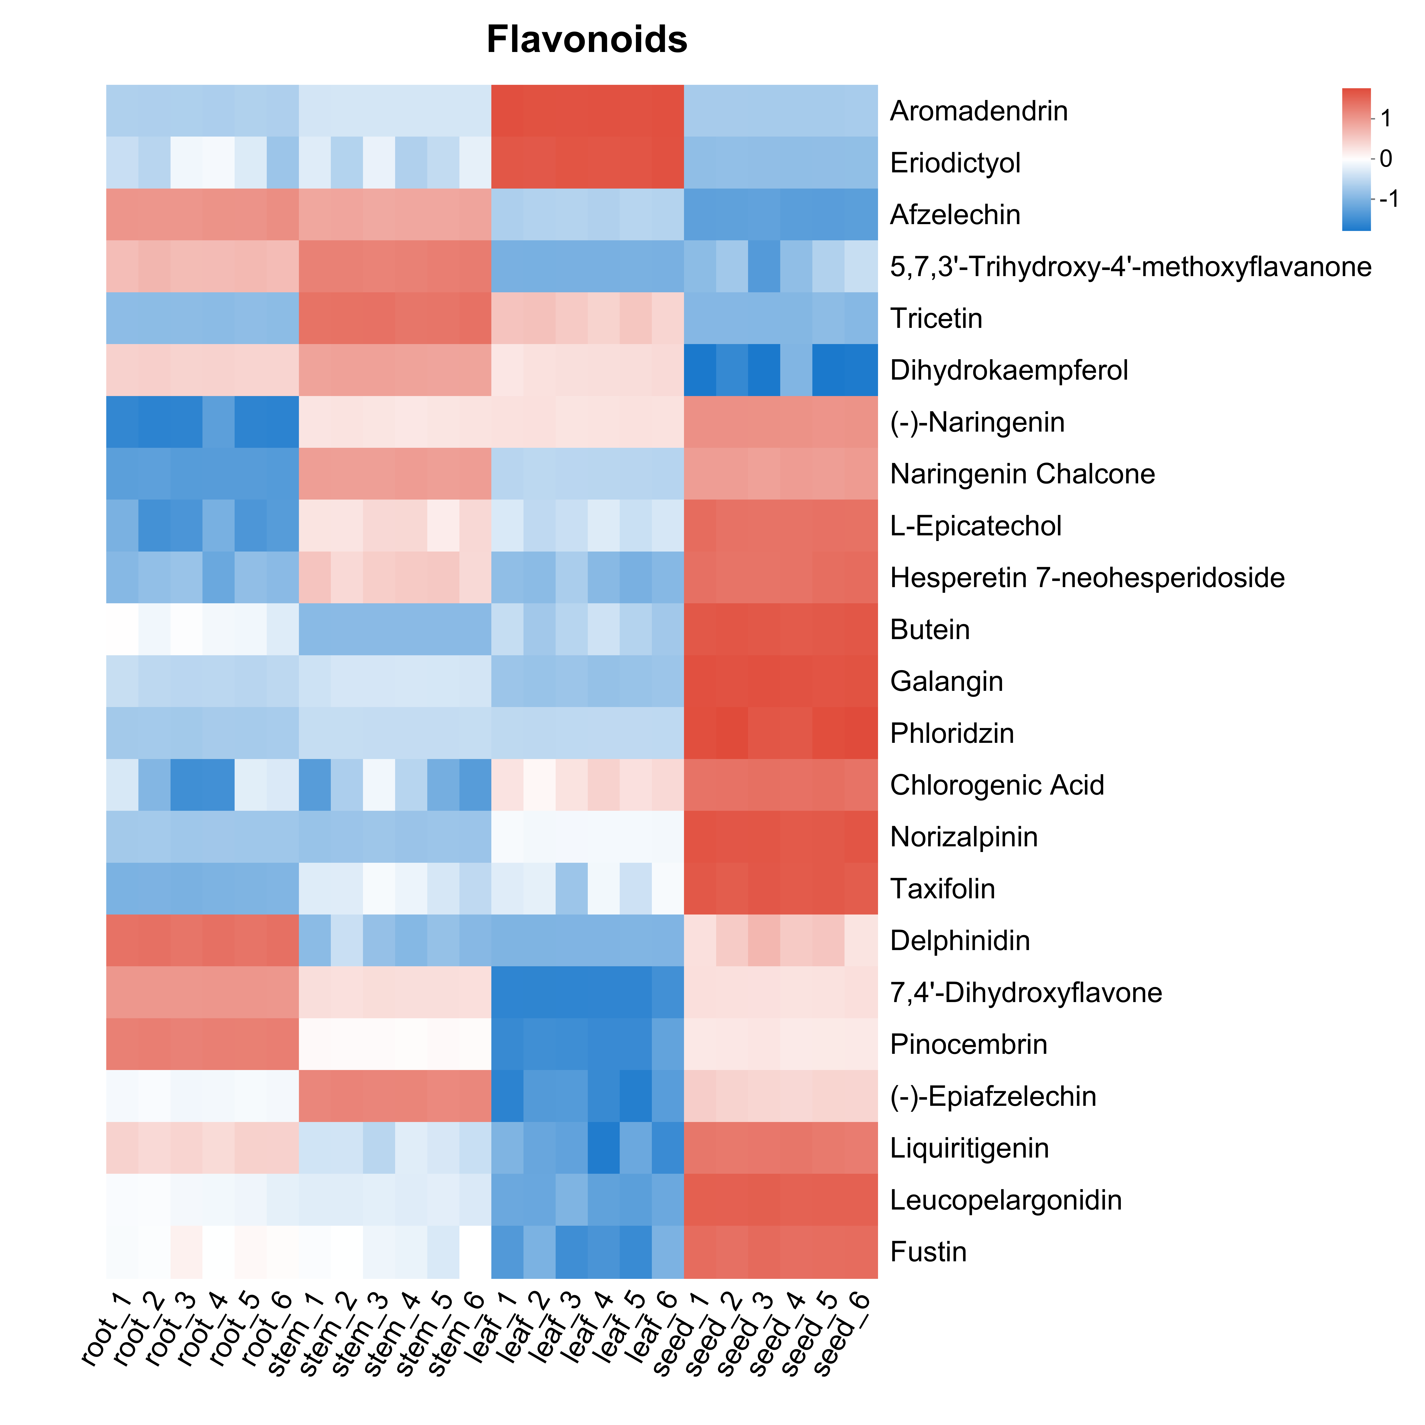
Fig. S6 DAMs related to the biosynthesis of flavonoids in different tissues of S. tonkinensis.
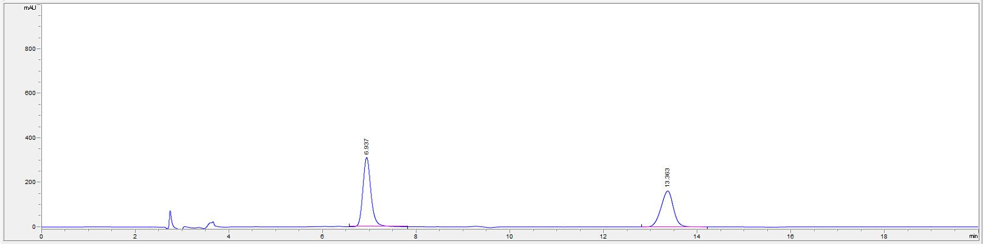
Fig. S7 The map of reference substances for matrine and oxymatrine

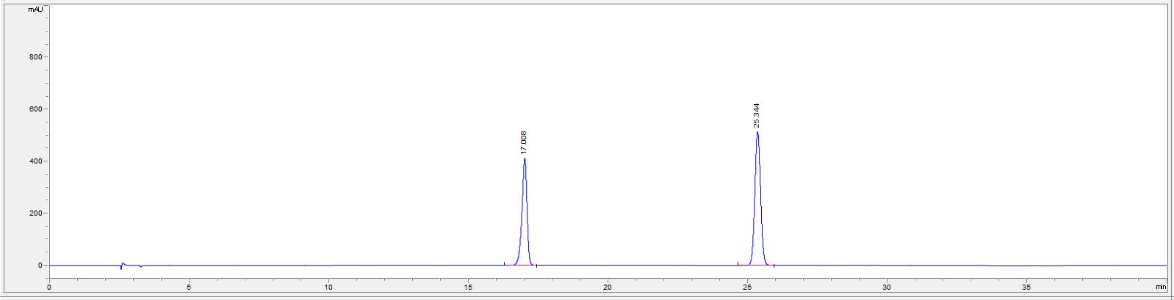
Fig.S8 The map of reference substances for genistin and genistein

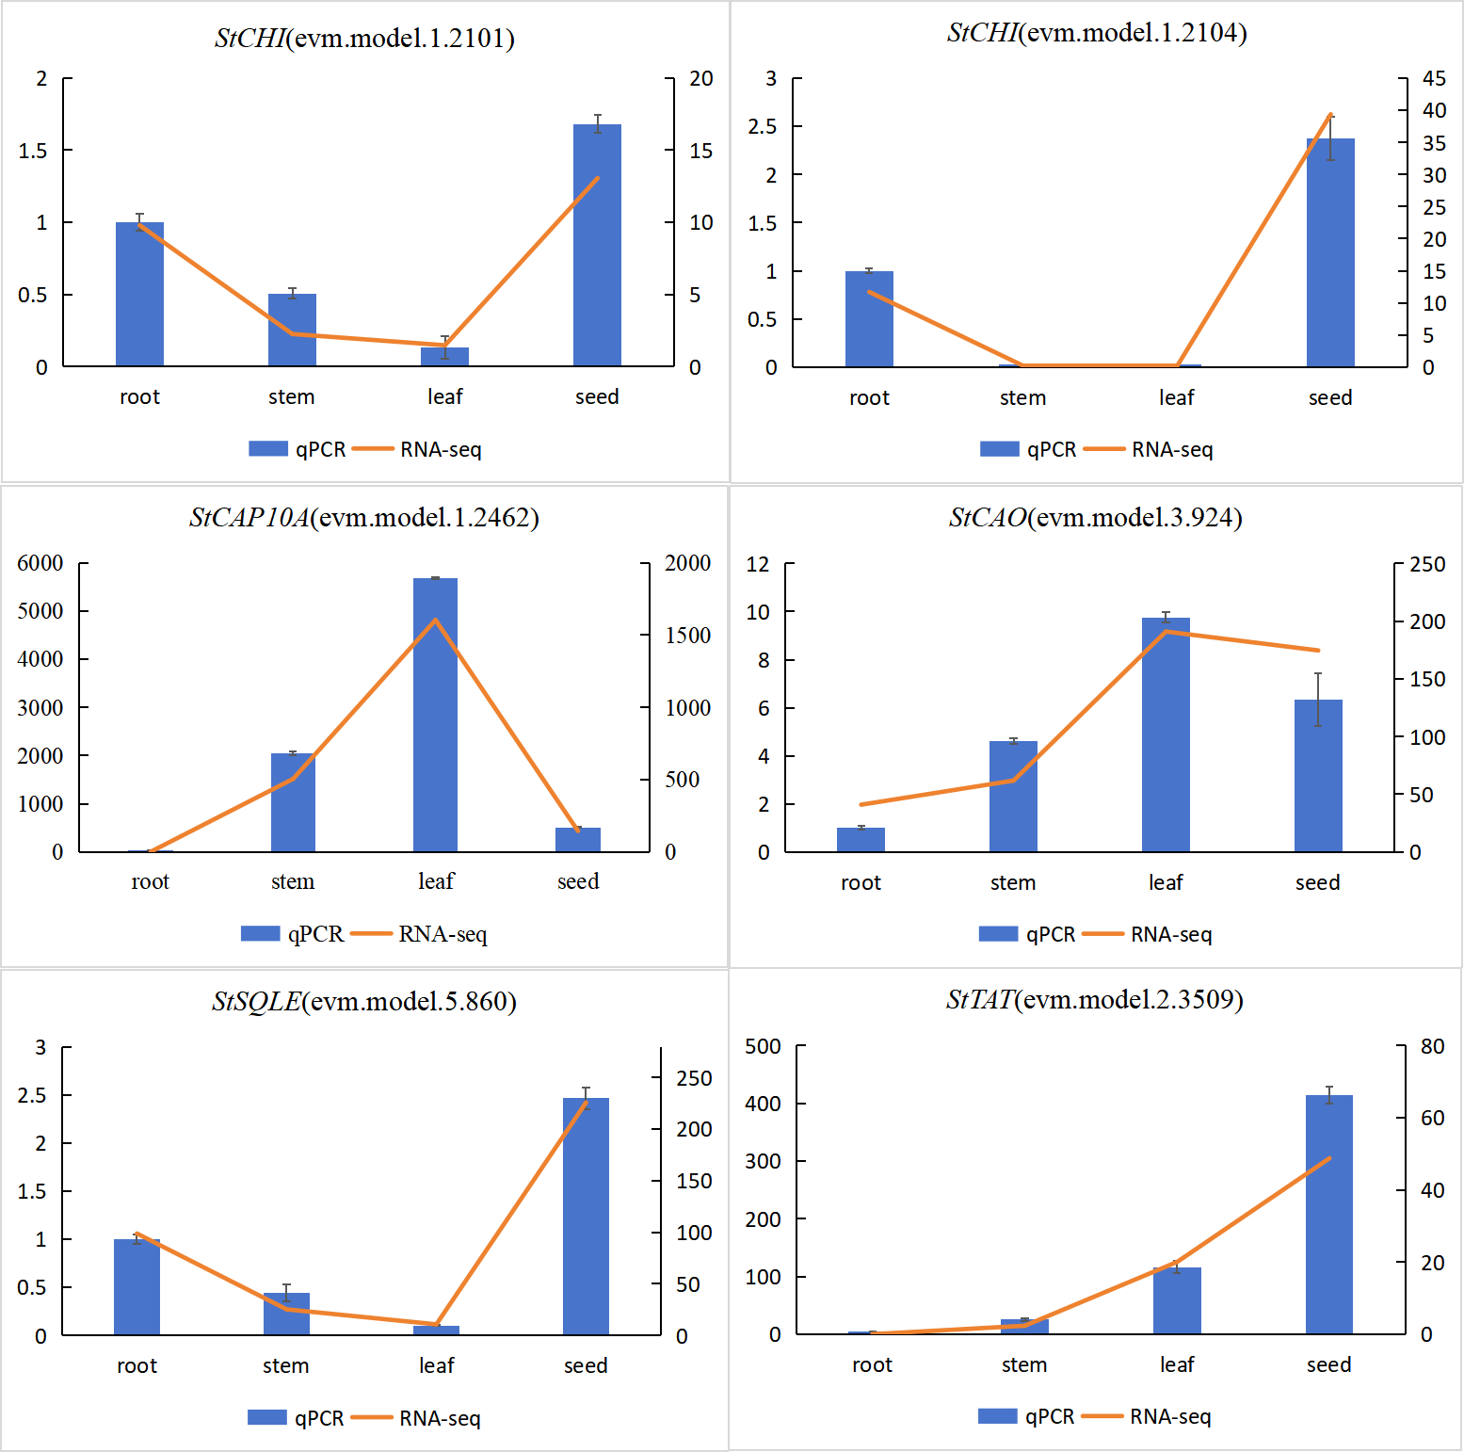

Fig. S9 Verification of StCAO, StTAT, StSQLE, StCHI, and StCAP10A

