Supplementary Figures
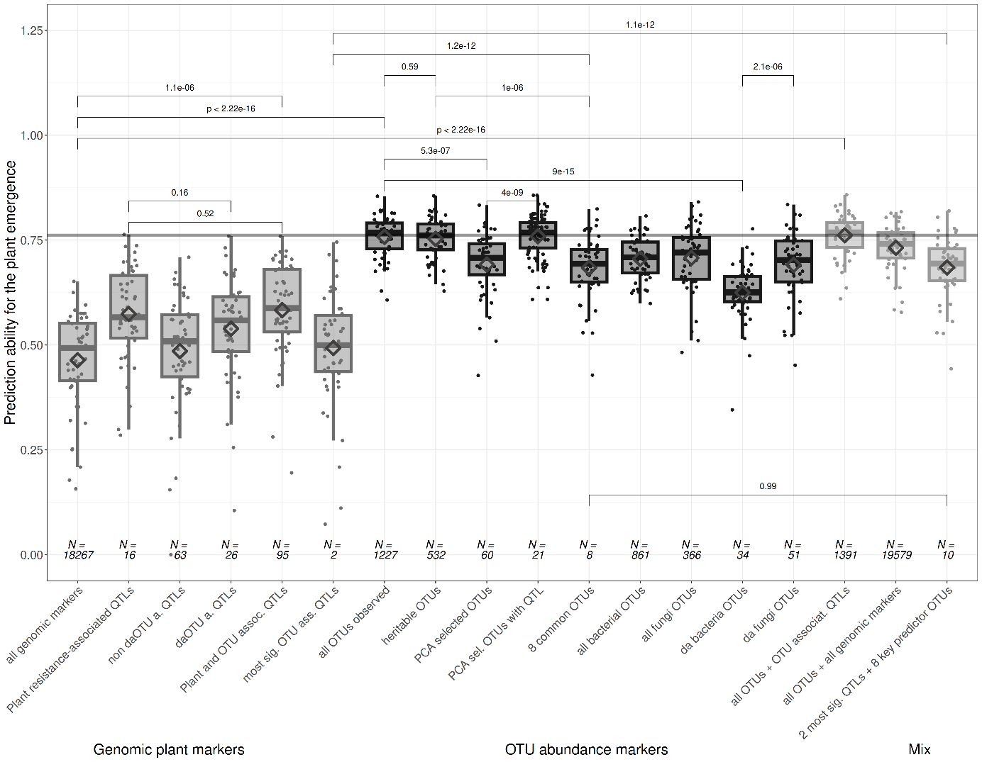
Suppl. Figure 1 - Boxplots of the genomic prediction (phenotype forcast) correlation scores (predicted vs. measured in a dedicated test set) of the emergence rate using either all available markers or a subset of these (e.g. QTLs) (6 left-sided boxplots, light gray background), OTUs as predictors (dark gray background), or a combination of both (3 right-sided boxplots). "N =" indicates the number of genomic markers or OTU markers used as predictors to estimate the root rot index in a Bayes-A or Bayes-B regression model. 5-fold cross validation with 10 replicates were performed for each set, highlighted by the dots. The brackets at the top present the pairwise comparisons derived p-values from a mean comparison. The gray horizontal line shows the highest average prediction ability across all predictor sets and ten cross-validations.

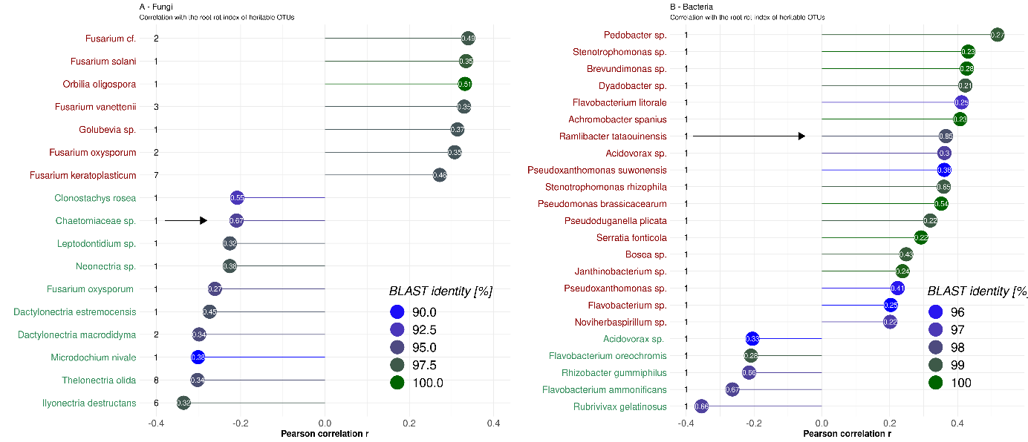
Suppl. Figure 2 – Pearson correlation (r) of annotated OTUs to the pea root rot index. OTUs were annotated to species or genus by BLAST. The number on the species' right or genus name indicates the number of matched OTUs. The coloring of species or genus names illustrates the negative (red) or positive (green) correlation with the root rot index (RRI). The color in the lollipop plot indicates the BLAST identity to the most similar NCBI database organism. The value in the circle shows the narrow-sense genomic heritability. Fungi (A) and Bacteria (B) are separated in subplots. The arrow indicates the highest narrow-sense genomic heritability per group.

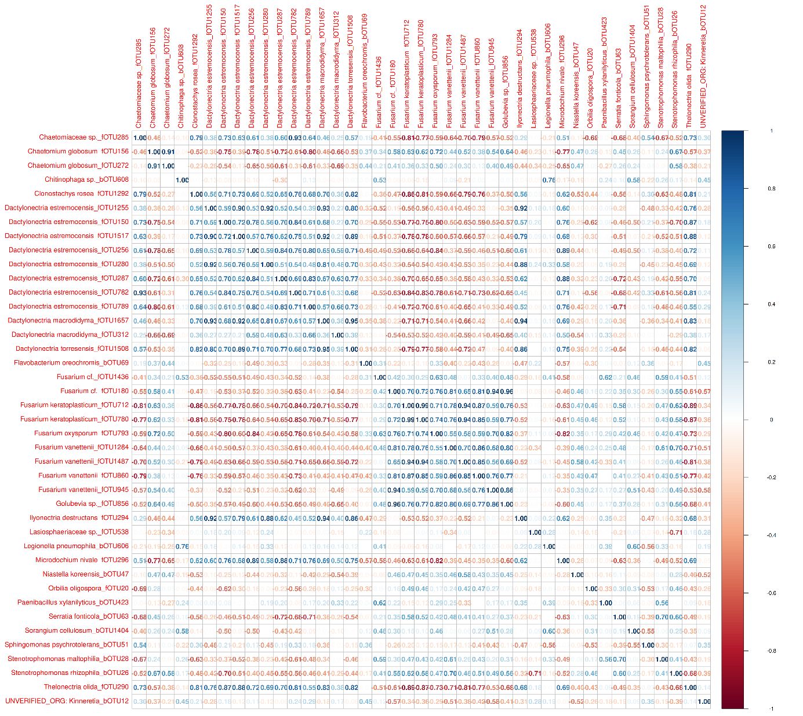
Suppl. Figure 3 – Pearson correlation of OTUs with a genomic heritability above 0.15. Correlations have been calculated separately for low-infected (A) and highly-infected (B) genotypes. Boxes indicate selected OTUs, based on the previous analysis

Supplentary Tables

Suppl. Table 1: List of all detected QTLs across all OTUs above the significance threshold for the respective group. Besides the genomic position, the -logP value and the respective OTU are listed.
[Excel File]
Supple Table 2: OTUs selected based on a PCA for OTU-based genomic predictions for phenotype predictions of root rot index (RRI) and emergence rate. For OTUs colored in green we detected a QTL.
negative | Positive left | Positive top
bOTU26 | fOTU285 | fOTU237
bOTU28 | fOTU782 | fOTU43
fOTU272 | fOTU1657 | fOTU148
bOTU84 | fOTU1508 | fOTU59
bOTU129 | fOTU1255 | bOTU63
bOTU53 | fOTU150 | bOTU246
bOTU63 | fOTU290 | fOTU306
fOTU156 | fOTU1517 | bOTU342
bOTU39 | fOTU144 | fOTU200
fOTU134 | fOTU1292 | bOTU253
fOTU194 | fOTU1576 | fOTU918
bOTU65 | fOTU294 | bOTU216
fOTU20 | fOTU296 | fOTU343
bOTU121 | fOTU943 | bOTU308
bOTU86 | fOTU256 | bOTU94
bOTU107 | fOTU326 | fOTU387
bOTU115 | bOTU168 | bOTU387
bOTU87 | fOTU280 | bOTU268
bOTU212 | fOTU22 | bOTU302
fOTU1082 | fOTU82 | bOTU196

