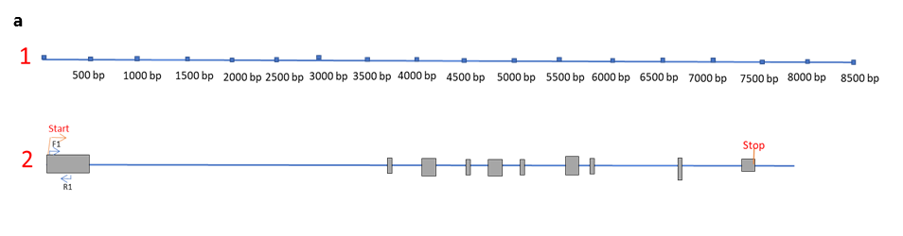
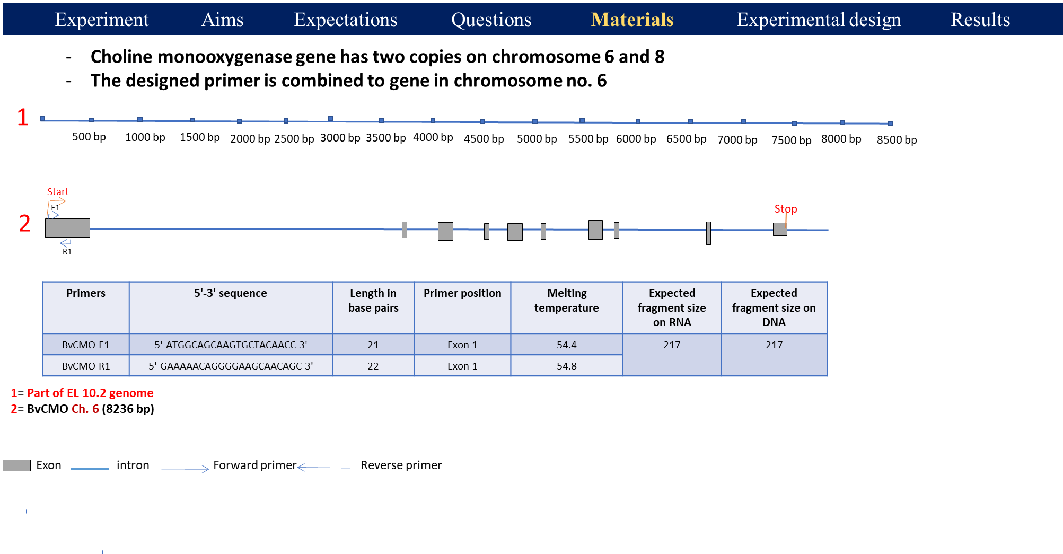
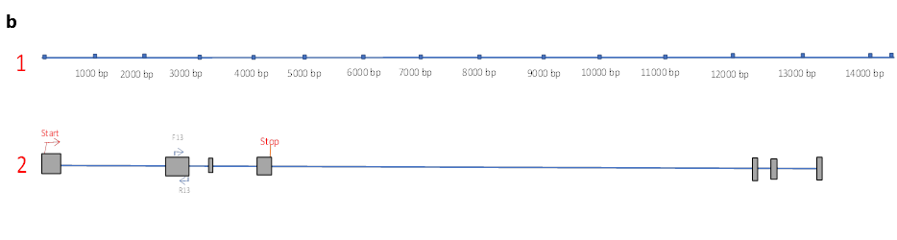
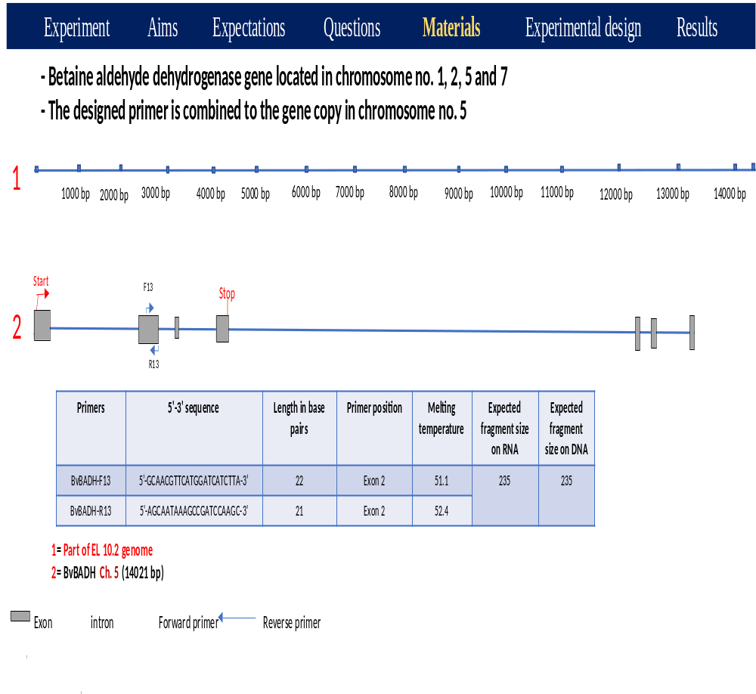

Fig. S1: Gene alignment of the CMO gene (a) and the BADH gene (b) based on genomic DNA sequence data designed by the CLC Main Workbench 20.0.3 software tool (QIAGEN).

Table S1: Seed accession codes, geographical distribution, and germination rates of B. maritima (L.) and B. vulgaris (L.).
Accession code | Abbreviation | Crop type | Geographical origin | Germination rate | Number of seeds for 3 plants | Number of seeds for 6 plants
080279 | B. maritima 1 | Wild beet | Italy | 50 | 6 | 12
081683 | B. maritima 2 | Wild beet | North Wales | 10 | 30 | 60
205431 | B. maritima 3 | Wild beet | Greece | 30 | 10 | 20
960071 | B. maritima 4 | Wild beet | Italy | 140 | 3 | 6
093303 | B. vulgaris 1 | Sugar beet | USA | 30 | 10 | 20
080365 | B. vulgaris 2 | Sugar beet | Soviet Union | 80 | 4 | 8
080366 | B. vulgaris 3 | Sugar beet | Austria | 160 | 2 | 4
081898 | B. vulgaris 4 | Sugar beet | Turkey | 130 | 3 | 6

Table S2: Primer sequences, lengths, positions, melting temperatures, and fragment sizes of CMO and BADH genes based on genomic DNA sequence data from EL10.2 and the reference beet genome.
Primers | Sequence (5`-3`) | Length (bp) | Primer position | Melting temperature | Expected fragment size on RNA | Expected fragment size on DNA
BvCMO-F | 5`-ATGGCAGCAAGTGCTACAACC-3` | 21 | Exon 1 | 54.4 | 217 | 217
BvCMO-R | 5`-GAAAAACAGGGGAAGCAACAGC-3` | 22 | Exon 1 | 54.8 | 217 | 217
BvBADH-F | 5`-GCAACGTTCATGGATCATCTTA-3` | 22 | Exon 2 | 51.1 | 235 | 235
BvBADH-R | 5`-AGCAATAAAGCCGATCCAAGC-3` | 21 | Exon 2 | 52.4 | 235 | 235
BvGAPDH-F | 5`-CACCACCGATTACATGACATACA-3` | 23 | - | 61.5 | *Wetzel et al. (2021)
BvGAPDH-R | 5`-GGATCTCCTCTGGGTTCCTG-3` | 20 | - | 62.0

* Wetzel V, Willems G, Darracq A, Galein Y, Liebe S, Varrelmann M. The Beta vulgaris-derived resistance gene Rz2 confers broad-spectrum resistance against soilborne sugar beet-infecting viruses from different families by recognizing triple gene block protein1. Mol Plant Pathol. 2021; 22(7):829-842. https://doi.org/10.1111/mpp.13066.

