Identification of QTLs for aphid (Melanaphis sacchari) resistance in sorghum (Sorghum bicolor) based on BSA-seq and analysis of candidate genes
Junli Du^{1,3} · Kunliang Zou^{1,3} · Qi Shen^{1 ,3}· Yang Liu² · Minghui Guan^{2,3} · Tonghan Wang¹ · Degong Wu¹ · Lihua Wang^{1,3} · Yongfei Wang^{1,3} · Jieqin Li^{1,3,*}
Junli Du and Kunliang Zou contributed equally to this work.
1 College of Agriculture, Anhui Science and Technology University, Chuzhou, 233100, China
2 College of Resources and Environment, Anhui Science and Technology University, Chuzhou, 233100, China
3 Anhui Province International Joint Research Center of Forage Bio-breeding, Chuzhou, 233100, China adu83419@163.com
* Correspondence: wlhljq@163.com (J. L.)
Supplementary Table 1 Genetic Testing of Aphid Resistance Genes in Sorghum.
Plant Materials | Total Plants | Highly Resistant Plants | Resistant Plants | Intermediate Plants | Susceptible Plants | Highly Susceptible Plants
F₁ | 93 | 50 | 43 | 0 | 0 | 0
F₂ | 436 | 51 | 75 | 171 | 94 | 45
Supplementary Table. 2 Eight SSR marker primers associated with the qMsa-6 region.
Marker | 5' End Sequence | 3' End Sequence
Sb6M815 | GTGAGGCGAATGAAAGTAACC | TTATGCGGTCCAGATTAGAGTT
Sb6M1592 | AGACAGCAGGTGATTCTGAAGA | ACCGGCCAAGCATTGTAGT
Sb6M2226 | CGGACACATTCTGTTGCTTC | CGAAGTACATGGAGCTGCA
Sb6M2672 | TTCACCAACTAAACAAGGCT | CAGTGAAGCCAAGCCAATG
Sb6M2796 | TCGCAGAATGTAACCGTGTAAG | TGTGCCGTAAGATTCGATATGAC
Sb6M3464 | GTAACCAGTGATTCTTGCTTCGT | CAACCTCACAGCTCTTCTTCAG
Sb6M6574 | CATGTCAGTGCTAGGTAAATCCA | GTGTTGTCATTGTAGTGCCAAG
Sb6M14023 | CCTAATCTGTAGCTCAAAGATG | GTTGCTAGAAGAATGATGGACT

Supplementary Table. 3 Primers used for qPCR of candidate genes.
Primer Name | 5' End Sequence | 3' End Sequence
eIF4a1 | TGGCGAAGGATGGTTTCTAAGT | GGAGCGGCACATAGCCTACTC
SbiRTX2783.06G018200 | CTGTTGTGGTGATCTCAGGCAAGT | CTCGCAGATATGTCGCAGGCTAG
SbiRTX2783.06G018300 | AGGTTGCTTCAGTCATTGGTGCTA | GGCGGTCCATCTTCTCTCTGTTG
SbiRTX2783.06G018400 | GGCTTACAACCGTGGTGTGGAC | GGTCTCTAGGCTGGACAAGGTATG
SbiRTX2783.06G018450 | TCCGCCATCACTGACGAAGAAG | GCAACCATTACACTCTGAGGAAGC
SbiRTX2783.06G018500 | GGCTGCTTCTGCTGTGCTCAA | CCTTCGGCTCTTCCATCTGGAG
SbiRTX2783.06G018800 | AGGTTGCTTCAGTCATTGGTGCTA | GGCGGTCCATCTTCTCTCTGTTG
SbiRTX2783.06G018900 | AAGATGGAAGAGCCGAAGAGAACT | TCCTCCTCGTCTTGCCTGTCA
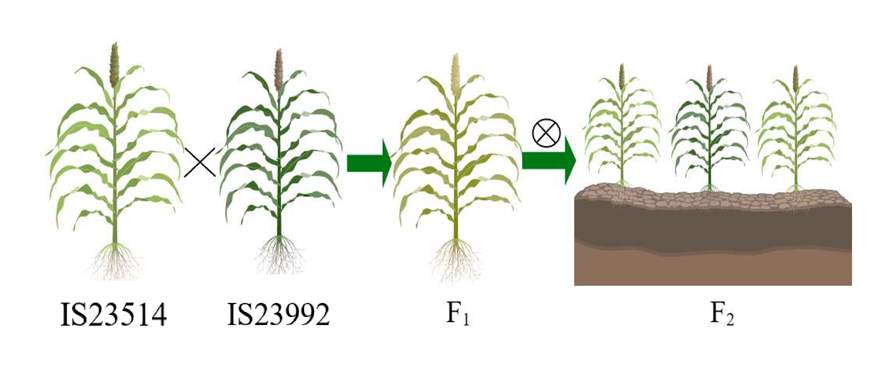
Supplementary Figure 1 Schematic Diagram of the Construction of the Segregating Population.
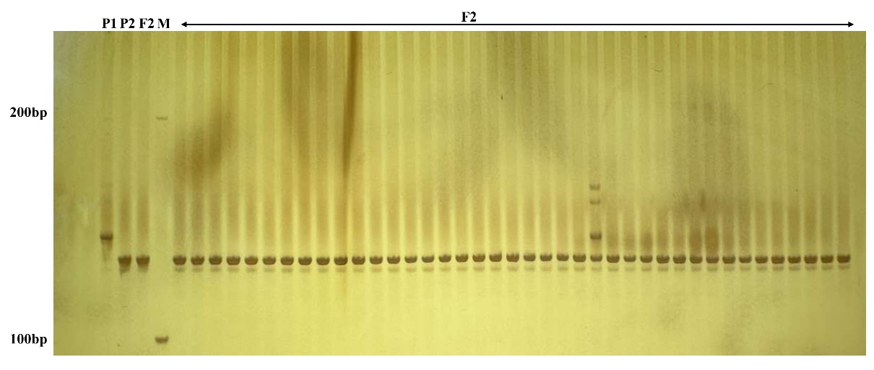
Supplementary Figure 2 Amplification results of InDel marker Sb6M2796 in F₂ aphid-susceptible individuals (10% Polyacrylamide Gel Electrophoresis). P1 represents the aphid-resistant parent IS23514; P2 represents the aphid-susceptible parent IS23992; M denotes the Marker; and F₂ indicates the recessive aphid-susceptible individuals

