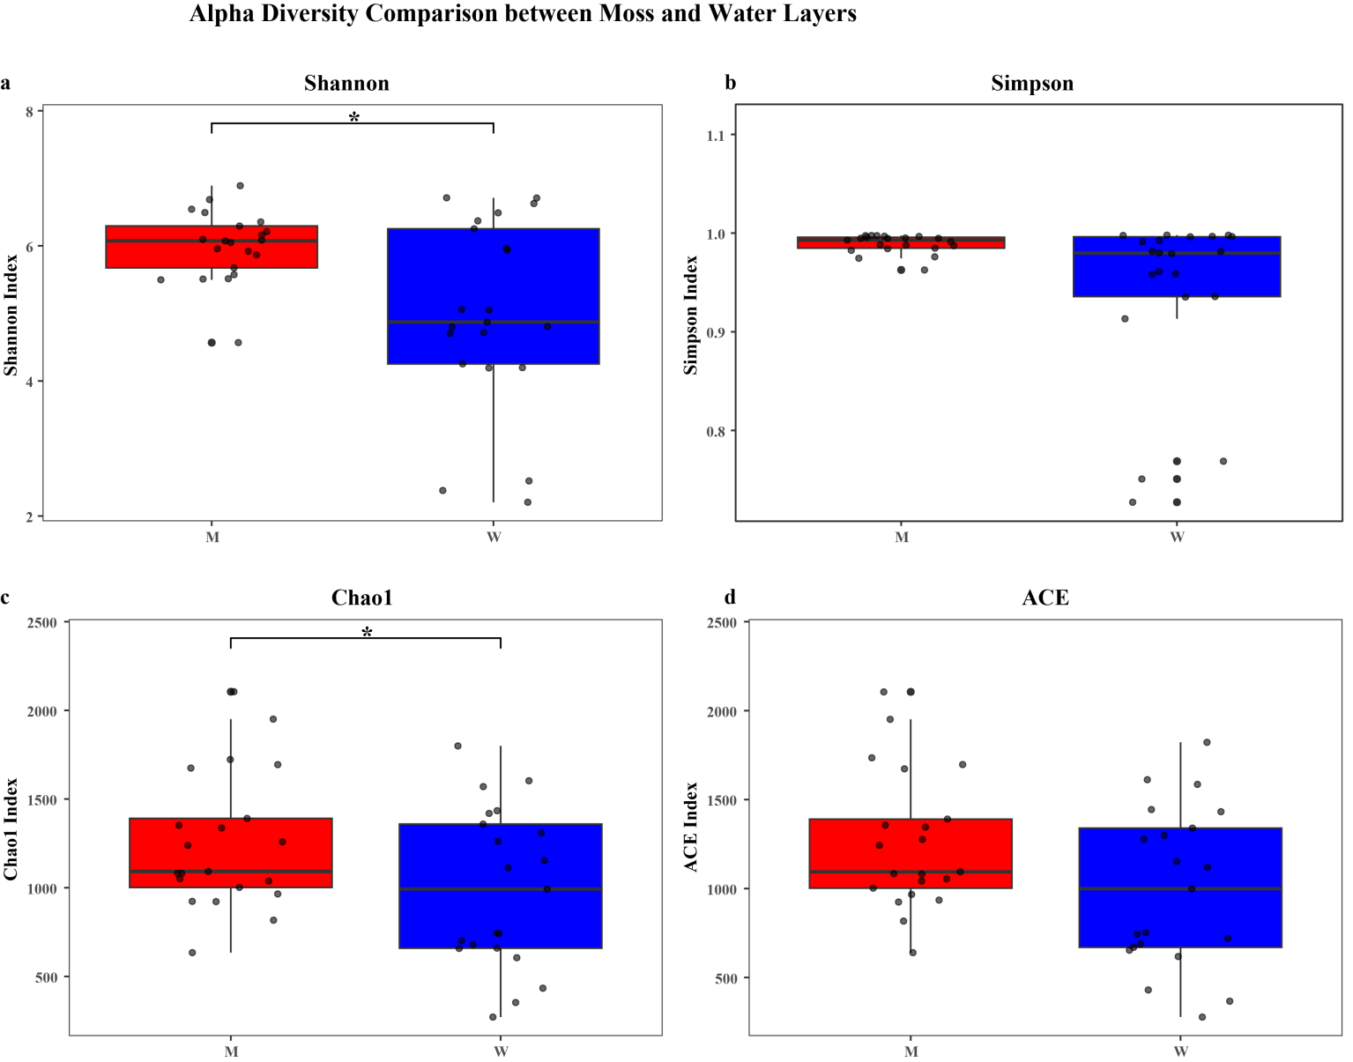
Fig. S1 Boxplots of alpha diversity of core bacteria in moss and moss water layers (*: p<0.05).

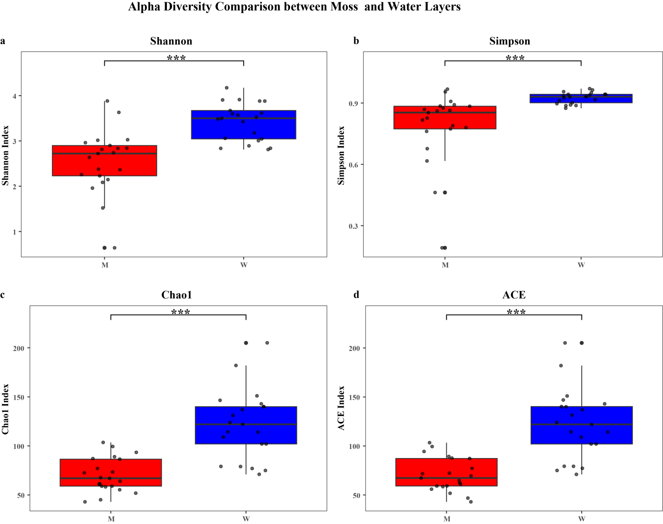
Fig. S2 Boxplots of alpha diversity of core bacteria in moss and moss water layers (*: p<0.05; **: p<0.01; ***: p<0.001).

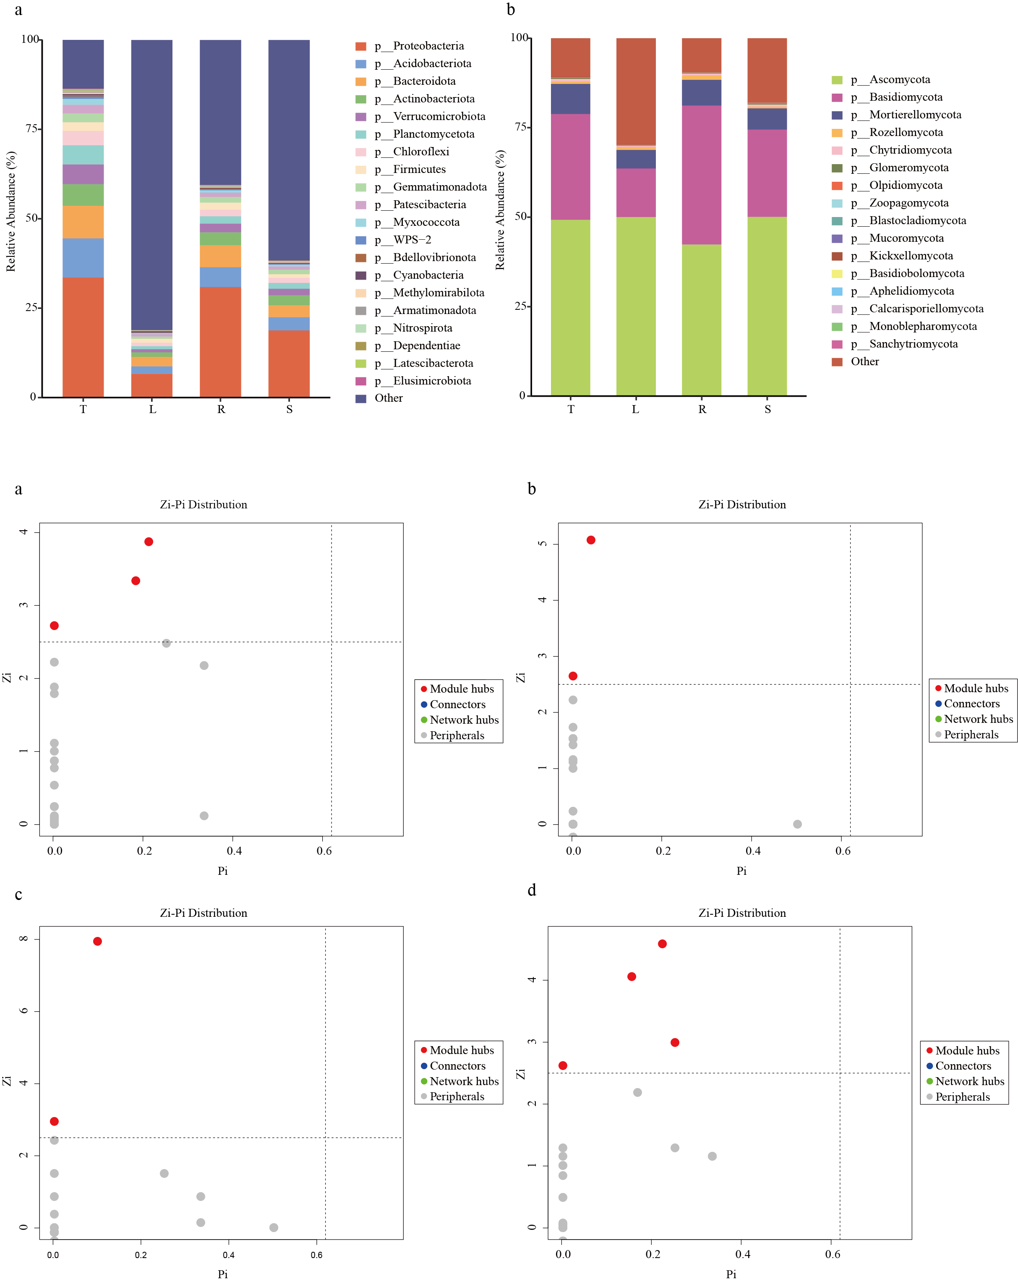
Fig. S3 Zi-Pi analyst: (a) Zi-Pi distribution of bacteria in the moss layer; (b) Zi-Pi distribution of fungi in the moss layer; (c) Zi-Pi distribution of bacteria in the moss water layer; (d) Zi-Pi distribution of fungi in the moss water layer.

Fig. S4 The composition of endophytic bacteria at the phylum level in different tissues of C.fanjingshanensis: (a) endophytic bacteria. (b) endophytic fungi.

