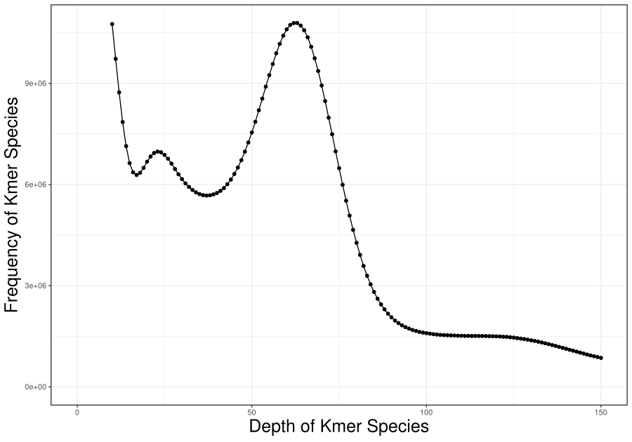
Figure S1 K-mer depth frequency distribution plot

