Supplementary information
Supplemental Fig. S1 Comparison of plant height-related traits in various wheat ecological regions of China.
Supplemental Fig. S2 Trend of PH, LI2, LI3, LI4 and LI5 across years of release and the proportion of LI2, LI3, LI4, and LI5 in PH across years of release.
Supplemental Fig. S3 Correlation analysis of plant height-related traits and yield-related traits.
Supplemental Fig. S4 The Manhattan plot of association analysis of plant height-related traits and the trend of favorable SCVs frequency across years of release.
Supplemental Fig. S5 Analysis of QLI5.sxau-1B.
Supplemental Fig. S6 Effects of increasing favored SCVs at stable loci on plant height-related traits.
Supplemental Fig. S7 The number and effect of favorable SNPs and SCVs allelic variations in landraces and modern cultivars.
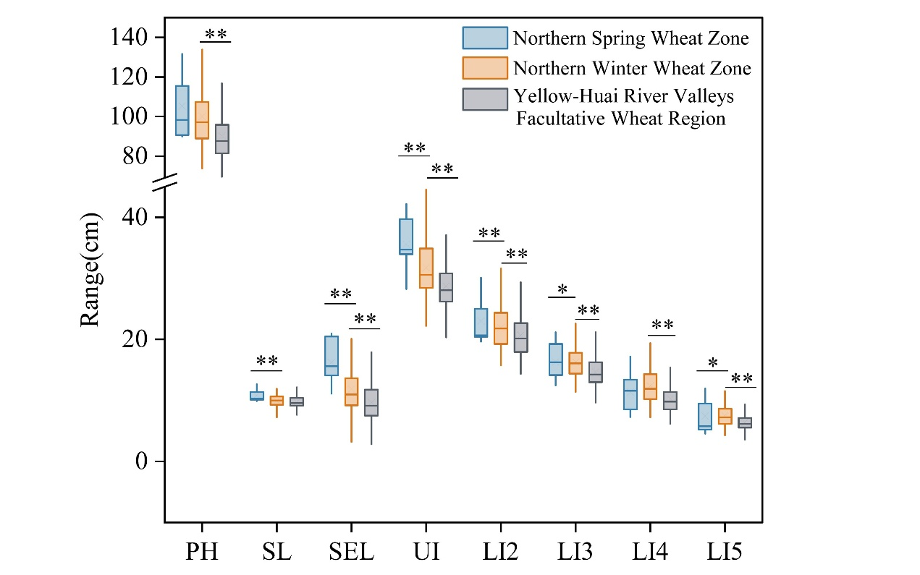
Supplemental Fig. S1 Comparison of plant height-related traits in various wheat ecological regions of China. Different letters indicate significant differences. *, **, and *** indicated significant differences at 0.05,0.01 and 0.001 levels, respectively.

Supplemental Fig. S2 Trend of PH, LI2, LI3, LI4 and LI5 across years of release and the proportion of LI2, LI3, LI4, and LI5 in PH across years of release.
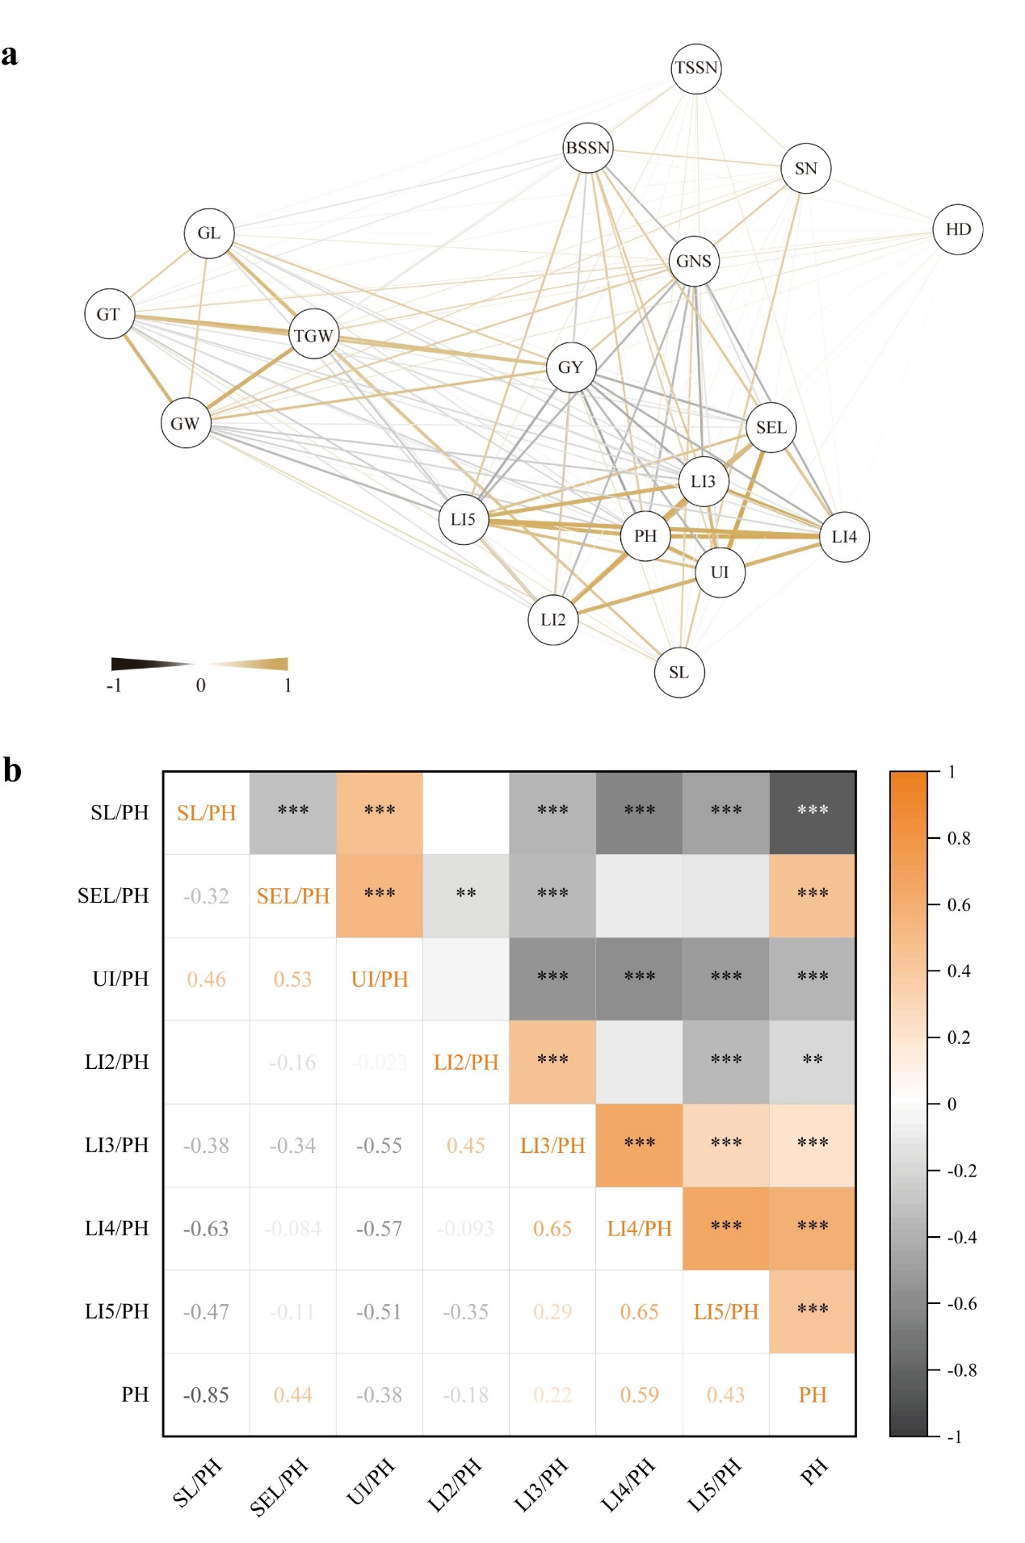Supplemental Fig. S3 Correlation analysis of plant height-related traits and yield-related traits a Genetic correlation among the plant height-related traits and yield-related traits. b Correlation analysis of the proportion of PHCs to PH and PH. **, and *** indicated significant differences at 0.01 and 0.001 levels, respectively.

Supplemental Fig. S4 The Manhattan plot of association analysis of plant height-related traits and the trend of favorable SCVs frequency across years of release a Manhattan plot of association analysis on plant height-related traits; b The change in the frequencies of favored SCVs of SEL and SL in Chinese modern wheat cultivars released from 1940s to 2010s.

Supplemental Fig. S5 Analysis of QLI5.sxau-1B. a Idiogram of Mg1B-1 identified with Oligo-FISH. b-c Manhattan plot of Mg1B-1 and QLI5.sxau-1B identified with GWAS. d Effect of QLI5.sxau-1B on LI5 in the Panel-1.
Supplemental Fig. S6 Effects of increasing favored SCVs at stable loci on plant height-related traits.
Supplemental Fig. S7 The number and effect of favorable SNP and SCV allelic variations in landraces and modern cultivars a The relationship of the number of favored allelic variations to LI4, SEL, SL, and UI in modern cultivars and landraces, n represents the number of cultivars carrying a particular favorable allele; b Effects of the numbers of favored SNPs and SCVs on SEL, UI, LI2, LI3, LI4, and LI5. c PH bean plots of the accessions classified by the peak SNP haplotypes (CC versus TT). Pie charts (above) show the number and percentage of the two SNP haplotypes.

