Appendix 1: The design of L9 (3) 4 orthogonal experiment for the differentiation of adventitious buds from leaf explants of 741 poplar differentiated seedlings
Level | Considerations
Level | A（6-BA）mg·L⁻¹ | B（auxin） | C（TDZ）mg·L⁻¹
1 | 0.4 | NAA | 0
2 | 0.7 | IAA | 0.005
3 | 1.0 | IBA | 0.01

Appendix 2: Effects of Different Types and Concentrations of Exogenous Hormones on the Induction of adventitious buds in 741 Poplar Differentiated Seedlings Leaves
Process | 6-BA（mg/L） | Growth hormone | TDZ（mg/L） | Differentiation rate（%） | Number of differentiated shoots | Bud growth state
H1 | 0.4 | IBA | 0 | 0.00±0.00 | 0.00±0.00 | Almost no buds grow, leaves are brown
H2 | 0.4 | NAA | 0.005 | 0.00±0.00 | 0.00±0.00 | Almost no buds grow, and the leaves undergo severe browning
H3 | 0.4 | IAA | 0.01 | 0.00±0.00 | 0.00±0.00 | Not sprouting, yellowing of leaves
H4 | 0.7 | IBA | 0.005 | 0.00±0.00 | 0.00±0.00 | Not sprouting, leaves yellow brown
H5 | 0.7 | NAA | 0.01 | 41.33±7.22 | 30.33±9.38 | The petiole slightly sprouts and the leaves become thicker
H6 | 0.7 | IAA | 0 | 0.00±0.00 | 0.00±0.00 | Not sprouting, yellowing of leaves
H7 | 1.0 | IBA | 0.01 | 22.33±6.23 | 17.33±4.63 | The petiole slightly sprouts
H8 | 1.0 | NAA | 0 | 0.00±0.00 | 0.00±0.00 | Not sprouting, yellowing of leaves
H9 | 1.0 | IAA | 0.005 | 0.00±0.00 | 0.00±0.00 | Not sprouting, leaves slightly thickened

Appendix 3: Effects of Different Types and Concentrations of Exogenous Hormones on the Induction of adventitious buds in 741 Yang Rooted Seedlings Leaves
Process | 6-BA（mg/L） | Growth hormone | TDZ（mg/L） | Differentiation rate（%） | Number of differentiated shoots | Bud growth state
F1 | 0.4 | IBA | 0 | 3.00±0.00f | 1.00±0.00f | Very few buds, yellowing of leaves, and no swelling of incisions
F2 | 0.4 | NAA | 0.005 | 25.00±1.53e | 10.00±1.73ef | Small buds and yellowing around leaves
F3 | 0.4 | IAA | 0.01 | 82.33±2.03a | 80.67±2.19a | Multiple clustered buds and green leaves
F4 | 0.7 | IBA | 0.005 | 33.00±7.94de | 16.67±4.70de | Few clustered buds, green leaves, and early sprouting time
F5 | 0.7 | NAA | 0.01 | 46.33±13.38cd | 26.00±7.77cd | Few clustered buds, mild vitrification, yellow green leaves
F6 | 0.7 | IAA | 0 | 2.00±2.00f | 2.00±0.58f | Very few buds and no swollen leaves
F7 | 1.0 | IBA | 0.01 | 66.00±2.31ab | 43.00±2.65ab | Multiple single buds, long stems, and locally yellowed leaves
F8 | 1.0 | NAA | 0 | 6.00±1.00f | 2.67±0.89f | Very few buds and yellow leaves
F9 | 1.0 | IAA | 0.005 | 59.67±2.91bc | 35.00±3.60bc | Multiple solitary buds, moderate vitrification, thicker and greener leaves

Note: Different letters in the table indicate that different treatments in the same column differ significantly at the 0.05 level

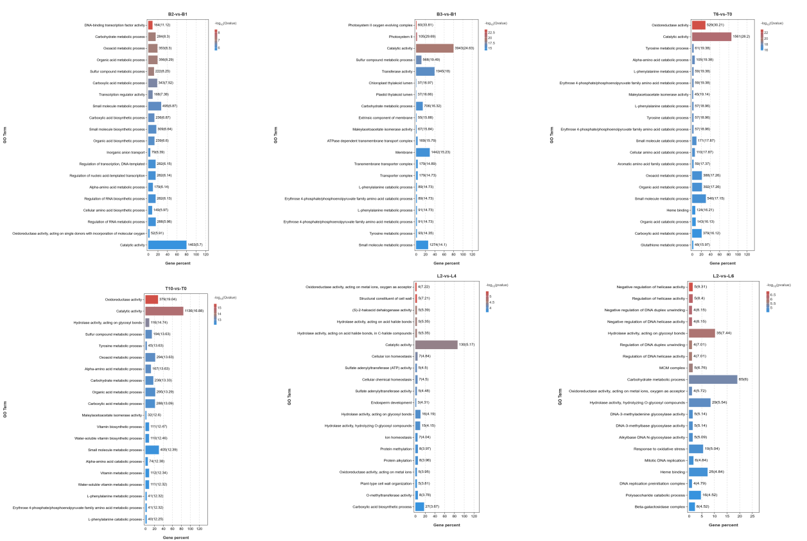

Figure 1. Significant enrichment of GO under three treatments

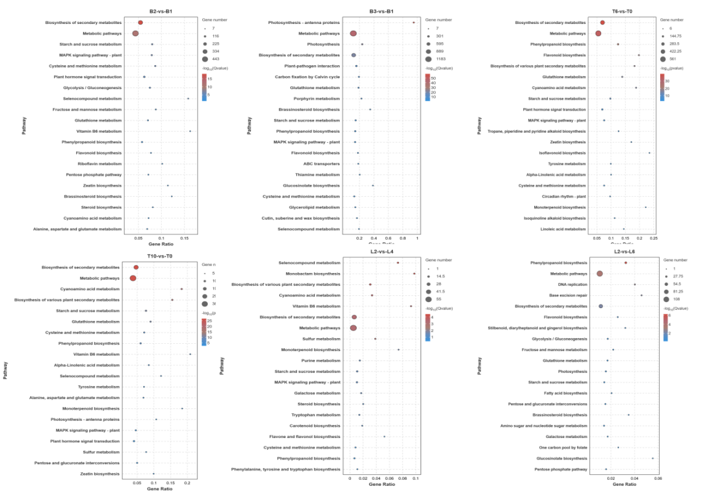

Figure 2. Significant enrichment of KEGG under three treatments

