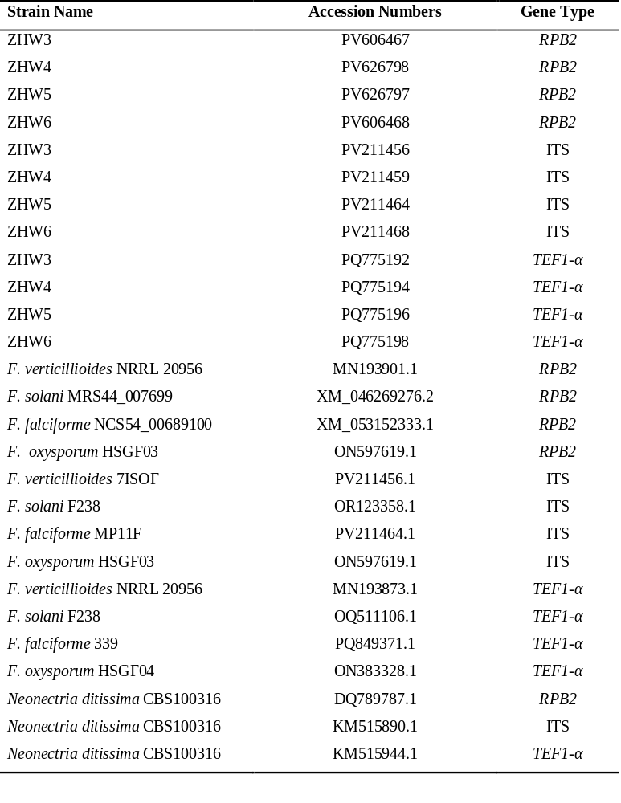Supplementary Table 1 Strains and Accession Numbers for ITS, TEF1-α and RPB2

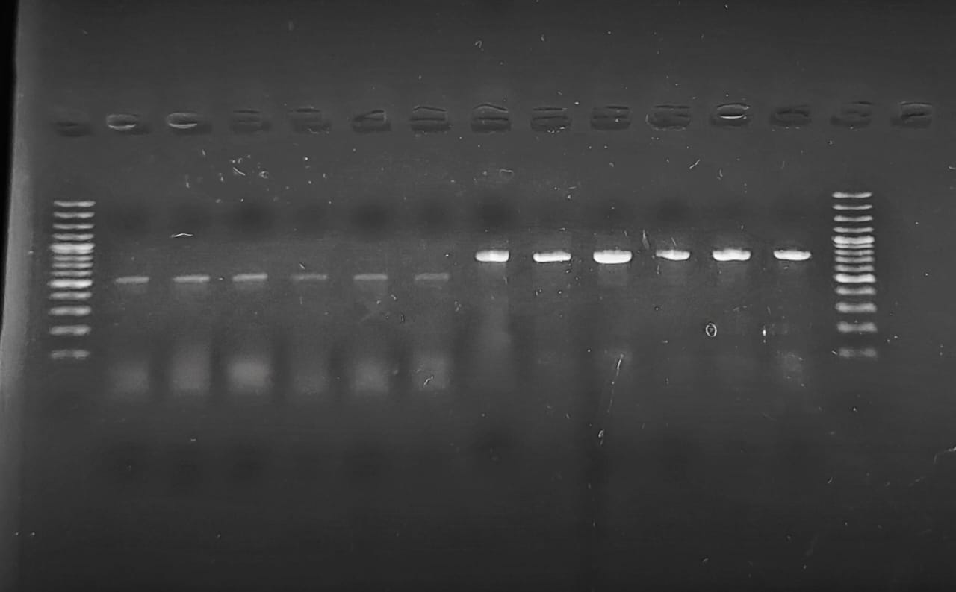
L 1 2 3 4 5 6 7 8 9 10 11 12 L

Supplementary Fig. 1 Different Fusarium isolates identified with TEF1-α (samples 1-6) and ITS (samples 7-12) primers with PCR products of 550 and 780 bp respectively using 100 bp ladder (L) from dry rot potato tubers from Batakundi, Manshera and Haripur regions of KP.

