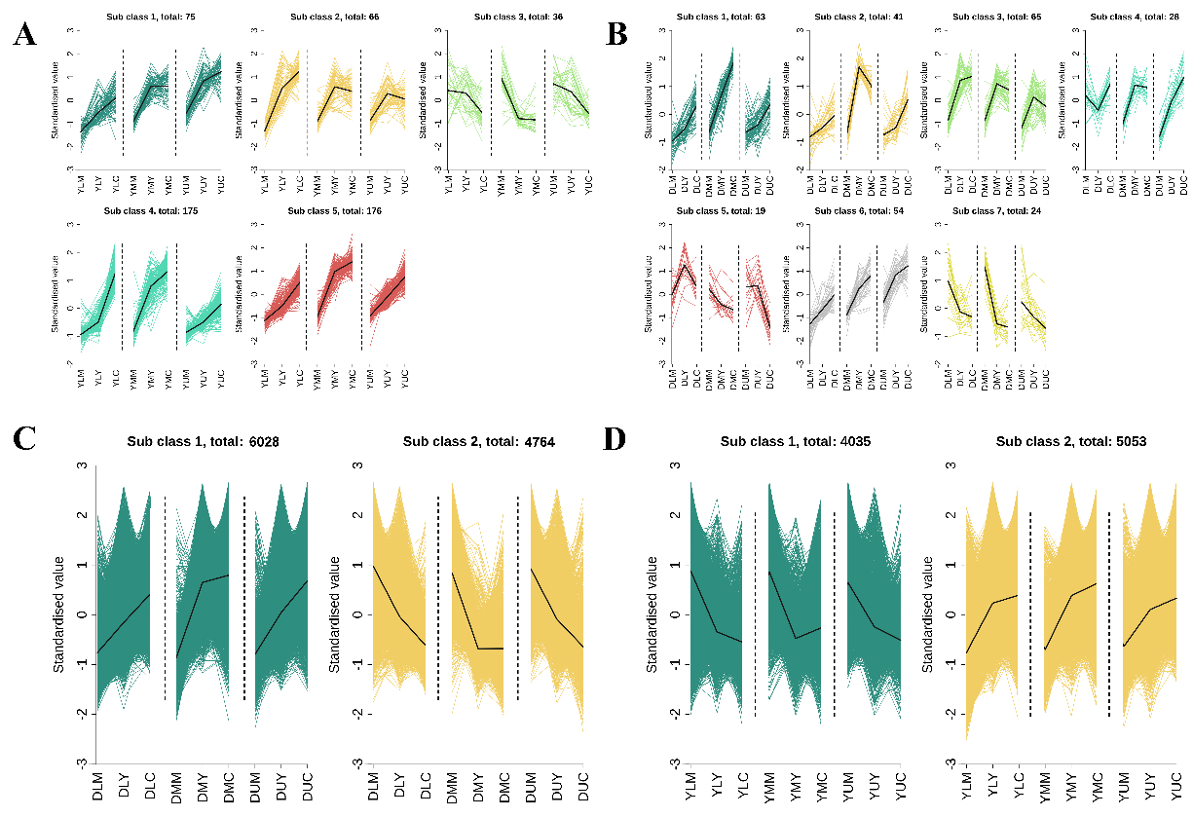
Fig. S1. K-means cluster analysis of differentially accumulated metabolites (DAMs) and differentially expressed genes (DEGs) specific to each cultivar. (A) Unique DAMs were divided into five clusters in Dabaijin (Sub class 1: 75, Sub-class 2: 66, Sub-class 3: 36, Sub-class 4: 175, Sub-class 5: 176). (B) Unique DAMs were divided into seven clusters in Yunyan87 (Sub-class 1: 63, Sub-class 2: 41, Sub-class 3: 65, Sub-class 4: 28, Sub-class 5: 19, Sub-class 6: 54, Sub-class 7: 24). (C) Unique DEGs were divided into two clusters in Dabaijin (Sub-class 1: 6028, Sub-class 2: 4764). (D) Unique DAMs were divided into two clusters in Yunyan87 (Sub-class 1: 4035, Sub-class 2: 5053).

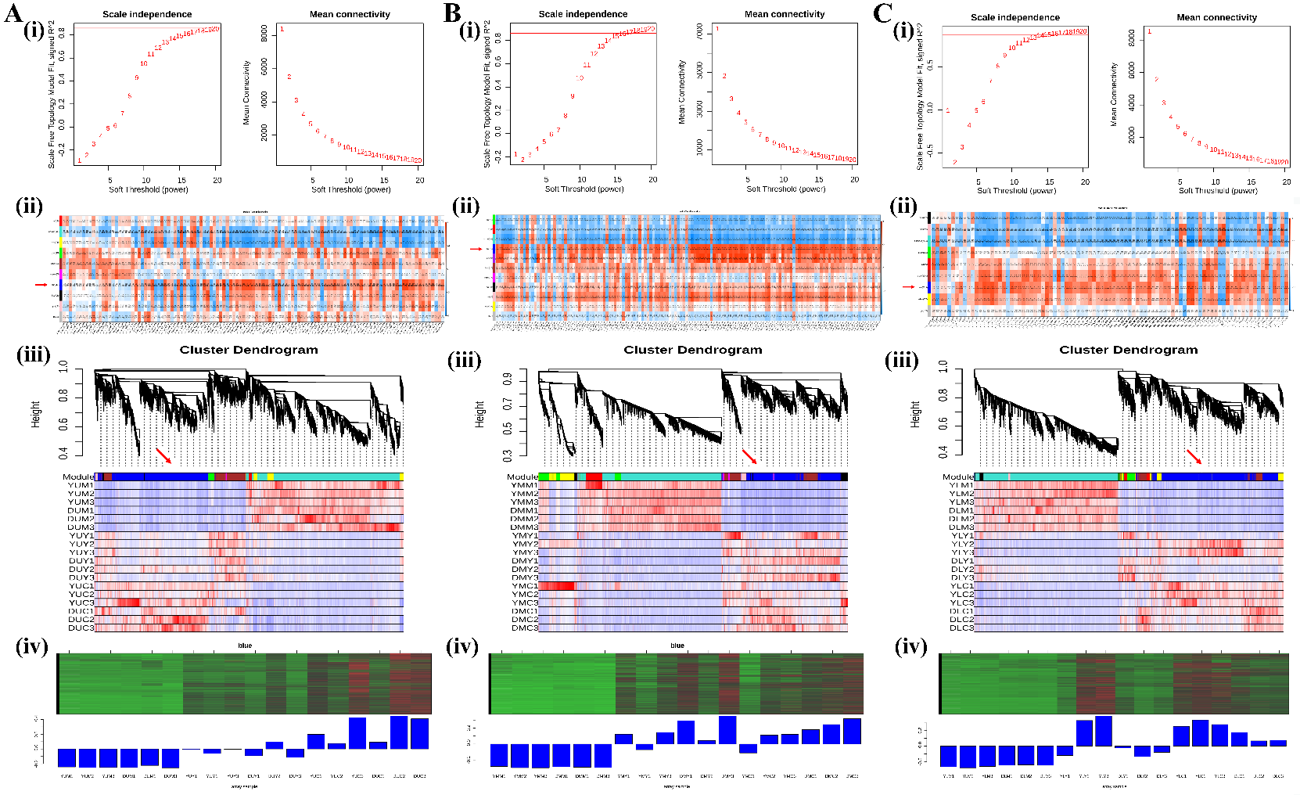
Fig. S2. The DEGs in the upper, middle, and lower leaves were subjected to WGCNA analysis with the unique DAMs in Dabaijin. (A) Upper leaves. (B) Middle leaves. (C) Lower leaves. (i) Soft threshold selection. (ii) Matrix of module-metabolite associations. The number of genes per module is shown next to the module name. Correlation coefficients and P-values between modules and metabolites are shown with the row-column intersections. (iii) Expression patterns of DEGs and DAMs. The red arrow points to the blue module. (iv) Significantly upregulated blue module.

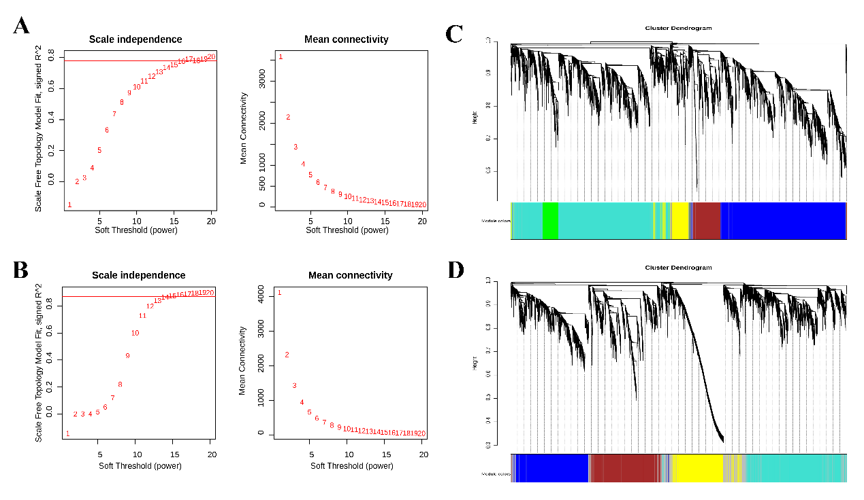Fig. S3. The soft threshold selection between unique DEGs of Dabaijin (A) and Yunyan87 (B) and eight core DAMs was determined by WGCNA analysis. (C) Clustering dendrogram of co-expression modules of Dabaijin. (D) Clustering dendrogram of co-expression modules of Yunyan87. Each color represents a module.

