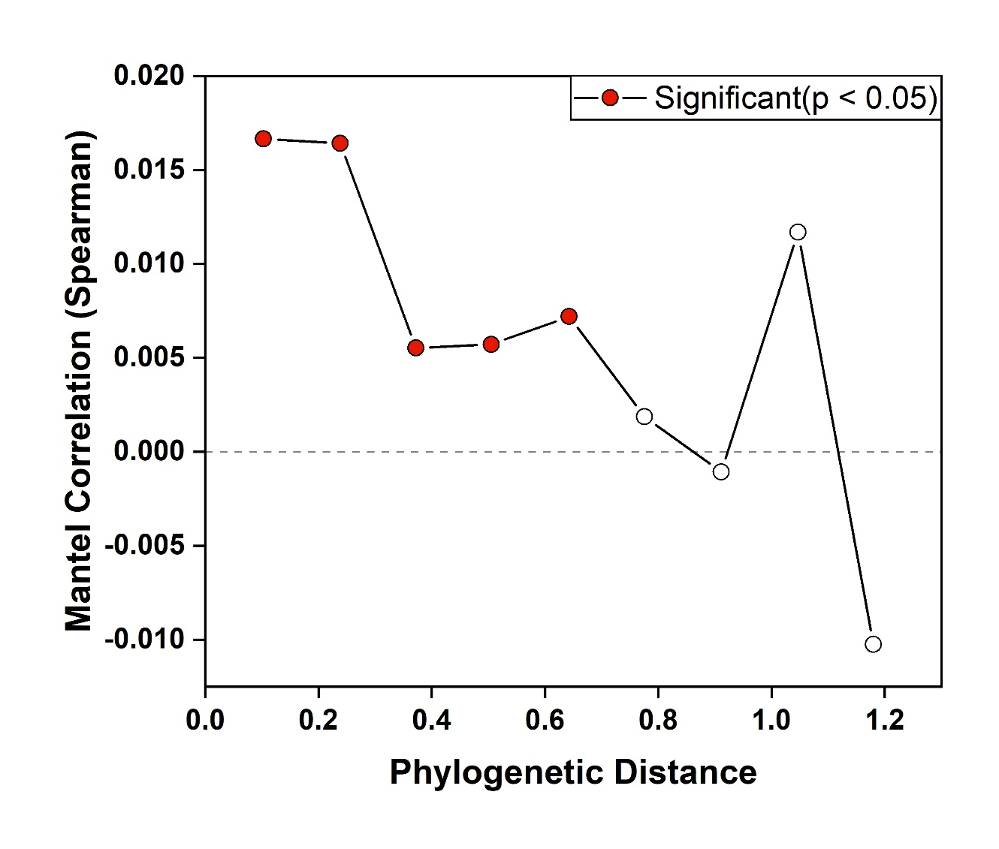
FIG S1 Phylogenetic Mantel correlogram showing significant phylogenetic signals across short phylogenetic distances. Red solid symbols indicate significant correlations, while open symbols indicate nonsignificant correlations. The plot relates between operational taxonomic units (OTUs) niche differences to between-OTU phylogenetic distances across phylogenetic scales.

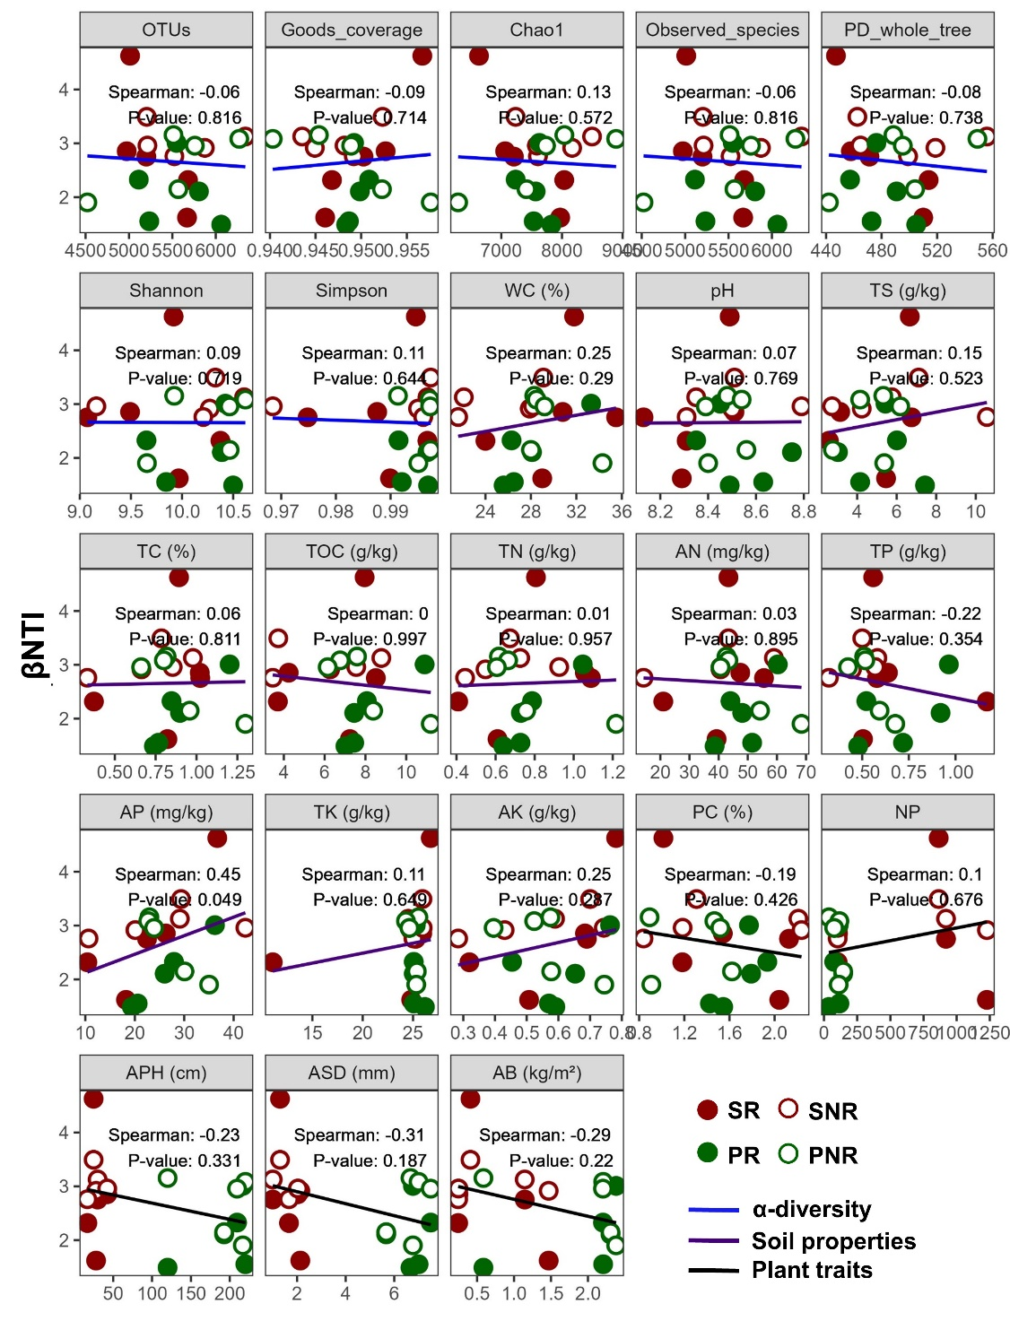
FIG S2 Effects of bacterial diversity, soil properties, and plant traits on bacterial assembly processes. PC, plant cover; NP, plant number; APH, average plant height; ASD, average stem diameter; AB, Aboveground biomass. SR, rhizosphere soil of Suaeda salsa; SNR, non-rhizosphere soil of S. salsa; PR, rhizosphere soil of Phragmites australis; PNR, non-rhizosphere soil of P. australis.

FIG S3 Predicted functional profiles of bacterial communities in different soils. SR, rhizosphere soil of Suaeda salsa; SNR, non-rhizosphere soil of S. salsa; PR, rhizosphere soil of Phragmites australis; PNR, non-rhizosphere soil of P. australis.

Table S1 Relative abundance of major bacterial phyla in different soils
 | SR (%) | SNR (%) | PR (%) | PNR (%)
Proteobacteria^{A} | 30.46 ± 4.16b | 37.43 ± 5.26a | 27.29 ± 3.23b | 29.03 ± 5.07b
Bacteroidota^{B} | 13.03 ± 2.91b | 16.84 ± 2.25ab | 15.81 ± 1.90ab | 19.17 ± 4.69a
Chloroflexi^{C} | 6.96 ± 1.71b | 10.63 ± 3.43b | 7.08 ± 0.96b | 13.75 ± 2.19a
Actinobacteriota^{D} | 7.76 ± 3.22 | 6.81 ± 1.86 | 8.41 ± 4.11 | 7.46 ± 2.47
Desulfobacterota^{D} | 7.19 ± 2.97b | 5.53 ± 1.52b | 10.48 ± 2.48a | 4.61 ± 1.65b
Firmicutes^{DE} | 14.05 ± 7.12a | 1.62 ± 0.80b | 6.07 ± 3.79b | 2.13 ± 1.13b
Acidobacteriota^{EF} | 3.26 ± 1.14 | 3.83 ± 0.99 | 3.70 ± 0.39 | 4.40 ± 1.30
Verrucomicrobiota^{EF} | 2.28 ± 0.39c | 4.49 ± 0.64ab | 2.92 ± 0.78bc | 5.05 ± 2.29a
Myxococcota^{F} | 1.79 ± 0.54 | 1.76 ± 0.94 | 3.70 ± 2.01 | 2.71 ± 2.23
Cyanobacteria^{F} | 3.65 ± 2.58a | 0.98 ± 0.60b | 4.46 ± 2.10a | 0.79 ± 0.65b
Gemmatimonadota^{F} | 1.70 ± 0.91 | 2.97 ± 0.41 | 2.35 ± 0.88 | 2.72 ± 0.66
Planctomycetota^{F} | 1.54 ± 0.26 | 1.56 ± 0.45 | 1.25 ± 0.49 | 1.72 ± 0.41
Patescibacteria^{F} | 1.94 ± 0.62a | 0.78 ± 0.35b | 0.69 ± 0.12b | 0.94 ± 0.34b
Data are presented as mean ± standard deviation. Different uppercase letters indicate significant differences among total relative abundance across phyla, while lowercase letters indicate significant differences among sample groups at p < 0.05. SR, rhizosphere soil of Suaeda salsa; SNR, non-rhizosphere soil of S. salsa; PR, rhizosphere soil of Phragmites australis; PNR, non-rhizosphere soil of P. australis.

Table S2 Module scores and major taxa abundance in bacterial co-occurrence networks of Suaeda salsa, Phragmites australis, and the joint network. Module scores represent the proportion of nodes in each module, and major taxa abundance represents the relative abundance of dominant phyla within modules.
 | Module scores |  |  |  | Major taxa abundance
 | S. salsa | P. australis | Joint network |  | S. salsa | P. australis |  | Joint network
Module1 | 28.94% | 20.55% | 13.99% | Proteobacteria | 35.41% | 34.61% | 35.10%
Module2 | 18.82% | 19.22% | 12.96% | Bacteroidota | 14.34% | 14.73% | 14.90%
Module3 | 16.92%% | 14.98% | 10.91% | Firmicutes | 5.89% | 6.66% | 6.73%
Module4 | 14.68% | 12.81% | 8.64% | Actinobacteriota | 5.64% | 5.24% | 6.10%
Module5 | 4.06% | 6.07% | 7.2% | Desulfobacterota | 5.47% | 4.74% | 5.21%
Module6 | 0.17% | 0.5% | 6.07% | Verrucomicrobiota | 4.73% | 4.74% | 4.85%
Module7 | 0.17% | 0.42% | 5.14% | Chloroflexi | 4.39% | 4.49% | 4.13%
Module8 | – | 0.08% | 4.94% | Patescibacteria | 3.91% | 3.91% | 3.50%
Module9 | – | – | 4.63% | Acidobacteriota | 3.57% | 3.74% | 3.23%
Module10 | – | – | 2.26% | Planctomycetota | 3.32% | 3.49% | 2.78%
Module11 | – | – | 1.34% | Myxococcota | 2.49% | 2.83% | 2.42%
Module12 | – | – | 1.03% | Cyanobacteria | 1.08% | 1.08% | 1.44%)
Remains | – | – | < 1% | Remains | ≤ 1.08% | ≤ 1% |  | < 1%

Table S3 Topological roles of bacterial genera in the networks of of Suaeda salsa, Phragmites australis, and the joint network.
 | S. salsa |  | P. australis |  | Joint network
 | Nodes | Proportion | Nodes | Proportion | Nodes | Proportion | Zi | Pi
Peripherals | 960 | 79.60% | 894 | 74.38% | 663 | 68.21% | ≤2.5 | ≤0.62
Connectors | 227 | 18.82% | 289 | 24.04% | 288 | 29.63% | ≤2.5 | >0.62
Module hubs | 19 | 1.58% | 18 | 1.50% | 20 | 2.06% | >2.5 | ≤0.62
Network hubs | 0 | 0% | 1 | 0. 083% | 1 | 0.103% | >2.5 | >0.62

Table S4 Correlations between biotic and abiotic factors and bacterial phylum structures based on Mantel’s test. Mantel’s r indicates the strength of correlation, with associated p-values.
Affecters | Phylum | Mantel’s r | p-value
Diversity | Planctomycetota | 0.244 | 0.038
Metabolic function | Proteobacteria | 0.495 | 0.001
Metabolic function | Actinobacteriota | 0.294 | 0.013
Metabolic function | Planctomycetota | 0.377 | 0.003
Plant traits | Bacteroidota | 0.168 | 0.025
Plant traits | Patescibacteria | 0.222 | 0.011
Soil properties | Patescibacteria | 0.478 | 0.012
Key genus | Firmicutes | 0.336 | 0.027
Key genus | Acidobacteriota | 0.336 | 0.009
Key genus | Gemmatimonadota | 0.508 | 0.001
Key genus | Patescibacteria | 0.579 | 0.002

Table S5 Importance ranking of factors significantly affecting bacterial genus structure. F-values indicate effect size, and the proportion column denotes the level of significance.
Sorting | Factors | F | Proportion
1 | Methane metabolism | 17.7 | <0.01
2 | APH | 15.8 | <0.01
3 | AB | 15.8 | <0.01
4 | Acidobacteriota | 14.6 | <0.01
5 | Verrucomicrobiota | 14.6 | <0.01
6 | Firmicutes | 13.7 | <0.01
7 | Stem | 13.4 | <0.01
8 | Desulfobacterota | 12.7 | <0.01
9 | Plant-pathogen interaction | 10.9 | 0.01–0.05
10 | AN | 10.5 | 0.01–0.05
11 | Proteobacteria | 10.4 | 0.01–0.05
12 | TC | 10.4 | 0.01–0.05
13 | Actinobacteriota | 9.7 | 0.01–0.05
14 | Cyanobacteria | 9.5 | 0.01–0.05
15 | AP | 9.4 | 0.01–0.05
16 | Carbohydrate metabolism | 9.2 | 0.01–0.05
PC, plant cover; NP, plant number; APH, average plant height; Stem, average stem diameter; AB, Aboveground biomass.

