Integrated metabolomic and transcriptomic profiling reveals leaf-specific flavonoid biosynthesis in Paris polyphylla Sm.
Wang Yang^{1†}, Zhihao Li^{1,2†}, Juncheng Lin¹, Changhu Ke¹, Huimin Liu¹, Fangling Ren¹, Huilin Huang¹, Pengju Wang¹, Lun Wu¹, Tingwen Ming¹, Jingjian Liu^{1,2*}, Peng Li^{1*}
¹ Sinopharm Dongfeng General Hospital, School of Pharmaceutical Sciences, Hubei University of Medicine, Shiyan, Hubei 442000, China
² Hubei Key Laboratory of Wudang Local Chinese Medicine Research, Hubei University of Medicine, Shiyan, Hubei 442000, China
†Wang Yang and Zhihao Li contributed equally to this work and should be considered as equal first authors.
*Correspondence: liujj95@163.com (Jingjian Liu); dfyylp@163.com (Peng Li)
2. Methods
2.4 Targeted metabolomics validation
Table S1. Standard information for targeted metabolomics detection of metabolites
Name | Molecular formula | CAS Number
Kaempferol | C₁₅H₁₀O₆ | 520-18-3
Vitexin | C₂₁H₂₀O₁₀ | 3681-93-4
Apigenin | C₁₅H₁₀O₅ | 520-36-5
(+)-Dihydroquercetin | C₁₅H₁₂O₇ | 480-18-2
(+)-Dihydrokaempferol | C₁₅H₁₂O₆ | 480-20-6
Quercetin | C₁₅H₁₀O₇ | 117-39-5
Rutin | C₂₇H₃₀O₁₆ | 153-18-4
Luteolin | C₁₅H₁₀O₆ | 491-70-3
Naringenin | C₁₅H₁₂O₅ | 480-41-1
Naringenin Chalcone | C₁₅H₁₂O₅ | 73692-50-9
Catechin | C₁₅H₁₄O₆ | 7295-85-4
Epicatechin | C₁₅H₁₄O₆ | 490-46-0
Dihydromyricetin | C₁₅H₁₂O₈ | 27200-12-0
Isorhamnetin | C₁₆H₁₂O₇ | 480-19-3
Kaempferol-3-O-glucoside | C₂₁H₂₀O₁₁ | 480-10-4
Quercetin 3-β-D-glucoside | C₂₁H₂₀O₁₂ | 21637-25-2
Trans-Ferulic acid | C₁₀H₁₀O₄ | 537-98-4
4-Hydroxybenzoic acid | C₇H₆O₃ | 99-96-7
Hydrocinnamic acid | C₉H₁₀O₂ | 501-52-0
Trans-Cinnamic acid | C₉H₈O₂ | 140-10-3
Vanillic acid | C₈H₈O₄ | 121-34-6
Vanillin | C₈H₈O₃ | 121-33-5
Gallic acid | C₇H₆O₅ | 149-91-7
Benzoic acid | C₇H₆O₂ | 65-85-0
Salicylic acid | C₇H₆O₃ | 69-72-7
Sinapic acid | C₁₁H₁₂O₅ | 530-59-6
Syringic acid | C₉H₁₀O₅ | 530-57-4
Syringaldehyde | C₉H₁₀O₄ | 134-96-3
3,4-Dihydroxybenzoic acid | C₇H₆O₄ | 99-50-3
Caffeic acid | C₉H₈O₄ | 331-39-5
p-Hydroxycinnamic acid | C₉H₈O₃ | 501-98-4
Protocatechualdehyde | C₇H₆O₃ | 139-85-5
Resveratrol | C₁₄H₁₂O₃ | 501-36-0
Phthalic acid | C₈H₆O₄ | 88-99-3
Isoliquiritigenin | C₁₅H₁₂O₄ | 961-29-5
Daidzein | C₁₅H₁₀O₄ | 486-66-8
Phloretin | C₁₅H₁₄O₅ | 60-82-2
Genistin | C₂₁H₂₀O₁₀ | 529-59-9
Luteoloside | C₂₁H₂₀O₁₁ | 5373-11-5

2.5 Real-time quantitative PCR (RT-qPCR) analysis
Table S2. Primer information for RT-qPCR detection of genes
Gene Name | Primers | Primer sequence (5' to 3')
g4439_i3 | QF1 | GTAGTCGTAGGTGAGGTGGC
 | QR1 | GCCCAATTTTCCTCCTTCGC
g5996_i1 | QF2 | ATCCCTTCGGAGTTCATCC
 | QR2 | ATCGTGCTCTCAGGAATGC
g5996_i5 | QF2 | ATCCCTTCGGAGTTCATCC
 | QR2 | ATCGTGCTCTCAGGAATGC
g7402_i1 | QF1 | TGTTGGGCATCCTGTCTTCC
 | QR1 | CTTGAAACACGAAGGGCTGC
g8511_i1 | QF1 | TGTTCACCGGGTATTCGCTC
 | QR1 | GAAGTGCCTCCGACTCGATG
g10358_i0 | QF1 | CGAACCCCTCCCCTTCAATC
 | QR1 | CACCGAGGAGACGAAGACTG
g11378_i1 | QF2 | CGGGTTCTCCTTCAGTATCTC
 | QR2 | AACAGCGAGCATCTCACAG
g13140_i0 | QF2 | TAACAAAGTCCCAGCCCTC
 | QR2 | CAATCGGAGATACCTAAAGGC
g13978_i0 | QF2 | TTTCGGCAGAGATTAGGTTC
 | QR2 | TGGAGAAGGTGGTGTTCAC
g14777_i0 | QF2 | CAAACCCATACCTCAAAGGAG
 | QR2 | CAAACGGACATCCACTGTG
g15079_i0 | QF1 | CATGGCGTCGAGTATCTCCC
 | QR1 | CCGAGCTCATCCGATTCCTC
g19264_i1 | QF2 | CAGCCCTTATTGTTGGGTC
 | QR2 | TTGCTCCCTCGCTATTAGG
g21237_i0 | QF1 | CCCGCGATGGTTATAGGTCC
 | QR1 | TGCCAAAATGTGTGCCTTGG
g21513_i1 | QF1 | TCGGCATTCTTGAACCTCCC
 | QR1 | CACGATTACGCTCTTGCTGC
g22039_i0 | QF1 | TCCTCCAAGAAACGAGACGC
 | QR1 | CGACTACCTCCGACACTTCG
g22228_i4 | QF1 | GGGTGGTGGTGATCAAGGAG
 | QR1 | TTGTGCTAGAGGTTGCAGGG
g24489_i0 | QF1 | CAGTGGGTCACCTGTAGCTG
 | QR1 | GTGAGCAAGAGCAGCACATG
g26448_i0 | QF2 | TCTTCCACCTCATCTTCCC
 | QR2 | TTCCCTCAGTTGCTTTGC
g28593_i1 | QF2 | CTCTTTGTCCCTCGCCGATC
 | QR2 | TGATGAGCTCCTTGAGGCTG
g33122_i0 | QF2 | TGAAGGACCCGTTGAACTG
 | QR2 | TCTCCATCACCCACTCACTG
g33444_i0 | QF2 | AACAACATCACGAGGCTTG
 | QR2 | TTTGAACTCCTGCCCTTG
g33638_i1 | QF2 | GAGAAGGTGGTGGAGAACTG
 | QR2 | TTCGTTTGAACTCTGCGAC
g33932_i0 | QF2 | TTGACCTCTCGCCTTTGCTC
 | QR2 | CCGGAGATGGATTTGGGGAC
g60557_i0 | QF2 | TGACTCCAAGACCATCAGC
 | QR2 | CCTATCGGCACCATACTAATG
g75651_i0 | QF2 | TTCTGGGCTTACATCACCC
 | QR2 | TCCTGAAAGTATGCCGACC
g2475_i1 | QF2 | GCCAATGGAAACGACTTC
 | QR2 | CGGAGGTGTCAATCTTGTC
g18969_i0 | QF2 | CTTGGAAAGTCGGATTCG
 | QR2 | GGACACAACCGTCATAACTG
g6348_i0 | QF2 | CATCGCCTCCTTGTTCTTC
 | QR2 | TTATGCGGTTTGAGAGCG
g12695_i0 | QF1 | CCCCACTTCTTCCAGCTCTG
 | QR1 | TGCTCCTCCTCCCTAACTCC

3 Results
3.1 Non-targeted metabolomics analysis of Paris polyphylla Sm.
Fig. S1 Quality control plots of non-targeted metabolomics. (A) The PCA plot of overall samples; (B) The RSD distribution plot of samples; (C, E, and G) The PCA score plots of Leaves group vs Roots group, Leaves group vs Stems group, and Stems group vs Roots group in sequence (n=6); (D, F, and H) The permutation test of Leaves group vs Roots group, Leaves group vs Stems group, and Stems group vs Roots group in sequence.
Fig S2. The bar chart analysis of top 20 pathway statistics. (A-C) The top 20 metabolic pathways of Leaves group vs Roots group, Leaves group vs Stems group, and Stems group vs Roots group in sequence.
3.2 Transcriptomics analysis of Paris polyphylla Sm.
Fig S3. The sample PCA plot and differentially expressed MA plot: (A) The PCA plot of transcriptome samples (n=4); (B-D) The MA map of Leaves group vs Roots group, Leaves group vs Stems group, and Stems group vs Roots group in sequence.

3.3 Combined metabolomic and transcriptomics analysis
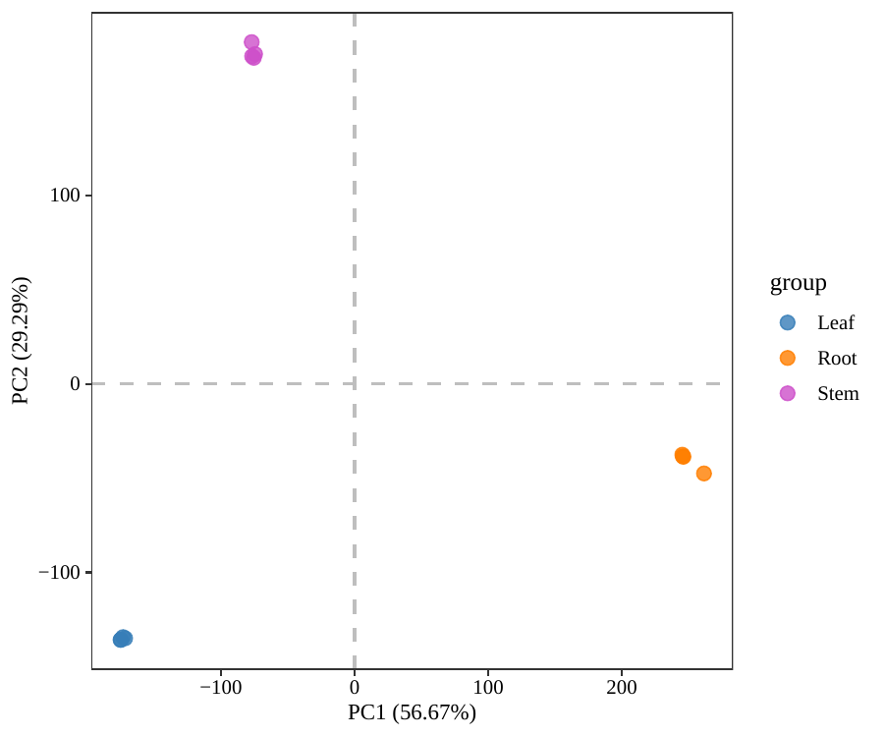
Fig. S4 The PCA plot combining transcriptomics and non-targeted metabolomics data.

Fig. S5 The KEGG pathway diagram of flavonoid biosynthesis for non-targeted metabolomics and transcriptomics combined analysis. (A-C) The KEGG pathway diagram of Leaves group vs Roots group, Leaves group vs Stems group, and Stems group vs Roots group in sequence.
Fig. S6 (A-P) Targeted metabolomics content bar chart. (R = Roots, S = Stems, L = Leaves, n = 4, ns: non-significant, *. P < 0.05; **. P < 0.01; ***. P < 0.001)

Fig. S7 (A-L) RT-qPCR validation of key genes. (R = Roots, S = Stems, L = Leaves, n = 3, ns: non-significant, *. P < 0.05; **. P < 0.01; ***. P < 0.001)

