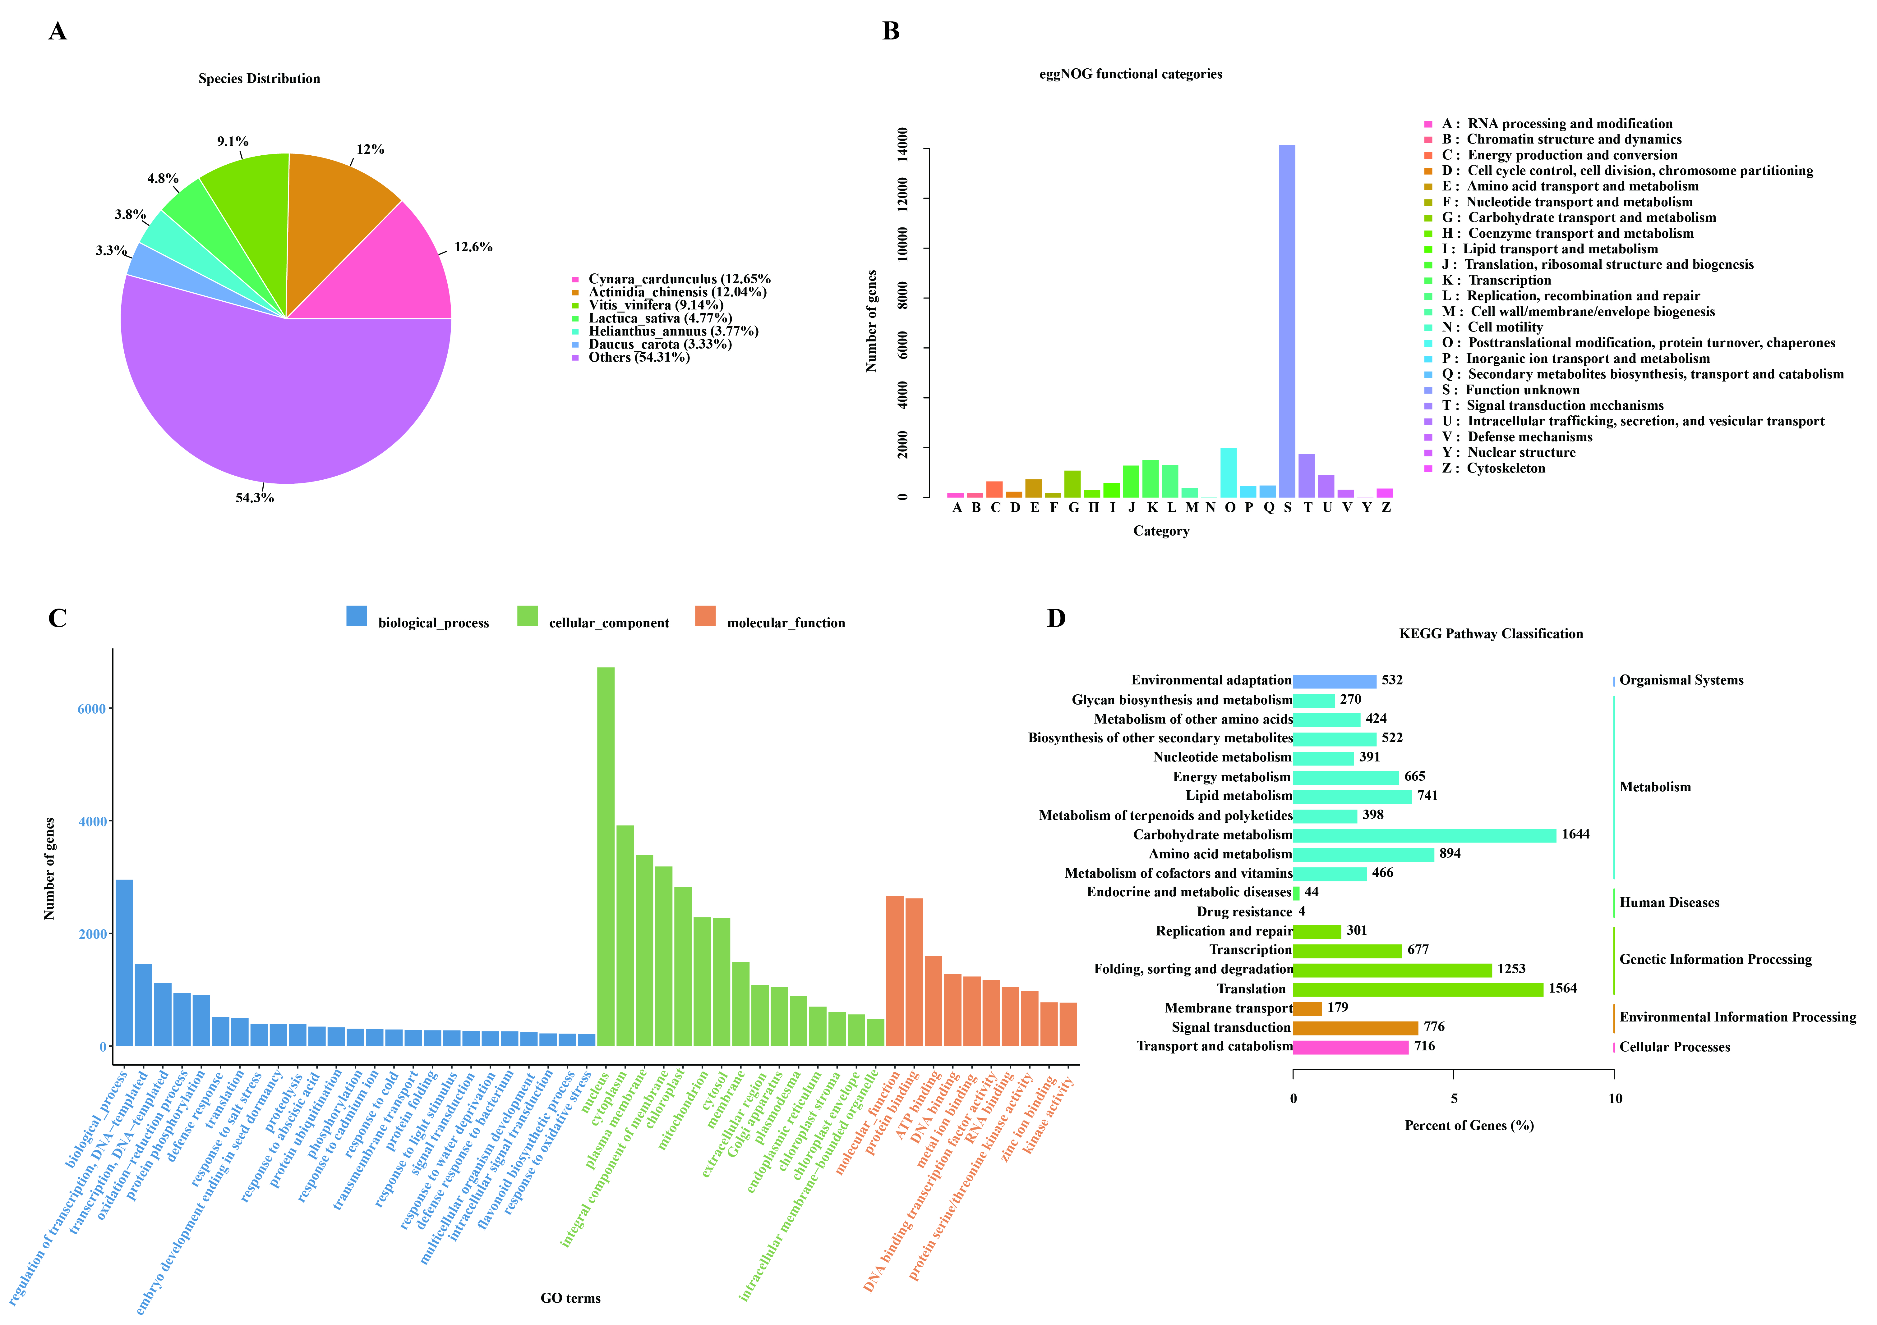
Fig S1. Gene annotation and functional classification. A Distribution of species annotated by NR. B Classification of eggNOG functional annotations for Unigenes. X-axis, Annotation type; Y-axis, Number of genes. C Classification of GO functional annotations for Unigenes. X-axis, Annotation type; Y-axis, Number of genes. D Classification of KEGG functional annotations by Unigenes. X-axis, Percent of genes; Y-axis, Annotation type
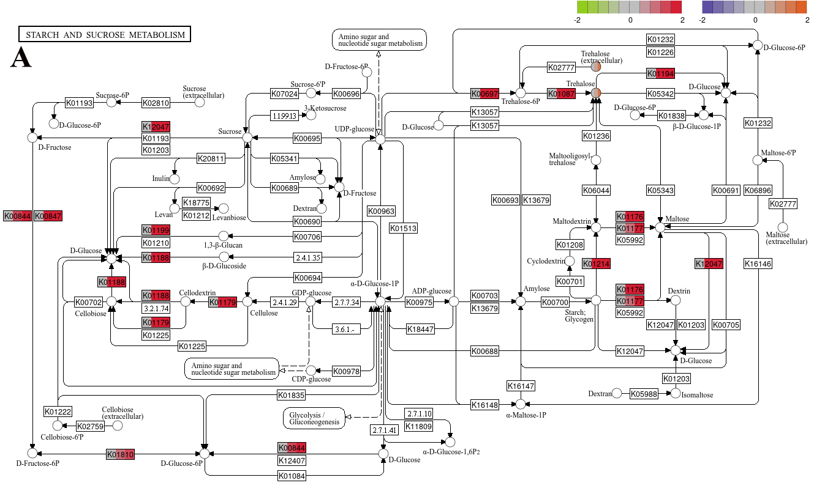
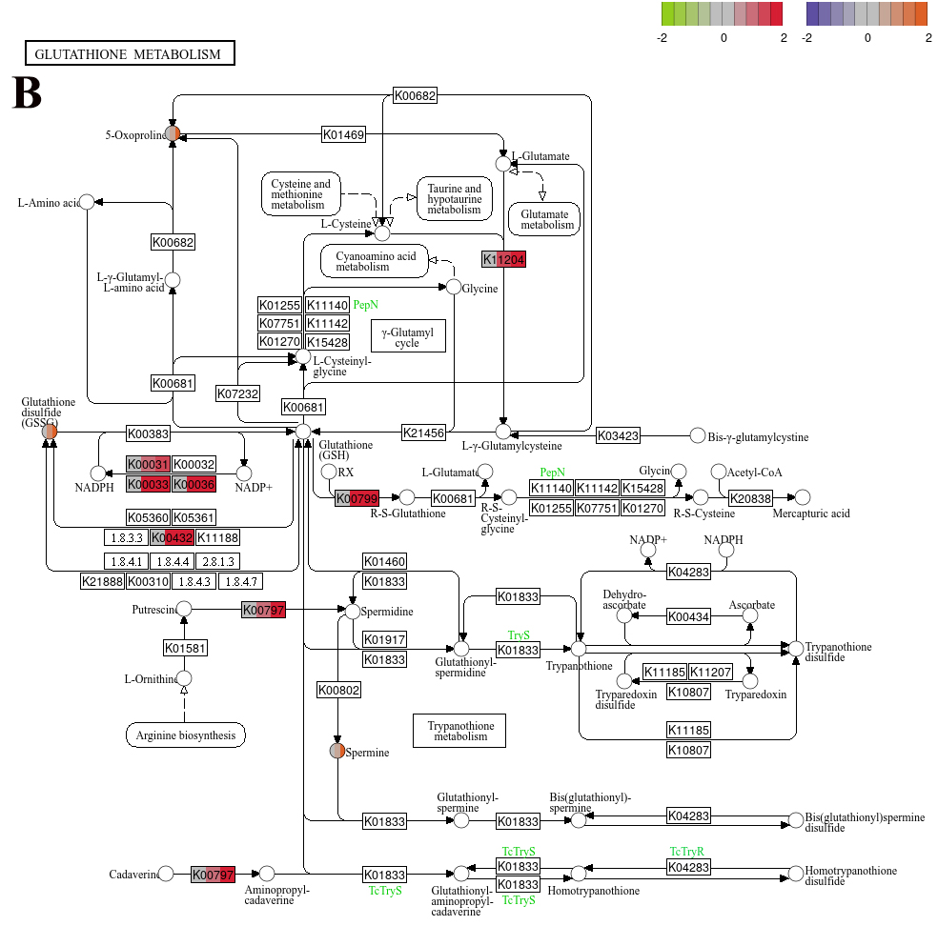
Fig S2. Regulation of various synthetic pathways under drought stress. A Starch and sucrose metabolism (map00500). B Glutathione metabolism (map00480). Square on the pathway diagram represent genes and circles represent compounds. Each square and circle from left to right represents the expression levels of three groups, respectively, corresponding to C, MD, and SD, respectively. Shades of colours represent Log₂FC values. The access map was obtained from the KEGG database (https://www.kegg.jp/kegg/kegg)

