Supplementary materials legends

Fig. S1. Distribution of maximum ancestry proportion per individual under K = 15. This histogram shows the distribution of the highest ancestry proportion assigned to each of the 1,693 Korean landrace soybean accessions based on population structure analysis using sNMF (sparse non-negative matrix factorization). The x-axis represents the maximum ancestry coefficient (Q value) for each individual across the 15 inferred ancestral populations, while the y-axis indicates the number of individuals (frequency). A substantial number of accessions exhibit a maximum ancestry proportion close to 1.0, suggesting clear membership to a single ancestral population, whereas others display more admixed genetic backgrounds. This distribution supports the choice of K = 15 as the optimal number of ancestral populations and reflects both distinct population structure and admixture within the panel.

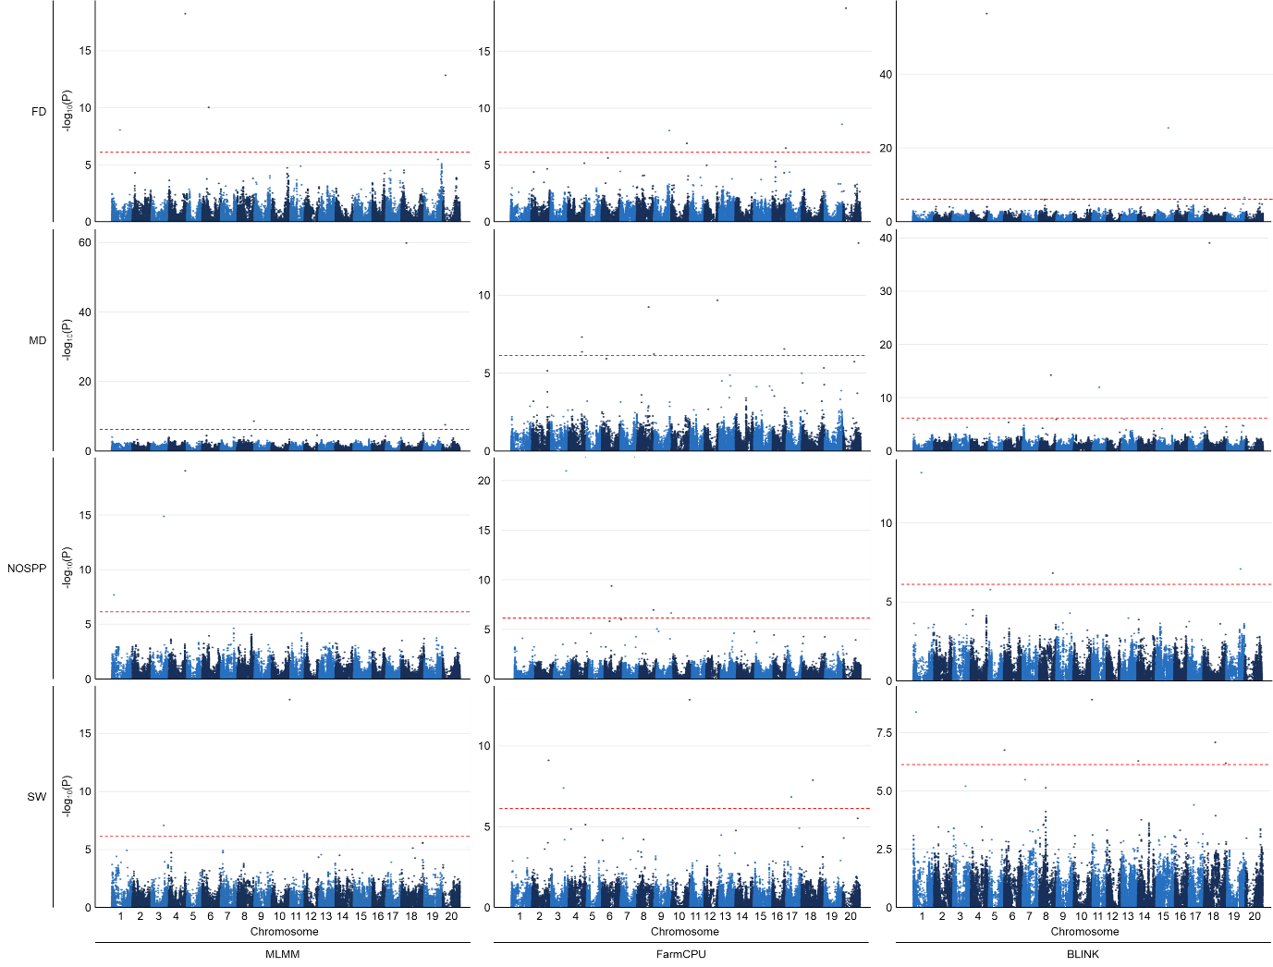
Fig. S2. Manhattan plots from genome-wide association studies (GWAS) for four key agronomic and seed quality traits in 1,693 Korean landrace soybean accessions. Genotyping was performed using the 180K Axiom® SoyaSNP array, and 67,222 high-quality SNPs were retained after quality control. The horizontal red dashed line denotes the genome-wide significance threshold. SNPs exceeding this threshold are considered significantly associated with the respective traits, with greater –log₁₀(P) values indicating stronger statistical evidence. Chromosomes are alternately colored to enhance visual distinction. FD (flowering date), MD (maturity date), NOSPP (number of seeds per pod), and SW (seed weight). Rows correspond to traits and columns to GWAS models (MLMM, FarmCPU, BLINK).

Table S1. Number of individuals assigned to each of the 15 inferred populations from the sNMF analysis
Population | Number of individuals
Pop1 | 73
Pop2 | 94
Pop3 | 102
Pop4 | 298
Pop5 | 124
Pop6 | 30
Pop7 | 47
Pop8 | 99
Pop9 | 63
Pop10 | 23
Pop11 | 470
Pop12 | 119
Pop13 | 35
Pop14 | 45
Pop15 | 71

Table S2. Haplotype sequences and their frequencies within LD blocks surrounding significant SNP markers
Trait | Marker | Chr | Haplotype | Sequence  (5' to 3') | Frequency (%)
FD | AX-90317042 | 9 | Hap1 | C-G-A-G-T-A-G | 50.7
 |  |  | Hap2 | A-T-C-A-C-A-A | 36.9
 |  |  | Hap3 | A-T-C-A-C-T-A | 7.4
 |  |  | Hap4 | A-T-C-A-T-A-A | 4.8
 | AX-90392707 | 19 | Hap1 | T-A-A-T-C-G-G-G-A-G-G-T-A-T-A-C | 33.5
 |  |  | Hap2 | C-C-G-C-C-A-A-A-T-T-A-C-C-C-C-T | 29.5
 |  |  | Hap3 | C-C-G-C-T-A-A-A-T-T-A-C-C-C-C-T | 24.2
 |  |  | Hap4 | T-A-A-T-C-G-G-G-A-G-A-T-A-T-A-C | 9.1
 |  |  | Hap5 | T-A-A-T-C-G-G-G-A-G-G-T-A-T-A-T | 2.1
 | AX-90406392 | 16 | Hap1 | A-T | 65.1
 |  |  | Hap2 | G-G | 34.9
MD | AX-90435384 | 8 | Hap1 | C-G-T-G-A-G-T-C-A-C-C-T | 38.4
 |  |  | Hap2 | C-G-T-G-A-G-T-C-A-T-G-T | 22.2
 |  |  | Hap3 | C-G-T-G-A-G-T-C-G-C-C-T | 18.9
 |  |  | Hap4 | T-T-A-A-A-A-A-T-G-C-G-G | 13.0
 |  |  | Hap5 | T-T-A-A-G-A-A-T-G-C-G-G | 5.8
 |  |  | Hap6 | C-G-T-G-A-A-T-C-A-T-G-T | 1.5
NOSPP | AX-90334048 | 6 | Hap1 | T-T-T-G-A-A-T-T | 41.5
 |  |  | Hap2 | T-T-T-G-A-A-T-C | 28.6
 |  |  | Hap3 | C-G-C-A-C-C-A-T | 23.4
 |  |  | Hap4 | T-T-C-G-A-A-T-C | 4.5
 |  |  | Hap5 | C-G-C-G-C-C-A-T | 1.1
 | AX-90525597 | 1 | Hap1 | C-A | 70.4
 |  |  | Hap2 | T-A | 24.1
 |  |  | Hap3 | C-G | 5.5
 | AX-90343598 | 9 | Hap1 | A-G-A-A-T-G-A-G-A-T-G-G-A-T | 49.9
 |  |  | Hap2 | G-T-A-C-C-G-A-T-A-T-G-A-A-C | 18.8
 |  |  | Hap3 | G-G-G-A-C-A-T-G-G-C-A-A-G-C | 16.6
 |  |  | Hap4 | G-G-G-A-T-G-A-G-A-T-G-A-A-C | 6.6
 |  |  | Hap5 | G-G-G-A-C-G-A-T-A-T-G-A-A-C | 3.8
 |  |  | Hap6 | G-G-A-A-T-G-A-G-A-T-G-A-A-C | 2.5
 | AX-90467095 | 8 | Hap1 | C-T-T-A-C-A-C-T-C-T-A-C-T-C-G | 86.5
 |  |  | Hap2 | A-A-C-G-T-G-T-A-G-A-G-T-G-T-A | 5.4
 |  |  | Hap3 | A-T-C-G-T-G-T-A-G-A-G-T-G-T-A | 5.4
 |  |  | Hap4 | C-T-T-A-C-A-C-T-G-T-A-C-T-C-G | 1.4
SW | AX-90450605 | 1 | Hap1 | G-T | 62.8
 |  |  | Hap2 | G-C | 24.5
 |  |  | Hap3 | T-T | 12.7
 | AX-90358463 | 14 | Hap1 | A-T-G-A-C-C-A-G | 55.8
 |  |  | Hap2 | G-C-A-G-A-T-G-G | 21.0
 |  |  | Hap3 | G-T-G-A-C-C-A-G | 12.4
 |  |  | Hap4 | G-C-A-G-A-T-A-G | 5.5
 |  |  | Hap5 | A-T-G-A-C-C-A-T | 4.0
 |  |  | Hap6 | A-T-G-A-C-C-G-T | 1.0
 | AX-90474666 | 6 | Hap1 | G-C-G-A-C-T-T-C-T-C-C-G-A | 42.3
 |  |  | Hap2 | T-T-A-G-C-A-T-T-T-C-C-G-A | 30.6
 |  |  | Hap3 | T-T-A-G-T-T-A-T-G-A-T-C-G | 14.2
 |  |  | Hap4 | G-C-A-A-C-T-T-C-T-C-C-G-A | 7.8
 |  |  | Hap5 | G-C-A-A-C-A-T-T-T-C-C-G-A | 2.6
 | AX-90486788 | 6 | Hap1 | T-C-C-C-T | 43.2
 |  |  | Hap2 | A-A-T-T-C | 26.7
 |  |  | Hap3 | T-C-T-C-T | 20.3
 |  |  | Hap4 | T-C-T-C-C | 9.5

Table S3. Novelty assessment of candidate genes based on literature evidence
Gene ID | Chr. | Reported function | Reference | Novelty  in this study
Glyma.04G180000 | 4 | DEG context only | - | Novel
Glyma.06G194900 | 6 | Light-harvesting chlorophyll a/b binding protein; PSI LHCA4 homolog (GmLHCA4b) | Dai et al., 2024  [1] | No
Glyma.06G195400 | 6 | No clear functional paper found | - | Novel
Glyma.06G195500 | 6 | DEG context only | - | Novel
Glyma.09G196800 | 9 | No clear functional paper found | - | Novel
Glyma.09G196900 | 9 | No clear functional paper found | - | Novel
Glyma.09G197000 | 9 | DEG context only | - | Novel
Glyma.09G197100 | 9 | No clear functional paper found | - | Novel
Glyma.09G197700 | 9 | No clear functional paper found | - | Novel
Glyma.10G193200 | 10 | Soybean cyst nematode resistance | Zhou et al., 2021  [2] | No
Glyma.10G193400 | 10 | Soybean cyst nematode resistance | Zhou et al., 2021  [2] | No
Glyma.10G193500 | 10 | Superoxide Dismutase family | Lu et al., 2020  [3] | No
Glyma.10G193900 | 10 | No clear functional paper found | - | Novel
Glyma.10G194000 | 10 | No clear functional paper found | - | Novel
Glyma.15G212200 | 15 | No clear functional paper found | - | Novel
Glyma.16G200300 | 16 | No clear functional paper found | - | Novel
Glyma.16G200700 | 16 | MADS-box; transcription factor; related flowering time | Ogiso et al., 2019  [4] | No
Glyma.16G200800 | 16 | No clear functional paper found | - | Novel
Glyma.19G222700 | 19 | No clear functional paper found | - | Novel
Glyma.20G043000 | 20 | No clear functional paper found | - | Novel
Glyma.08G345500 | 8 | AGC kinase family involved in salt stress response | Liu et al., 2025  [5] | No
Glyma.08G265300 | 8 | No clear functional paper found | - | Novel
Glyma.11G169700 | 11 | No clear functional paper found | - | Novel
Glyma.11G169900 | 11 | K⁺ ionic homeostasis | Li et al., 2025  [6] | No
Glyma.11G170000 | 11 | No clear functional paper found | - | Novel
Glyma.12G187400 | 12 | No clear functional paper found | - | Novel
Glyma.12G187700 | 12 | No clear functional paper found | - | Novel
Glyma.16G154400 | 16 | No clear functional paper found | - | Novel
Glyma.16G154600 | 16 | No clear functional paper found | - | Novel
Glyma.16G155000 | 16 | aquaporin; related to water transport, heat stress tolerance | Feng et al., 2019  [7] | No
Glyma.16G155300 | 16 | No clear functional paper found |  | No
Glyma.16G155600 | 16 | No clear functional paper found | - | Novel
Glyma.18G117500 | 18 | No clear functional paper found | - | Novel
Glyma.20G043000 | 20 | No clear functional paper found | - | Novel
Glyma.20G175100 | 20 | No clear functional paper found | - | Novel
Glyma.20G175500 | 20 | NAC super family; transcription factor | Pinheiro et al., 2009  [8] | No
Glyma.01G047700 | 1 | No clear functional paper found | - | Novel
Glyma.01G048200 | 1 | involved in root hair growth; phosphate released | Shan et al., 2024  [9] | No
Glyma.03G126000 | 3 | No clear functional paper found | - | Novel
Glyma.04G179800 | 4 | No clear functional paper found | - | Novel
Glyma.04G180000 | 4 | No clear functional paper found | - | Novel
Glyma.06G206700 | 6 | No clear functional paper found | - | Novel
Glyma.08G284100 | 8 | Leucine-rich repeat receptor-like kinase family; Sclerotinia sclerotiorum resistance | Chang et al., 2018  [10] | No
Glyma.09G186700 | 9 | DWF1, brassinosteroid synthesis | Xiang et al., 2024  [11] | No
Glyma.19G130800 | 19 | Seed storage protein and fatty acid synthesis | Kumar et al., 2023  [12] | No
Glyma.01G057100 | 1 | No clear functional paper found | - | Novel
Glyma.02G263500 | 2 | threonine content in seeds | Li et al., 2024  [13] | No
Glyma.02G263700 | 2 | No clear functional paper found | - | Novel
Glyma.02G264300 | 2 | No clear functional paper found | - | Novel
Glyma.02G264600 | 2 | Soybean cyst nematode resistance | Dong, 2022 [14] | No
Glyma.02G264700 | 2 | related to the number of pods and seeds per pod | Li et al., 2018  [15] | No
Glyma.02G264800 | 2 | No clear functional paper found | - | Novel
Glyma.03G126000 | 3 | PIN-FORMED(PIN) protein | Ma et al., 2021  [16] | No
Glyma.03G126100 | 3 | No clear functional paper found | - | Novel
Glyma.03G126600 | 3 | No clear functional paper found | - | Novel
Glyma.06G014700 | 6 | No clear functional paper found | - | Novel
Glyma.06G014900 | 6 | No clear functional paper found | - | Novel
Glyma.06G015000 | 6 | Controlling the sucrose content of seeds | Kang et al., 2024  [17] | No
Glyma.06G015200 | 6 | No clear functional paper found | - | Novel
Glyma.06G015400 | 6 | No clear functional paper found | - | Novel
Glyma.06G015600 | 6 | No clear functional paper found | - | Novel
Glyma.06G015700 | 6 | No clear functional paper found | - | Novel
Glyma.06G015900 | 6 | No clear functional paper found | - | Novel
Glyma.06G016000 | 6 | No clear functional paper found | - | Novel
Glyma.10G274300 | 10 | GmLUX transcription factor | Tianxiao et al., 2025  [18] | No
Glyma.10G274400 | 10 | KCS(3-ketoacyl-CoA synthase) family | Gong et al., 2023  [19] | No
Glyma.14G017200 | 14 | No clear functional paper found | - | Novel
Glyma.14G018100 | 14 | SABATH gene family | Wen et al., 2025  [20] | No
Glyma.14G018300 | 14 | rolled leaves and short petioles | Wang et al., 2022  [21] | No
Glyma.17G162400 | 17 | red leaf blotch disease resistance | Lukanda et al., 2023  [22] | No
Glyma.18G154600 | 18 | No clear functional paper found | - | Novel

Reference in Table S3
1. Dai D, Huang L, Zhang X, Zhang S, Liu J, Yuan X, et al. Identification and functional analysis of GmPasL regulating pod color in vegetable soybean. BMC Plant Biol. 2024;24:925.
2. Zhou L, Song L, Lian Y, Ye H, Usovsky M, Wan J, et al. Genetic characterization of qSCN10 from an exotic soybean accession PI 567516C reveals a novel source conferring broad-spectrum resistance to soybean cyst nematode. Theor Appl Genet. 2021;134:859–874.
3. Lu W, Duanmu H, Qiao Y, Jin X, Yu Y, Yu L, et al. Genome-wide identification and characterization of the soybean SOD family during alkaline stress. PeerJ. 2020;8:e8457.
4. Ogiso-Tanaka E, Shimizu T, Hajika M, Kaga A, Ishimoto M. Highly multiplexed AmpliSeq technology identifies novel variation of flowering time-related genes in soybean (Glycine max). DNA Res. 2019;26:243–260.
5. Liu W, Yang S, Chen Y, Ye S, Lin W, Lin X, et al. Genome-wide analysis of AGC genes related to salt stress in soybeans (Glycine max). Int J Mol Sci. 2025;26:2588.
6. Li M, Pan S, Li N, Zhang L, Wang G, Ding Y, Luan T, Hu Y. Ionic Homeostasis, carbohydrate metabolism, and oxidative balance underlie wild soybean resistance to low potassium stress. Physiol Plant. 2025;177:e70281.
7. Feng ZJ, Liu N, Zhang GW, Niu FG, Xu SC, Gong YM. Investigation of the AQP family in soybean and the promoter activity of TIP2;6 in heat stress and hormone responses. Int J Mol Sci. 2019;20:262.
8. Pinheiro GL, Marques CS, Costa MDBL, Reis PAB, Alves MS, Carvalho CM, et al. Complete inventory of soybean NAC transcription factors: Sequence conservation and expression analysis uncover their distinct roles in stress response. Gene. 2009;444:10–23.
9. Shan Z, Chu Y, Sun G, Chen R, Yan J, He Q, et al. Mechanisms of vacuolar phosphate efflux supporting soybean root hair growth in response to phosphate deficiency. J Integr Plant Biol. 2024;66:1983–1999.
10. Chang HX, Sang H, Wang J, McPhee KE, Zhuang X, Porter LD, et al. Exploring the genetics of lesion and nodal resistance in pea (Pisum sativum L.) to Sclerotinia sclerotiorum using genome-wide association studies and RNA-Seq. Plant Direct. 2018;2:e00064.
11. Xiang X, Yang H, Yuan X, Dong X, Mai S, Zhang Q, et al. CRISPR/Cas9-mediated editing of GmDWF1 brassinosteroid biosynthetic gene induces dwarfism in soybean. Plant Cell Rep. 2024;43:116.
12. Kumar V, Goyal V, Mandlik R, Kumawat S, Sudhakaran S, Padalkar G, et al. Pinpointing genomic regions and candidate genes associated with seed oil and protein content in soybean through an integrative transcriptomic and QTL meta-analysis. Cells. 2023;12:97.
13. Li X, Tan P, Xiong G, Ma R, Gao W, Jiang A, et al. Densification of genetic map and stable quantitative trait locus analysis for amino acid content of seed in soybean (Glycine max L.). Plants. 2024;13:2020.
14. Dong J, Hudson ME. WI12_{Rhg1} interacts with DELLAs and mediates soybean cyst nematode resistance through hormone pathways. Plant Biotechnol J. 2022;20:283–296.
15. Li C, Zou J, Jiang H, Yu J, Huang S, Wang X, et al. Identification and validation of number of pod - and seed - related traits QTLs in soybean. Plant Breed. 2018;137:730–745.
16. Ma C, Ma S, Kang Q, Wang Y, Sun Y, Qi Z, et al. QTL mapping of genes related to Nod factor signalling using recombinant inbred lines of soybean (Glycine max). Plant Breed. 2021;140:1070–1080.
17. Kang SH, Shin SY, Kang BH, Chowdhury S, Lee WH, Kim WJ, et al. Screening germplasms and detecting quantitative trait loci for high sucrose content in soybean. Plants. 2024;13:2815.
18. Tianxiao L, Xiao H, Wang J, Zhang L, Fan T, Huang M, et al. Genome-wide characterization of the GmLUX binding preferences and its epigenic features in the soybean genome. Front Plant Sci. 2025;16:1607224.
19. Gong Y, Wang D, Xie H, Zhao Z, Chen Y, Zhang D, et al. Genome-wide identification and expression analysis of the KCS gene family in soybean reveal their potential roles in response to abiotic stress. Plant Sci. 2023;14:1291731.
20. Wen K, Zhong W, Feng L, Han T, Suo H, Ren H, et al. Genome-wide identification of SABATH gene family in soybean relate to salt, aluminum, chromium toxicity. Sci Rep. 2025;15:14030.
21. Wang X, Liu C, Tu B, Li Y, Chen H, Zhang Q, et al. Characterization on a novel rolled leaves and short petioles soybean mutant based on Seq-BSA and RNA-seq analysis. J Plant Biol. 2022;65:261–277.
22. Lukanda MM, Dramadri IO, Adjei EA, Badji A, Arusei P, Gitonga HW, et al. Genome-wide association analysis for resistance to Coniothyrium glycines causing red leaf blotch disease in soybean. Genes. 2023;14:1271.

