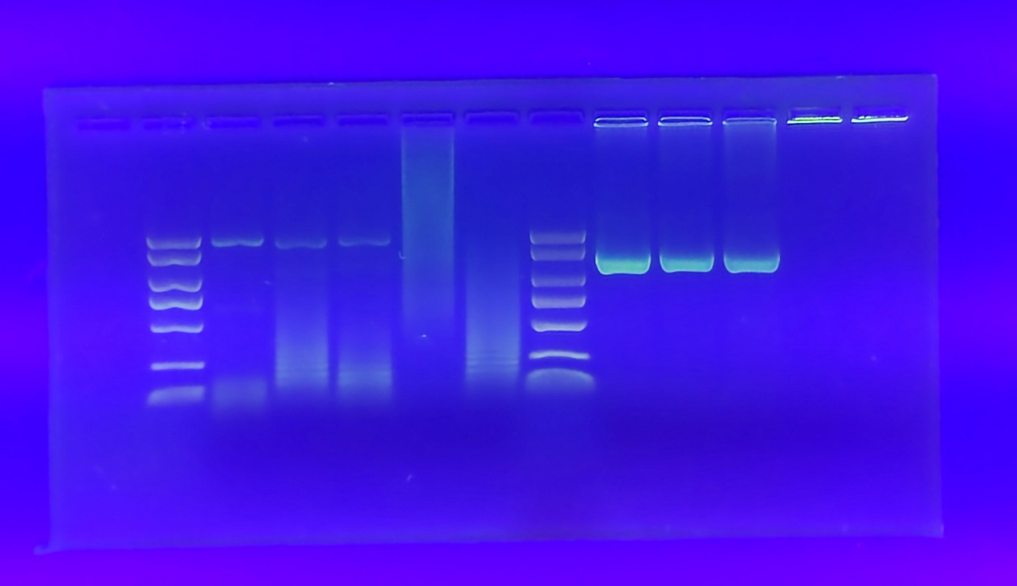
Supplemental Figure 1: Original agarose gel image of PCR detection for phytoplasma

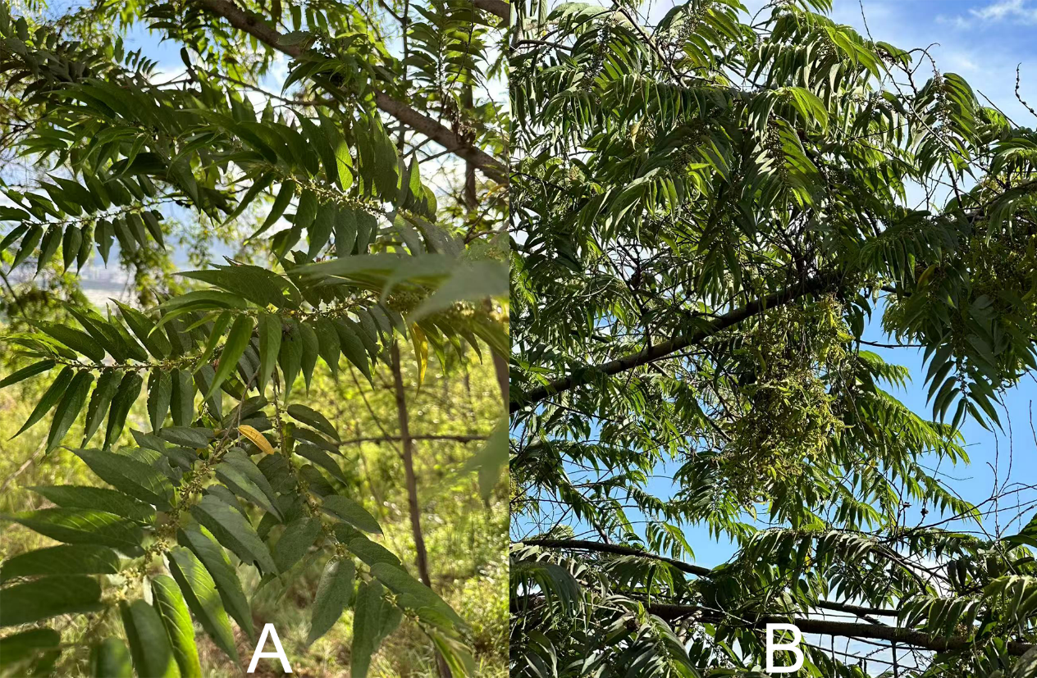
Supplemental Figure 2: Field symptoms of witches' broom disease on Trema levigata
A:Health ；B：witches' broom disease on Trema levigata

