Supplementary Materials

APPENDICES
Appendix 1 : Analysis of Variance of germination percentage, 2023
SOV | D.f. | S.S. | M.S. | F value | F pr.
Genotypes | 4 | 21635.6 | 5408.9 | 21.7321*** | 1.670e-08
PEG concn | 2 | 11591.1 | 5795.6 | 23.2857**** | 7.867e-07
Interaction | 8 | 13564.4 | 1695.6 | 6.8125*** | 4.362e-05
Residuals | 30 | 13564.4 | 0.2998

Appendix 2: Analysis of Variance of germination speed, 2023
SOV | D.f. | S.S. | M.S. | F value | F pr.
Genotypes | 4 | 21635.6 | 0.3040 | 1.01 | 0.431
PEG concn | 2 | 35.947 | 17.9735 | 10.3249*** | 0.0003874
Interaction | 8 | 18.744 | 2.3430 | 1.3460 | 0.2598635
Residuals | 30 | 4.4976 | 0.2998

Appendix 3 : Analysis of Variance of days to first germination, 2023
SOV | D.f. | S.S. | M.S. | F value | F pr.
Genotypes | 4 | 536.00 | 134.000 | 9.4072*** | 4.737e-05
PEG concn | 2 | 408.04 | 204.022 | 14.3229*** | 4.298e-05
Interaction | 8 | 447.73 | 55.967 | 3.9290** | 0.00281
Residuals | 30 | 427.33 | 14.244

Appendix 4 : Analysis of Variance of plant height, 2023
SOV | D.f. | S.S. | M.S. | F value | F pr.
Genotypes | 4 | 45.67 | 11.422 | 3.5282* | 0.01785
PEG concn | 2 | 110.719 | 55.360 | 17.1005 *** | 1.106e-05
Interaction | 8 | 50.500 | 6.312 | 1.9499 . | 0.08876
Residuals | 30 | 97.119 | 3.237

Appendix 5: Analysis of Variance of leaf number, 2023
SOV | D.f. | S.S. | M.S. | F value | F pr.
Genotypes | 4 | 77.340 | 19.3351 | 11.1248*** | 1.183e-05
PEG concn | 2 | 11.568 | 5.7839 | 3.3279 * | 0.04951
Interaction | 8 | 41.433 | 5.1791 | 2.9799 * | 0.01398
Residuals | 30 | 52.141 | 1.7380

Appendix 6: Analysis of Variance of root length, 2023
SOV | D.f. | S.S. | M.S. | F value | F pr.
Genotypes | 4 | 264.229 | 66.057 | 11.8602*** | 6.767e-06
PEG concn | 2 | 2.803 | 1.401 | 0.2516 | 0.77917
Interaction | 8 | 120.354 | 15.044 | 2.7011* | 0.02287
Residuals | 30 | 167.089 | 5.570

Appendix 7 : Analysis of Variance of shoot length, 2023
SOV | D.f. | S.S. | M.S. | F value | F pr.
Genotypes | 4 | 40.159 | 10.0397 | 7.7127 *** | 0.0002126
PEG concn | 2 | 33.431 | 16.7157 | 12.8412 *** | 9.355e-05
Interaction | 8 | 40.722 | 5.0903 | 3.9104** | 0.0028965
Residuals | 30 | 39.052 | 1.3017

Appendix 8 : Analysis of Variance of canopy spread, 2023
SOV | D.f. | S.S. | M.S. | F value | F pr.
Genotypes | 4 | 75.225 | 18.8063 | 3.1980 * | 0.02664
PEG concn | 2 | 30.290 | 15.1449 | 2.5754 . | 0.09286
Interaction | 8 | 94.084 | 11.7605 | 1.9998 . | 0.08107
Residuals | 30 | 176.421 | 5.8807

Appendix 9 : Analysis of Variance of root spread , 2023
SOV | D.f. | S.S. | M.S. | F value | F pr.
Genotypes | 4 | 354.01 | 88.503 | 14.3449 *** | 1.178e-06
PEG concn | 2 | 29.96 | 14.978 | 2.4277 | 0.1053788
Interaction | 8 | 230.42 | 28.803 | 4.6685*** | 0.0008749
Residuals | 30 | 185.09 | 6.170

Appendix 10 : Analysis of Variance of root weight, 2023
SOV | D.f. | S.S. | M.S. | F value | F pr.
Genotypes | 4 | 0.026849 | 0.0067123 | 4.6273** | 0.004978
PEG concn | 2 | 0.000908 | 0.0004542 | 0.3131 | 0.733546
Interaction | 8 | 0.019108 | 0.0023885 | 1.6466 | 0.153373
Residuals | 30 | 0.043518 | 0.0014506

Appendix 11 : Analysis of Variance of shoot weight, 2023
SOV | D.f. | S.S. | M.S. | F value | F pr.
Genotypes | 4 | 0.31383 | 0.078457 | 3.3355* | 0.02253
PEG concn | 2 | 0.00198 | 0.000991 | 0.0421 | 0.95878
Interaction | 8 | 0.47316 | 0.059145 | 2.5144* | 0.03194
Residuals | 30 | 0.70567 | 0.023522

Appendix 12: Analysis of Variance of total biomass, 2023
SOV | D.f. | S.S. | M.S. | F value | F pr.
Genotypes | 4 | 0.47518 | 0.118794 | 4.0210** | 0.009964
PEG concn | 2 | 0.00093 | 0.000465 | 0.0158 | 0.984380
Interaction | 8 | 0.64102 | 0.080127 | 2.7122* | 0.022428
Residuals | 30 | 0.88631 | 0.029544

Appendix 13 : Analysis of Variance of root shoot ratio, 2023
SOV | D.f. | S.S. | M.S. | F value | F pr.
Genotypes | 4 | 15.5346 | 3.8837 | 8.5065*** | 0.0001034
PEG concn | 2 | 1.3548 | 0.6774 | 1.4838 | 0.2429515
Interaction | 8 | 8.2697 | 1.0337 | 2.2642 . | 0.0501799
Residuals | 30 | 13.6965 | 0.4565

Appendix 14 : Analysis of Variance of Vigor Test Index, 2023
SOV | D.f. | S.S. | M.S. | F value | F pr.
Genotypes | 4 | 5404330 | 1351083 | 18.5102*** | 9.247e-08
PEG concn | 2 | 1292544 | 646272 | 8.8541*** | 0.0009504
Interaction | 8 | 3014985 | 376873 | 5.1633*** | 0.0004172
Residuals | 30 | 2189736 | 72991

ACRONYMS AND ABBREVIATIONS
°C  AFU | : Degree Celsius  : Agriculture and Forestry University
ANOVA  cm | : Analysis of Variance  : Centimeter
CRD | : Completely Randomized Design
CV | : Coefficient of Variance
DAS | : Days After Sowing
df | : Degree of Freedom
DMRT | : Duncan’s Multiple Range Test
et al. | : et alii, and others
FAO | : Food and Agricultural Organization
g  G% | : Gram  :Germination percentage
ha  ha⁻¹ | : Hectare  : Per Hectare
i.e. | : That is
LSD  m | : Least Significant Difference  : Meter
mg | : Milligram
MPa | : Megapascal
ns | : Non-Significant
VI  VTI | : Vigor Index  : Vigor Test Index
Wt. | : Weight

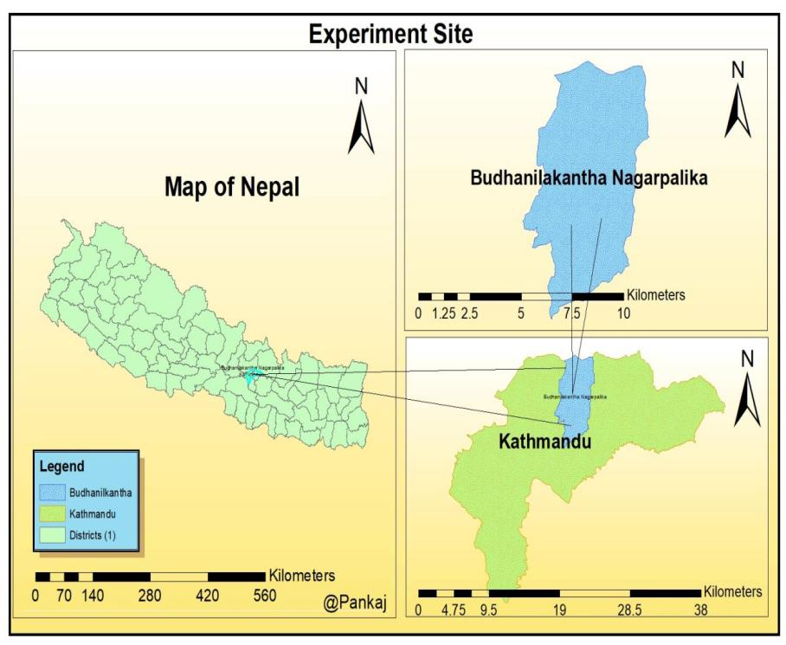
Figure 2: Map of Nepal showing research site
Table 3: Genotypes with their sources
S.N | Genotypes | Source of genotypes
1 | Khumal 2 | Horticultural Development Center, Khumaltar
2 | Monoprecos | Horticultural Development Center, Khumaltar
3 | NGRCO9569 | Gene Bank Khumaltar
4 | NGRCO9571 | Gene Bank Khumaltar
5 | Srijana | Agrovet
Table 4: Treatment combination details
Treatments | Details | Treatments | Details | Treatments | Details
T1 | V1P0 | T6 | V1P1 | T11 | V1P2
T2 | V2P0 | T7 | V2P1 | T12 | V2P2
T3 | V3P0 | T8 | V3P1 | T13 | V3P2
T4 | V4P0 | T9 | V4P1 | T14 | V4P2
T5 | V5P0 | T10 | V5P1 | T15 | V5P2

3.4 Layout of the experiment
Table 5: Layout of the experiment
 | Rep I |  | Rep II |  | Rep III
 | T7 |  | T2 |  | T9
 | T10 |  | T12 |  | T5
 | T1 |  | T5 |  | T10
 | T3 |  | T7 |  | T4
 | T15 |  | T4 |  | T11
 | T5 |  | T1 |  | T12
 | T9 |  | T6 |  | T3
 | T13 |  | T3 |  | T1
 | T11 |  | T8 |  | T7
 | T14 |  | T11 |  | T2
 | T8 |  | T10 |  | T13
 | T4 |  | T15 |  | T15
 | T6 |  | T14 |  | T8
 | T12 |  | T9 |  | T6
 | T2 |  | T13 |  | T14

Table 1: Released and registered tomato varieties, 1960-2021
Name of released varieties | Year of release | Origin | production Potential (MT/ha) | Maturity (Days) | Recommended Domain
Khumal hybrid-3 F1 | 2021 | - | 62.40 | 65 | Terai and Hills
Khumal hybrid-2 F1 | 2021 | - | 74.80 | 66 | Terai and Hills
Red Glory F1 | 2019 | - | 70-80 | 70-8- | Irrigated area of Terai
Red Cover F1 | 2019 | - | 75-85 | 70-80 | Irrigated area of Terai
Eureka, F1 | 2010 | - | 93.7 | 102 | Terai and Hills
NS 53, F1 | 2010 | - | 90-100 | 90-100 | Terai and Hills
NS 2535, F1 | 2010 | - | 140-150 | 75-80 | Terai and Hills
Surakshya, F1 | 2010 | - | 80-90 | 75-80 | Terai and Hills
NS 815, F1 | 2010 | - | 80-90 | 70-80 | Mid Hill and Terai
Amita, F1 | 2010 | - | 96.2 | 95-100 | Mid Hill and Terai
Gaurav 555 | 2010 | - | 106 | 100-105 | Terai
Srijana | 2010 | Nepal | 110 | 70-80 | Mid Hill and Terai
Roma | 1995 | - | 12-15 | 65s-70 | Mid Hill and Terai
Manprekas | 1995 | - | 20-40 | 80-90 | Mid Hill and Terai
NBL-1 | 1990 | - | 20-30 | 65-70 | High and Mid Hill, Terai
Pusa Ruby | 1990 | India | 15.0 | 60 | High and Mid Hill, Terai
Source: (Krishi diary, 2023; ABPSD, 2019)

Table 2: Area, production, and productivity of tomato

 | Year | Area (ha) | Production (t) | Productivity (t/ha)
National | 2023 | 24,389 | 400,774 | 21.00
Kathmandu | 2023 | 175 | 18,050 | 90.57
Kathmandu | 2022 | 190 | 18,050 | 95.0
Kathmandu | 2021 | 211 | 20,453 | 96.9
Kathmandu | 2020 | 212 | 10,259 | 83.9
(MoALD, 2023)

Drought stress affect
Biomass production
Rate of respiration
Gene Expression
Synthesis of secondary metabolites
Cell division
Seed size and seed weight
Rate of seed germination
Development/growth of roots
Leaf area
Gaseous exchange
Photosynthetic pigments and rate of photosynthesis
Maturity

Figure . Effect of drought in plants (modified from Asati et al., 2022)

PCA

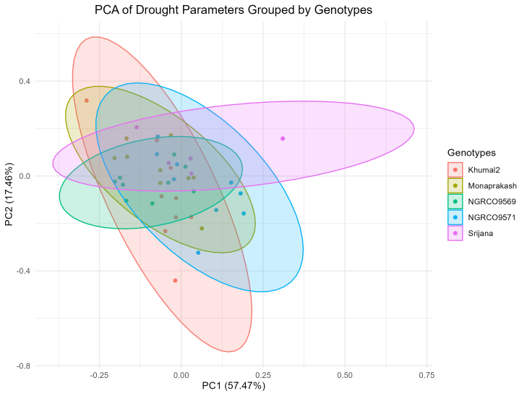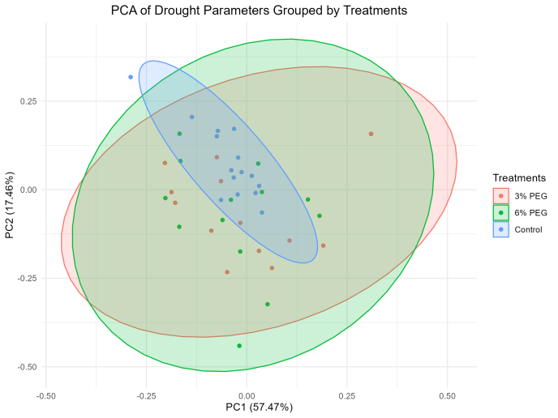
A B
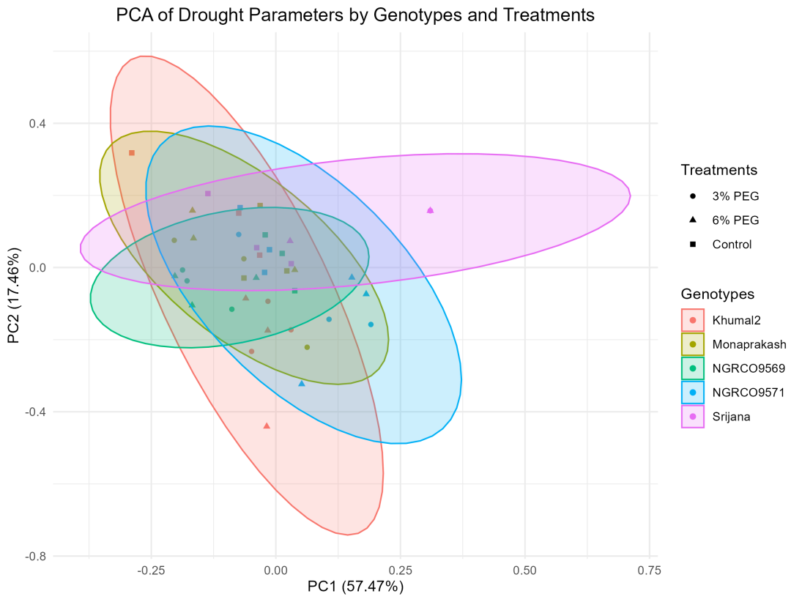
C
Figure 8. A) PCA biplot of drought parameters by genotypes and treatments, B) PCA biplot of drought parameters by treatments, C) PCA biplot of drought parameters by genotypes and treatments

