Fig. S1 Environment factors of Ju’nan in September, including maximum and minimum temperatures, maximum and minimum humidities, the precipitations and weather conditions.
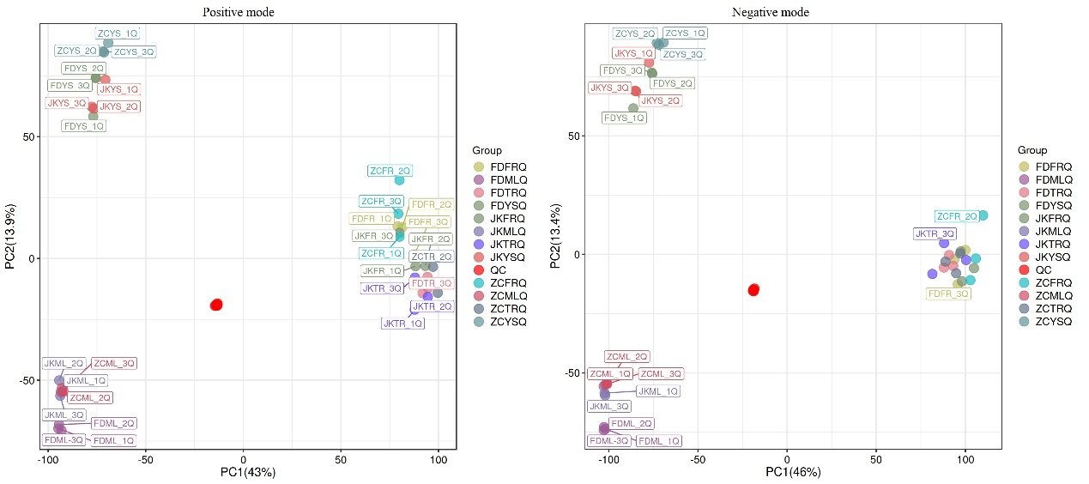Fig. S2 The PCA score plot of metabolic profiling analysis in QC samples in positive and negative ion modes.
Fig. S3 Quantitative RT-PCR validations. A total of 15 genes were selected for qRT-PCR analysis. The CsGAPDH gene was chosen as the reference gene.
Fig. S4 Overview schematic summarizing key findings across cultivars.

