List of Supporting information

Methods S-1 Transcriptome analyses.

Figure S1. Effects of different stress treatments on physiological parameters in wheat.
(A) Proline (Pro) content; (B) Malondialdehyde (MDA) content. Combined heat and drought stress had the most severe impact on wheat plants. According to Tukey’s test (α = 0.05), box plots labeled with the same letter indicate no significant difference.

Figure S2. GO enrichment analysis of downregulated genes in wheat under DS, HS, and HD treatments. (a) Heatmap of upregulated GO terms across three developmental stages. The heatmap illustrates the enrichment patterns of downregulated GO terms across the JS, SPDS, and TS stages under DS, HS, and HD. The color intensity represents the degree of enrichment, with darker shades indicating stronger enrichment. The color scale in white (low, p-value ≥ 10⁻²), pink (medium, 10⁻² < p-value ≤ 10⁻⁶), and red (high, p-value < 10⁻⁶) represents the relative P-value significance which is determined by Fisher’s exact test. (b-d) UpSet plots and GO enrichment analysis at individual developmental stages. The UpSet plots display the intersection of significantly upregulated GO terms among DS, HS, and HD at JS (b), SPDS (c), and TS (d) stages, with the set sizes representing the number of enriched GO categories.

Figure S3. Twelve TaAP2/ERF genes were randomly selected for experimental validation using quantitative RT-PCR. Gene expression patterns in grain were analyzed at 4 h and 8 h after DS, HS, and HD treatments, showing a high degree of consistency with the RNA-seq data.

Figure S4. Expression profiles of TraesCS5A02G215900 in wheat tissues under DS, HS, and HD stress conditions. Quantitative RT-PCR was performed to evaluate the expression levels of TraesCS5A02G215900 in wheat roots, stems, leaves, and grains at 0 h, 4 h, and 8 h after the onset of DS, HS, and HD treatments. Each value represents the mean ± standard error (SE) of three biological replicates. Gene expression was normalized to TaActin, and relative transcript abundance was calculated using the 2^–ΔΔCt method, with the expression at 0 h used as the calibrator. The results revealed tissue-specific and time-dependent induction of TraesCS5A02G215900, with the most prominent upregulation observed in spikes under HD stress at 8 h.

Figure S5. Calculation of copy number and relative expression level of TaEREBP1-L in two transgenic events. (A) The copy number ratio of TaEREBP1-L and lectin gene (Ta. LOC123165130) in Arabidopsis T0 transgenic plants was determined using digital PCR. When the ratio is equal to 0.5, transgenic Arabidopsis plants obtain one insertion copy, and when the ratio is equal to 1, two insertion copies are obtained. (B) The relative expression of TaEREBP1-L in the leaves of T3 homozygous transgenic Arabidopsis was determined by qRT-PCR. The relative level of transcripts was standardized by Actin (NM_001339262). The bar represents the average value of the triplicate. * Significantly different, using Fisher's minimum significant difference test.

Figure S6. Physiological characteristics of wild-type (WT) and transgenic Arabidopsis under abiotic stress conditions. (A) Catalase (CAT) activity, superoxide dismutase (SOD) activity, and malondialdehyde (MDA) content of WT and transgenic lines (OE-50-1 and OE-50-2) under DS, HS, and HD. (B) Water loss rates from detached leaves. Data are presented as means ± standard deviation (n = 3). Asterisks indicate significant differences according to Student’s t-test (***P < 0.001).

Figure S7. Phenotypic and physiological responses of transgenic Arabidopsis to drought, heat, and combined stress. (a) Two-week-old plants grown under standard conditions were subjected to drought, heat (38 ℃), or combined stress for 10 or 7 days, respectively. Morphological and physiological parameters were monitored throughout the treatments. (b) Stress-induced accumulation of ABA, JA, and proline was measured in both OE and WT plants. Data represent mean ± SE (n=5), with asterisks (*P < 0.05, **P < 0.01) denoting statistically significant differences between transgenic and WT lines (Student’s t-test).

Figure S8. Four genes were randomly selected for experimental validation using quantitative RT-PCR. Gene expression patterns in leaves were analyzed at 4 h after DS, HS, and HD treatments.Each bar represents the mean expression level ± standard error (SE), with different colors corresponding to different stress treatments.

Figure S9. TaEREBP1-L directly activates the promoters of ABA/JA biosynthesis genes in Nicotiana benthamiana. (A, B) Dual-luciferase reporter assay in N. benthamiana leaves to assess the transcriptional activation of TaAAO3 and TaAOC2 promoters by TaEREBP1-L. (a-d) Schematic representation of effector and reporter constructs used in the assay. The effector contained either an empty vector or 35S-driven TaEREBP1-L. The reporter consisted of the TaAAO3 (panel A) or TaAOC2 (panel B) promoter fused to the firefly luciferase (LUC) reporter gene. The Ubi3 promoter driving LUC was used as the internal reference. (e) Relative luciferase activity measured in agroinfiltrated N. benthamiana leaves. TaEREBP1-L significantly enhanced the transcriptional activity of both TaAAO3 and TaAOC2 promoters compared to the empty vector control. Values represent means ± SD (n = 6). Statistical significance was determined using Student’s t-test: P < 0.05 (*), P < 0.01 (**).

Methods S-1
Transcriptome analyses
RNA extraction and library preparation
Total RNA was extracted using the TRIzol Reagent (Vazyme, USA). RNA quality was checked by RNase-free agarose gel electrophoresis and then verified using an Agilent 2100 Bio-analyzer (Agilent Technologies, Santa Clara, CA, United States). mRNA was enriched with magnetic beads with Oligo (dT). Fragmentation buffer was then added to cleave the mRNA into small fragments. The first-strand cDNA was synthesized with random hexamers-primed, then the second-strand cDNA was synthesized using dNTPs and DNA polymerase I, and the double-strand cDNA was purified using AMPure XP beads. The purified double-stranded cDNA was then subjected to end repair, A-tailed, and ligated with sequencing adapters, followed by fragment size selection with AMPure XP beads, and finally, PCR enrichment to obtain the final cDNA library. Following agarose gel electrophoresis and extraction of cDNA from gels, the cDNA fragments were purified and enriched by PCR to construct the final RNA-Seq libraries, which were sequenced on the Illumina HiSeq X Ten platform using the paired-end mode. Three biological replicates were performed for each sample, thus a total of 45 RNA-Seq libraries were constructed and sequenced.
Transcriptome analysis
Raw RNA-Seq reads were filtered to remove low-quality sequences (Q20<85%), reads with more than 5% N bases (bases unknown), and reads containing adaptor sequences, using an in-house Perl script. The cleaned reads were mapped to the wheat reference genome of Chinese Spring (http://plants.ensembl.org/Triticum_aestivum/Info/Index) using HISAT2. Uniquely mapped reads were extracted, and gene expression was quantified by featureCounts and the number of fragments mapped to the exons of each gene. The expression of each gene in each sample was normalized to FPKM (expected number of Fragments Per Kilobase of transcript sequence per Millions of base pairs sequenced). At least two of the three biological replicates were considered to have gene expression detected in the samples (FPKM > 0). Differentially expressed genes were identified using DESeq2 and P-value corrected using false discovery rate (FDR) for multiple assays. In our study, genes with FDR<0.05 and fold change>2 were set as differentially expressed genes (DEGs). Gene ontology (GO) terms and KEGG pathways enriched in the DEGs were identified using the same methods described in Method S-2. GO terms and KEGG pathways with corrected P-value < 0.05 were considered significantly enriched in the differential expressed genes.

Bioinformatic analysis
Cluster analysis
Cluster 3.0 (http://bonsai.hgc.jp/~mdehoon/software/cluster/software.htm) and Java Treeview software (http://jtreeview.sourceforge.net) were used to perform hierarchical clustering analysis. Euclidean distance algorithm for similarity measure and average linkage clustering algorithm (clustering uses the centroids of the observations) for clustering were selected when performing hierarchical clustering. A heat map was often presented as a visual aid in addition to the dendrogram.
GO annotation
The gene sequences of the selected differentially expressed genes were locally searched using the NCBI BLAST+ client software (NCBI-blast-2.2.28) and InterProScan to find homologous sequences, then gene ontology (GO) terms were mapped and sequences were annotated using the software program Blast2GO. The GO annotation results were plotted by R scripts.
KEGG annotation
Following annotation steps, the studied genes were blasted against the online Kyoto Encyclopedia of Genes and Genomes (KEGG) database (http://geneontology.org/) to retrieve their KEGG orthology identifications and were subsequently mapped to pathways in KEGG.
Enrichment analysis
Enrichment analyses were applied based on Fisher’ exact test, considering the whole quantified genes as a background dataset. Benjamini- Hochberg correction for multiple testing was further applied to adjust derived p-values. And only functional categories and pathways with p-values under a threshold of 0.05 were considered significant.
PCA
After normalized to total peak intensity, the processed data were uploaded before importing into SIMCA-P (version 14.1, Umetrics, Umea, Sweden), where it was subjected to multivariate data analysis, including Pareto-scaled principal component analysis (PCA).

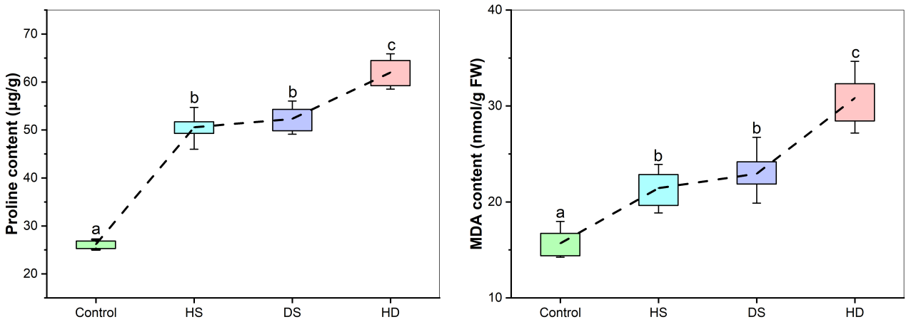
B
A
Figure S1. Effects of different stress treatments on physiological parameters in wheat.
(A) Proline (Pro) content; (B) Malondialdehyde (MDA) content. Combined heat and drought stress had the most severe impact on wheat plants. According to Tukey’s test (α = 0.05), box plots labeled with the same letter indicate no significant difference.

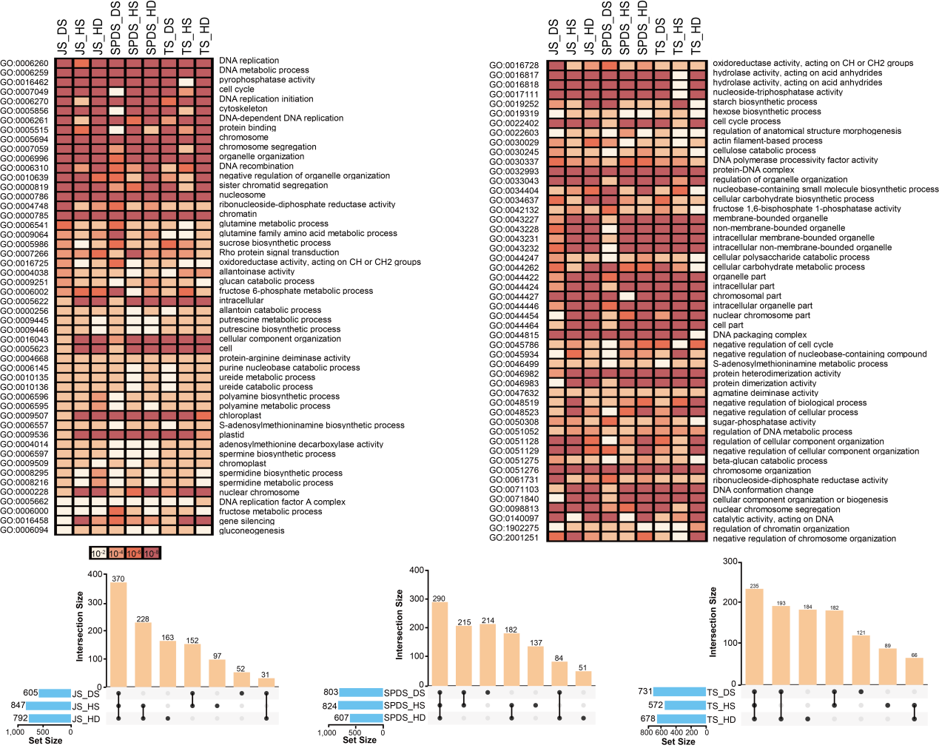
B
A
Figure S2. GO enrichment analysis of downregulated genes in wheat under DS, HS, and HD treatments. (A) Heatmap of upregulated GO terms across three developmental stages. The heatmap illustrates the enrichment patterns of downregulated GO terms across the JS, SPDS, and TS stages under DS, HS, and HD. The color intensity represents the degree of enrichment, with darker shades indicating stronger enrichment. The color scale in white (low, p-value ≥ 10⁻²), pink (medium, 10⁻² < p-value ≤ 10⁻⁶), and red (high, p-value < 10⁻⁶) represents the relative P-value significance which is determined by Fisher’s exact test. (B) UpSet plots and GO enrichment analysis at individual developmental stages. The UpSet plots display the intersection of significantly upregulated GO terms among DS, HS, and HD at JS (b), SPDS (c), and TS (d) stages, with the set sizes representing the number of enriched GO categories.
Note:By integrating the downregulated gene analysis with previously observed upregulation trends, several key adaptive strategies emerge. Energy reallocation is evident, as upregulated genes were predominantly involved in ATP-dependent transmembrane transport, whereas downregulated genes were associated with sugar metabolism and oxidative phosphorylation, suggesting a shift from energy production to energy conservation and redistribution. Growth suppression for stress adaptation was also observed, with significant downregulation of DNA replication, cell cycle progression, and cytoskeletal organization, indicating that cellular growth processes are actively suppressed to prioritize stress-responsive pathways. Additionally, metabolic trade-offs were apparent, as pathways related to polyamine biosynthesis, carbohydrate metabolism, and amino acid metabolism were repressed, while transporter activity, osmotic regulation, and antioxidant mechanisms were enhanced, suggesting a functional shift favoring stress defense over biomass accumulation.

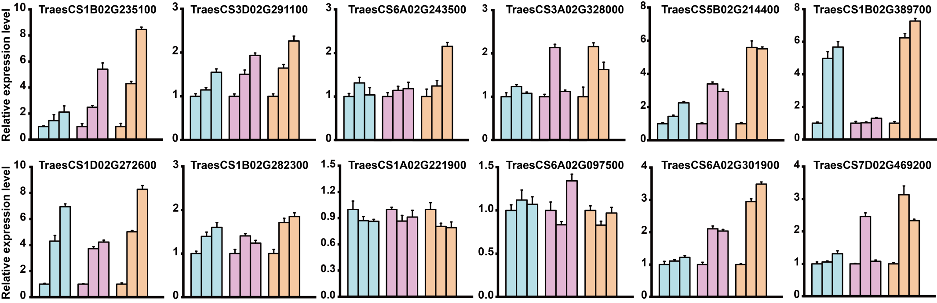
Figure S3. Twelve TaAP2/ERF genes were randomly selected for experimental validation using quantitative RT-PCR. Gene expression patterns in grain were analyzed at 4 h and 8 h after DS, HS, and HD treatments, showing a high degree of consistency with the RNA-seq data.

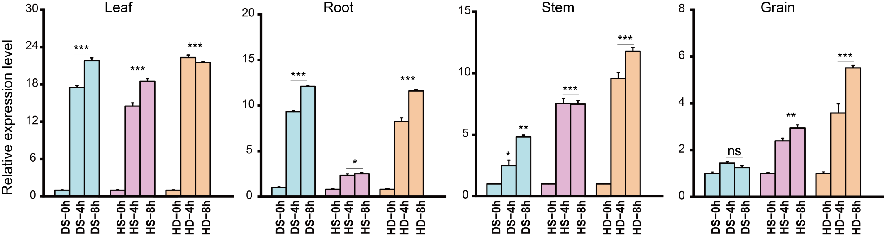

Figure S4. Expression profiles of TraesCS5A02G215900 in wheat tissues under DS, HS, and HD stress conditions. Quantitative RT-PCR was performed to evaluate the expression levels of TraesCS5A02G215900 in wheat roots, stems, leaves, and grains at 0 h, 4 h, and 8 h after the onset of DS, HS, and HD treatments. Each value represents the mean ± standard error (SE) of three biological replicates. Gene expression was normalized to TaActin, and relative transcript abundance was calculated using the 2^–ΔΔCt method, with the expression at 0 h used as the calibrator. The results revealed tissue-specific and time-dependent induction of TraesCS5A02G215900, with the most prominent upregulation observed in spikes under HD stress at 8 h.
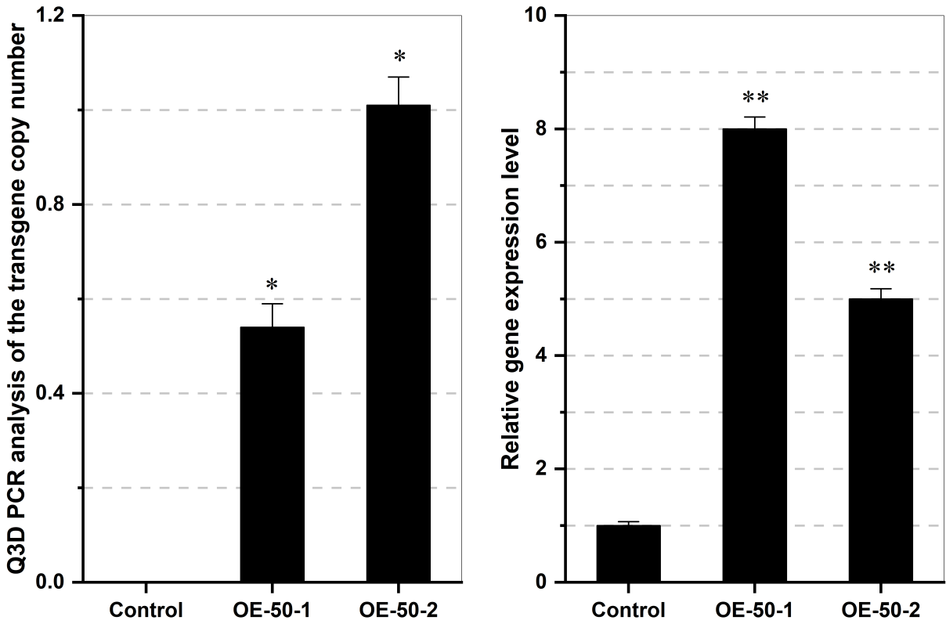
B
A
Figure S5. Calculation of copy number and relative expression level of TaEREBP1-L in two transgenic events. (A) The copy number ratio of TaEREBP1-L and lectin gene (Ta. LOC123165130) in Arabidopsis T0 transgenic plants was determined using digital PCR. When the ratio is equal to 0.5, transgenic Arabidopsis plants obtain one insertion copy, and when the ratio is equal to 1, two insertion copies are obtained. (B) The relative expression of TaEREBP1-L in the leaves of T3 homozygous transgenic Arabidopsis was determined by qRT-PCR. The relative level of transcripts was standardized by Actin (NM_001339262). The bar represents the average value of the triplicate. * Significantly different, using Fisher's minimum significant difference test.

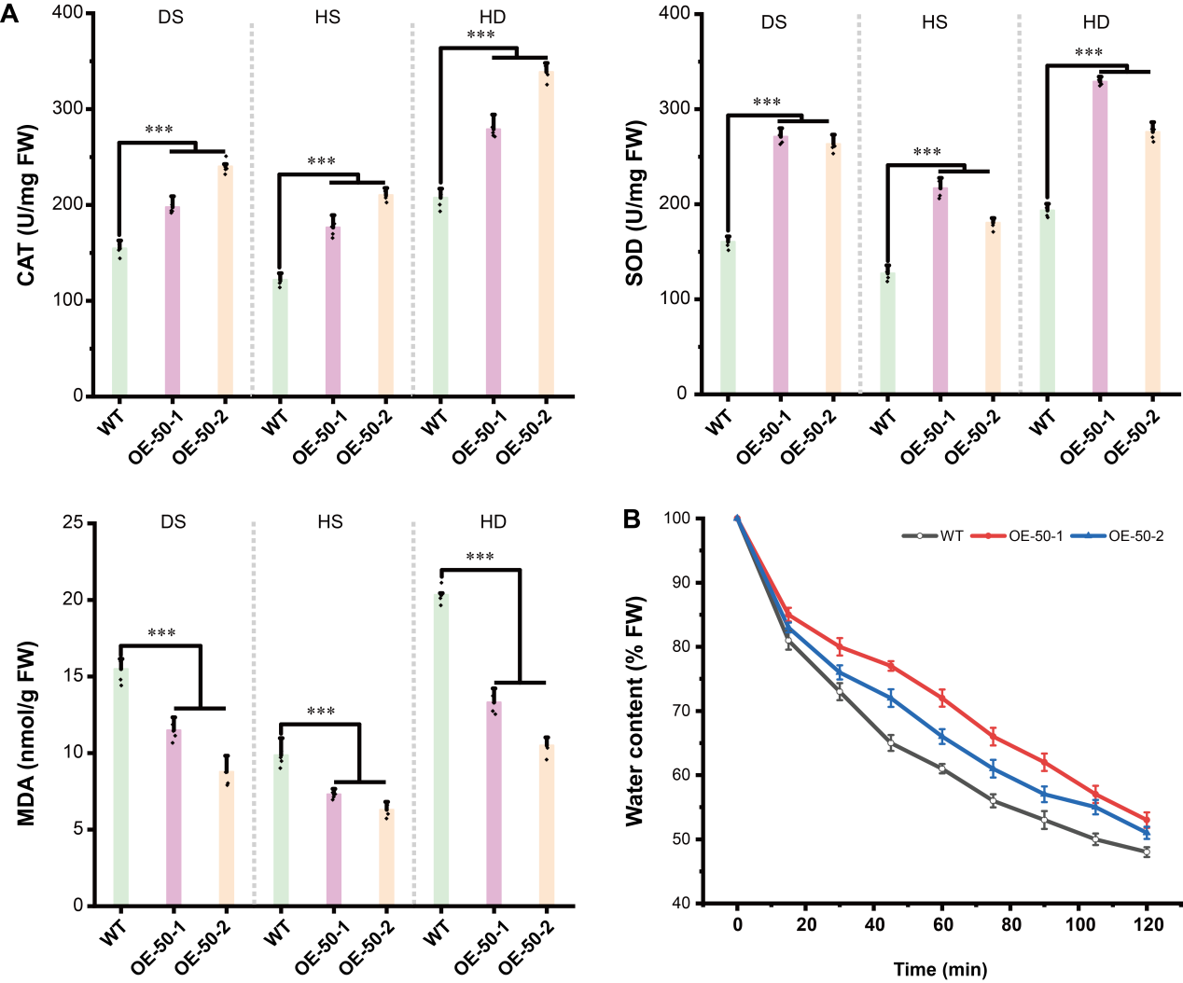
Figure S6. Physiological characteristics of wild-type (WT) and transgenic Arabidopsis under abiotic stress conditions. (A) Catalase (CAT) activity, superoxide dismutase (SOD) activity, and malondialdehyde (MDA) content of WT and transgenic lines (OE-50-1 and OE-50-2) under DS, HS, and HD. (B) Water loss rates from detached leaves. Data are presented as means ± standard deviation (n = 3). Asterisks indicate significant differences according to Student’s t-test (***P < 0.001)

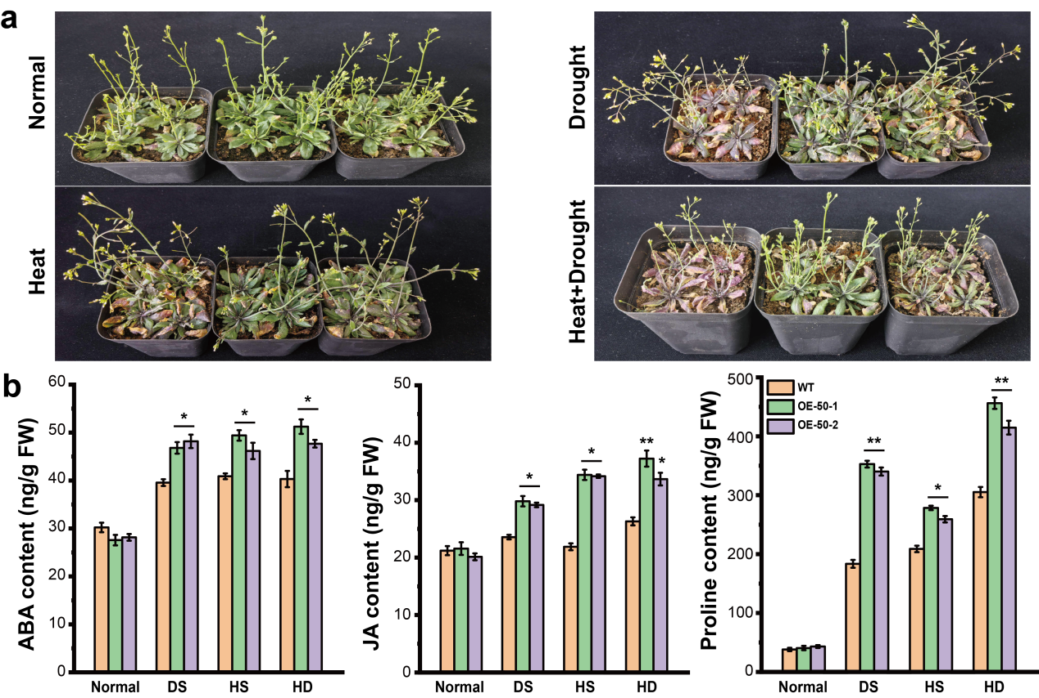
Figure S7. Phenotypic and physiological responses of transgenic Arabidopsis to drought, heat, and combined stress. (a) Two-week-old plants grown under standard conditions were subjected to drought, heat (38 ℃), or combined stress for 10 or 7 days, respectively. Morphological and physiological parameters were monitored throughout the treatments. (b) Stress-induced accumulation of ABA, JA, and proline was measured in both OE and WT plants. Data represent mean ± SE (n=5), with asterisks (*P < 0.05, **P < 0.01) denoting statistically significant differences between transgenic and WT lines (Student’s t-test).

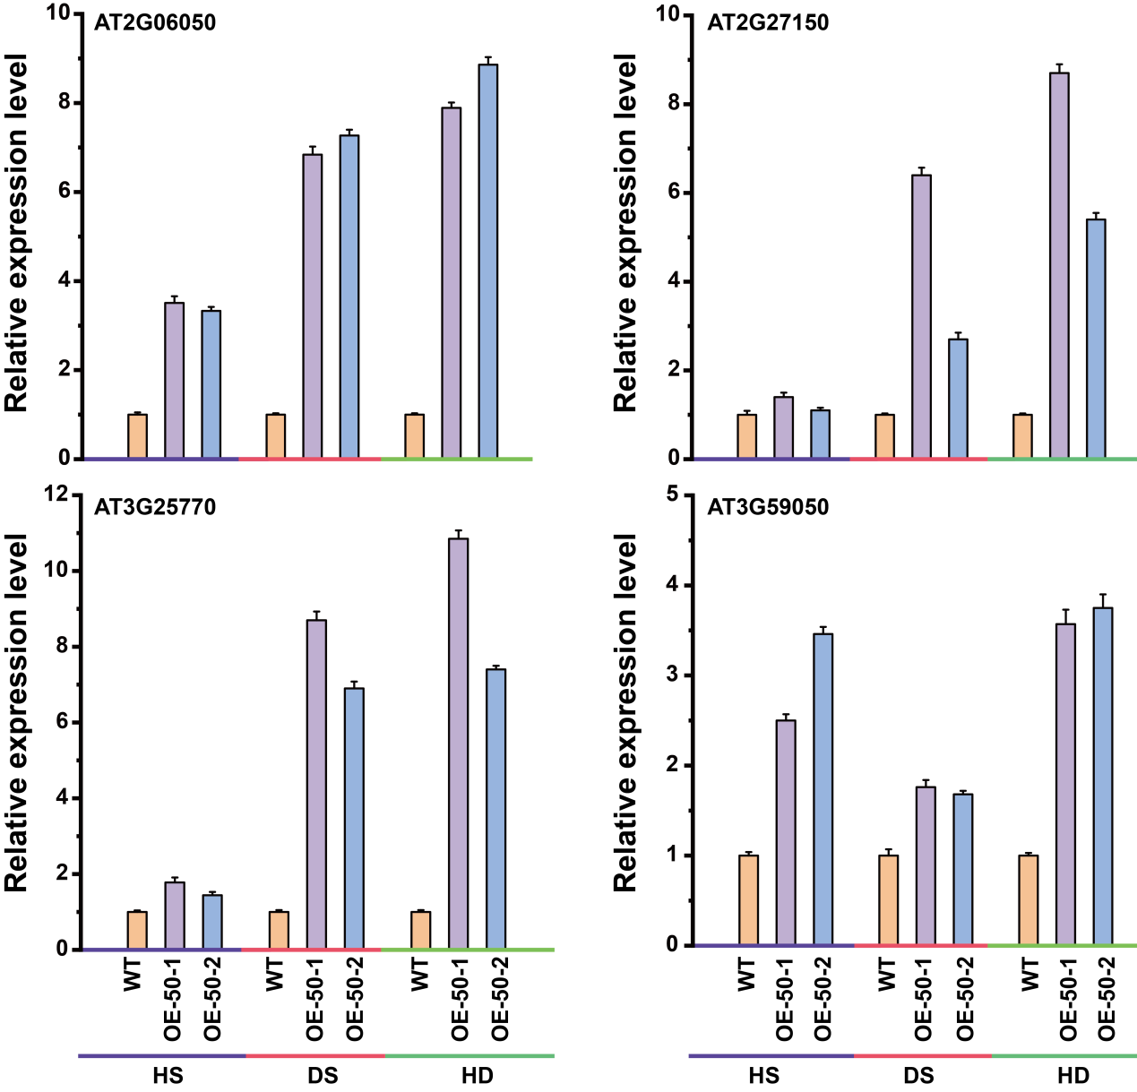
Figure S8. Four genes were randomly selected for experimental validation using quantitative RT-PCR. Gene expression patterns in leaves were analyzed at 4 h after DS, HS, and HD treatments.Each bar represents the mean expression level ± standard error (SE), with different colors corresponding to different stress treatments.
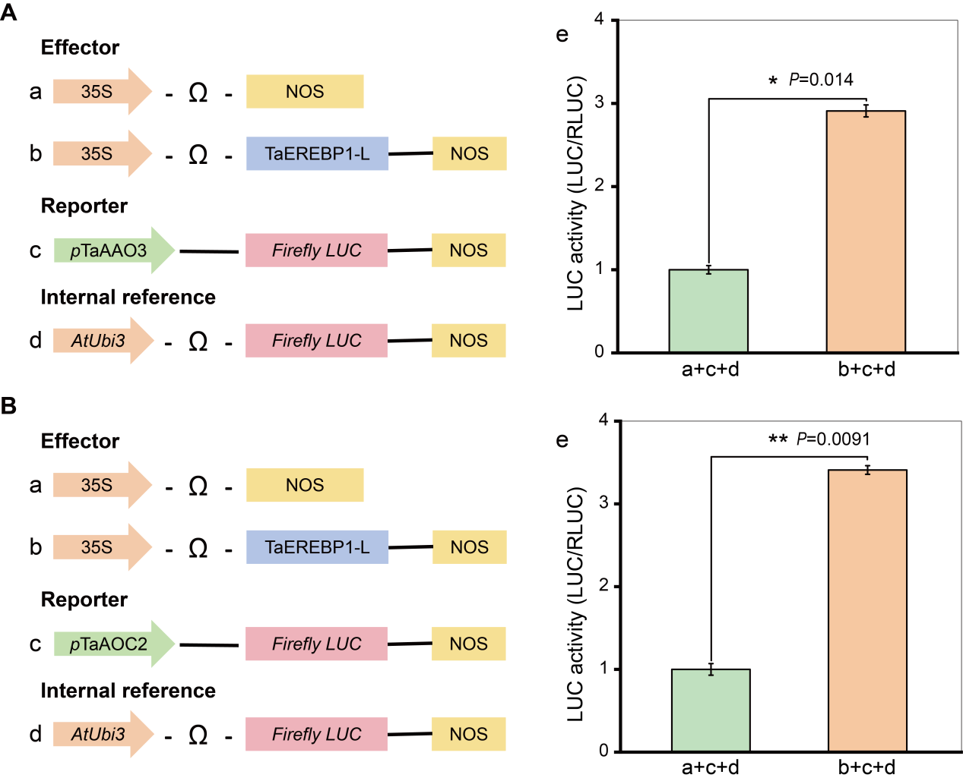
Figure S9. TaEREBP1-L directly activates the promoters of ABA/JA biosynthesis genes in Nicotiana benthamiana. (A, B) Dual-luciferase reporter assay in N. benthamiana leaves to assess the transcriptional activation of TaAAO3 and TaAOC2 promoters by TaEREBP1-L. (a-d) Schematic representation of effector and reporter constructs used in the assay. The effector contained either an empty vector or 35S-driven TaEREBP1-L. The reporter consisted of the TaAAO3 (panel A) or TaAOC2 (panel B) promoter fused to the firefly luciferase (LUC) reporter gene. The Ubi3 promoter driving LUC was used as the internal reference. (e) Relative luciferase activity measured in agroinfiltrated N. benthamiana leaves. TaEREBP1-L significantly enhanced the transcriptional activity of both TaAAO3 and TaAOC2 promoters compared to the empty vector control. Values represent means ± SD (n = 6). Statistical significance was determined using Student’s t-test: P < 0.05 (*), P < 0.01 (**).

