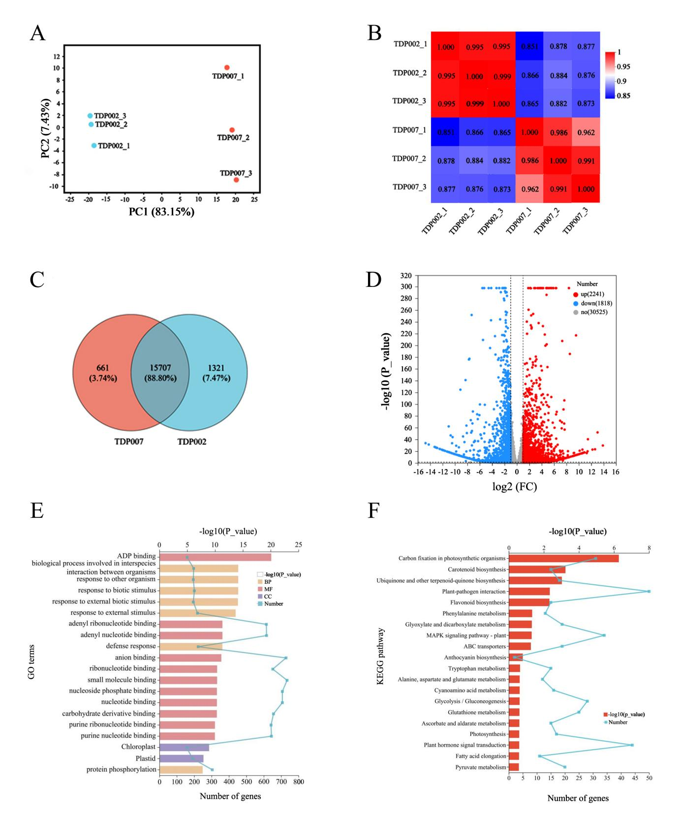
Supplementary figure 1. Multivariate statistical analysis of transcriptome data in millet leaf sheaths. (A) PCA score plot. (B) Heat map of inter-sample correlation. (C) Venn diagram showing the overlapping and unique genes in purple and green millet leaf sheaths. (D) Volcano map of DEGs. Red color represents the up-regulated DEGs; blue color represents the down-regulated DEGs; gray represents genes with no significant differential expression. (E) Statistical bar chart and line graph of the top 20 GO terms significantly enriched by DEGs. The vertical axis represents the GO terms; the horizontal axis represents the number of DEGs enriched in each GO terms; orange represents the BP component; pink represents the MF component; blue represents the CC component. (F) Statistical bar chart and line graph of the top 20 KEGG pathways significantly enriched by DEGs. The vertical axis represents the KEGG pathways; the horizontal axis represents the number of DEGs enriched in each KEGG pathways.

