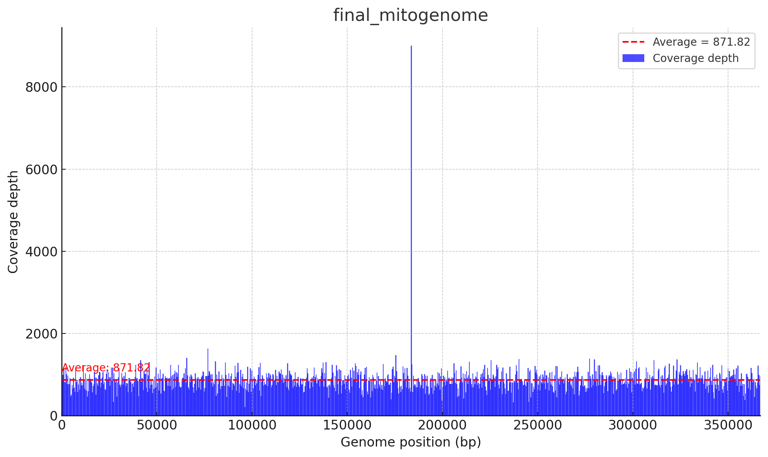

Supplementary Fig. S1: Coverage depth across genome positions (0–366,925 bp) for the final mitochondrial genome. Blue bars show coverage depth, with a red dashed line marking the average depth (871.82).

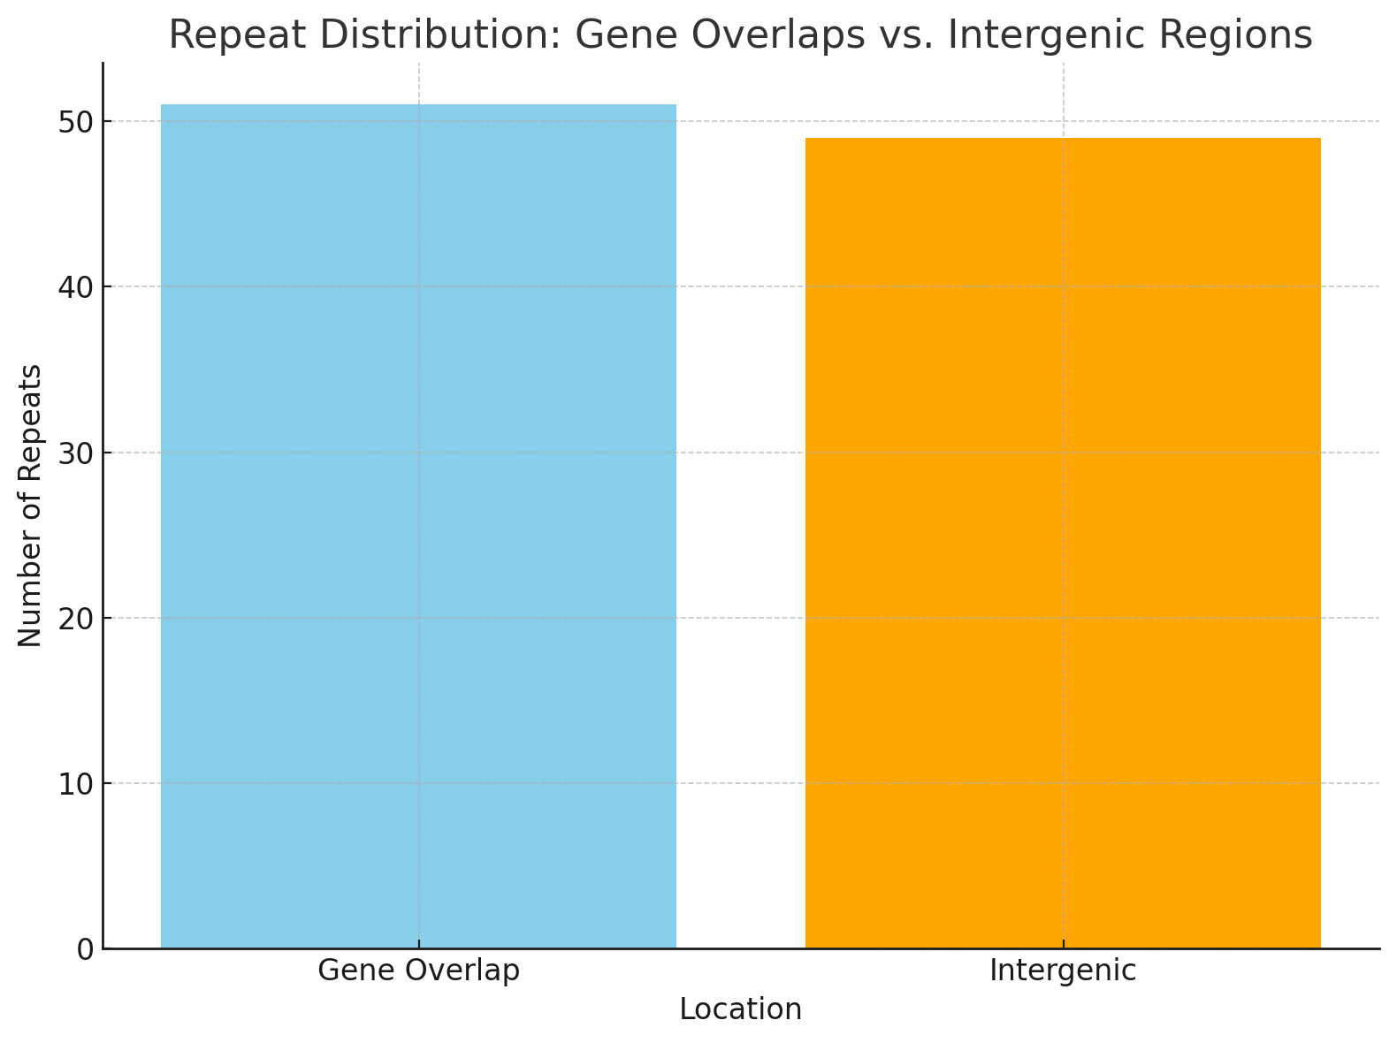
Supplementary Fig. S2: Repeat content analysis in the P. tetragonolobus mitochondrial genome. The diagram illustrates the distribution and classification of repeats, including forward, palindromic, and tandem repeats. Repeat types are categorized based on their length and genomic location, highlighting conserved patterns and unique features within the mitochondrial genome.

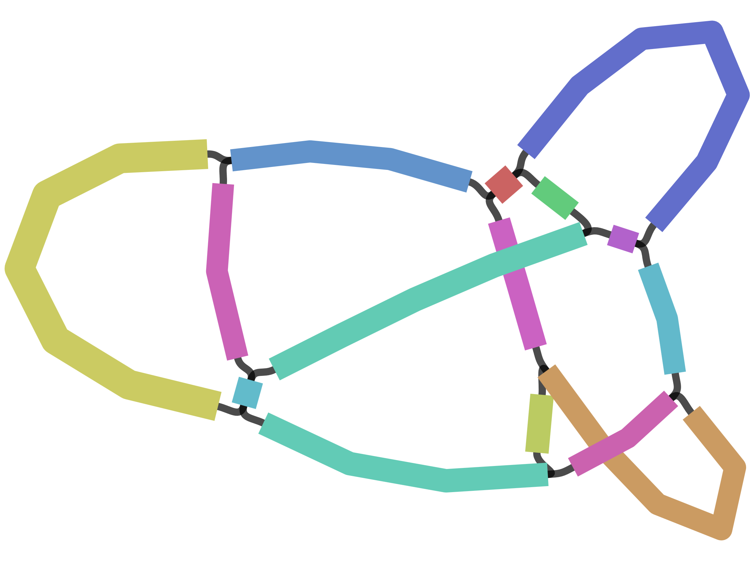
Supplementary Fig. S3: Bandage visualization of the Psophocarpus tetragonolobus mitochondrial genome assembly. The assembly graph, based on PacBio HiFi reads, displays branching nodes and circular paths suggestive of repeat-mediated recombination. These features indicate the presence of alternative conformations, including subgenomic molecules and inversion variants, characteristic of dynamic, multipartite plant mitogenomes. Such structural flexibility may enhance genomic plasticity and stress adaptation.

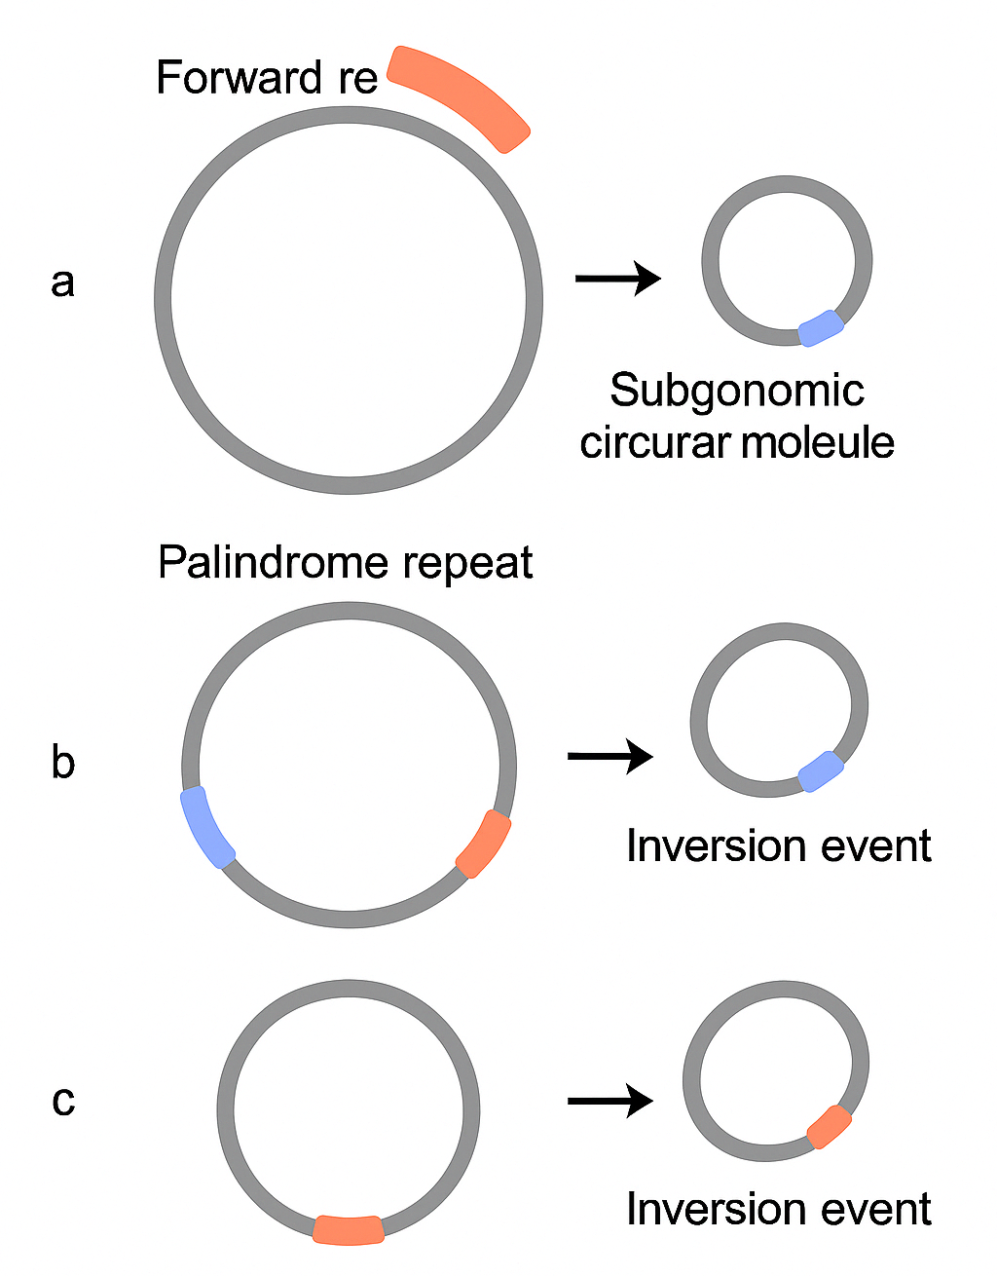
Supplementary Fig. S4: Hypothetical recombination-mediated conformational changes in the mitochondrial genome of Psophocarpus tetragonolobus. This figure illustrates three possible structural rearrangements facilitated by large repeat sequences. (a) Recombination between direct (forward) repeats may result in the excision of a subgenomic circular molecule. (b) Recombination between palindromic repeats located in opposite orientations can lead to an inversion event within the circular genome. (c) An alternative configuration showing inversion between distant palindromic repeats. These models highlight the potential for dynamic and multipartite mitochondrial conformations, driven by repeat-mediated homologous recombination — a common feature in many plant mitogenomes.

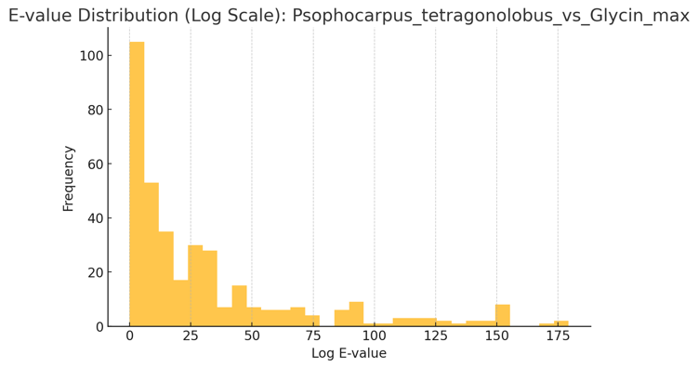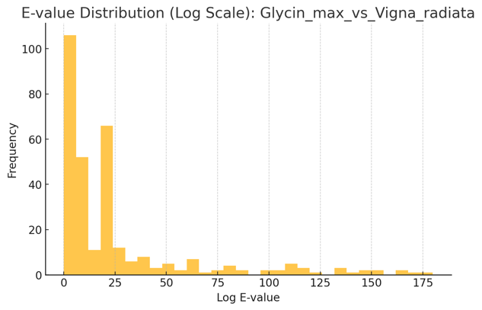

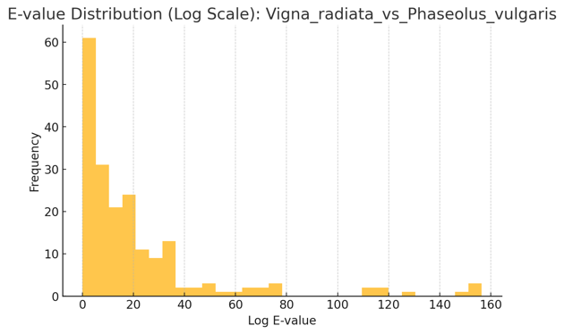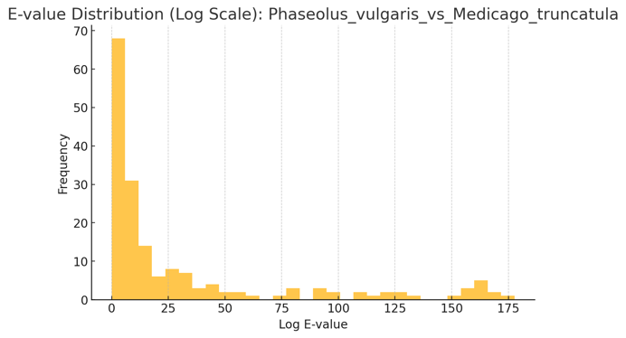
Supplementary Fig. S5: Distribution of E value (log scale) for each pairwise BLAST performed for synteny analysis

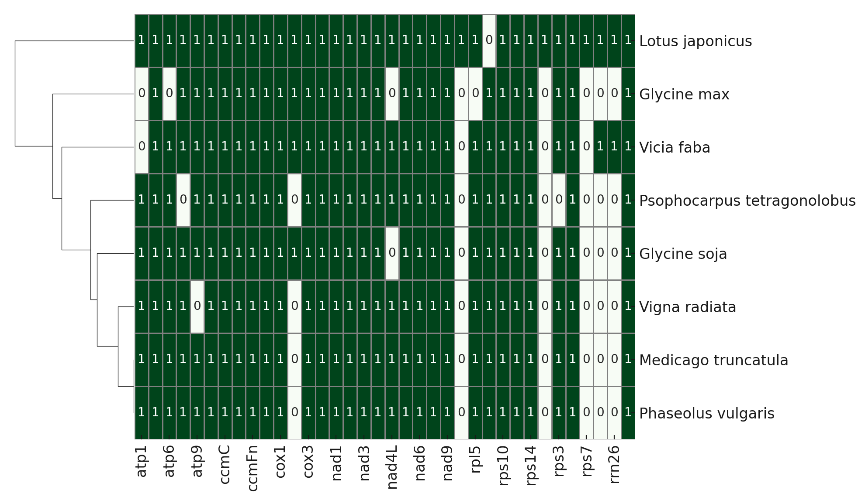
Supplementary Fig. S6: Heatmap showing presence (green) and absence (white) of core mitochondrial genes across eight legume species. Hierarchical clustering reflects similarity in gene content, with P. tetragonolobus grouping closely with G. max and V. radiata.

