S1 Appendix: Detailed Methodology for the Evaluation of Elite CIP-Bred Sweetpotato Genotypes.
Stage 1: Seed Treatment and Germination
The International Potato Center (CIP) in Lima, Peru, provided seeds from nine different sweet potato families, which were then transported to Bangladesh Agricultural University's (BAU) Department of Genetics and Plant Breeding. The seeds were treated with sulfuric acid to disrupt dormancy before being put in a plant culture environment to germinate. Following germination, the seedlings were kept in a net house until they were ready to be transplanted into soil.

Stage 2: Preliminary Screening
The seedlings were moved to the Department of Genetics and Plant Breeding's field lab at BAU once they germinated. Nine rows were planted with 100 seedlings from the nine families. Following this first assessment, 60 genotypes from each family with greater efficiency were chosen for additional screening, yielding 540 genotypes in total.

Stage 3: Multi-Location Evaluation and Selection
The 540 genotypes that were chosen were assessed in two different places: a farmer's field 60 kilometers away and the field laboratory at BAU. A partially replicated design was used for a total of four trials in both locations. Performance determined which 30 genotypes advanced to the next phase.
Stage 4: Final Evaluation of Elite Genotypes
In the last phase, three common check varieties (BARI Sweetpotato-15, BARI Sweetpotato-17, and BAU Sweetpotato-5) were assessed in addition to seven elite genotypes among the 30 chosen. This assessment comprised six trials carried out across two seasons (early and late winter) at three different locations: the BAU campus, farmers' fields, and the char area along the Brahmaputra riverbed. Two or three replications were used in the randomized complete block design (RCBD) trials.

Table S1 Climatic condition in the riverbank (Char Land) during the experimental period
(Source: Bangladesh Meteorological Department; research reports from BAU and published articles)

Months | Max | Min | Mean | Max | Min | Avg | Avg
Months | Temp | Temp | Temp | Humidity | Humidity | Humidity | Rainfall
Months | (°C) | (°C) | (°C) | (%) | (%) | (%) | (mm)
Sep-24 | 33.3 | 26.8 | 30.6 | 81.1 | 66.6 | 80.5 | 114.6
Oct-24 | 32.2 | 24.6 | 29.1 | 76.8 | 49.3 | 76.8 | 74
Nov-24 | 29.9 | 20.9 | 26.2 | 66.6 | 46.5 | 66.6 | 17.3
Here, Max= Maximum, Min= Minimum, Temp= Temperature, Avg= Average, Sep-24= September 2024, Oct-24= October 2024, Nov-24= November 2024

Table S2 Randomized Complete Block Design (RCBD) every plot size 2.5m*2m, each block containing 20 genotypes

Block1 |  | Block2 |  | Block3
G-47 | G-353 | BARI-15 | G-54 | BARI -17 | G-193
G-54 | G-416 | BAU -5 | G-47 | G-275 | G-54
G-89 | BAU -5 | G-89 | G-193 | BARI-15 | G-276
G-138 | BARI -15 | G-287 | G-138 | BAU-5 | Amtoli-1
G-184 | BARI -17 | G-275 | Amtoli-2 | G-353 | Amtoli-2
G-193 | BARI -18 | G-276 | Amtoli-2 | G-287 | Amtoli-3
G-275 | Amtoli-1 | G-353 | Amtoli-3 | G-47 | Japan
G-276 | Amtoli-2 | Japan | BARI-17 | G-138 | G-89
G-287 | Amtoli-3 | G-416 | BARI-18 | G-310 | G-184
G-310 | Japan | G-310 | G-184 | G-416 | BARI-18

Table S3 Trait-Wise Mean Performance of 20 Diverse Sweet Potato Genotypes Under Field Conditions
G | CL | NV | VL | LV | LA | LL | LW | SM | NTR | TRM | NER | ERM | Glu | Flu | Sru | SC | LVP | VPD | ETR | Y
G1 | 52.5 | 7.0 | 2.9 | 15.0 | 182.0 | 33.8 | 22.9 | 18.5 | 101.7 | 6.7 | 62.7 | 6.0 | 6.2 | 5.3 | 5.7 | 0.6 | 3.2 | 1.0 | 89.3 | 13.4
G2 | 64.6 | 8.5 | 2.9 | 25.0 | 308.4 | 24.7 | 22.7 | 13.8 | 117.3 | 13.6 | 97.7 | 11.7 | 3.3 | 3.7 | 3.2 | 0.7 | 3.6 | 1.2 | 97.5 | 27.1
G3 | 49.9 | 5.3 | 3.2 | 17.7 | 130.3 | 27.0 | 26.6 | 13.6 | 98.0 | 5.0 | 48.7 | 3.3 | 6.4 | 5.6 | 5.8 | 0.7 | 3.8 | 1.4 | 159.1 | 10.1
G4 | 41.5 | 6.3 | 2.8 | 16.3 | 312.3 | 25.3 | 26.5 | 22.2 | 102.3 | 5.4 | 58.7 | 4.5 | 5.2 | 3.9 | 4.9 | 0.7 | 3.4 | 1.1 | 61.8 | 10.9
G5 | 45.8 | 6.0 | 2.5 | 20.7 | 152.7 | 38.1 | 34.8 | 17.9 | 80.3 | 3.1 | 39.3 | 2.4 | 4.4 | 4.5 | 3.5 | 0.7 | 3.5 | 1.1 | 100.2 | 6.3
G6 | 47.7 | 5.3 | 3.2 | 18.0 | 261.2 | 37.6 | 37.6 | 21.0 | 140.3 | 8.1 | 74.7 | 6.8 | 6.6 | 6.6 | 8.2 | 0.5 | 3.6 | 1.3 | 141.6 | 16.2
G7 | 60.8 | 5.0 | 2.1 | 15.7 | 113.4 | 24.6 | 21.9 | 8.8 | 76.0 | 7.3 | 57.3 | 6.5 | 3.0 | 4.5 | 7.3 | 0.4 | 3.8 | 1.5 | 195.9 | 14.6
G8 | 64.7 | 7.0 | 2.8 | 17.3 | 527.9 | 45.2 | 37.5 | 31.2 | 135.7 | 22.4 | 115.7 | 18.9 | 4.4 | 4.1 | 3.1 | 0.4 | 3.7 | 1.5 | 180.7 | 44.8
G9 | 48.1 | 6.3 | 2.8 | 19.7 | 132.1 | 28.6 | 27.0 | 16.7 | 74.7 | 4.1 | 40.3 | 3.2 | 7.9 | 5.3 | 5.6 | 0.4 | 3.9 | 1.5 | 225.7 | 8.3
G10 | 52.0 | 6.0 | 2.5 | 18.0 | 142.5 | 30.0 | 28.3 | 9.0 | 32.0 | 1.4 | 17.7 | 1.2 | 6.4 | 4.3 | 2.9 | 0.6 | 3.6 | 1.3 | 93.6 | 2.9
G11 | 56.1 | 7.0 | 3.1 | 16.0 | 217.8 | 31.5 | 31.3 | 22.4 | 115.7 | 5.7 | 63.0 | 4.8 | 2.9 | 4.5 | 3.2 | 0.6 | 3.6 | 1.3 | 183.8 | 11.4
G12 | 45.5 | 6.0 | 2.1 | 15.0 | 224.6 | 24.6 | 21.8 | 17.5 | 86.0 | 5.7 | 48.3 | 4.9 | 5.6 | 5.4 | 5.7 | 0.5 | 3.6 | 1.3 | 176.5 | 11.3
G13 | 56.2 | 6.7 | 2.8 | 16.3 | 192.2 | 31.3 | 31.9 | 17.3 | 125.3 | 7.1 | 62.7 | 5.9 | 3.5 | 5.3 | 3.7 | 0.7 | 3.5 | 1.2 | 175.8 | 14.2
G14 | 50.3 | 7.0 | 2.6 | 20.3 | 292.9 | 38.4 | 27.8 | 19.9 | 111.0 | 6.2 | 61.7 | 5.4 | 3.3 | 5.0 | 4.7 | 0.5 | 3.8 | 1.5 | 206.2 | 12.3
G15 | 50.8 | 6.3 | 3.2 | 18.7 | 171.8 | 24.7 | 22.7 | 23.7 | 195.7 | 7.9 | 82.0 | 6.0 | 4.9 | 5.6 | 5.2 | 0.6 | 3.8 | 1.4 | 189.7 | 15.9
G16 | 54.5 | 6.0 | 3.3 | 25.3 | 291.6 | 28.6 | 27.0 | 21.5 | 54.0 | 2.0 | 22.0 | 1.5 | 4.1 | 5.6 | 5.1 | 0.4 | 3.6 | 1.3 | 157.0 | 4.0
G17 | 52.9 | 7.3 | 4.5 | 22.0 | 390.1 | 26.8 | 25.4 | 16.1 | 70.7 | 2.2 | 20.3 | 1.1 | 2.2 | 2.3 | 2.9 | 0.4 | 3.9 | 1.6 | 161.8 | 4.5
G18 | 50.0 | 6.3 | 3.0 | 20.0 | 232.2 | 24.3 | 22.8 | 32.8 | 63.3 | 1.2 | 13.3 | 0.6 | 3.0 | 4.2 | 3.6 | 0.5 | 3.8 | 1.5 | 135.0 | 2.5
G19 | 54.7 | 6.7 | 3.2 | 18.3 | 377.4 | 26.6 | 25.7 | 18.6 | 122.7 | 8.7 | 72.3 | 7.7 | 6.7 | 5.3 | 4.7 | 0.5 | 3.7 | 1.4 | 159.5 | 17.3
G20 | 51.1 | 7.3 | 3.3 | 18.7 | 341.9 | 33.3 | 31.2 | 15.1 | 29.0 | 0.9 | 11.0 | 0.5 | 2.5 | 2.2 | 2.2 | 0.6 | 3.5 | 1.2 | 131.3 | 2.0
CV | 12 | 14.9 | 17.6 | 17.3 | 42.3 | 19.6 | 18.3 | 35.3 | 45.9 | 79.5 | 56.8 | 84.6 | 55.4 | 36.1 | 43.4 | 43 | 9.8 | 20.6 | 46.5 | 79.5
LSD (5%) | 4.17 | 42.76 | 2.44 | 25.05 | 14.23 | 2.07 | 2.58 | 2.56 | 0.42 | 0.41 | 0.44 | 7.3 | 1.06 | 0.28 | 2.9 | 24.1 | 2.45 | 2.48 | 5.57 | 4.87
p value | <0.01 | <0.01 | <0.01 | <0.01 | 0.68 | <0.01 | 0.14 | <0.01 | 0.91 | 0.88 | 0.31 | 0.24 | <0.01 | <0.01 | <0.01 | <0.01 | <0.01 | <0.01 | <0.01 | <0.01
Here, CL= Chlorophyll content , NV = Number of vines per plant, VL= Vine length (m), LV= Number of leaves per vine, LA= Leaf area (m²), LL=Leaf length (m), LW=Leaf width (m), SM= Shoot mass (kg), NTR= number of total roots plot⁻¹, MTR=Mass of total roots plot⁻¹ (kg), NER= Number of economic roots plot⁻¹, MER= Mass of economic roots plot⁻¹, Glu= Glucose, Fru= Fructose, Sru= Sucrose, SC= Stomatal conductance (molm⁻²s⁻¹), LVP= Leaf vapor pressure (kPa), VPD= Vapor pressure deficit (kPa), ETR= Electron transport rate (µmolm⁻²s⁻¹), Y=Yield (t ha⁻¹); Here, Genotypes G1 = G-47, G2 = G-54, G3 = G-89, G4 = G-138, G5 = G-184, G6 = G-193, G7 = G-276, G8 = BAU SP-5, G9 = G-287, G10 = G-310, G11 = G-353, G12 = G-416, G13 = G-275, G14 = BARI SP-15, G15 = BARI SP-17, G16 = BARI SP-18, G17 = Amtoli-1, G18 = Amtoli-2, G19 = Amtoli-3, G20 = Japan

Table S4 Cluster Mean Values of Twenty Sweet Potato (Ipomoea batatas L.) Genotypes for Twenty Quantitative Traits
Groups | Cluster I |  | Cluster II | Cluster III | Cluster IV
CL | 48.6 | 64.7 |  | 52.0 | 52.5
NV | 6.5 | 7.8 |  | 6.2 | 6.6
VL | 2.8 | 2.9 |  | 2.8 | 3.6
LV | 17.7 | 21.2 |  | 17.6 | 22.4
LA | 226.3 | 418.1 |  | 211.4 | 304.6
LL | 32.1 | 35.0 |  | 29.5 | 26.6
LW | 28.7 | 30.1 |  | 27.4 | 25.1
SM | 16.6 | 22.5 |  | 17.9 | 23.5
NTR | 69.1 | 126.5 |  | 114.5 | 62.7
TRM | 3.5 | 18.0 |  | 6.6 | 1.8
NER | 37.9 | 106.7 |  | 61.1 | 18.6
ERM | 2.9 | 15.3 |  | 5.5 | 1.1
Glu | 4.9 | 3.8 |  | 5.1 | 3.1
Fru | 4.0 | 3.9 |  | 5.3 | 4.0
Sru | 3.9 | 3.2 |  | 5.4 | 3.9
SC | 0.6 | 0.5 |  | 0.5 | 0.4
LVP | 3.4 | 3.6 |  | 3.7 | 3.7
VPD | 1.1 | 1.3 |  | 1.4 | 1.5
ETR | 95.2 | 139.1 |  | 181.4 | 151.2
Y | 7.1 | 36.0 |  | 13.2 | 3.6
Cluster Size | 5 | 2 |  | 3 | 10
Here, CL= Chlorophyll content , NV = Number of vines per plant, VL= Vine length (m), LV= Number of leaves per vine, LA= Leaf area (m²), LL=Leaf length (m), LW=Leaf width (m), SM= Shoot mass (kg), NTR= number of total roots plot⁻¹, MTR=Mass of total roots plot⁻¹ (kg), NER= Number of economic roots plot⁻¹, MER= Mass of economic roots plot⁻¹, Glu= Glucose, Fru= Fructose, Sru= Sucrose, SC= Stomatal conductance (molm⁻²s⁻¹), LVP= Leaf vapor pressure (kPa), VPD= Vapor pressure deficit (kPa), ETR= Electron transport rate (µmolm⁻²s⁻¹), Y=Yield (t ha⁻¹)

Figure S1 Genetic Variations in Tuber Morphology: A Longitudinal Sectional Analysis of Twenty Genotypes of Sweet Potatoes
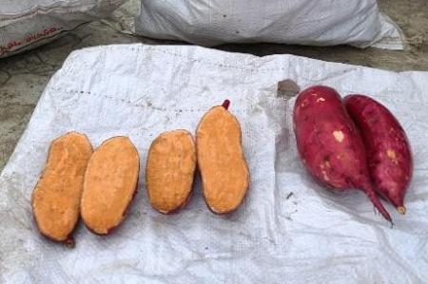G-47 | 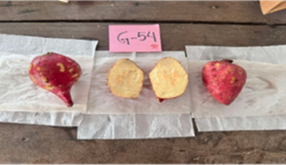  G-54 | 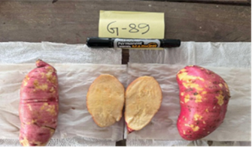  G-89 | 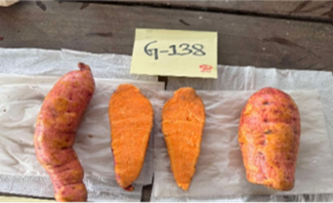  G-138
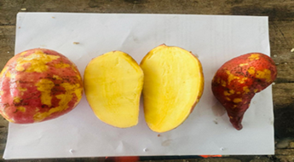  G-184 | 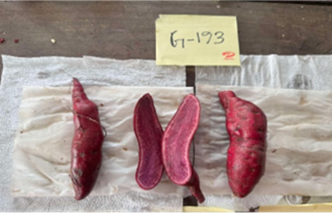  G-193 | 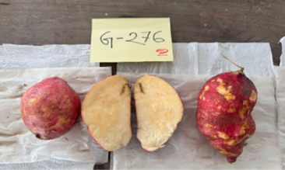  G-276 | 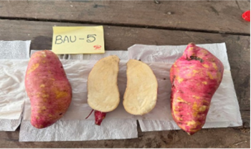  BAU sweetpotato-5
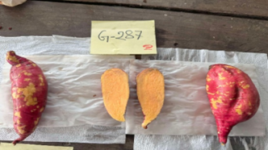  G-287 | 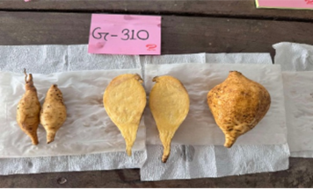  G-310 | 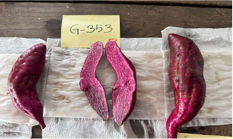  G-353 | 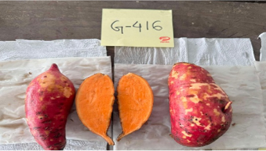  G- 416
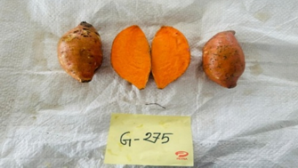  G-275 | 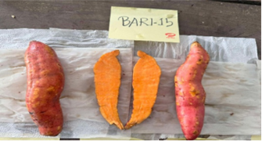  BARI sweetpotato-15 | 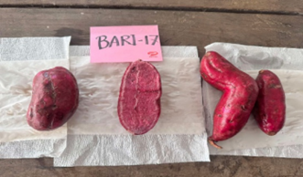  BARI sweetpotato-17 | 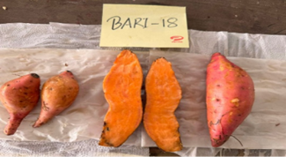  BARI sweetpotato-18
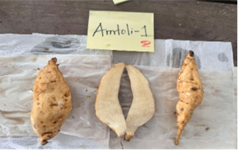  Amtoli-1 | 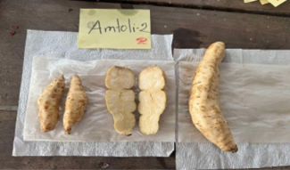  Amtoli-2 | 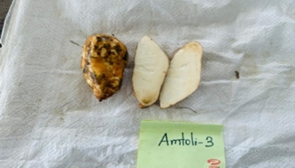  Amtoli-3 | 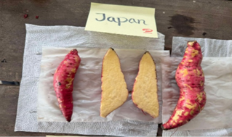  Japan
Here, Genotypes G1 = G-47, G2 = G-54, G3 = G-89, G4 = G-138, G5 = G-184, G6 = G-193, G7 = G-276, G8 = BAU SP-5, G9 = G-287, G10 = G-310, G11 = G-353, G12 = G-416, G13 = G-275, G14 = BARI SP-15, G15 = BARI SP-17, G16 = BARI SP-18, G17 = Amtoli-1, G18 = Amtoli-2, G19 = Amtoli-3, G20 = Japan

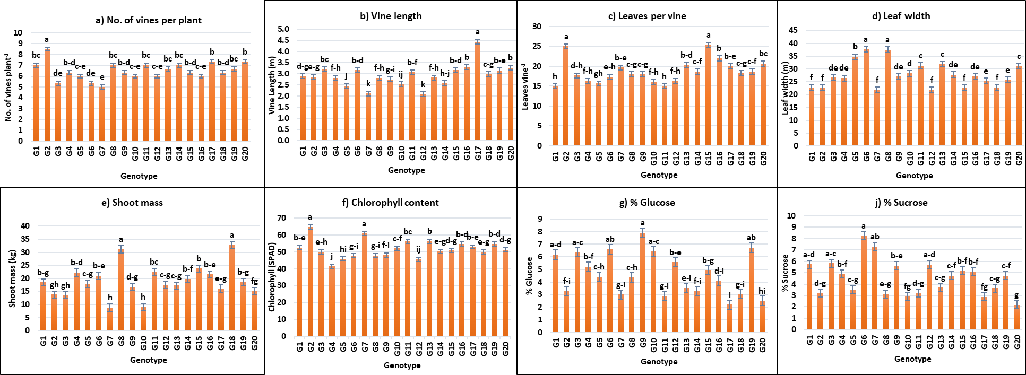Figure S2 Comparative performance of 20 sweet potato genotypes for morphological, physiological and nutritional traits: (a) Number of vines per plant (NV), (b) Vine length (VL, cm), (c) Number of leaves per vine (LV), (d) Leaf width (LW, cm), (e) Shoot mass per plot (SW, kg), (f) Chlorophyll (SPAD), (g) %Glucose, (h) %Fructose. Vertical bars represent ± standard error (SE) of percentage values and different letters above the bars indicate significant differences between genotypes at p < 0.05. Genotypes G1 = G-47, G2 = G-54, G3 = G-89, G4 = G-138, G5 = G-184, G6 = G-193, G7 = G-276, G8 = BAU SP-5, G9 = G-287, G10 = G-310, G11 = G-353, G12 = G-416, G13 = G-275, G14 = BARI SP-15, G15 = BARI SP-17, G16 = BARI SP-18, G17 = Amtoli-1, G18 = Amtoli-2, G19 = Amtoli-3, G20 = Japan
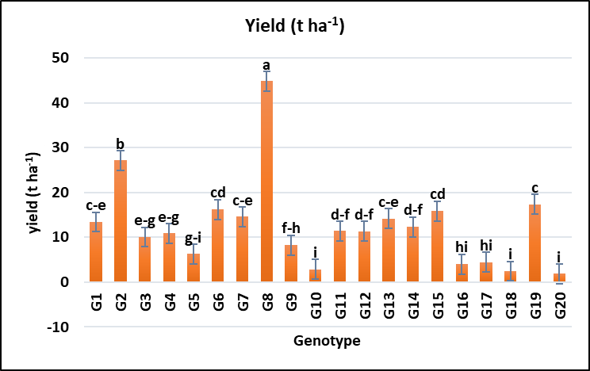
Figure S3 Comparative performance of 20 sweet potato genotypes for yield ton per hectare. Vertical bars represent ± standard error (SE) of percentage values and different letters above the bars indicate significant differences between genotypes at p < 0.05. Genotypes G1 = G-47, G2 = G-54, G3 = G-89, G4 = G-138, G5 = G-184, G6 = G-193, G7 = G-276, G8 = BAU SP-5, G9 = G-287, G10 = G-310, G11 = G-353, G12 = G-416, G13 = G-275, G14 = BARI SP-15, G15 = BARI SP-17, G16 = BARI SP-18, G17 = Amtoli-1, G18 = Amtoli-2, G19 = Amtoli-3, G20 = Japan

