Table.S1 Measurement of photosynthetic and fluorescence parameters of birch trans-BpPIN3
Lines | Fv/Fm | ØPSII | qN | qP | Pn | Tr
WT | 0.73±0.005a | 0.62±0.06ab | 0.36±0.14bc | 0.91±0.04d | 10.38±0.85c | 2.2±0.34d
OE1 | 0.71±0.003b | 0.64±0.01a | 0.27±0.02cd | 0.93±0.01cd | 12.51±1.41a | 3.19±0.81ab
OE2 | 0.70±0.001c | 0.59±0.012b | 0.36±0.03bc | 0.92±0.02cd | 11.93±0.24ab | 2.96±0.14bc
OE3 | 0.71±0.02b | 0.52±0.07c | 0.53±0.14a | 0.94±0.01bc | 10.17±1.45c | 2.38±0.6cd
RE1 | 0.71±0.001b | 0.66±0.01a | 0.20±0.03d | 0.98±0.03a | 11.27±1.13bc | 2.69±0.68bcd
RE2 | 0.72±0.006b | 0.58±0.03b | 0.43±0.08b | 0.96±0.04b | 12.99±1.83a | 3.64±0.91a
RE3 | 0.72±0.003b | 0.59±0.03b | 0.41±0.07b | 0.94±0.01bcd | 10.9±0.45bc | 2.57±0.3cd
Note：Different letters denote statistically significant differences after one-way ANOVA
Table.S2 Gene ID and primers used for qRT-PCR
Gene name | Forward primer（5′-3′） | Reverse primer（5′-3′）
Bpev01.c0778.g0010 (QKY) | CGTTGAGCCACATCTTACGC | CGAACCTTCCGTTGATCACTC
Bpev01.c0826.g0009 (TRN2) | ATCAACTTCGTAGCCATGCTC | GCTACGACCAAGATCAATATGCC
Bpev01.c1610.g0010 (FBX92) | ATCCATGCCTCATATTCCACT | ACCATTACATGAGCCTACCAC
Bpev01.c0571.g0017 (SDE) | CTGAAGCAACAAAACCGCTGA | GGAAGCCATCTCCAAGCAT
Bpev01.c0146.g0033 (CUL4) | TGCCGTCATCTGCTCTACCTG | ATATGGCCGCAATCAGACCC
Bpev01.c0570.g0017(MSL10) | CGGCTGTCCAACAACTTCACA | GAACATAAACCCCACGAGCAG
Bpev01.c1498.g0001 (YUCCA6) | ACATGCGGAGTACGATTCCAC | GTAGCCGCCACCAACCAC
Bpev01.c0043.g0011 (LBD1) | ACTGAGCCATTCAAGTTCACC | GCTCACTGCATCCGCTCT
Bp18S | GAGGTAGCTTCGGGCGCAACT | GCAGGTTAGCGAAATGCGATAC

Fig.S1 qRT-PCR validation of the transcriptome data
Student’s T-test. Results are shown as mean expression ± standard deviation (SD) of three independent experiments.

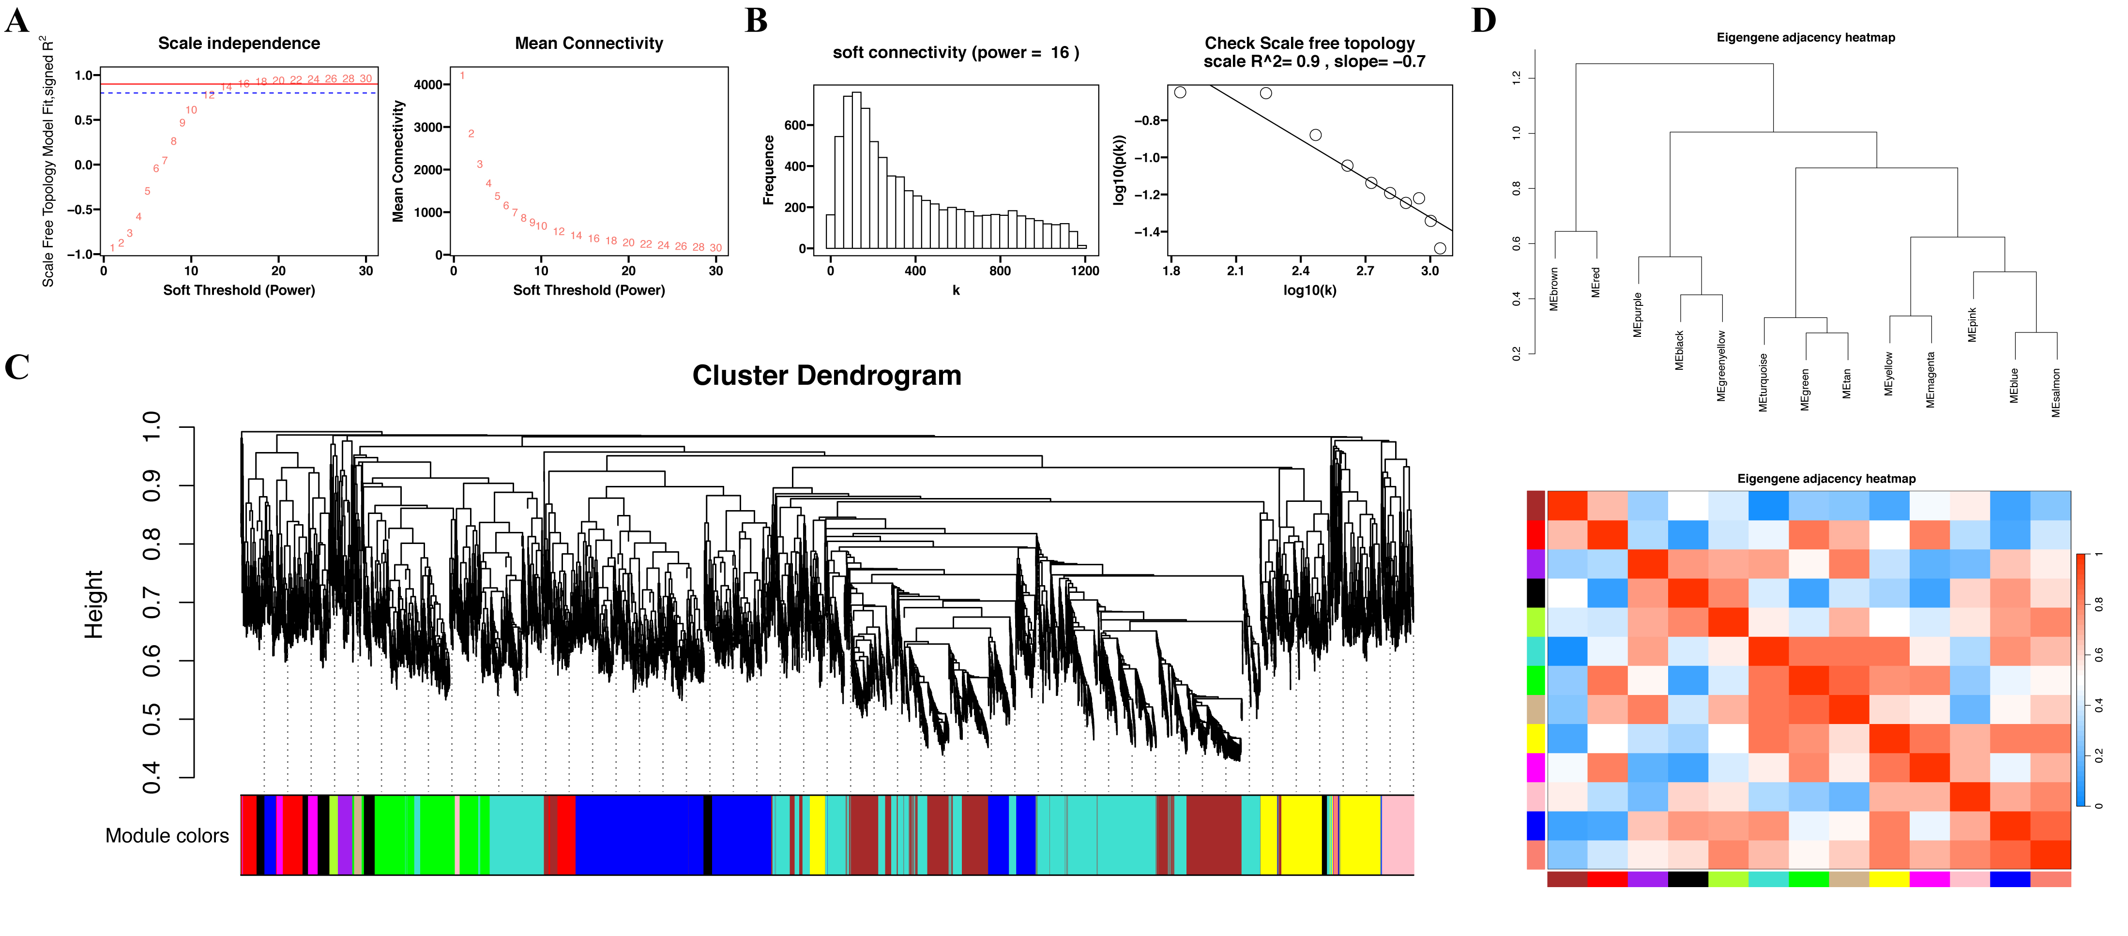
Fig.S2 WGCNA Analysis
A. Soft threshold analysis; B. Soft threshold determination; C. Gene clustering system tree and gene network module construction; D. Module correlation analysis.

