Supplementary file- Genomic Dissection of Early Seedling Vigour Traits in Chickpea Reveals Key Marker-Trait Associations" (New revised title: Dissection of Genomic Regions Underlying Early Seedling Vigour in Chickpea through Genome-Wide Association Mapping) (Submission ID: e182e59a-e1f6-49f3-884d-adf9543dc6c1).
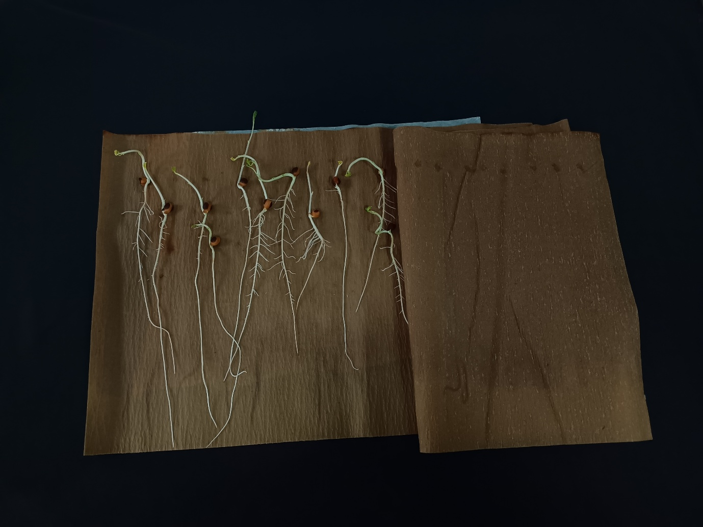
Supplementary Fig. S1. Representative image of chickpea seedlings used for phenotyping root length, shoot length, and early seedling vigour traits.
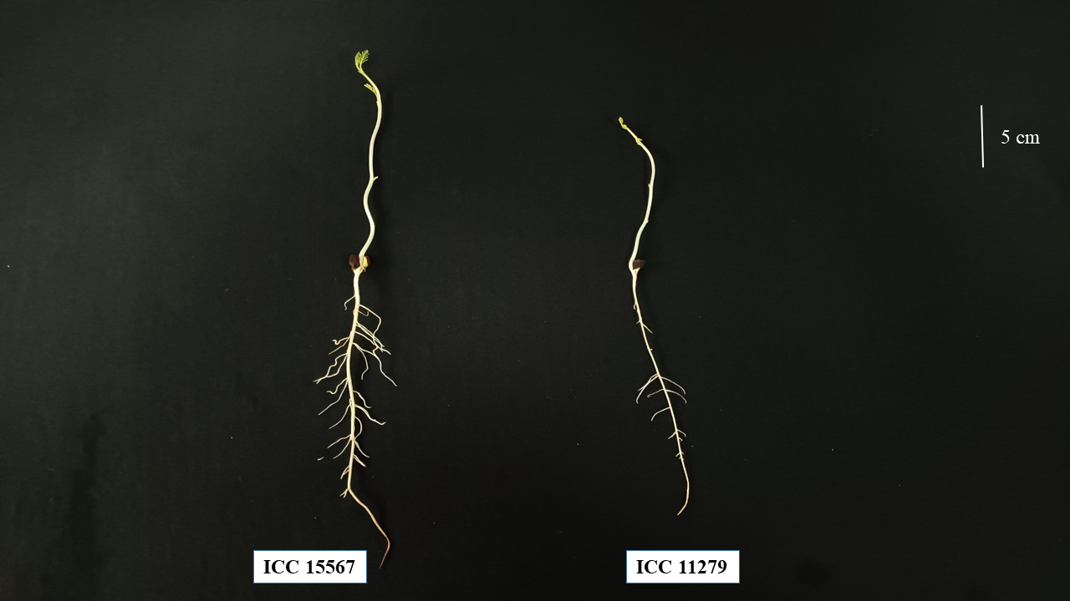Supplementary Fig. S2. Representative image of chickpea seedlings displaying contrasting phenotypes for root and shoot growth at the early seedling stage.
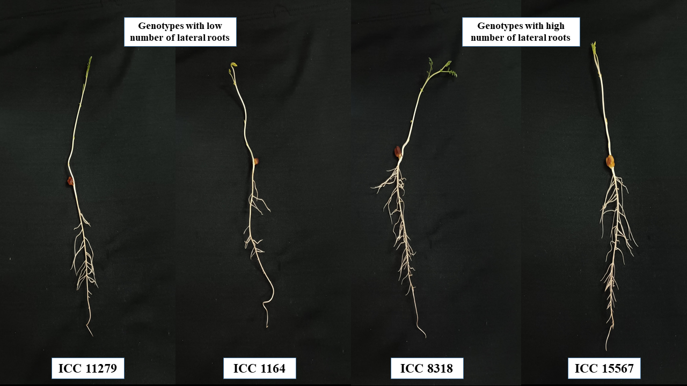
Supplementary Fig. S3. Representative photos of chickpea genotypes with a variable number of lateral roots
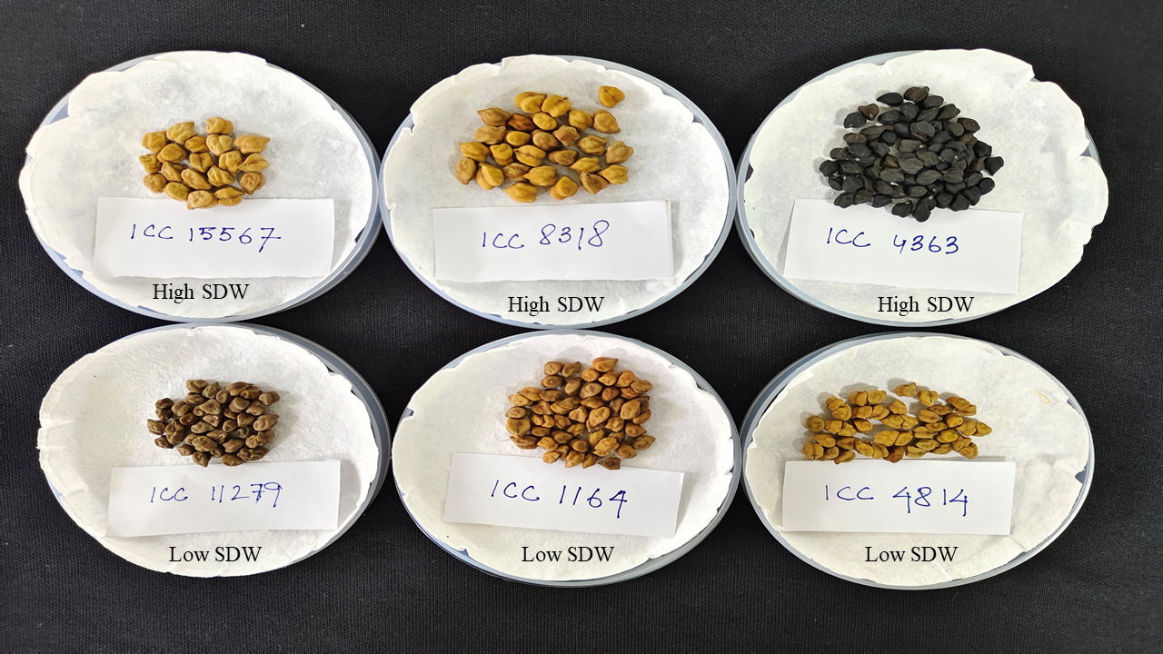
Supplementary Fig. S4. Seed images of higher SDW and lower SDW chickpea genotypes
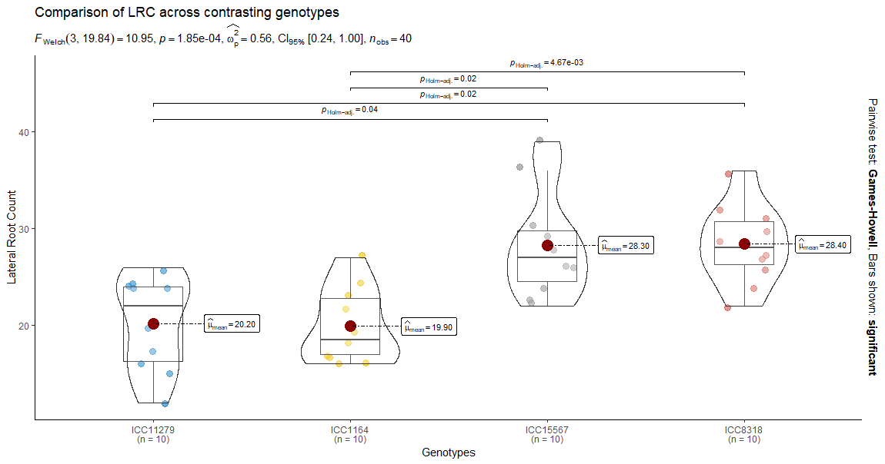
Supplementary Fig. S5. Comparison of lateral root count (LRC) among the four contrasting chickpea genotypes at the early seedling stage. Lateral roots having a length >1 mm were considered in the count. Genotypes ICC15567 and ICC8318 showed significantly higher LRC values, whereas ICC11279 and ICC1164 exhibited lower LRC, confirming phenotypic differences consistent with genetic variation in lateral-root–associated genes identified in the study. Data represent mean ± SE (n = 10), and statistical significance was determined by one-way ANOVA followed by Games–Howell post-hoc test (p < 0.05).

