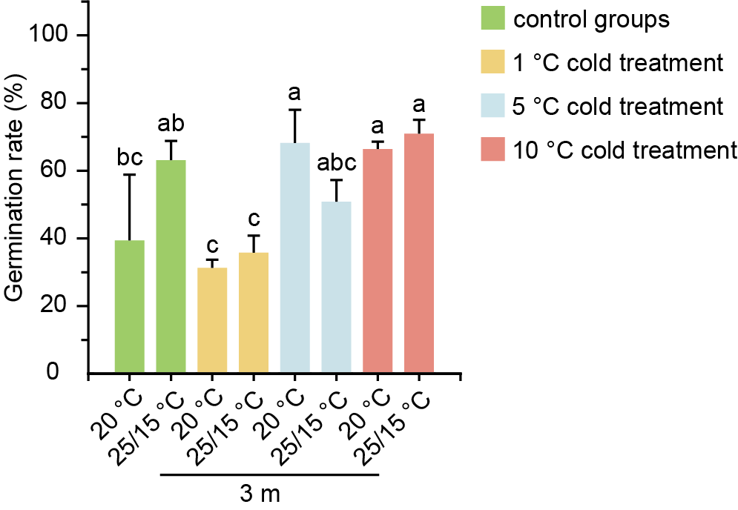
Figure S1. The germination rate of Rosa 'Kent' seeds treated with different temperatures.
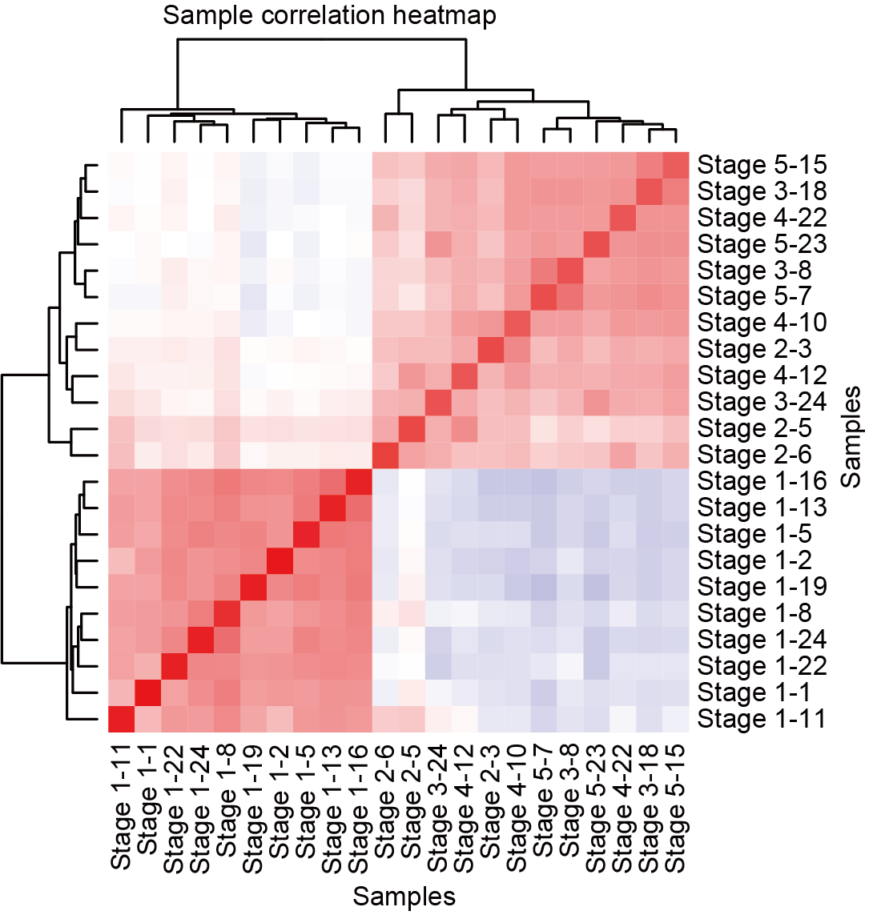
Figure S2. Correlation analysis among RNA sequencing data.
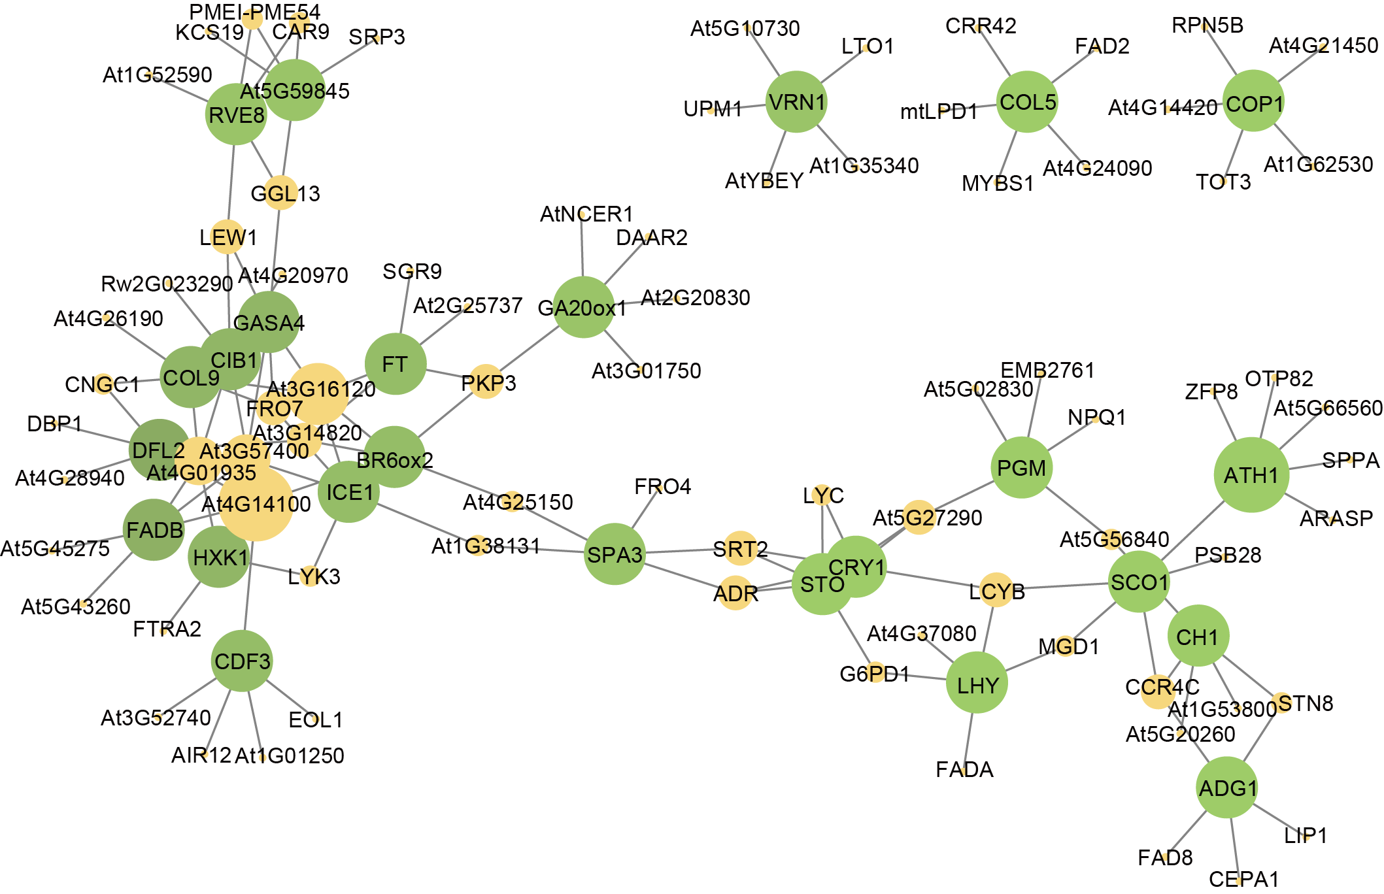
Figure S3. The flowering regulatory gene correlation network of the hub transcription factors (green circles) and their potential target genes (yellow circles) for the MEbrown module.
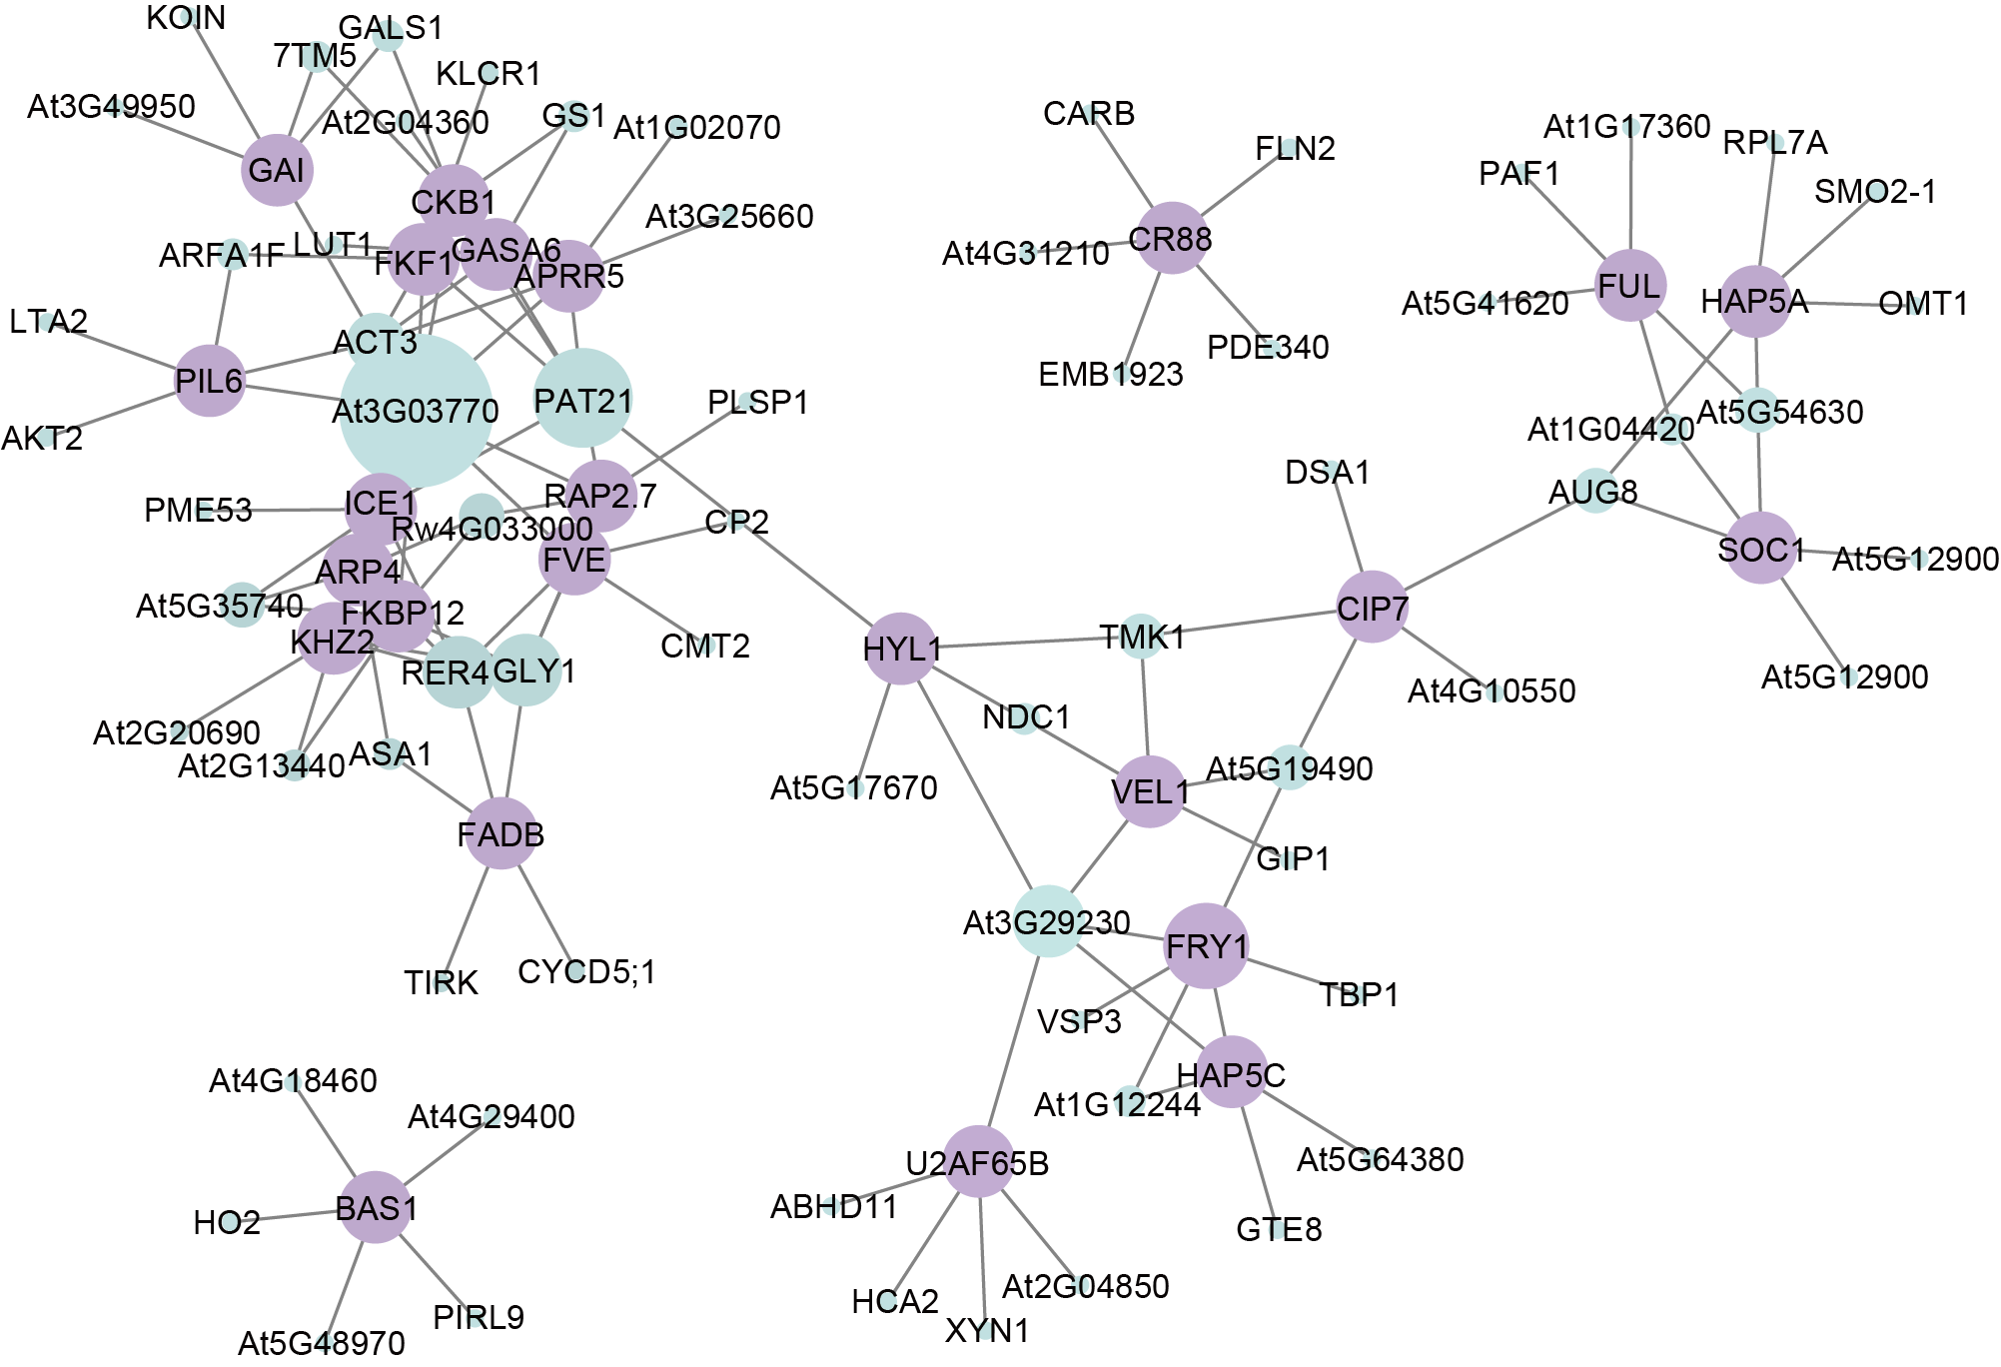
Figure S4. The flowering regulatory gene correlation network of the hub transcription factors (purple circles) and their potential target genes (cyan circles) for the MEblue module.
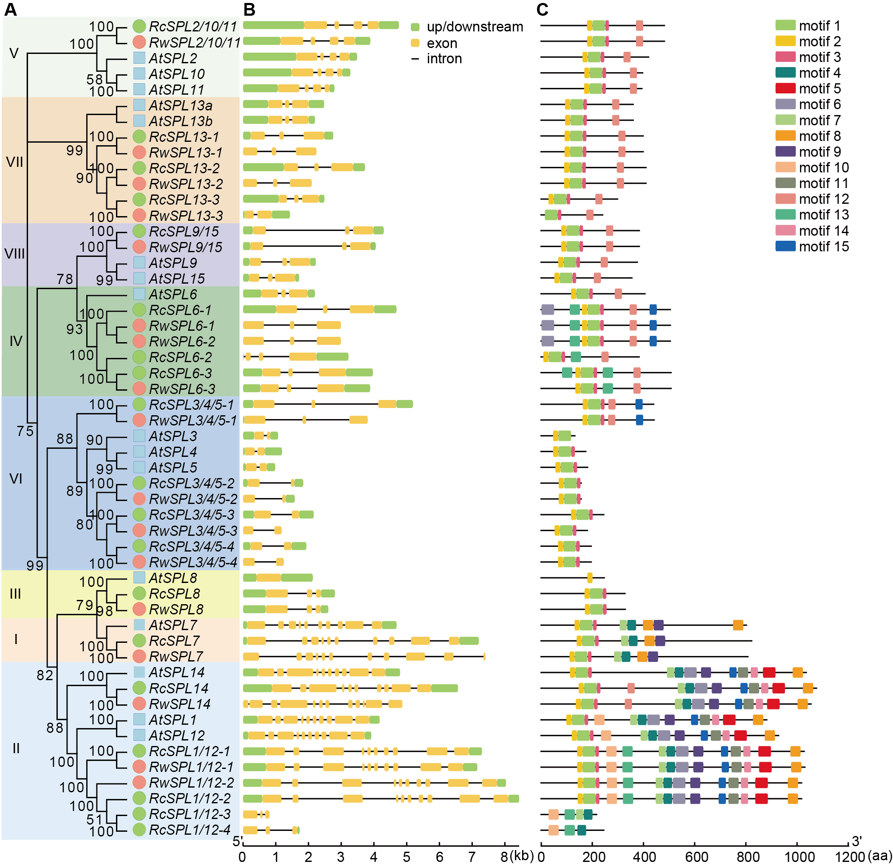
Figure S5. (A) Phylogenetic, (B) gene structure and (C) conserved motif analyses of the SPLs gene family in BT (RwSPL) and OB (RcSPL).
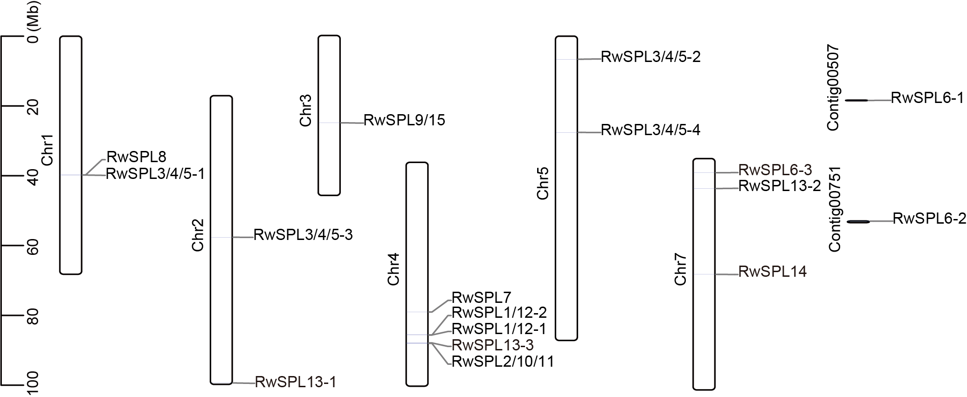
Figure S6. The SPLs chromosomal localization in BT genome.
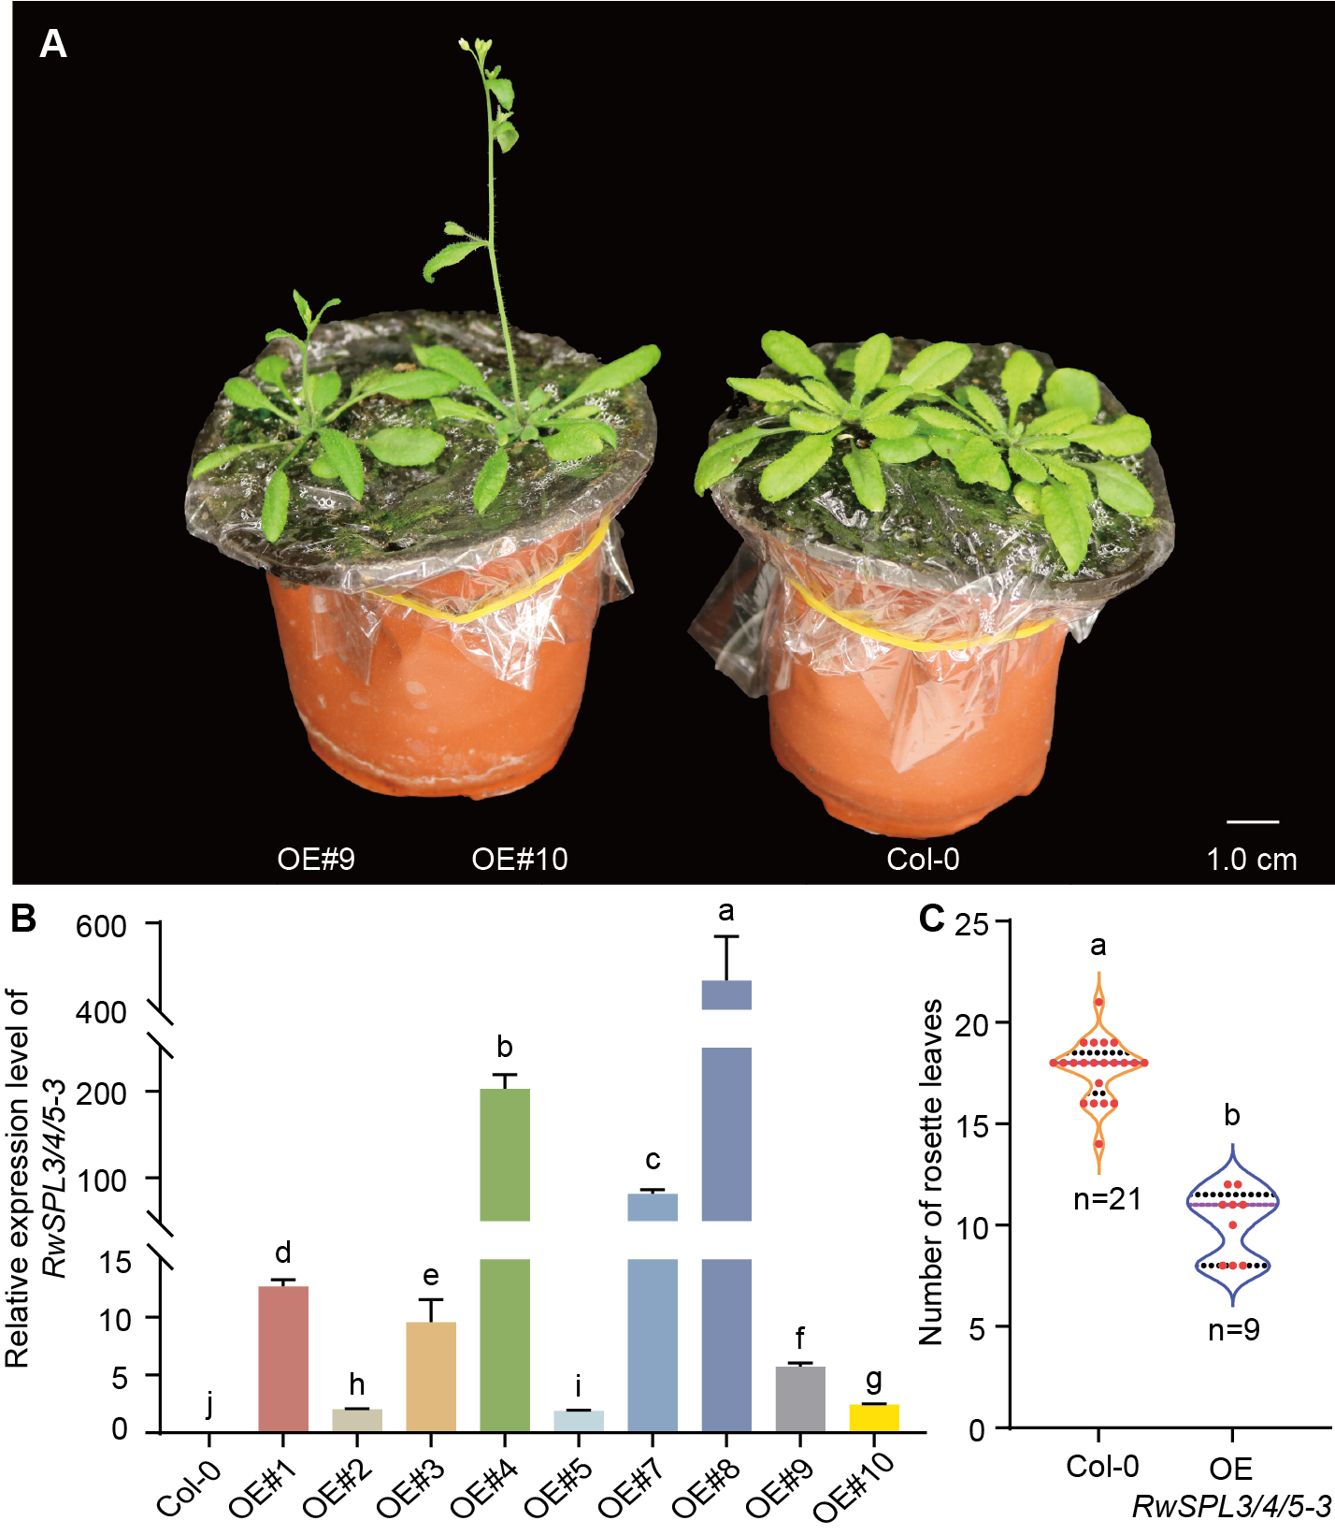
Figure S7. RwSPL3/4/5-3 is a significant promoter of precocious flowering in transgenic Arabidopsis thaliana.

