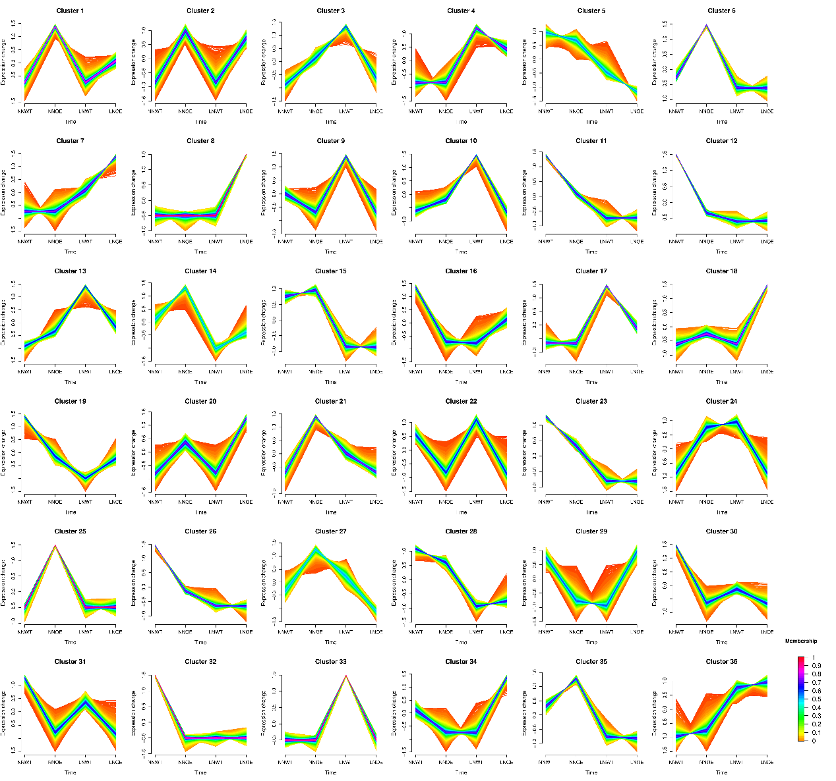
Fig S1. Fuzzy c-means clustering identified 36 distinct co-expression profiles of lncRNAs and TFs in the root of WT and TaNPF6.2-OE wheat along different N concentration treatment. The x axis represents two N concentration treatments: WT and TaNPF6.2-OE, while the y axis represents log₂-transformed, normalized intensity ratios in each treatment.
Fig S2. Expression profiles of wheat potential cis-regulated target DEmRNAs and their DElncRNAs in WT and TaNPF6.2-OE under different N concentration conditions from “transport”. A Heatmap for the DElncRNAs between WT and TaNPF6.2-OE under normal N and low N. B Heatmap for the cis-regulated target DEmRNAs between WT and TaNPF6.2-OE under normal N and low N.
Prediction and metabolic functions of potential cis-regulated target DEmRNAs and their DElncRNAs in wheat roots. a and b In the NNWT vs. NNOE comparison and NNWT vs. LNWT, expression pattern comparisons of cis-regulated target DEmRNAs and their DElncRNAs.
Fig S3. Expression profiles of wheat potential cis-regulated target DEmRNAs and their DElncRNAs in WT and TaNPF6.2-OE under different N concentration conditions from “transport”. A Heatmap for the DElncRNAs between WT and TaNPF6.2-OE under normal N and low N. B Heatmap for the cis-regulated target DEmRNAs between WT and TaNPF6.2-OE under normal N and low N.

