Supplementary Figures
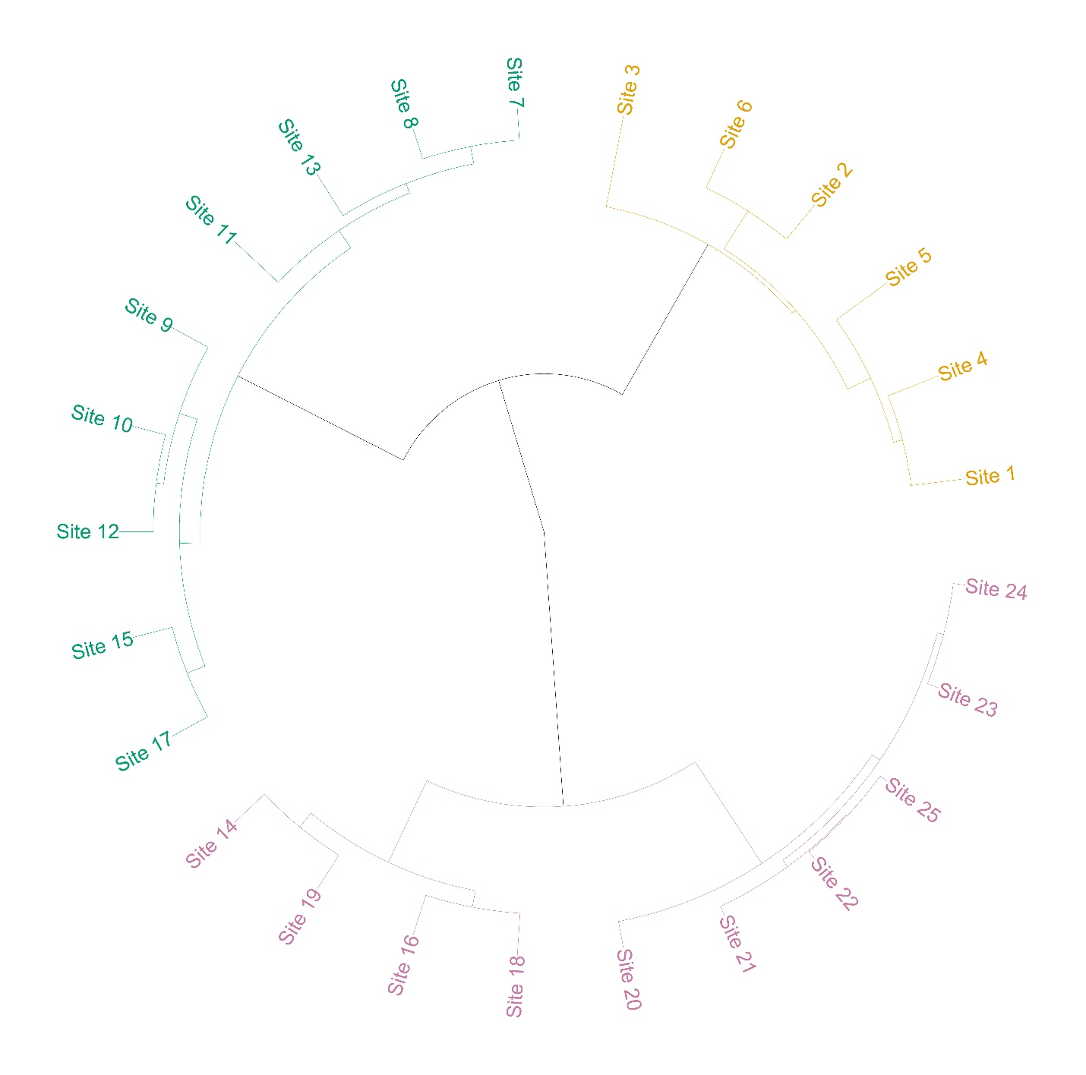
Supplementary Figure 1. Dendrogram generated using Ward’s agglomerative clustering method based on species composition across 25 vegetation plots. Three distinct plant associations were identified: Abies pindrow-Viburnum-grandiflorum-Achillea millefolium (AVA), Swertia petiolate-Iris kashmiriana-Potentilla nepalensis (SIP), and Pedicularis-pectinata-Juncus himalensis-Parnassia nubicola (PJP). The color-coded branches represent the grouping of sites corresponding to each association.
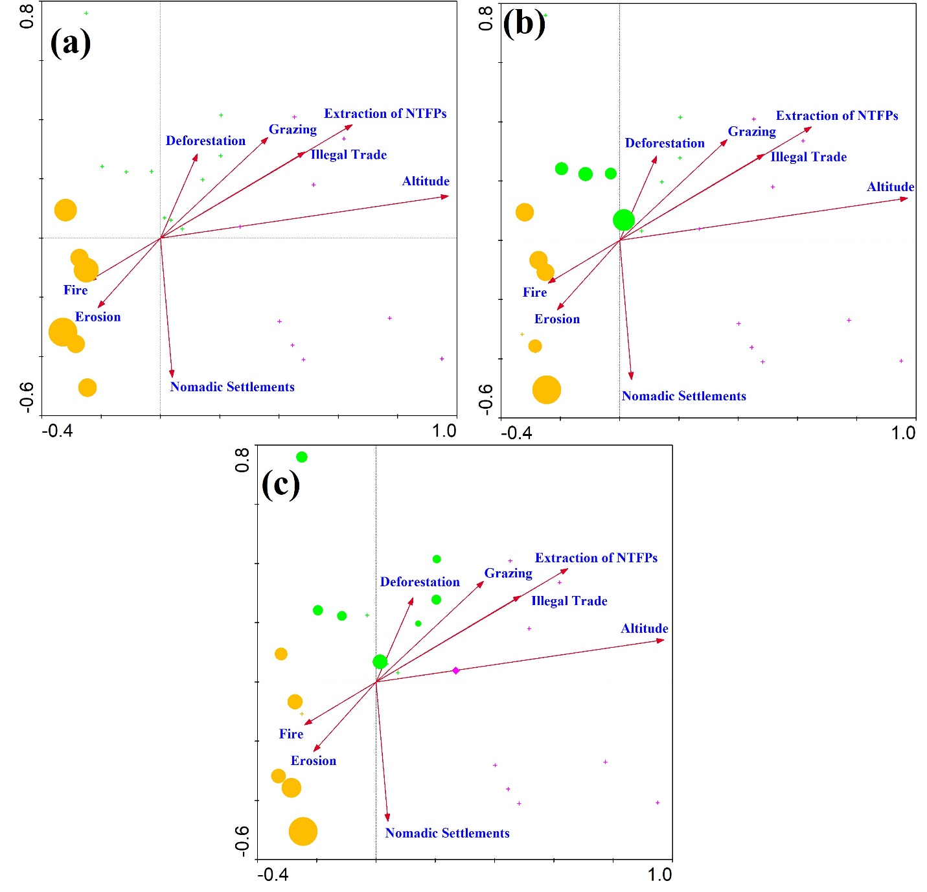
Supplementary Figure 2. Canonical correspondence analysis (CCA) triplots showing the relationship between environmental/threat variables and species composition for the Abies pindrow-Viburnum grandiflorum-Achillea millefolium (AVA) association. Arrows represent the direction and strength of environmental gradients. Orange circles indicate AVA plots, highlighting their association with disturbance factors such as fire, erosion, nomadic settlements, and deforestation.
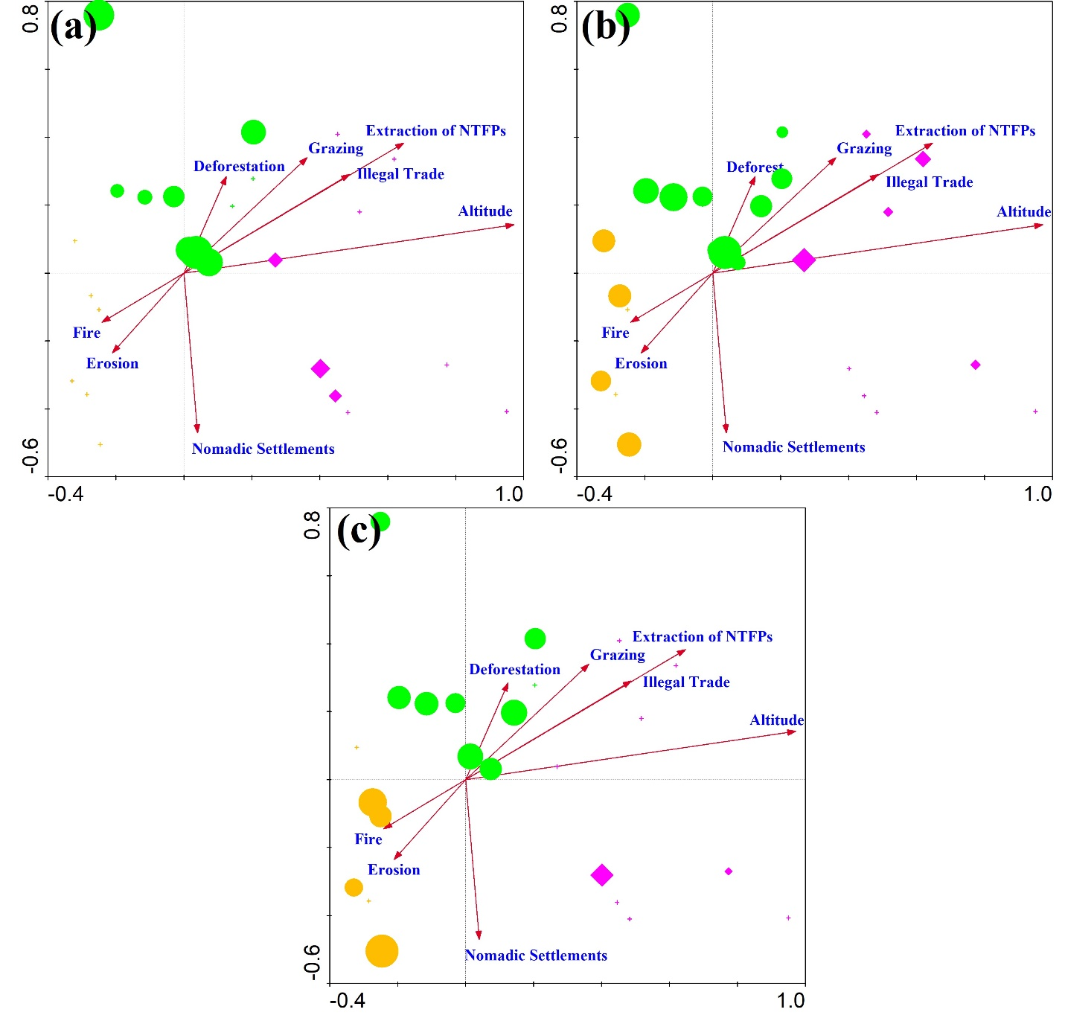
Supplementary Figure 3. CCA triplots for the Swertia-petiolata-Iris kashmiriana-Potentilla nepalensis (SIP) association. Green circles represent SIP plots, which are primarily aligned with the altitude vector, indicating strong elevation-driven community structure. Additional vectors suggest moderate influence from deforestation, grazing, and NTFP extraction on this mid-elevation vegetation group.
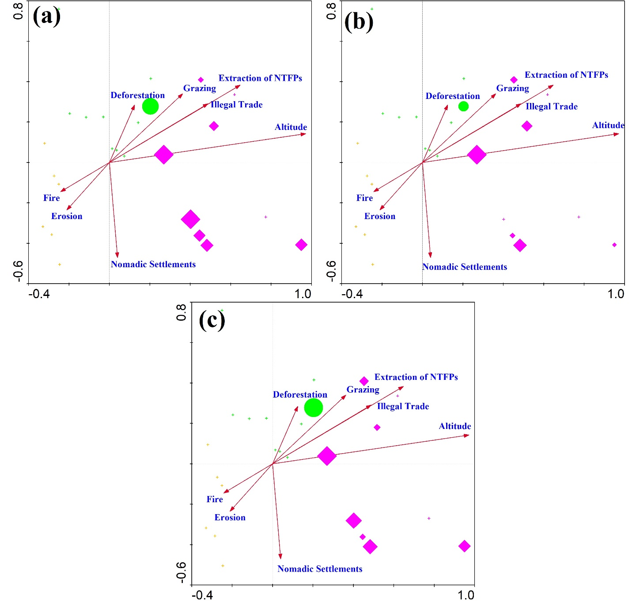
Supplementary Figure 4. CCA triplots for the Pedicularis-pectinata-Juncus himalensis-Parnassia nubicola (PJP) association. Magenta diamonds indicate PJP plots, showing a clear alignment with the altitude axis. The direction of vectors such as illegal trade, nomadic settlements, and grazing also suggests that anthropogenic pressures extend into these high-altitude ecosystems.

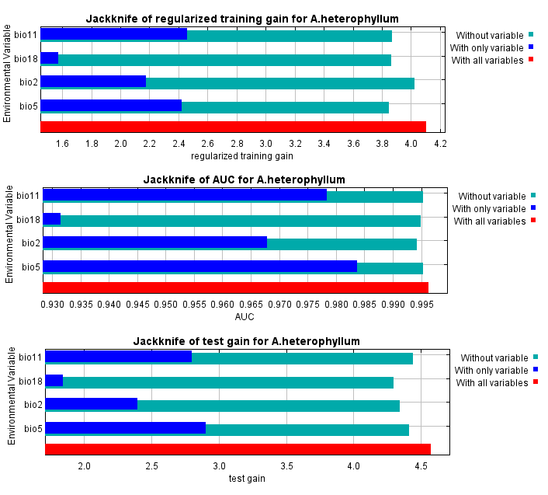
Supplementary Figure 5. Jackknife test of variable importance for Aconitum heterophyllum based on MaxEnt modelling. Bars represent the regularized training gain (top), test AUC (middle), and test gain (bottom) for each bioclimatic variable when used in isolation (dark blue), excluded from the model (light blue), or used in combination with all variables (red). Bio5 (maximum temperature of warmest month) contributed the most information individually and led to the greatest drop in model performance when omitted, indicating it is the most influential variable. Bio18 (precipitation of warmest quarter) also added complementary information, while bio11 (mean temperature of coldest quarter) and bio2 (mean diurnal range) had lesser impacts.
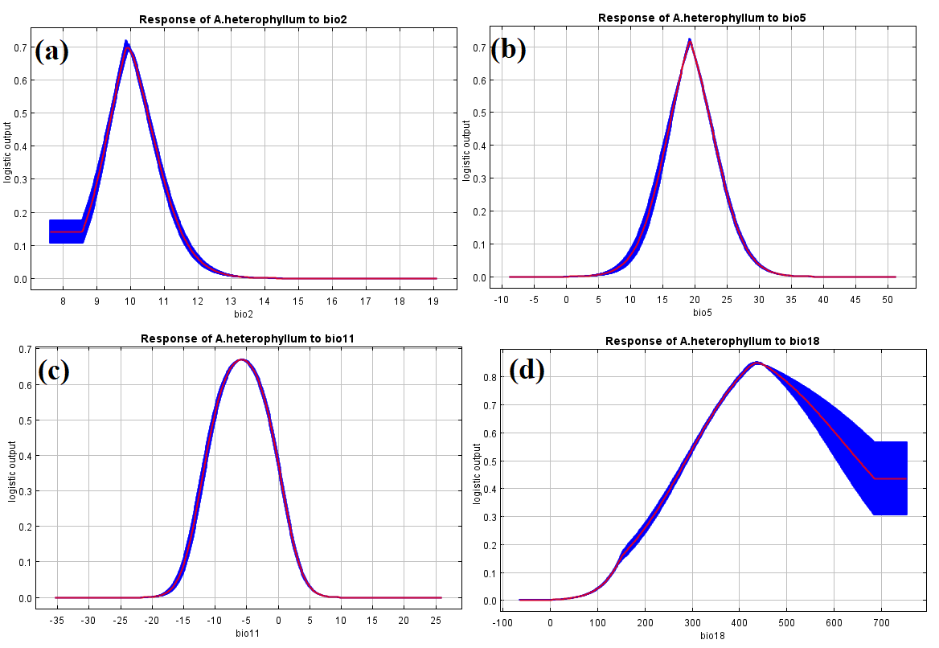
Supplementary Figure 6. Response curves showing the influence of individual bioclimatic variables on the predicted suitability for Aconitum heterophyllum, derived from MaxEnt modelling. The red line represents the mean logistic output, and the blue shaded area indicates ±1 standard deviation. (a) bio2 – Mean diurnal temperature range: suitability peaks sharply around 10 °C, then declines. (b) bio5 – Maximum temperature of warmest month: optimal suitability occurs near 20 °C, with sharp declines at both lower and higher temperatures. (c) bio11 – Mean temperature of coldest quarter: peak suitability occurs around –6 °C. (d) bio18 – Precipitation of warmest quarter: suitability rises with precipitation, peaking at approximately 400 mm before declining, suggesting intolerance of both dry and overly saturated summer conditions.

