Supplementary Information 1. Test for intra-specific niche differentiation
Traditionally, ENMs were usually constructed at the species level, assuming niche conservatism within species. In the last decade, however, a growing number of studies have demonstrated intraspecific differential response to climatic predictors, highlighting the importance of incorporating intraspecific variation into ENMs, at the subspecies [e.g., 1, 2]( or phylogenetic lineages level [e.g., 3-7]. This approach has been shown to provide more accurate future predictions of species range shifts under climate change for a wide range of organisms [2-4, 8-10].
Materials and methods
Based on the results of phylogeographic analysis (see Results, section 2), separate ENMs were performed for the two main U. glabra intra-specific branches, corresponding to the Alpine and Apennine distributional ranges, respectively (hereafter, ALP and APE), assuming Colle di Cadibona (Liguria region), the conventional boundary between the two mountain chains. In our models, we did not separate the APE lineage into the two main detected haplogroups (corresponding to Northern and Southern Apennines) for the following reasons: (i) a separation would not have allowed for a sufficient number of points to inform the models; (ii) we had no clear evidence for a strong climatic difference between these two sub-regions, for justifying the construction of two separate ecological niche models, contrary to that between the Alps and Apennines, which constitutes two distinct and well recognised climatic regions [11] and corresponding eco-regional provinces [12].
In order to compare the niches of the two U. glabra intraspecific lineages and test for ecological differentiation, we assessed the niche overlap, niche similarity, and niche equivalence using the environmental principal component analysis method (PCA-env) [13]. PCA-env first translates the multivariable environmental space into a two-dimensional space performing a PCA, then computes the density of occurrences in the multivariate space using a kernel density function, to take into account potential bias on occurrence records due to unequal sampling effort [13]. Niche overlap between the two lineages was computed by means of the Schoener’s D [14], which is a particularly suitable metric to compare Grinnellian niches [15] and ranges between 0 (lack of overlap) and 1 (complete overlap). Niche equivalency test evaluates whether two ecological niches are indistinguishable from each other [16, 17]; it is a conservative test, since it only compares the modelled niches of the two species (or lineages, in our case), regardless potential differences in available habitat. Niche similarity test, on the other hand, evaluates if the niche occupied by one species is more similar to the niche of the other species than expected by chance, while taking into account background environmental heterogeneity, i.e. the differences in available habitat between two species [13, 17]. Schoener’s D, as well as niche equivalency and similarity tests between the two U. glabra lineages (ALP and APE) were computed with the R package ecospat v. 4.1.0, setting overlap.alternative = ‘higher’, in order to test the alternative hypothesis of niche equivalency/similarity [18]. The significance of similarity/equivalency tests was assessed with 10,000 replicates.
Results
Niche overlap between the two U. glabra lineages (ALP and APE) was found to be low (Schoener’s D = 0.178; Fig. 5). Niche equivalency test showed that niche overlap between the two lineages is significantly smaller than the null distribution (p = 1), indicating that ALP and APE lineages do not occupy equivalent niches. Consistently, niche similarity tests resulted in non-significant p-values (p > 0.05), confirming that the two niches are not more similar than expected by chance (see below figures).
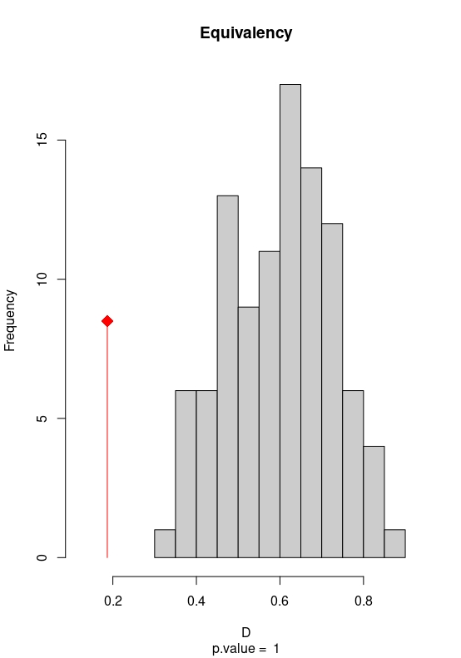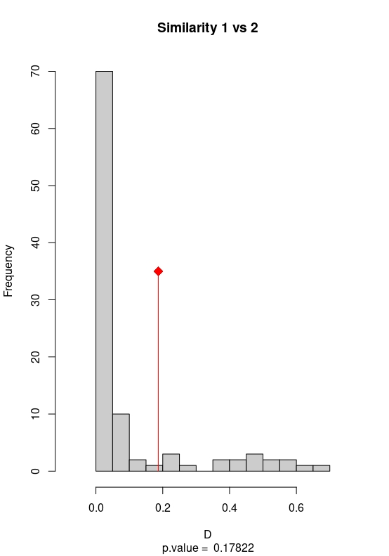

Supplementary Information 2. MaxEnt variable contribution and response curves
Here are reported MaxEnt tests of variables contribution. In the current ENM for ALP the variables showing the highest permutation importance were bio1 (58.4%), pH (34.5%), bio18 (5.1%), and the jackknife importance score of the training and test data (Table S3; Fig. S6-S7) showed that bio1, pH and bio15 contributed the highest gain to the model when used in isolation (i.e. individually carrying crucial information for the model's predictive ability). For the APE lineage, the variables showing the highest permutation importance were pH (50.9%), bio15 (28.7%), bio19 (8.6%), with jackknife score highlighting pH, bio1, bio18 (precipitation of the warmest quarter), bio19 (precipitation of the coldest quarter), as the variables with the highest individual contribution.
Results of MaxEnt variable contribution, taking together permutation importance and jackknife tests, highlighted the importance of bio1 (annual mean temperature), soil pH, and bio15 (precipitation seasonality) for both the ALP and APE models (although with different relative contribution), with, in addition, bio18 and bio19 being more relevant for the APE model. The response curve for pH was very similar between ALP and APE: a sigmoid curve with the probability of presence being maximum for 4.5 < pH > 5, then decreasing and reaching low values (< 0.5) for pH > 6. This is in line with the edaphic preferences of the species which, across its European range, is known to grow better on mildly acid soils up to pH 4.7, and does not tolerate basic soils [18]. The response curve for bio1 (annual mean temperature) showed the typical bell shape of temperate species, with the peak at about 10 °C for both ALP and APE; however, the curve is sharper and more defined for ALP, while more spread-out for APE, showing higher variability in the probability of presence at lower and higher temperature values. Interestingly, annual precipitation seasonality showed opposite trends: a positive relationship with the probability of presence in ALP (i.e., the presence of wych elm is more likely where the distribution of precipitation over the year is more heterogeneous) and negative correlation in APE, with higher probability of presence (> 0.5) for bio15 < 30, corresponding to more uniform rainfall regimes. This difference could reflect the different climatic regimes experienced by U. glabra in the two analysed sub-ranges and, specifically, it may be interpreted as U. glabra avoiding Mediterranean climates of Central and Southern Italy, which are characterised by high precipitation seasonality (dry summers associated with frequent droughts).

Table S3 Relative contribution of the environmental variables to the MaxEnt models for the Alps and the Apennines. To estimate the percentage contribution, in each iteration of the training algorithm the increase in regularized gain is added to the contribution of the corresponding variable, or subtracted from it if the change to the absolute value of lambda is negative. For calculating the permutation importance, the values of each variable on training presence and background data are randomly permuted. The model is re-evaluated on the permuted data, and the resulting drop in training AUC is shown in the table, normalized to percentages. Values shown are averages over replicate runs.
 | ALPS |  | APENNINES
Variable | Contribution (%) | Permutation importance | Contribution (%) | Permutation importance
bio01 | 55.7 | 58.4 | 1.8 | 2.2
bio04 | 0.1 | 0 | 2.9 | 5.3
bio15 | 5.1 | 1.2 | 11.5 | 28.7
bio18 | 2.4 | 5.1 | 4.3 | 4.4
bio19 | 0.4 | 0.8 | 3.1 | 8.6
soil pH | 36.3 | 34.5 | 76.4 | 50.9

Note: permutation importance is less affected than percentage contribution by correlations among variables, since it assesses the actual impact of the variable on the model's predictive performance, independently of how often it was used during training. Therefore, it should be better reflect which variables are truly critical for predictions.
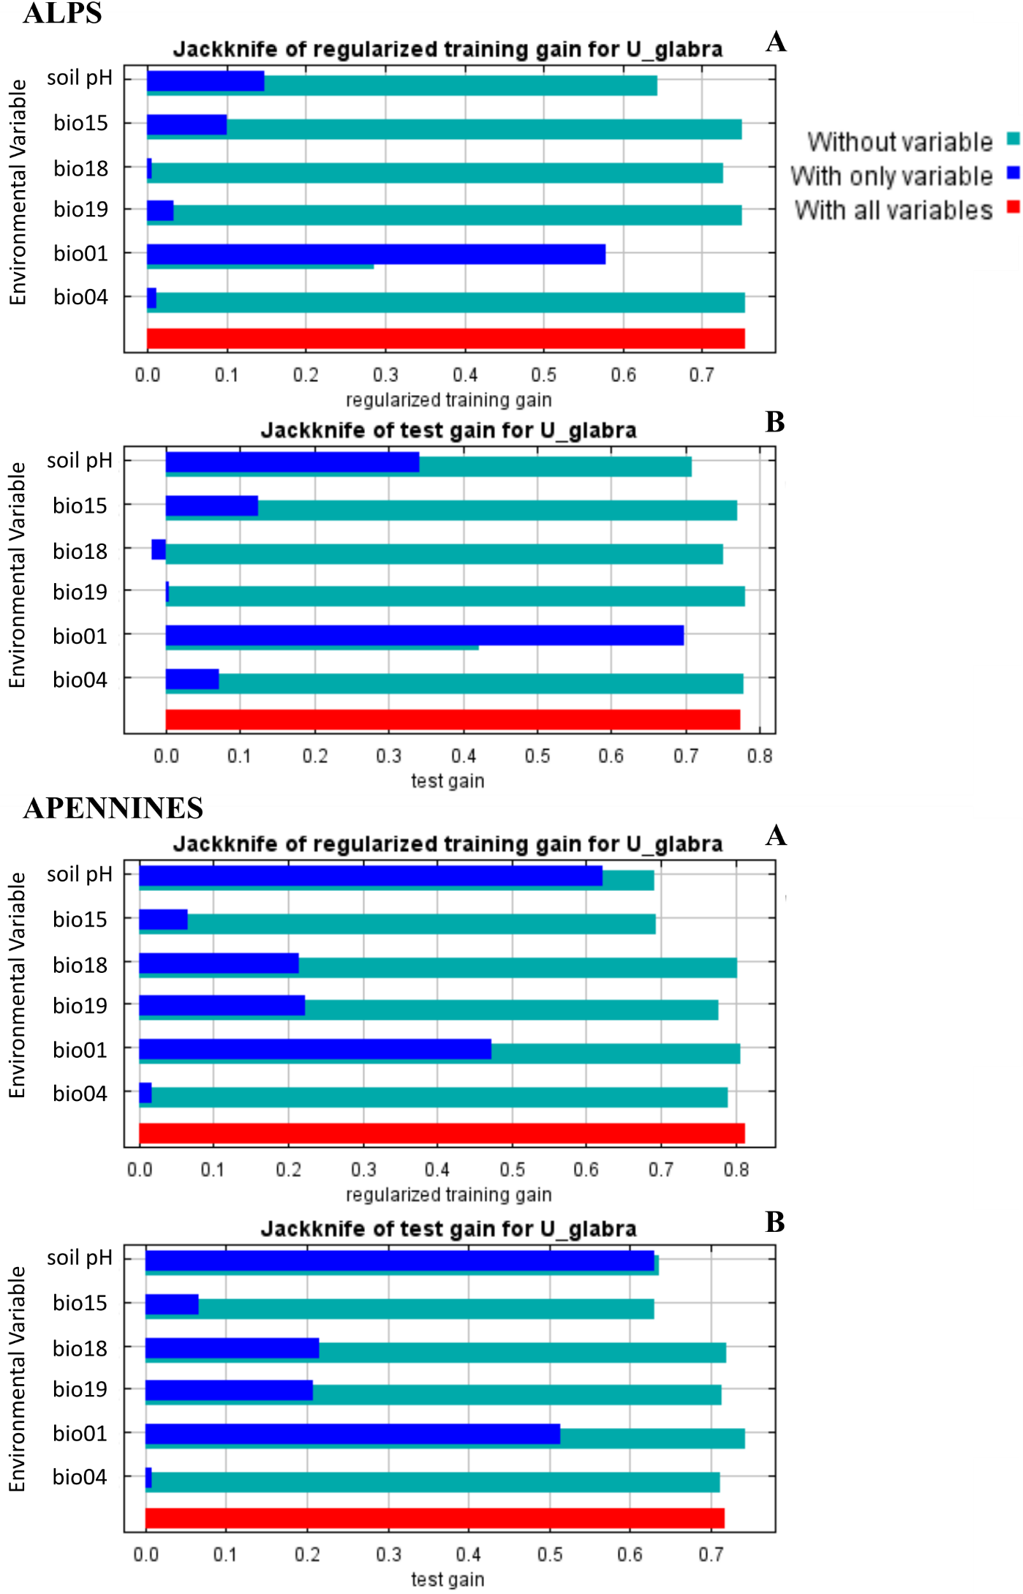

Fig. S5 Results of the jackknife test of variable importance using both A) training and B) test gain for the Alps and the Apennines. Values shown are averages over 10 replicate runs.

Fig. S6 Response curves for the three most important variables for Alps and Apennines: (A) pH, (B) bio1, (C) bio15. The y-axis represents the probability of wych elm presence (in logistic format), the x-axis represents the range of the environmental predictor. Red curves indicate the mean response over 10 replicate runs and blue margins represent the mean ± one standard deviation. The curves show changes in the predicted probability of presence as each environmental variable is varied, keeping all other variables at their average sample value.

Supplementary Information 3. Test for potential migration corridor for the Apennine lineage into the Alps
Materials and methods
Under future climate change, populations from the Apennines could potentially shift their range northward, tracking favourable climatic conditions into the southern Alps, provided that suitable habitats are available. In order to test this hypothesis, we ran Maxent models for the APE lineage under both current and future (SSP5 8.5; 2061-2080) climatic scenarios, using presence points for the APE lineage but bioclimatic variables covering the entire Italian Peninsula (i.e., without clipping the rasters to the extent of APE lineage’s assumed distribution). Based on the rasters resulting from current and future ENMs, spatial maps for the future habitat suitability variation (Δ = future - current suitability) for U. glabra in ALP and APE were generated by using R (raster and dplyr packages). Results from the new models were presented and discussed, also by comparing the emerging patterns with those obtained by clipping the bioclimatic rasters to the extent of the APE lineage’s assumed distribution (as reported in the main text), for the comparable area (i.e., the Apennine range).
Results
The projections from the new models for the APE lineage, built using bioclimatic variables covering the entire Italian Peninsula (Fig S6) show a high degree of similarity with those obtained from the previous analysis (based on clipped rasters; Fig. 5 in the main text), when considering the comparable area, though with the following differences. In the southern portion of the range, the inferred patterns of future increases and decreases in habitat suitability are very similar in terms of spatial distribution, but slightly more pronounced. Specifically, the predicted decrease in suitability extends more widely across the inner and eastern sectors, as well as in the Lazio region, although the magnitude of the decrease remains comparable. Conversely, the predicted increase along the southern Tyrrhenian coast and in southern Calabria (Aspromonte Mountains) is more extensive and slightly higher. In the northern Apennines (northern Tuscany, western Liguria, and the outer part of Emilia-Romagna), a more extensive area of decreasing suitability is evident. In these regions, scattered pixels of decreasing suitability were also predicted by the models using clipped environmental layers, although in that case the overall local trend was characterized by stable suitability values.
When considering the forecasts of the new models for the APE lineage in Northern Italy, the following patterns can be observed: (a) in the central and western parts of Northern Italy, habitat suitability for the APE lineage is predicted to remain stable or slightly increasing; however, in these areas the inferred current suitability for the APE lineage (as predicted by the new models) is also very low (< 0.1); therefore, the slight predicted increases are not biologically meaningful; (b) the only area in Northern Italy currently inferred as suitable for the APE lineage (i.e., the only portion of the Alps with pixels showing suitability > 0.4) corresponds to the western Alps, which may indeed represent a zone of potential geographic continuity between the Alpine and Apennine regions (Fig. S6 a). However, in this latter area, future projections indicate extensive clusters of pixels with decreasing habitat suitability for the APE lineage, almost perfectly matching the areas that currently show medium to high suitability (Fig. S6 b). In other words, the only Alpine regions currently predicted as suitable for the APE lineage correspond to those where habitat suitability is projected to decline under the future scenario (SSP5 8.5, 2061-2080). Similarly, the adjacent portions of the outer Northern Apennines are also predicted to experience a future decrease in habitat suitability.

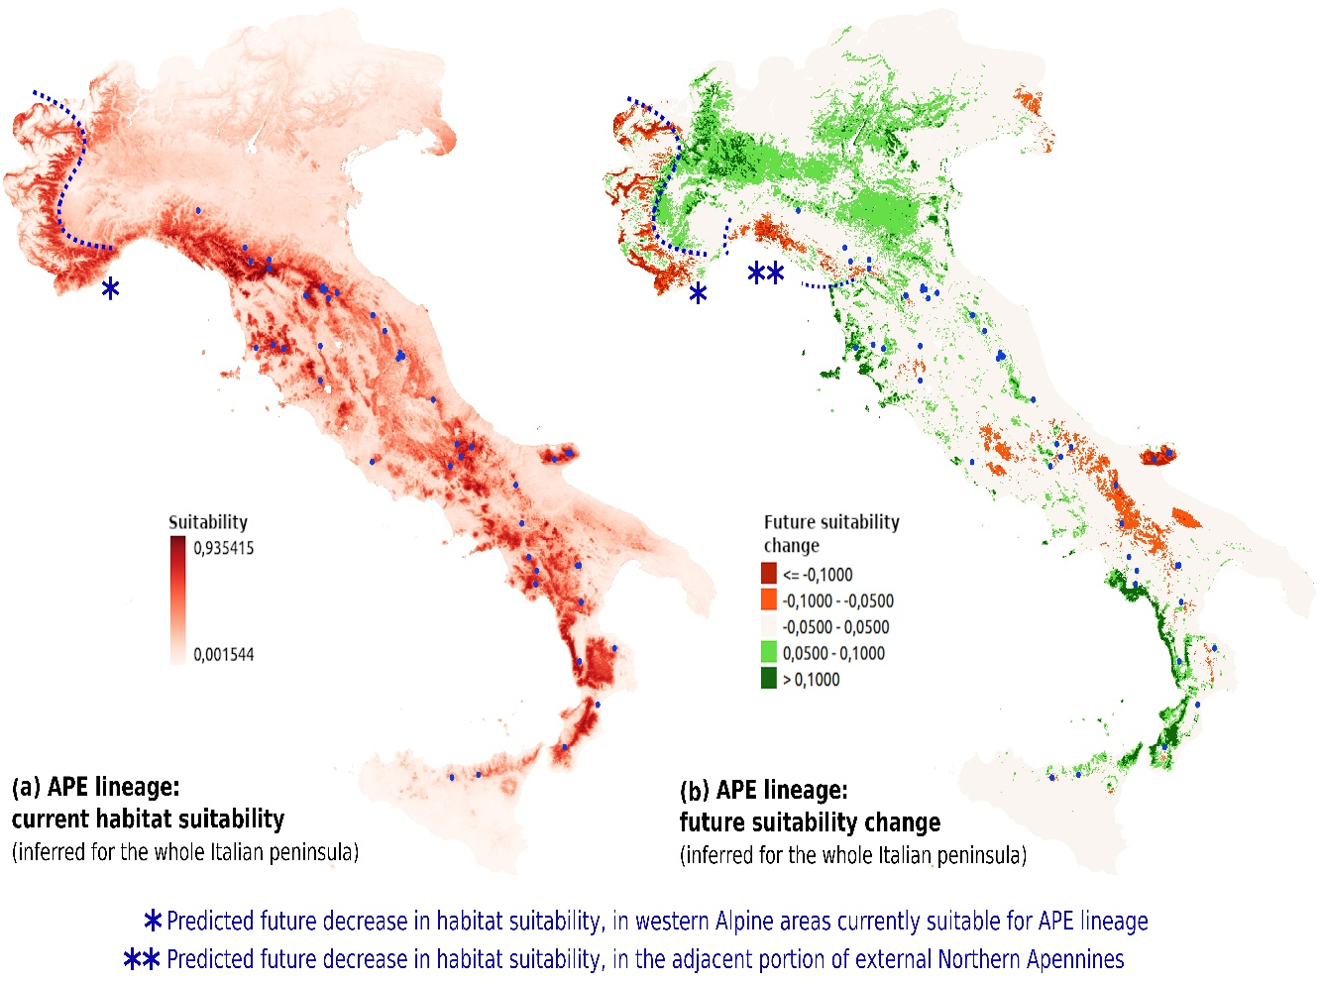

Fig. S6 Results of Maxent models and projected changes in habitat suitability (scenario: SSP5 8.5, 2061–2080) for the APE lineage, based on bioclimatic variables covering the entire Italian Peninsula. (a) Current habitat suitability; (b) Change in suitability (future minus current). Areas of geographic continuity between the northern Apennines and the southern Alps are indicated with blue dotted lines.
Discussion
In light of these findings, the potential for a natural migration corridor of the Apennine lineage into the Alps appears unlikely (or at least not a winning strategy). For the same reasons, potential assisted migration initiatives or, more generally, translocations of plant material from Apennine populations hosting at-risk haplotypes into Alpine areas also appear inadvisable, based on the outcomes of these models. Notably, areas where habitat suitability is predicted to remain stable or slightly increase have been identified within the Apennine range itself, as already reported in the manuscript. Therefore, any potential translocation of at-risk Apennine populations should preferably be directed toward these areas.
Methodological caveats
In traditional (species-based) ENMs, the modelling area should represent the so-called "accessible area", defined as "the area that has been accessible to the species of interest over relevant time periods" [19]. This is considered the ideal area for model development, testing, and comparison, not only from a biological perspective but also because of the mechanistic principles underlying model functioning. Indeed, because the estimation of ecological niches using correlative approaches relies on comparing the environmental characteristics of known occurrence sites with those of the environmental background across the study area, both the occurrence data (training points) and the environmental background (extent of the predictor layers) should roughly correspond to the same accessible area – namely, the region that the species could realistically occupy or disperse within (at current conditions; see also [20]). When this concept is transferred to a lineage-based ENM approach (where distinct lineages are treated as separate species from a purely ecological perspective), using environmental rasters covering the entire species range (e.g., ALP + APE) but occurrence data only for one lineage (e.g., APE) results in an unrealistically large background. This introduces background points that do not reflect the actual environmental conditions available to the focal lineage (APE, in this case). In theory, such a mismatch can bias model predictions in correlative ENMs.
Due to the aforementioned limitation, these results should be treated with caution and taken as a general indication.
References
- Oney B, Reineking B, O'Neill G, Kreyling J. Intraspecific variation buffers projected climate change impacts on Pinus contorta. Ecology and evolution. 2013; 3(2): 437-449. https://doi.org/10.1002/ece3.426
2. Jinga P, Liao Z, Nobis MP. Species distribution modeling that overlooks intraspecific variation is inadequate for proper conservation of marula (Sclerocarya birrea, Anacardiaceae). Global Ecology and Conservation. 2021; 32: e01908. https://doi.org/10.1016/j.gecco.2021.e01908
3. Hu ZM, Zhang QS, Zhang J et al. Intraspecific genetic variation matters when predicting seagrass distribution under climate change. Molecular Ecology. 2021; 30(15): 3840-3855. https://doi.org/10.1111/mec.15996
4. Zhang Z, Kass JM, Mammola S et al. Lineage‐level distribution models lead to more realistic climate change predictions for a threatened crayfish. Diversity and Distributions. 2021; 27(4): 684-695. https://doi.org/10.1111/ddi.13225
5. Ancillotto L, Viviano A, Baratti M, Sogliani D, Ladurner E, Mori E. Every branch in its niche: intraspecific variation in habitat suitability of a widely distributed small mammal, the harvest mouse Micromys minutus. Mammal Research. 2023; 68(4): 575-585. https://doi.org/10.1007/s13364-023-00693-3
6. Feng L, Zhou L, Zhang T, Wang X. Niche dynamics below the species level: Evidence from evaluating niche shifts within Quercus aquifolioides. Forests. 2023; 14(4): 690. https://doi.org/10.3390/f14040690
7. Song Y, Xu GB, Long KX et al. Ensemble species distribution modeling and multilocus phylogeography provide insight into the spatial genetic patterns and distribution dynamics of a keystone forest species, Quercus glauca. BMC Plant Biology. 2024; 24(1): 168. https://doi.org/10.1186/s12870-024-04830-1
8. Ikeda DH, Max TL, Allan GJ, Lau MK, Shuster SM, Whitham TG. Genetically informed ecological niche models improve climate change predictions. Global Change Biology. 2017; 23(1): 164-176. https://doi.org/10.1111/gcb.13470
9. Biaou S, Gouwakinnou GN, Noulèkoun F, Salako KV, Kpoviwanou JMRH, Houehanou TD, Biaou HSS. Incorporating intraspecific variation into species distribution models improves climate change analyses of a widespread West African tree species (Pterocarpus erinaceus Poir, Fabaceae). Global Ecology and Conservation. 2023; 45: e02538. https://doi.org/10.1016/j.gecco.2023.e02538
10. Song WH, Li JJ. The effects of intraspecific variation on forecasts of species range shifts under climate change. Science of the Total Environment. 2023; 857: 159513. https://doi.org/10.1016/j.scitotenv.2022.159513
11. Fratianni S, Acquaotta F. The climate of Italy. World Geomorphological Landscapes. Springer International Publishing, New York; 2017. https://dx.doi.org/10.1007/978-3-319-26194-2_4
12. Blasi C, Capotorti G, Copiz R, Guida D, Mollo B, Smiraglia D, Zavattero, L. Classification and mapping of the ecoregions of Italy. Plant Biosystems-An International Journal Dealing with all Aspects of Plant Biology. 2014; 148(6): 1255-1345. https://doi.org/10.1080/11263504.2014.985756
13. Broennimann O, Fitzpatrick MC, Pearman PB, Petitpierre B, Pellissier L, Yoccoz NG, Thuiller W, Fortin M-J, Randin C, Zimmermann NE, Graham C, Guisan A. Measuring ecological niche overlap from occurrence & spatial environmental data. Global Ecology and Biogeography. 2012; 21(4): 481-497. https://doi.org/10.1111/j.1466-8238.2011.00698.x
14. Warren DL, Glor RE, Turelli M. Environmental niche equivalency versus conservatism: quantitative approaches to niche evolution. Evolution. 2008; 62(11): 2868-2883. https://doi.org/10.1111/j.1558-5646.2008.00482.x
15. Rödder D, Engler JO. Quantitative metrics of overlaps in Grinnellian niches: advances and possible drawbacks. Global Ecology and Biogeography. 2011; 20(6): 915-927. https://doi.org/10.1111/j.1466-8238.2011.00659.x
16. Wiens JJ, Graham CH. Niche Conservatism: Integrating Evolution, Ecology, and Conservation Biology. Annual Review of Ecology, Evolution, and Systematics. 2005; 36: 519-539. https://doi.org/10.1146/annurev.ecolsys.36.102803.095431
17. Di Cola V, Broennimann O, Petitpierre B. ecospat: an R package to support spatial analyses and modeling of species niches and distributions. Ecography. 2017; 40(6): 774-787. https://doi.org/10.1111/ecog.02671.
18. Caudullo G, de Rigo D. Ulmus – elms in Europe: distribution, habitat, usage and threats. In: San-Miguel-Ayanz J, de Rigo D, Caudullo G, Houston Durrant T, Mauri A, editors. European Atlas of Forest Tree Species. Publ. Off. EU, Luxembourg; 2016.
19. Barve N, Barve V, Jiménez-Valverde A. et al.. The crucial role of the accessible area in ecological niche modeling and species distribution modeling. Ecological Modelling. 2011; 222(11): 1810-1819.
20. Merow C, Smith MJ, Silander Jr JA. A practical guide to MaxEnt for modeling species' distributions: what it does, and why inputs and settings matter. Ecography. 2013; 36(10): 1058-1069.

