Additional file 6. Spatially explicit conservation strategy for Ulmus glabra

1. Evaluating U. glabra representation in protected areas: overlap and proximity analyses
1.1. Methods
To evaluate the representation of U. glabra populations within the existing Italian conservation network, we performed a spatial analysis integrating both genetic and presence data with the national network of protected areas, including Natura 2000 sites [1] and designated Natural Parks [2].
We first assessed the spatial overlap between protected areas and two categories of georeferenced data points: (a) sampling sites for which haplotype-level genetic data were available (Table S1), and (b) species observational records (with no genetic data; Table S2). This allowed us to identify which records fell inside or outside the boundaries of protected areas. If a haplotype was found at least once in a protected area, it was classified as “protected.”. For observational records, lineage and haplogroup assignments were inferred based on the geographic location of each site. This approach is supported by the results of our phylogeographic analysis. Specifically, we found a clear match between lineage boundaries and geographic regions, with no evidence of admixture between the Alps and Apennines. For haplogroups, the boundary between N_APE and S_APE was identified at the southern edge of the Tuscan-Emilian Apennines. Observations located in intermediate zones, between the known ranges of N_APE and S_APE, were classified as N.D. (Not Determined), as well as the two observational records from Sicily.
Second, we performed a two-tier proximity analysis to further refine the conservation relevance of known U. glabra populations: (1) for all records located outside protected areas (genetic sites + observations), we calculated the minimum Euclidean distance to the nearest protected area (Level 1); (2) for observational records only, we calculated the minimum distance to the nearest sampling site with available genetic (haplotype) data (Level 2). Level 1 of proximity analysis was based on the rationale that shorter distances may indicate a higher likelihood of species presence inside the protected site, even in the absence of confirmed records, assuming suitable habitat continuity. Additionally, protected areas in close proximity may represent suitable targets for assisted migration efforts, due to potential environmental similarity and greater chances of genetic compatibility. Level 2 of proximity analysis may help to identify spatial gaps in the genetic dataset and supports the assumption that geographic proximity may reflect higher likelihood of shared haplogroup membership, under an isolation-by-distance model: such information can be used to assess whether certain haplogroups are likely represented (or absent) in protected areas, even if direct sampling is lacking. Overlap analysis was conducted in QGIS v.3.34, using the “Join attributes by location” tool; proximity analyses were carried out in QGIS using a customized Python script, available at: "https://github.com/amarchesini/spatial_analyis_mix/blob/main/QGIS_proximity_analysis". All distance computations were performed in a projected coordinate system (EPSG: 32632 – WGS 84 / UTM zone 32) to ensure accuracy in Euclidean measurements.
1.2. Results
Among the records with genetic data, we found that a substantial proportion of sites fall within protected areas (i.e., Natural Parks or Natura 2000 sites), with 45 out of 75 sites (60%) located inside designated conservation areas (Table 1; Fig. 1). However, the two U. glabra lineages differ markedly in terms of protection. For the ALP lineage, only 7 out of 35 sites (20%) are within protected areas, whereas for the APE lineage, almost all sites (38 out of 40; 95%) are protected.
A similar, though slightly more favorable, pattern emerged when considering haplotypes as the unit of analysis. Applying the rule that a haplotype is considered "protected" if it occurs in at least one protected site, 29 out of 42 Italian haplotypes (69%) were found to be represented within protected areas. This includes 13 out of 19 haplotypes (68.4%) belonging to the ALP lineage, and all 23 haplotypes (100%) of the APE lineage, including both the N_APE (North-central Apennines) and S_APE (South-central Apennines) haplogroups.
When examining observational records without associated genetic data, the overall percentage of sites located in protected areas was lower (33.3%) compared to the dataset with genetic information (60%). Nevertheless, a similar lineage-specific trend was observed: the percentage of protected sites is higher in the APE lineage (54.8%) than in the ALP lineage (15.6%).
Level 1 of proximity analysis (distance from protected areas) highlighted that, among the sites with available genetic data, all records located outside of protected areas were found at close distance to them, within 5 km of the nearest protected site (Table 2). Similarly, for observational records outside protected areas, two-thirds (36/52; 69.2%) were located less than 5 km distant, and the vast majority (96.1%) within 10 km from the nearest protected area. Only two records, both located in the Alpine region (ALP lineage), were situated at a distance of 10–20 km, and no records were found beyond 20 km from a protected area.
Level 2 of proximity analysis (distance from sites with genetic data) showed that the majority of observational records (83.3%) were located more than 10 km from the nearest sampling site with genetic (haplotype) data (Table 2). Over half of them (52.6%) were situated at distances greater than 50 km. This pattern was consistent when analyses were performed separately for the ALP and APE lineages. Raw results of the overlap and proximity analyses between U. glabra occurrences and protected area network are reported in Table S5.
Table 1. Overlap analysis of U. glabra sampling sites (genetic data; unit of analysis: site), haplotypes (genetic data; unit of analysis: haplotype), and observations (no genetic data) with protected areas. Lineage classification: ALP = Alps; APE = Apennines. Haplogroup classification: ALP = Alps; N_APE = Northern Apennines; S_APE = Southern Apennines.

Category | Protection Status | Sites with Genetic Data (n, %) | Haplotypes (n, %) | Observations (n, %)
Overall | Protected | 45 (60%) | 29 (69.0%) | 26 (33.3%)
 | Unprotected | 30 (40%) | 13 (31.0%) | 52 (66.7%)
By Lineage
ALP | Protected | 7 (20%) | 6 (31.6%) | 7 (15.6%)
 | Unprotected | 28 (80%) | 13 (68.4%) | 38 (84.4%)
APE | Protected | 38 (95%) | 23 (100%) | 17 (54.8%)
 | Unprotected | 2 (5%) | 0 (0%) | 14 (45.2%)
N.D. | Protected | / | / | 2 (100%)
 | Unprotected | / | / | 0 (0%)
By Haplogroup
ALP | Protected | 7 (20%) | 6 (31.6%) | 7 (15.6%)
 | Unprotected | 28 (80%) | 13 (68.4%) | 38 (84.4%)
N_APE | Protected | 14 (87.5%) | 8 (100%) | 6 (50%)
 | Unprotected | 2 (12.5%) | 0 (0%) | 6 (50%)
S_APE | Protected | 24 (100%) | 15 (100%) | 11 (64.7%)
 | Unprotected | 0 (0%) | 0 (0%) | 6 (35.3%)
N.D. | Protected | / | / | 2 (50%)
 | Unprotected | / | / | 2 (50%)

Table 2. Proximity analysis of U. glabra known populations; Level 1: proximity to the nearest protected area (only for records located outside protected areas); Level 2: proximity to the nearest sampling site with available genetic data (only for observational records). Lineage classification: ALP = Alps; APE = Apennines; ND = Not Determined (records from Sicily).

Category | Distance class | Level 1: Proximity to protected areas; genetic sites | Level 1: Proximity to protected areas; observations | Level 2: Proximity to genetic sites
Overall | <5 | 30 (100%) | 36 (69.2%) | 11 (14.1%)
 | 5-10 | 0 (0%) | 14 (26.9%) | 2 (2.6%)
 | 10-20 | 0 (0%) | 2 (3.9%) | 10 (12.8%)
 | 20–50 | 0 (0%) | 0 | 14 (17.9%)
 | >50 | 0 (0%) | 0 | 41 (52.6%)
By Lineage
ALP | <5 | 28 (100%) | 29 (76.3%) | 6 (13.3%)
 | 5-10 | 0 (0%) | 7 (18.4%) | 2 (4.4%)
 | 10-20 | 0 (0%) | 2 (5.3) | 7 (15.6%)
 | 20–50 | 0 (0%) | 0 | 11 (24.4%)
 | >50 | 0 (0%) | 0 | 19 (42.2%)
APE | <5 | 2 (100%) | 7 (50%) | 5 (16.1%)
 | 5-10 | 0 (0%) | 7 (50%) | 0 (0%)
 | 10-20 | 0 (0%) | 0 | 3 (9.7%)
 | 20–50 | 0 (0%) | 0 | 3 (9.7%)
 | >50 | 0 (0%) | 0 | 20 (64.5%)
ND | >50 | / | / | 2 (100%)

Figure 1. Spatial distribution of U. glabra sampling sites with genetic data (haplotypes reported; colored by lineage) and observational records (black triangles), on the map of the Italian protected area network (Natural Parks and Natura 2000 sites).

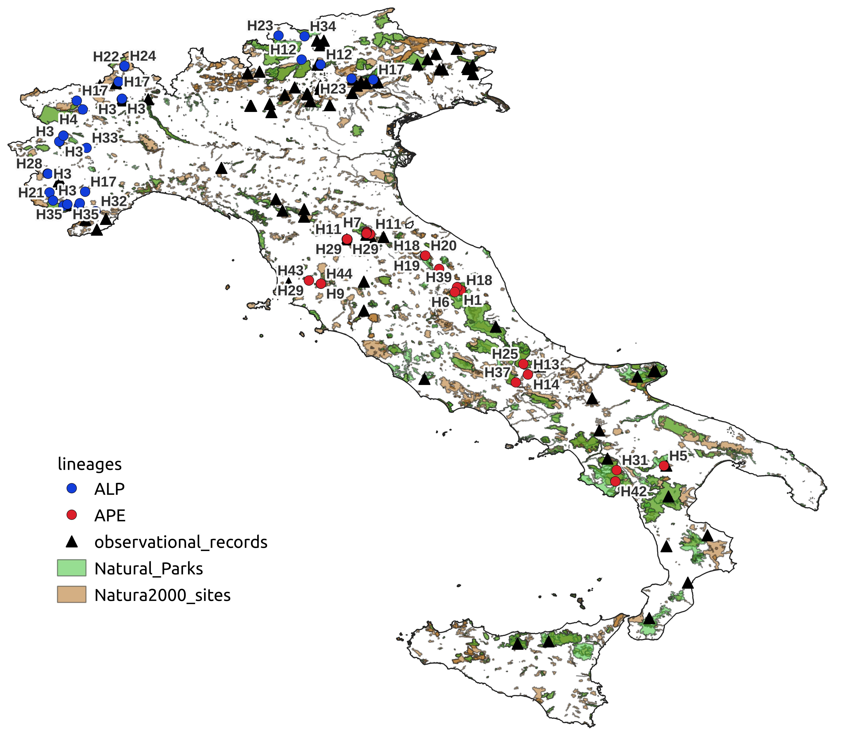
1.3. Discussion
Results of the overlap analysis suggested that known populations of U. glabra are overall well represented within the existing Italian network of protected areas (60% of genetic sampling sites and 33% of observational records). In terms of genetic representation, all haplotypes of the APE lineage, which is also the most phylogenetically diverse, are included in the conservation network, and may therefore be less vulnerable to habitat loss and degradation from anthropogenic pressure; in contrast, the ALP lineage may be at higher risk of haplotype erosion, due to its markedly lower representation in protected areas. The observed difference in the percentage of protected sites between genetic and observational records may be partially attributed to sampling bias, as genetic sampling efforts were likely more concentrated within protected areas. Nonetheless, the lineage-specific trend discussed above is consistent across both datasets, reinforcing the conclusion that the APE lineage benefits from greater conservation coverage. A plausible explanation for the contrasting protection status of the ALP and APE lineages lies in the geographic distribution of protected areas across the Italian peninsula. Indeed, Italian National and Regional Parks, as well as other terrestrial protected zones, are far more prevalent in mountainous regions [3] and, while U. glabra is typically a mountain species in its Apennine range, in Northern Italy it can also be found at lower elevations (particularly at foothills and in internal valleys) [4], which tend to be underrepresented in the current conservation network.
The proximity analysis revealed that most known U. glabra populations occur either within or in close vicinity (<5 km) of protected areas (100% of genetic sites and 69% of observational records). This suggests that existing conservation networks may encompass more populations than those identified through overlap analysis alone, assuming that short distances between observations and protected sites reflect a higher likelihood of species presence within those areas, even in the absence of confirmed records.
However, the large distances observed between observational records and sites with available genetic data, with half of them (52.6%) located > 50 Km distant, highlight spatial gaps in genetic sampling. These gaps may be relevant for conservation planning, as some haplotypes – or even entire haplogroups – might not have been captured in the current genetic survey.
Future efforts should (a) prioritize expanding the spatial coverage of genetic sampling, particularly in under-sampled areas with high habitat suitability, and (b) monitor natural parks and reserves where the species has not yet been recorded but may be present due to their proximity to known populations. Even in the absence of confirmed records, these areas could still represent suitable targets for reforestation or assisted migration, using nearby populations as sources – provided that habitat suitability is high and projected to remain stable in the near future.
Indeed, reforestation using local provenances should be preferable, because they are presumed to match environmental conditions of the target sites and avoid maladaptations [5].

2. Aligning protection with habitat suitability: present and future scenarios for U. glabra
2.1. Methods
We analyzed spatial patterns of habitat suitability in relation to protection status using the dataset of all U. glabra georeferenced sites (genetic sampling sites and field observations), each characterized by current and projected future habitat suitability values, as predicted by lineage-based Maxent models (see Results, subsection 3). Sites were classified as either “protected” or “unprotected” based on their spatial overlap with Natura 2000 sites and national or regional parks, as determined by the overlap analysis. Differences in current habitat suitability between protected and unprotected areas were visualized using boxplots. To test for statistical differences in suitability distributions between the two groups, we applied the non-parametric Wilcoxon rank-sum test, using the wilcox.test function from the stats R package.
Future changes in suitability were calculated as the difference between projected future suitability (under SSP5 8.5, 2061-2080; the furthest time horizon and most severe emission scenario; see Results, subsection 4) and current suitability. These changes were categorized into three classes: “Decrease” (< -0.05), “Stable” (-0.05 to +0.05), and “Increase” (> +0.05). Frequencies of change classes were compared between protected and unprotected sites using bar plots.
To integrate both the current condition and future trend, we classified current habitat suitability into three categories: “Low” (< 0.3), “Medium” (0.3-0.6), and “High” (> 0.6), and crossed these with the suitability change classes to define nine composite categories: “High and Decreasing”, “High and Stable”, “High and Increasing”, “Medium and Decreasing”, “Medium and Stable”, “Medium and Increasing”, “Low and Decreasing”, “Low and Stable”, and “Low and Increasing”. The distribution of these combined suitability profiles was then compared across protection status groups.
All analyses were conducted in R [6]. Data manipulation and summarization were performed using the dplyr package [7], and visualization was done using ggplot2 [8]. Plot arrangements and statistical comparisons were facilitated by ggpubr [9]. All analyses were performed on the full dataset as well as separately by lineage (ALP and APE).
2.2. Results
Overall, presence sites located within protected areas were characterized by medium to high levels of current habitat suitability, with an average suitability value of 0.60 ± 0.18. In contrast, sites outside protected areas showed a lower average suitability (0.51 ± 0.18). However, lineage-based analyses revealed a contrasting pattern between ALP and APE (Table 3; Fig. 2a,2b). In ALP, protected and unprotected sites exhibited nearly identical average suitability values. Conversely, in APE, the average suitability in protected sites (0.63) was almost double that of unprotected sites (0.34), with this difference being highly significant (Wilcoxon test, p < 0.001).
Different patterns emerged between ALP and APE, also when analyzing the distribution of future habitat suitability change, combined with current suitability (Table 4; Fig. 2c,2d). In the ALP lineage, the largest proportion of sites were located in unprotected areas with medium and stable habitat suitability (43.75%), followed by unprotected sites with high and stable suitability (26.25%), and unprotected sites with high but decreasing suitability (6.25%). Protected sites with medium or high and non-decreasing suitability accounted for only 10% of all sites.
In contrast, the APE lineage exhibited an opposite trend: nearly half of the records (47.89%) were located in protected areas with high and stable suitability, followed by protected sites with medium and stable suitability (18.31%). A notable portion (7%) of protected sites also showed medium and increasing suitability. Among unprotected sites, the most frequent class was low and stable suitability (11.27%), followed by medium and stable suitability (5.63%).
Overall, the two lineages therefore showed a contrasting pattern in relation to protection status: in ALP, 71% of known U. glabra populations occur in unprotected areas with medium to high, and stable or increasing habitat suitability, while in APE, 73% of known populations are found in protected areas with medium to high, and stable or increasing suitability.
Raw results of the spatial analysis of habitat suitability for U. glabra occurrences in relation to protection status are provided in Table S5.

Table 3. Average habitat suitability values (Maxent) of U. glabra known populations (genetic sampling sites and field observations), in relation to protection status; Protected = site included in protected areas; Unprotected = site not included in protected areas; Lineage classification: ALP = Alps; APE = Apennines; ND = Not Determined (observational records from Sicily).

Category | Protection Status | n | Current habitat suitability (mean ± SD)
Overall | Protected | 71 | 0.60 ± 0.18
 | Unprotected | 82 | 0.51 ± 0.18
By Lineage
ALP | Protected | 14 | 0.56 ± 0.17
 | Unprotected | 66 | 0.55 ± 0.14
APE | Protected | 55 | 0.63 ± 0.17
 | Unprotected | 16 | 0.34 ± 0.21
N.D. | Protected | 2 | 0.28 ± 0.05
 | Unprotected | / | /

Table 4. Distribution of U. glabra occurrences (genetic sites and observations), in relation to combined classes of current suitability x future variation, by protection status. Protected = site included in protected areas; Unprotected = site not included in protected areas; Low / Decrease, Medium / Decrease, High / Decrease: current suitability Low/Medium/High combined with decrease in future suitability; Low / Stable, Medium / Stable, High / Stable: current suitability Low/Medium/High combined with stable future suitability; Low / Increase, Medium / Increase, High / Increase: current suitability Low/Medium/High combined with increase in future suitability. Bold = potential climatic refugia (i.e., medium to high current suitability and stable or increasing)

Category | Protection | Combined class  (current suitability / future trend) | n |  |  | %
Overall | Unprotected | Low / Decrease | 0 |  |  | 0
 | Unprotected | Medium / Decrease | 1 |  |  | 0.65
 | Unprotected | High / Decrease | 5 |  |  | 3.27
 | Unprotected | Low / Stable | 10 |  |  | 6.54
 | Unprotected | Medium / Stable | 39 |  |  | 25.49
 | Unprotected | High / Stable | 23 |  |  | 15.03
 | Unprotected | Low / Increase | 2 |  |  | 1.31
 | Unprotected | Medium / Increase | 2 |  |  | 1.31
 | Unprotected | High / Increase | 0 |  |  | 0
 | Protected | Low / Decrease | 0 |  |  | 0
 | Protected | Medium / Decrease | 2 |  |  | 1.31
 | Protected | High / Decrease | 2 |  |  | 1.31
 | Protected | Low / Stable | 4 |  |  | 2.61
 | Protected | Medium / Stable | 17 |  |  | 11.11
 | Protected | High / Stable | 39 |  |  | 25.49
 | Protected | Low / Increase | 2 |  |  | 1.31
 | Protected | Medium / Increase |  |  | 5 | 3.27
 | Protected | High / Increase |  |  | 0 | 0
By Lineage
ALP | Unprotected | Low / Decrease |  | 0 |  | 0
 | Unprotected | Medium / Decrease |  | 0 |  | 0
 | Unprotected | High / Decrease |  | 5 |  | 6.25
 | Unprotected | Low / Stable |  | 2 |  | 2.5
 | Unprotected | Medium / Stable |  | 35 |  | 43.75
 | Unprotected | High / Stable |  | 21 |  | 26.25
 | Unprotected | Low / Increase |  | 2 |  | 2.5
 | Unprotected | Medium / Increase |  | 1 |  | 1.25
 | Unprotected | High / Increase |  | 0 |  | 0
 | Protected | Low / Decrease |  | 0 |  | 0
 | Protected | Medium / Decrease |  | 2 |  | 2.5
 | Protected | High / Decrease |  | 1 |  | 1.25
 | Protected | Low / Stable |  | 1 |  | 1.25
 | Protected | Medium / Stable |  | 3 |  | 3.75
 | Protected | High / Stable |  | 5 |  | 6.25
 | Protected | Low / Increase |  |  | 2 | 2.5
 | Protected | Medium / Increase |  |  | 0 | 0
 | Protected | High / Increase |  |  | 0 | 0
APE | Unprotected | Low / Decrease |  |  | 0 | 0
 | Unprotected | Medium / Decrease |  |  | 1 | 1.41
 | Unprotected | High / Decrease |  |  | 0 | 0
 | Unprotected | Low / Stable |  |  | 8 | 11.27
 | Unprotected | Medium / Stable |  |  | 4 | 5.63
 | Unprotected | High / Stable |  |  | 2 | 2.82
 | Unprotected | Low / Increase |  |  | 0 | 0
 | Unprotected | Medium / Increase |  |  | 1 | 1.41
 | Unprotected | High / Increase |  |  | 0 | 0
 | Protected | Low / Decrease |  |  | 0 | 0
 | Protected | Medium / Decrease |  |  | 0 | 0
 | Protected | High / Decrease |  |  | 1 | 1.41
 | Protected | Low / Stable |  |  | 2 | 2.82
 | Protected | Medium / Stable |  |  | 13 | 18.31
 | Protected | High / Stable |  |  | 34 | 47.89
 | Protected | Low / Increase |  |  | 0 | 0
 | Protected | Medium / Increase |  |  | 5 | 7.04
 | Protected | High / Increase |  |  | 0 | 0
Figure 2. Site protection and habitat suitability: present and future scenarios; (a,b) Current habitat suitability values for U. glabra in protected vs unprotected sites of presence, for ALP and lineage respectively (Wilcoxon test p-value = 0.48 for ALP, < 0.001 for APE); (c,d) Distribution of combined current and projected habitat suitability classes by protection status, for ALP and APE. Low -, Medium -, High - : Current suitability Low/Medium/High combined with Decrease in future suitability; Low =, Medium =, High = : Current suitability Low/Medium/High combined with Stable future suitability; Low +, Medium +, High + : Current suitability Low/Medium/High combined with Increase in future suitability.

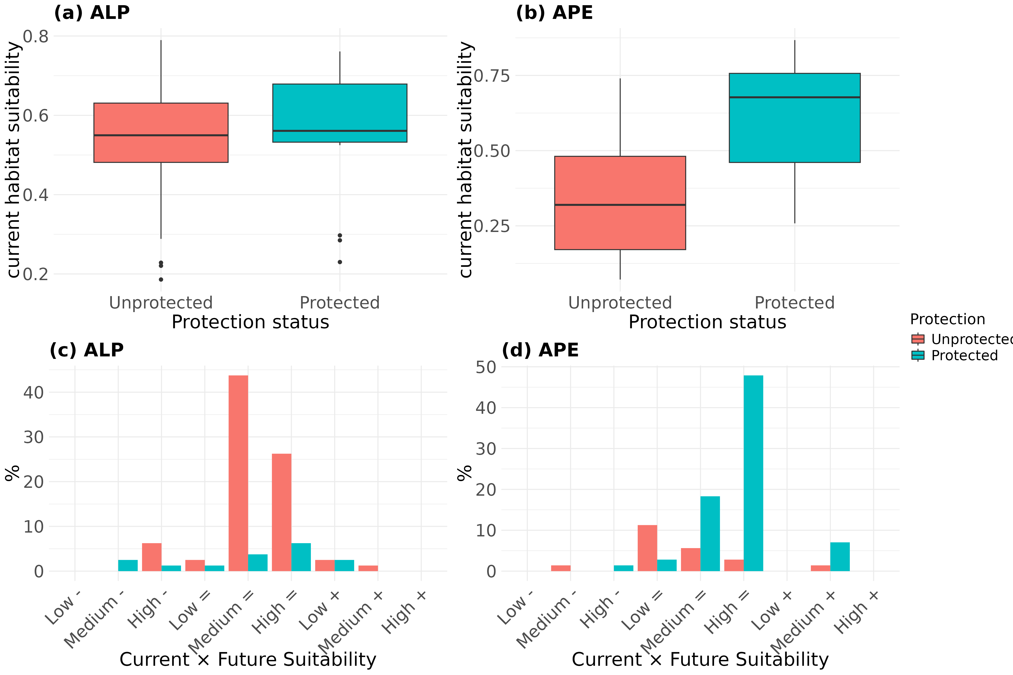
2.2. Discussion
Our findings revealed a marked contrast in the spatial relationship between habitat suitability and protection status across the two U. glabra lineages (ALP and APE). At a general level, sites within protected areas were associated with higher average current habitat suitability compared to those outside the protected network. However, lineage-specific analyses highlighted divergent patterns that suggest different conservation priorities for each lineage.
In the APE lineage, protected areas appear to effectively encompass the most suitable habitats for the species. The significantly higher average suitability in protected sites (0.63) compared to unprotected ones (0.34) underscores the importance of existing conservation measures in safeguarding APE populations. Moreover, a substantial portion of protected APE sites not only exhibit high current suitability but are also projected to maintain or improve their suitability in the future. This indicates that the protected area network is well-aligned with the ecological requirements of the APE lineage under current and projected environmental conditions.
Conversely, the ALP lineage displayed a more even distribution of habitat suitability across protected and unprotected areas, with no significant difference in average suitability values.
Notably, the majority of ALP populations are located outside protected areas (Table 1), many of which exhibit medium to high and stable or increasing suitability. This suggests that current conservation frameworks may inadequately cover key habitats for the ALP lineage.
The contrasting suitability patterns observed between ALP and APE in relation to protection status
likely reflect, at least in part, the already discussed niche differentiation between the two lineages,
coupled with different geographic characteristics of the Alps and Apennines and the geographic distribution of protected areas across the Italian peninsula. While APE in its Apennine range benefits from the higher concentration of protected areas in montane environments, ALP populations are more widespread across Northern Italy, including areas which are less-represented in the protected area network. By reinforcing patterns observed in previous analyses, these results provide additional support for implementing lineage-specific conservation strategies for U. glabra in the Italian peninsula. For the APE lineage, maintaining the integrity of existing protected areas may be sufficient to ensure long-term persistence. In contrast, effective conservation of ALP will likely require expanding protection efforts to encompass high-quality unprotected habitats.

References
1. EEA (European Environment Agency). Natura 2000 data - the European network of protected sites. 2022.
2. EUAP, Ministero dell’Ambiente e della Sicurezza Energetica – Direzione Protezione della Natura e del Mare. 2010. VI Elenco ufficiale delle aree naturali protette (EUAP). Retrieved on 4 July 2025 from the Geoportale Nazionale WFS web service: http://wms.pcn.minambiente.it/ogc?map=/ms_ogc/wfs/EUAP.map.
3. Maiorano L, Falcucci A, Boitani L. Gap analysis of terrestrial vertebrates in Italy: priorities for conservation planning in a human dominated landscape. Biological Conservation. 2006; 133(4): 455-473.
4. Pignatti S. Flora d'Italia. Edagricole, Bologna, Italy. 2017.
5. Krauss SL, Koch JM. Methodological insights: rapid genetic delineation of provenance for plant community restoration. Journal of Applied Ecology. 2004; 41(6): 1162-1173
6. R Core Team. R: A Language and Environment for Statistical Computing. R Foundation for Statistical Computing, Vienna, Austria. 2025. https://www.R-project.org/
7. Wickham H, François R, Henry L, Müller K. dplyr: A Grammar of Data Manipulation. R package version 1.1.3. 2023. https://CRAN.R-project.org/package=dplyr
8. Wickham H. ggplot2: Elegant Graphics for Data Analysis. Springer-Verlag New York. 2016.
9. Kassambara A. ggpubr: 'ggplot2' Based Publication Ready Plots. R package version 0.6.0. 2023. https://CRAN.R-project.org/package=ggpubr

