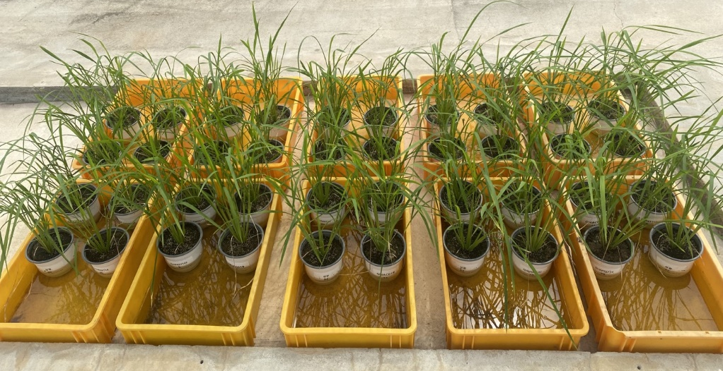
Supplementary Figure 1. Experiment setup for bacterial blight resistance assay and RNA-seq analysis. Samkwang and three knockout mutants (SK-s14, SK-w102, SK-n019) were inoculated with mock (MgCl_{２}) and Xoo (KACC10859) at 42 days after sowing.

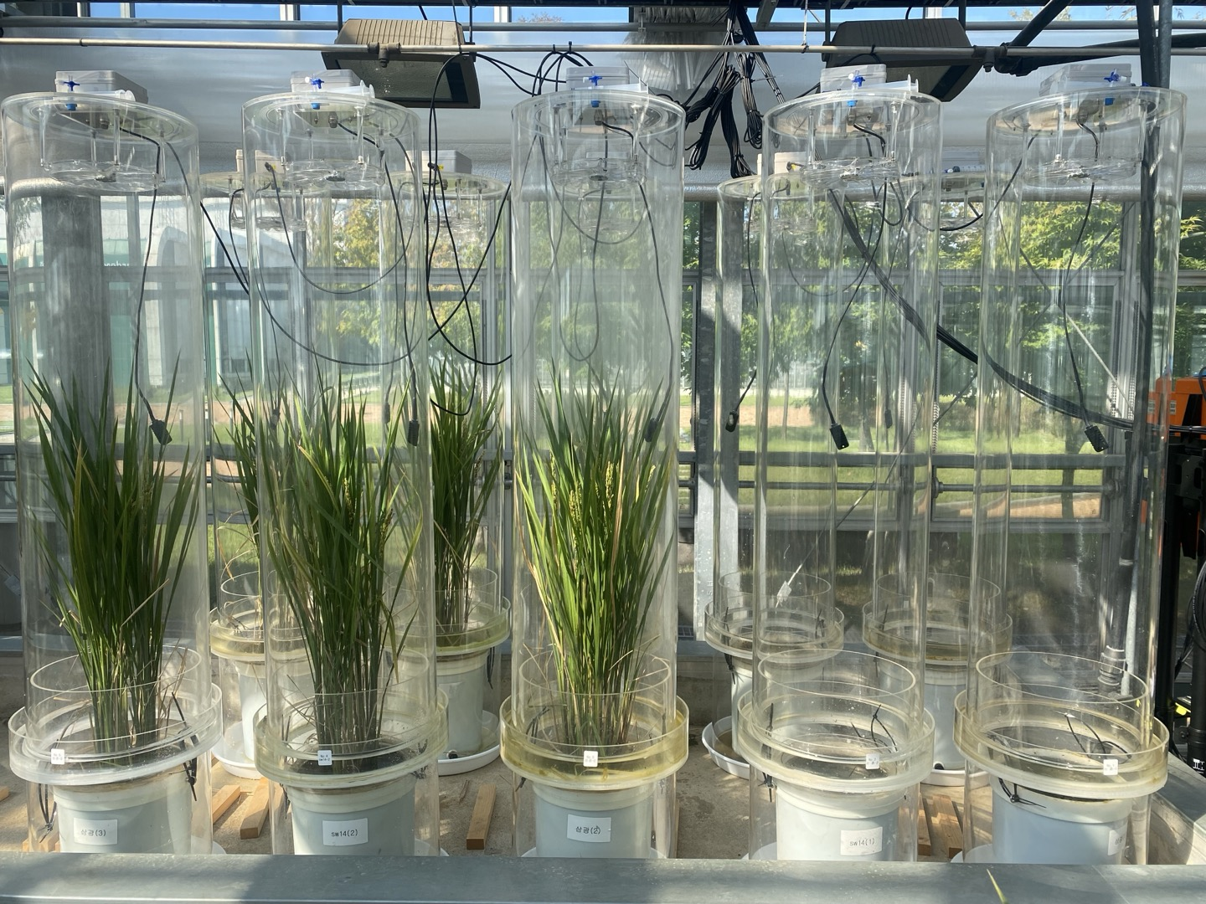
Supplementary Figure 2. Closed chamber experiment setup for methane gas collection.
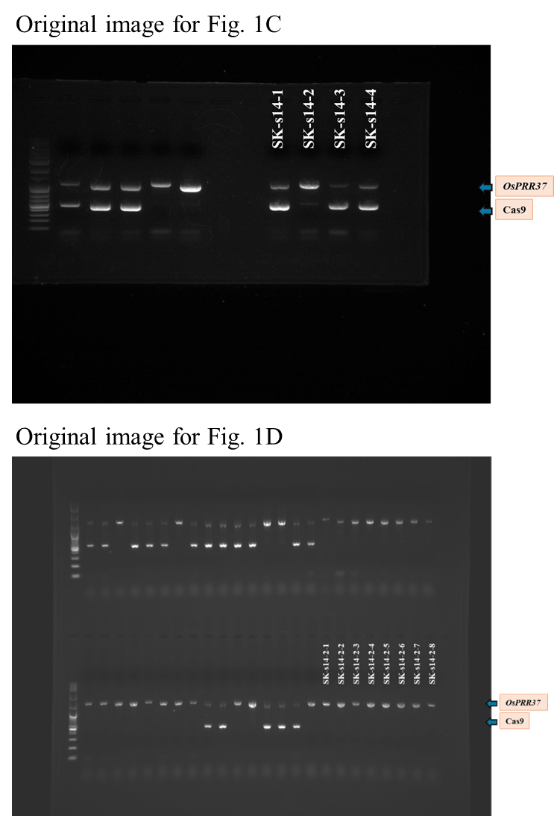
Supplementary Figure 3. Full-length gel image corresponding to Fig. 1C-D. Screening for Cas9 null-segregants of SK-s14 at T₁ and T₂ generation, respectively. Unused lanes are not labeled.
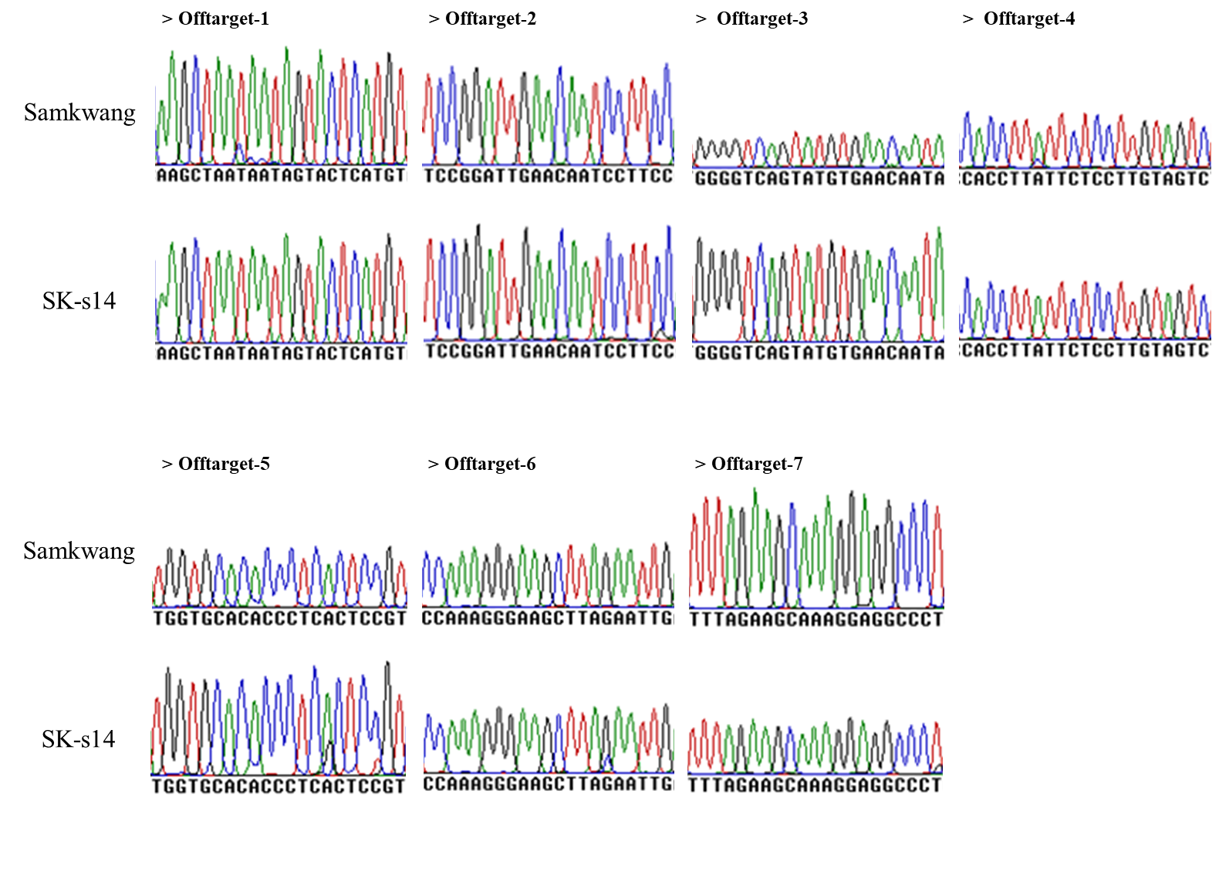
Supplementary Figure 4. Chromatograms of the seven selected off-target sites. See Table S2 for the positions and details of the selected off-target sites.
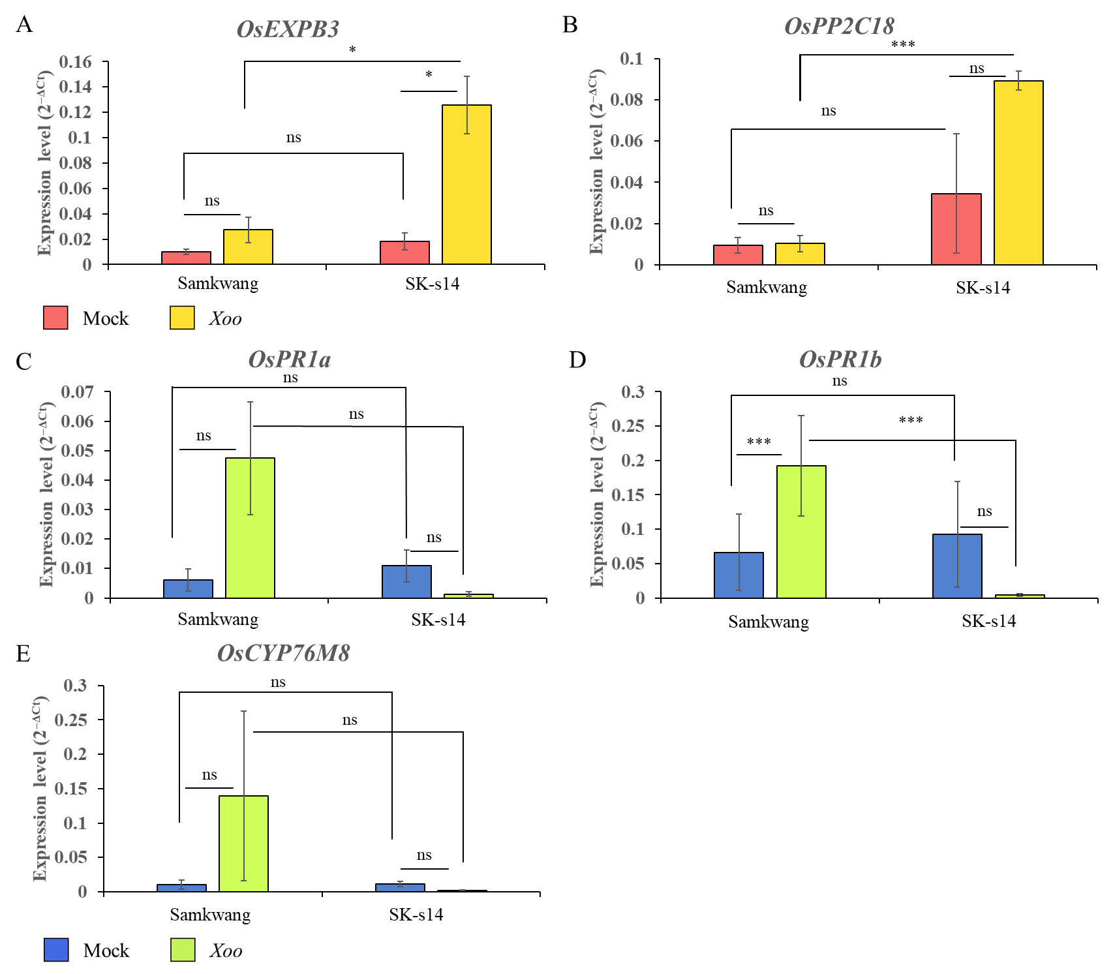
Supplementary Figure 5. qRT-PCR validation of selected DEGs. A, B Up-regulated DEGs; C–E Down-regulated DEGs. Relative expression levels were calculated using the 2^{-ΔCt} method, with three biological replicates. Each bar represents mean ± standard error (*** P < 0.001, ** P < 0.01, * P < 0.05, ^{ns} not significant).

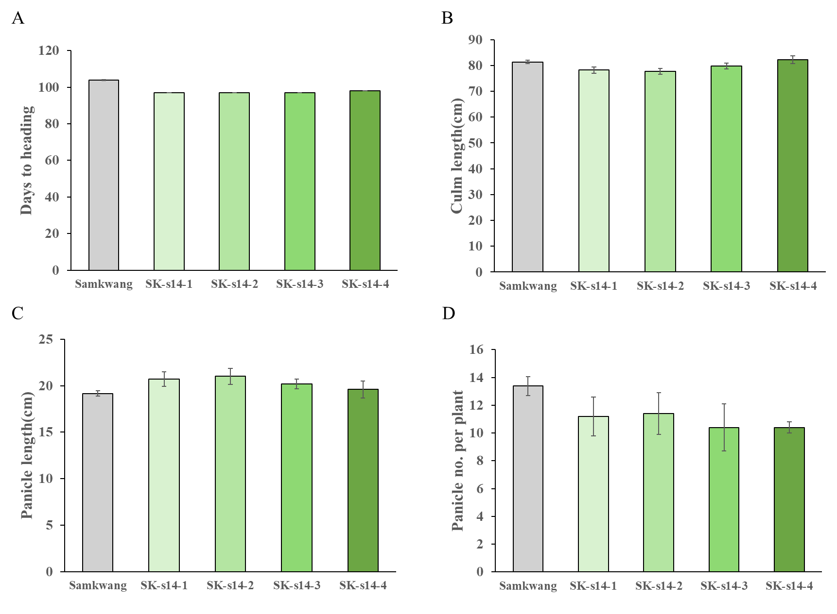
Supplementary Figure 6. Agronomic traits of SK-s14 (T₂ generation) in comparison with Samkwang. A Days to heading; B Culm length; C Panicle length; D Panicle number per plant. Each genotype was grown in a single row composed of 20 plants. Error bars represent stand errors.
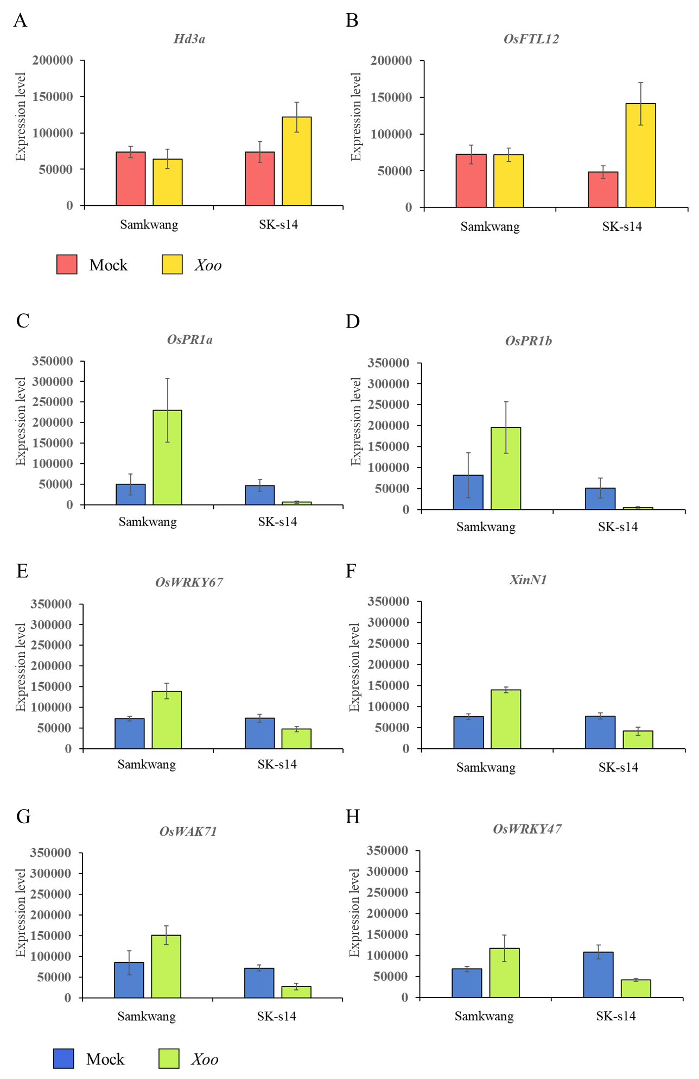
Supplementary Figure 7. Expression level of DEGs annotated in GO analysis. A, B Up-regulated DEGs; C–H Down-regulated DEGs. Expression level is based on TPM (transcripts per kilobase million). Each bar represents mean ± standard error.

