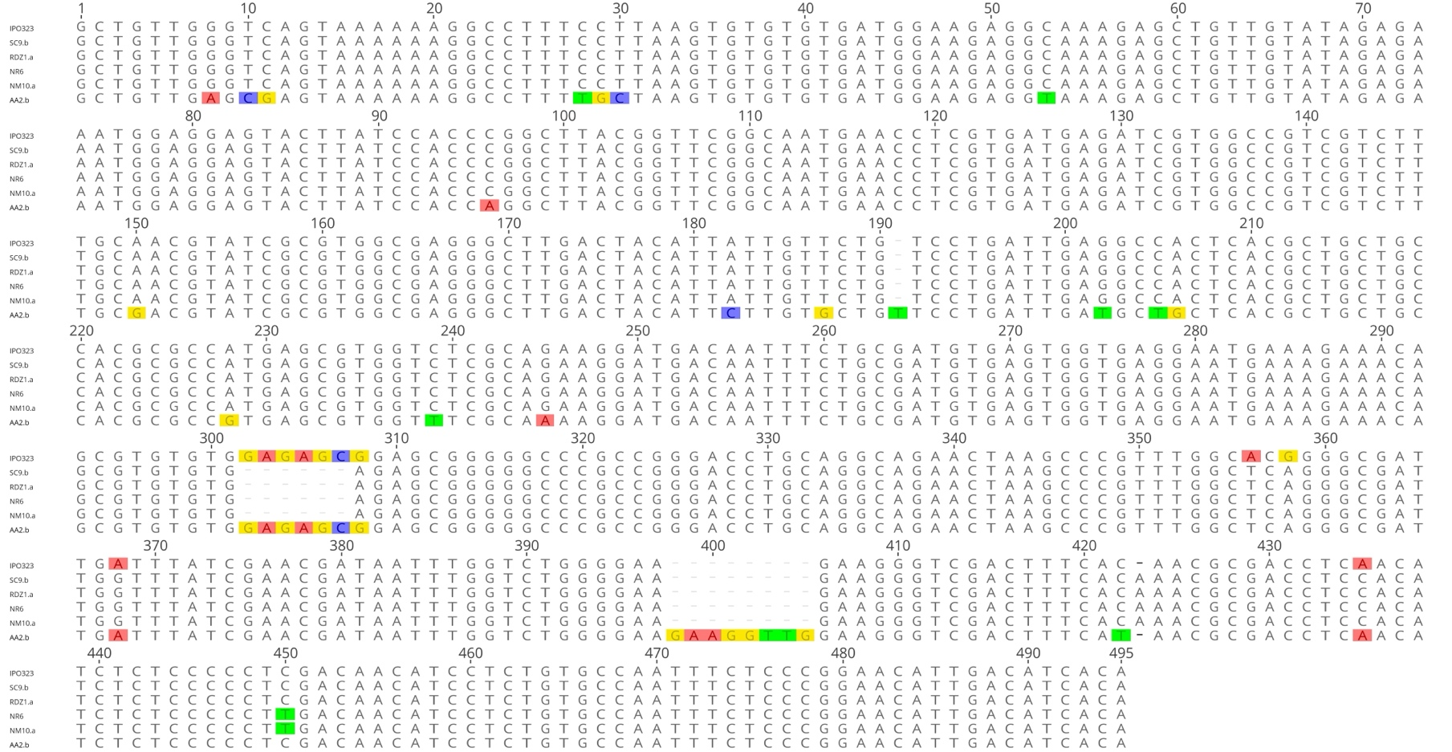

Figure S3 Sequence alignment of the 495 bp upstream region of the ZtCYP51 gene among seven Zymoseptoria tritici isolates. The promoter region of isolate AA2.b displays multiple point mutations and a unique 8 bp insertion spanning positions 398–405, which is absent in all other isolates. Additionally, isolates SC9.b, RDZ1.a, NR6, and NM10.a share a 6 bp deletion at positions 302–307. Repeated attempts to amplify this region in isolate KNA3 were unsuccessful, likely due to high sequence divergence or structural rearrangements. Conserved nucleotide regions are shaded in grey, and deletions are represented by dashed lines.

