Supplementary materials
Characterization of the mango phyllosphere microbiome during fruit-setting unveils unique community assembly and coexisting beneficial-pathogenic microbiota

Muzammil Hussain^{1,2,3,#}, Nazir Ahmed^{1,2,3,#}, Xiaona Xie^{1,2,3}, Zheng Teng^{1,2,3}, Xianbin Hou^{1,2,3}, Xi Li^{1,2,3}, Zhengzhou Yang^{1,2,3,*}, Zhengjie Zhu^{1,2,3*}

¹ College of Agriculture and Food Engineering, Baise University, Baise 533000, China
² Guangxi Key Laboratory of Biology for Mango, Baise 533000, China
³College of Subtropical Characteristic Agricultural Industry, Baise, China
# These authors contributed equally to this work.

Corresponding author’s email: yzz@bsuc.cn (Z. Yang)
zhuzhjie@bsuc.edu.cn (Z. Zhu)

ORCID: 0000-0001-6681-7513 (M. Hussain)

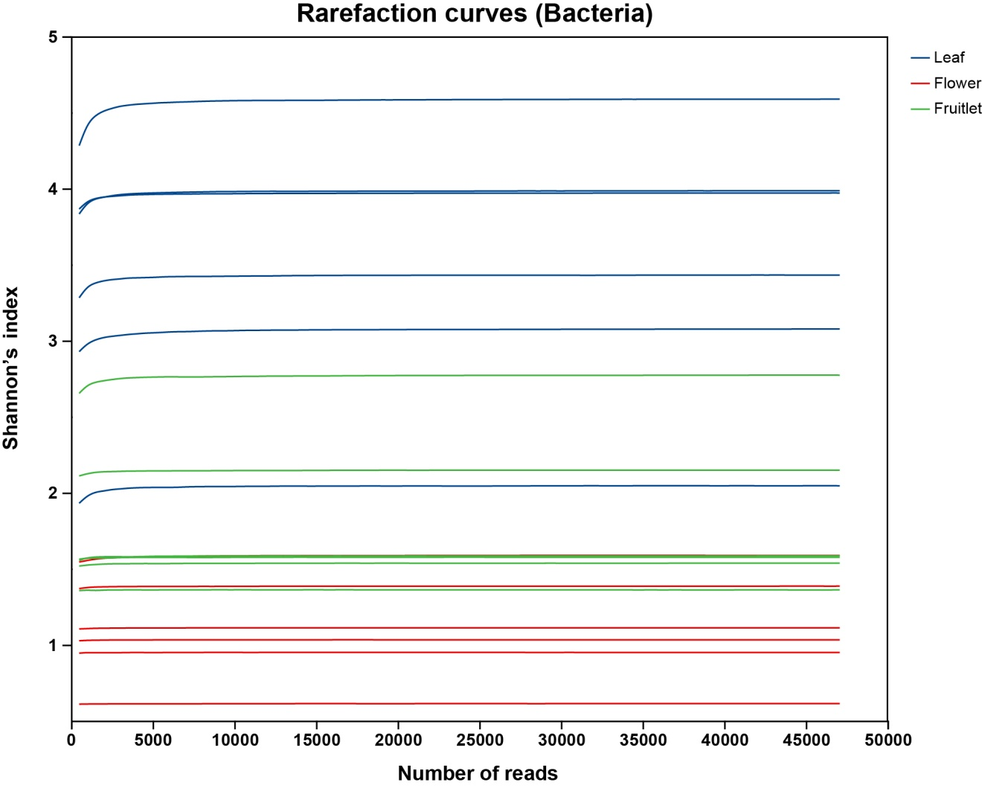
Figure S1. Rarefaction curves of mango leaf, flower and fruitlet samples. The Shannon index-based rarefaction curves indicating that the sequencing depth adequately captured the bacterial diversity present in the samples.

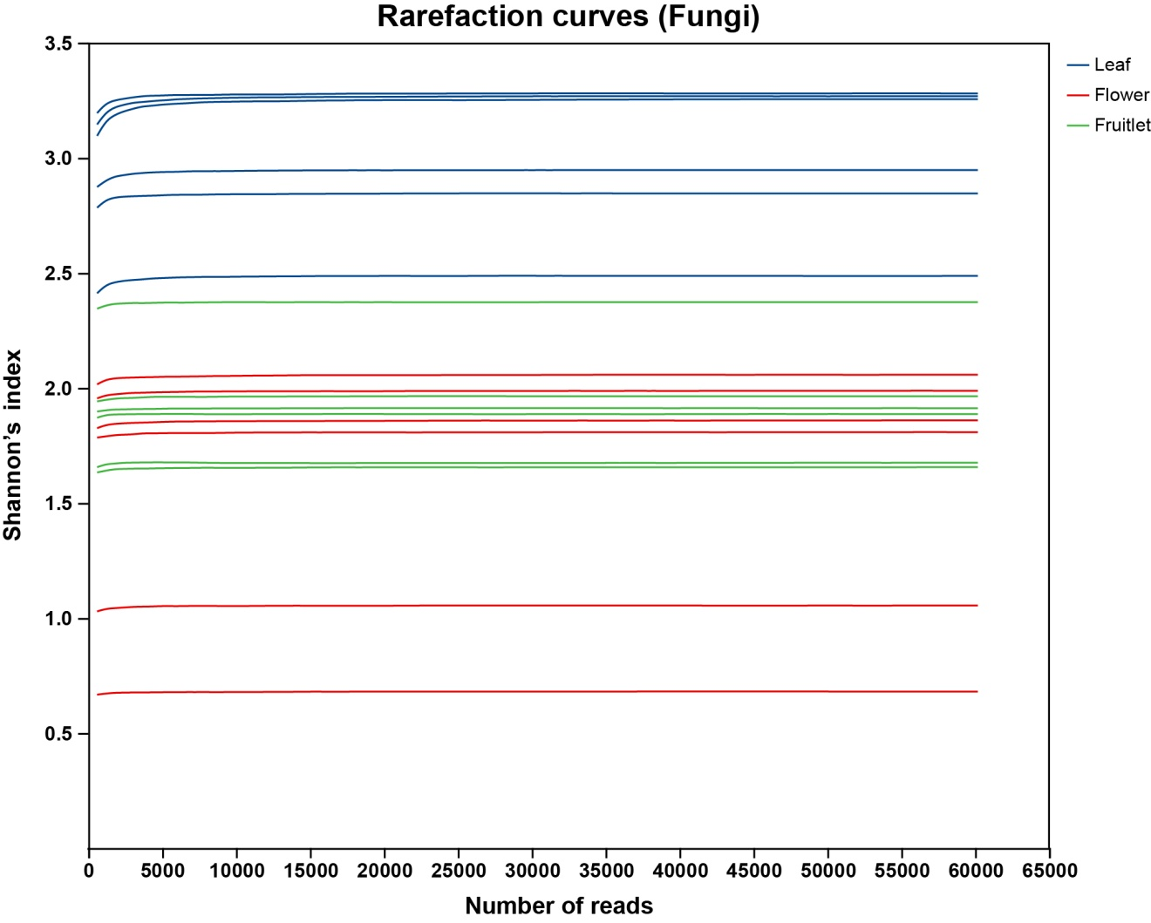
Figure S2. Rarefaction curves of mango leaf, flower and fruitlet samples. The Shannon index-based rarefaction curves indicating that the sequencing depth adequately captured the fungal diversity present in the samples.

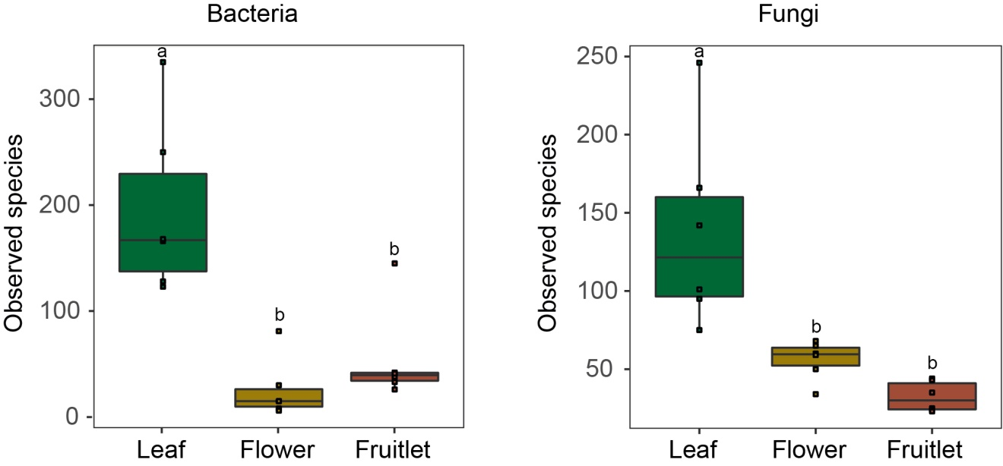
Figure S3. Observed species of bacterial and fungal communities in mango phyllosphere microbiome.

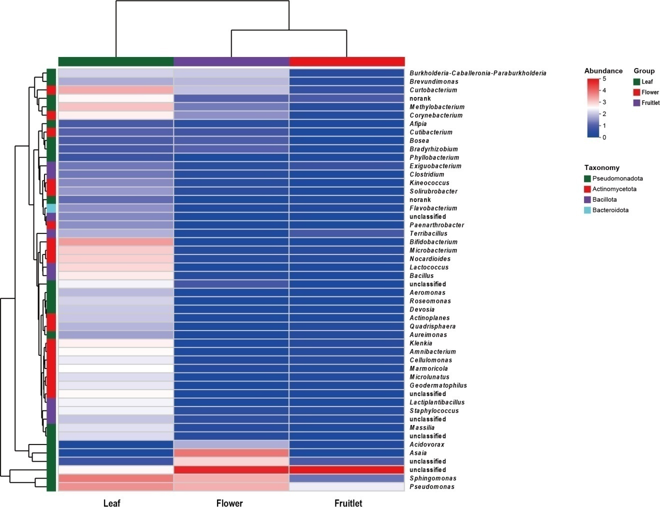
Figure S4. Heatmap showing the relative abundance of top 50 bacterial genera inhabiting the mango leaves, flowers and fruitlets.

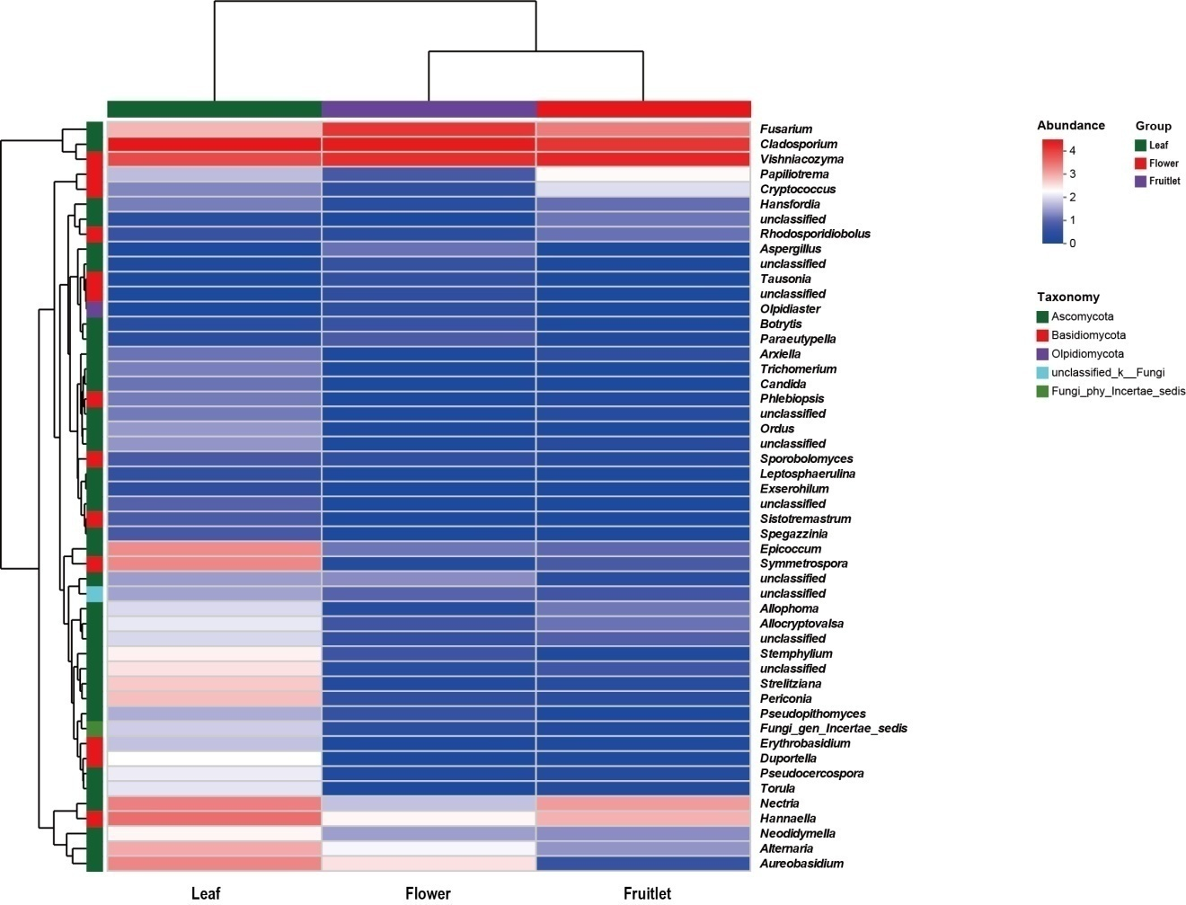
Figure S5. Heatmap showing the relative abundance of top 50 funagl genera inhabiting the mango leaves, flowers and fruitlets.

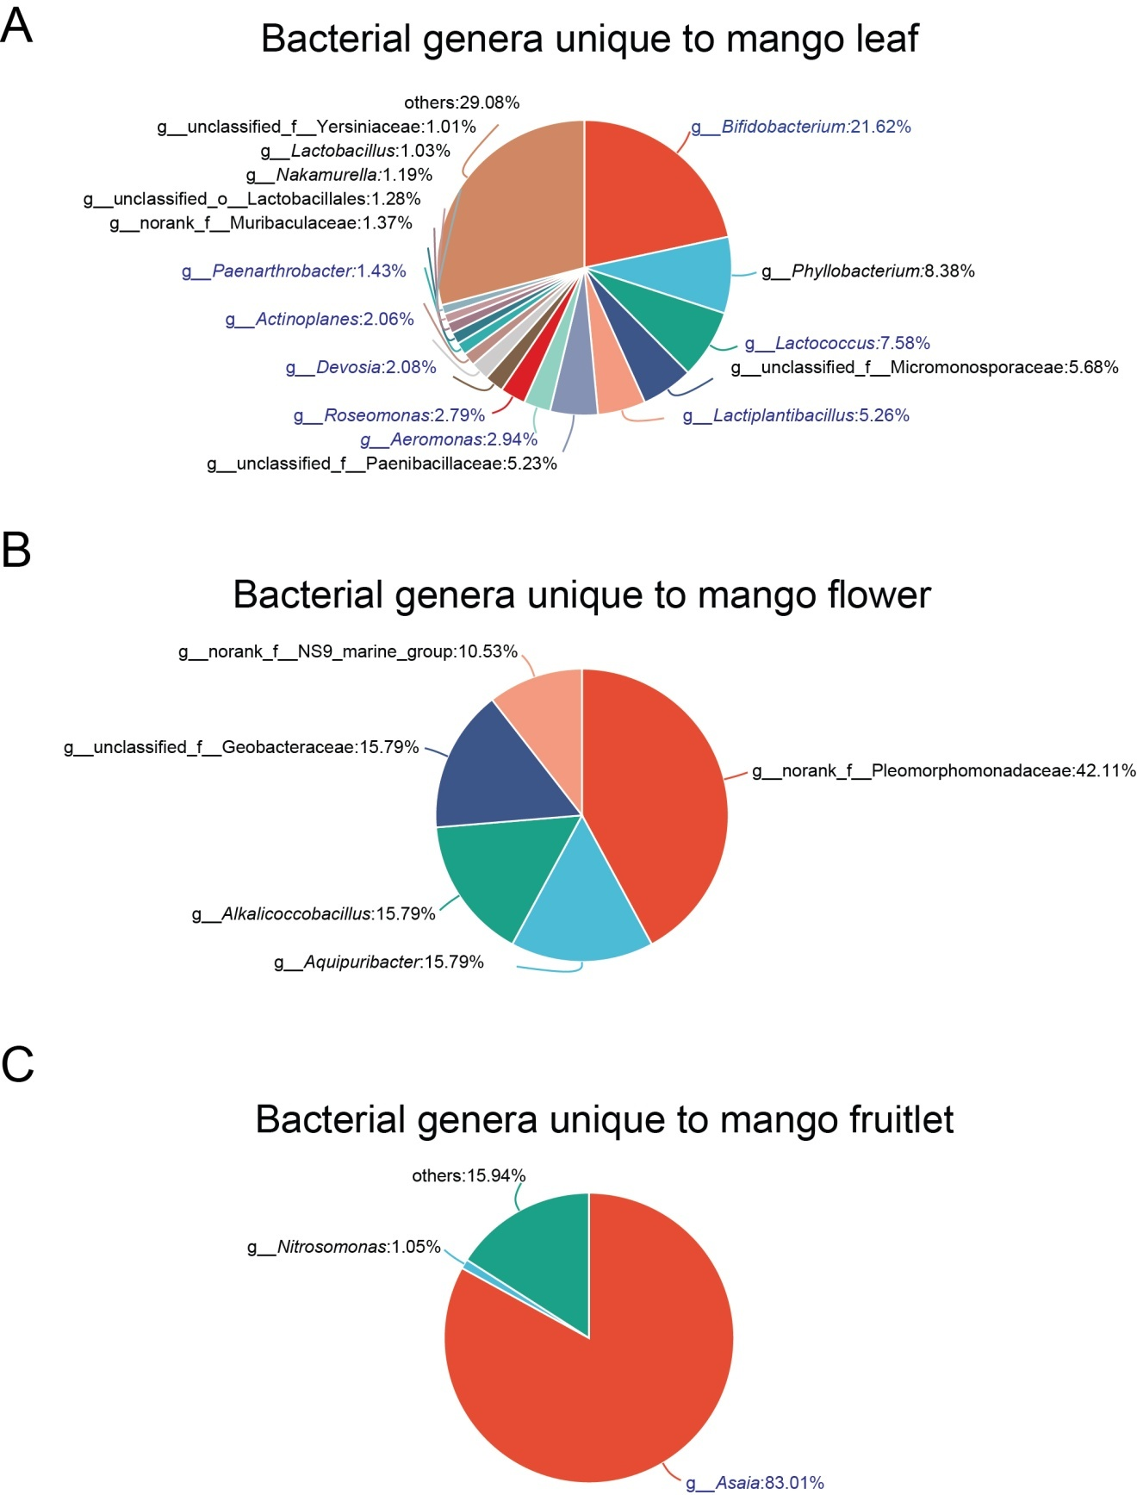
Figure S6. The unique bacterial taxa across leaves (A), flowers (B), and fruitlets (C) at the genus level are depicted in the pie chart. Core bacterial genera are highlighted in blue font in the pie chart.

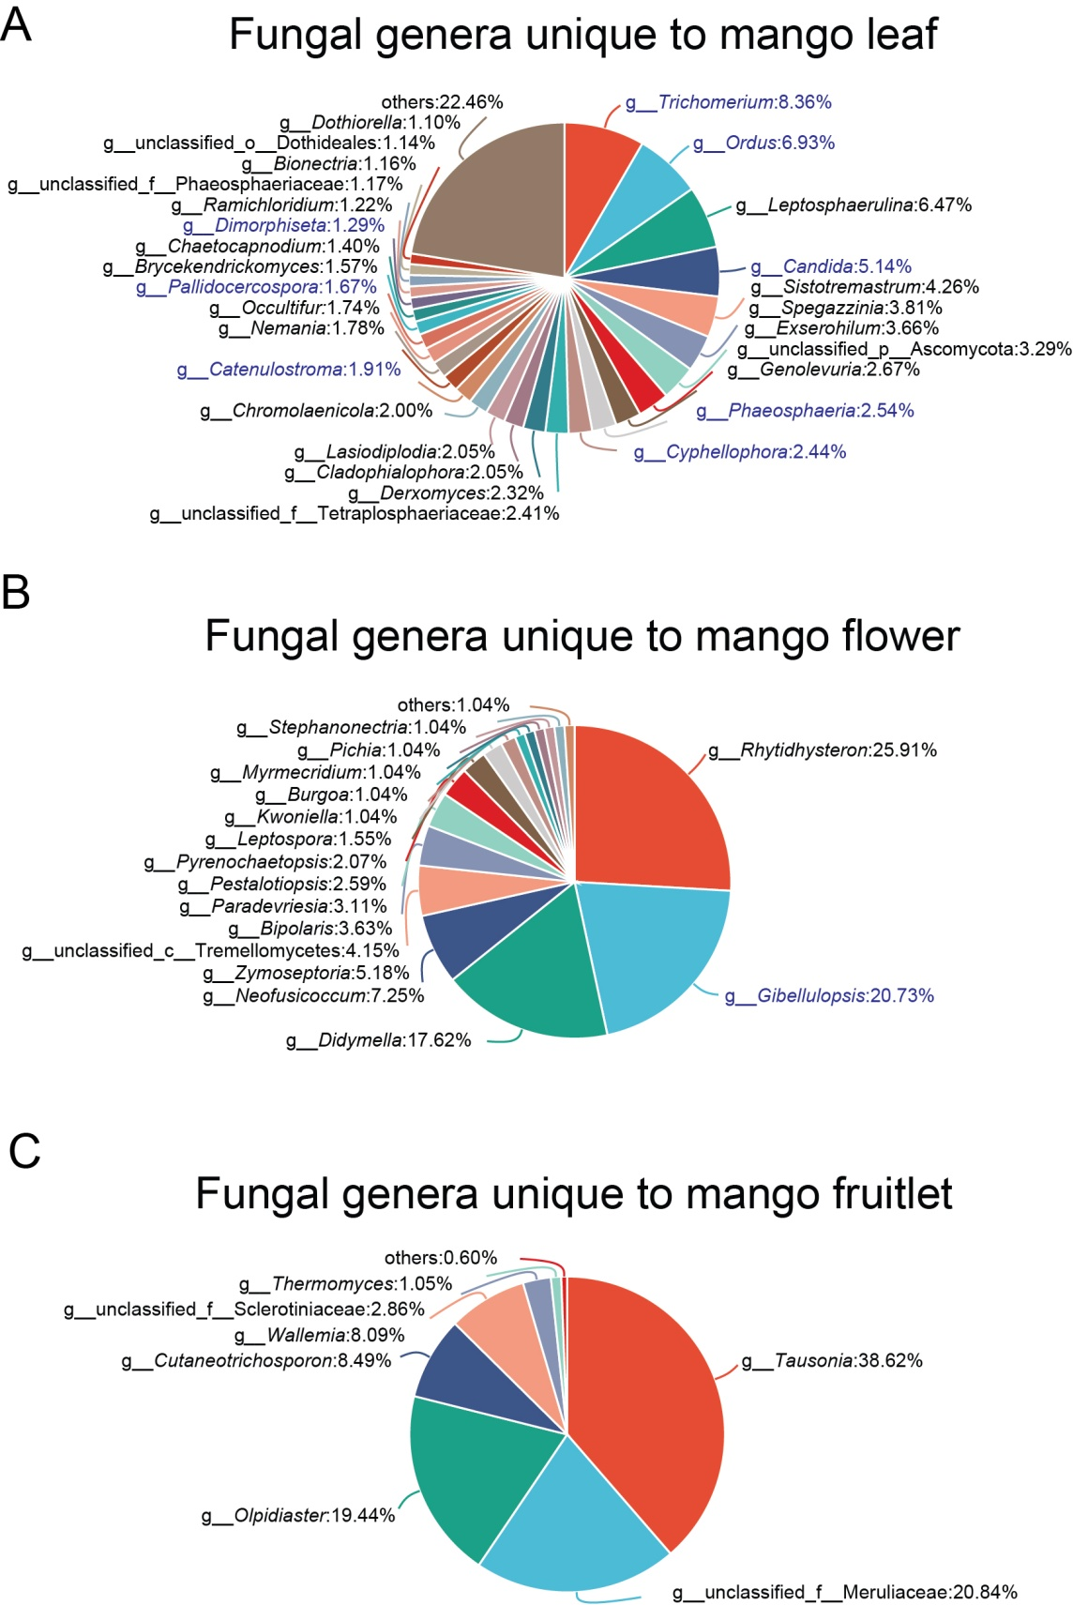
Figure S7. The unique fungal taxa across leaves (A), flowers (B), and fruitlets (C) at the genus level are depicted in the pie chart. Core fungal genera are highlighted in blue font in the pie chart.

Table S1. Taxonomic information of bacterial ASVs significantly enriched in mango leaves as compared to both flowers and fruitlets.
S. No. | ASVs | taxonomy
1 | ASV102 | d__Bacteria;p__Bacillota;c__Bacilli;o__Lactobacillales;f__Lactobacillaceae;g__Lactiplantibacillus
2 | ASV36 | d__Bacteria;p__Actinomycetota;c__Actinobacteria;o__Micrococcales;f__Microbacteriaceae;g__Curtobacterium
3 | ASV53 | d__Bacteria;p__Actinomycetota;c__Actinobacteria;o__Frankiales;f__Frankiaceae;g__Jatrophihabitans
4 | ASV17 | d__Bacteria;p__Actinomycetota;c__Actinobacteria;o__Bifidobacteriales;f__Bifidobacteriaceae;g__Bifidobacterium
5 | ASV19 | d__Bacteria;p__Bacillota;c__Bacilli;o__Bacillales;f__Bacillaceae;g__Bacillus
6 | ASV20 | d__Bacteria;p__Pseudomonadota;c__Gammaproteobacteria;o__Pseudomonadales;f__Pseudomonadaceae;g__Pseudomonas
7 | ASV99 | d__Bacteria;p__Pseudomonadota;c__Gammaproteobacteria;o__Pseudomonadales;f__Pseudomonadaceae;g__Pseudomonas
8 | ASV45 | d__Bacteria;p__Actinomycetota;c__Actinobacteria;o__Frankiales;f__Geodermatophilaceae;g__Klenkia
9 | ASV208 | d__Bacteria;p__Actinomycetota;c__Actinobacteria;o__Kineosporiales;f__Kineosporiaceae;g__Quadrisphaera
10 | ASV73 | d__Bacteria;k__norank_d__Bacteria;p__Actinomycetota;c__Actinobacteria;o__Propionibacteriales;f__Nocardioidaceae;g__Marmoricola
11 | ASV229 | d__Bacteria;p__Pseudomonadota;c__Gammaproteobacteria;o__Pseudomonadales;f__Moraxellaceae;g__Acinetobacter
12 | ASV31 | d__Bacteria;p__Bacillota;c__Bacilli;o__Lactobacillales;f__Streptococcaceae;g__Lactococcus
13 | ASV130 | d__Bacteria;p__Actinomycetota;c__Actinobacteria;o__Propionibacteriales;f__Nocardioidaceae;g__Nocardioides

Table S2. Taxonomic information of bacterial ASVs significantly enriched in mango fruitlet as compared to both leaves and flowers.
1 | ASV178 | d__Bacteria;p__Pseudomonadota;c__Alphaproteobacteria;o__Acetobacterales;f__Acetobacteraceae;g__Asaia
2 | ASV410 | d__Bacteria;p__Pseudomonadota;c__Gammaproteobacteria;o__Enterobacterales;f__unclassified_o__Enterobacterales;g__unclassified_o__Enterobacterales
3 | ASV185 | d__Bacteria;p__Pseudomonadota;c__Gammaproteobacteria;o__Enterobacterales;f__unclassified_o__Enterobacterales;g__unclassified_o__Enterobacterales

Table S3. Taxonomic information of fungal ASVs significantly enriched in mango leaves as compared to both flowers and fruitlets.
S. No. | ASVs | taxonomy
1 | ASV77 | d__Fungi;p__Ascomycota;c__Dothideomycetes;o__Pleosporales;f__Didymellaceae;g__Epicoccum
2 | ASV37 | d__Fungi;p__Ascomycota;c__Dothideomycetes;o__Pleosporales;f__Didymellaceae;g__Epicoccum
3 | ASV73 | d__Fungi;p__Basidiomycota;c__Cystobasidiomycetes;o__Cystobasidiomycetes_ord_Incertae_sedis;f__Symmetrosporaceae;g__Symmetrospora
4 | ASV78 | d__Fungi;p__Ascomycota;c__Dothideomycetes;o__Pleosporales;f__Didymellaceae;g__Epicoccum
5 | ASV74 | d__Fungi;p__Basidiomycota;c__Agaricomycetes;o__Corticiales;f__Corticiaceae;g__Duportella
6 | ASV149 | d__Fungi;p__Basidiomycota;c__Cystobasidiomycetes;o__Cystobasidiomycetes_ord_Incertae_sedis;f__Symmetrosporaceae;g__Symmetrospora

