SUPPORTING INFORMATION
Additional file 2

Comprehensive species sampling reveals pervasive pseudogenization and recurrent complete loss of plastid ndh genes in the genus Cymbidium (Orchidaceae)

Hai-Yao Chen^{1, 2, 6}, Li-Qiong Chen^{1, 2}, Xin Yao^{1, 2}, Zhi-Rong Zhang³, Ji-Dong Ya³, Xiao-Hua Jin⁴, De-Zhu Li³, Jun-Bo Yang³*, Wen-Bin Yu^{1, 2, 5, 7}*

* Corresponding authors: Jun-Bo Yang (jbyang@mail.kib.ac.cn); Wen-Bin Yu (yuwenbin@xtbg.ac.cn)
¹ Center for Integrative Conservation & Yunnan Key Laboratory for the Conservation of Tropical Rainforests and Asian Elephants, Xishuangbanna Tropical Botanical Garden, Mengla, Yunnan 666303, China
² Yunnan International Joint Laboratory for the Conservation and Utilization of Tropical Timber Tree Species, Xishuangbanna Tropical Botanical Garden, Chinese Academy of Sciences, Mengla, Yunnan 666303, China
³ Plant Germplasm and Genomics Center, Germplasm Bank of Wild Species, Kunming Institute of Botany, Chinese Academy of Sciences, Kunming, Yunnan 650201, China
⁴ State Key Laboratory of Plant Diversity and Specility Crops, Institute of Botany, Chinese Academy of Sciences, Haidian District, Beijing 100093, China
⁵ Southeast Asia Biodiversity Research Institute, Chinese Academy of Science, Mengla, Yunnan 666303, China
⁶ University of Chinese Academy of Sciences, Beijing 100049, China
⁷ Hainan Institute of National Park & Key Laboratory for National Park Protection and Development of Hainan Province, Haikou, Hainan 570203, China

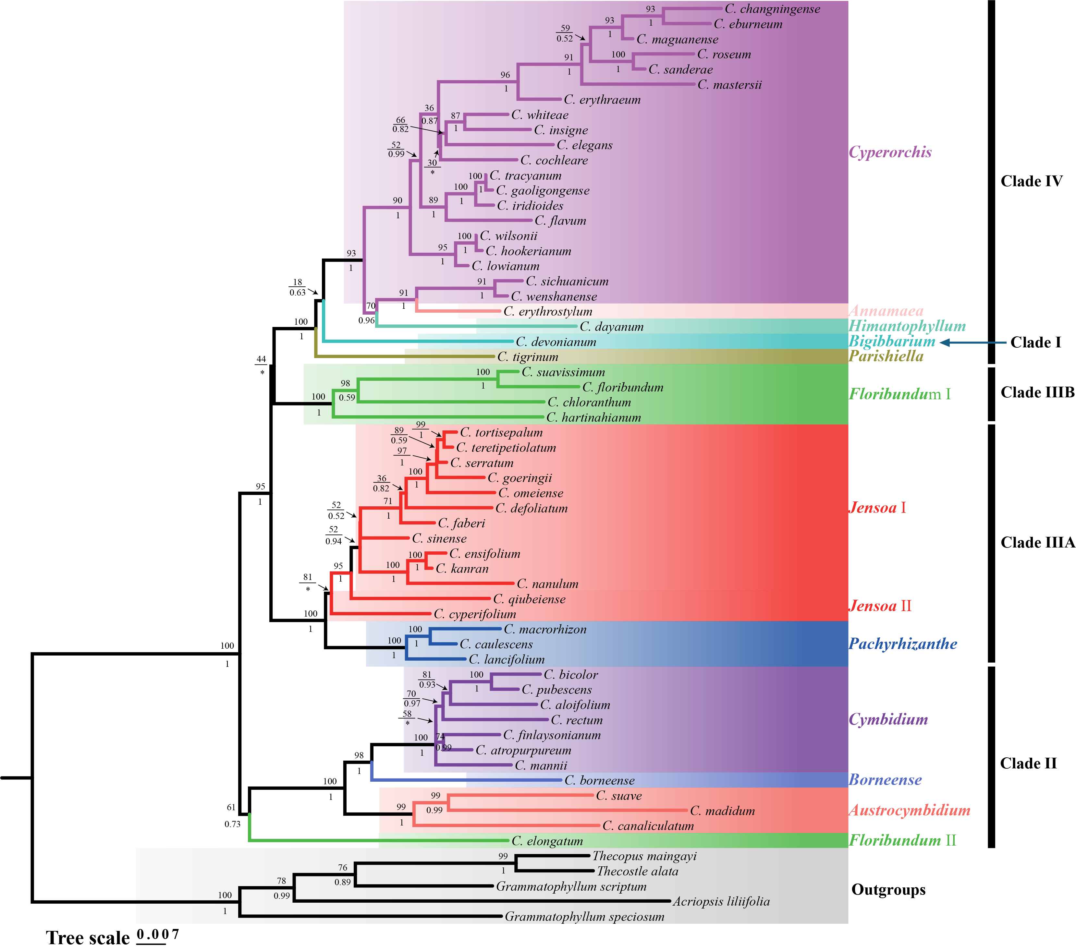

Figure S1. Phylogeny of Cymbidium based on nrDNA dataset. MLBS and BIPP values are shown above branch. Maximum Likelihood bootstrap (MLBS) and Bayesian Inference Posterior Probability (BIPP) values are shown above branch. Asterisks (*) denote nodes with topological incongruence in BI phylogeny.

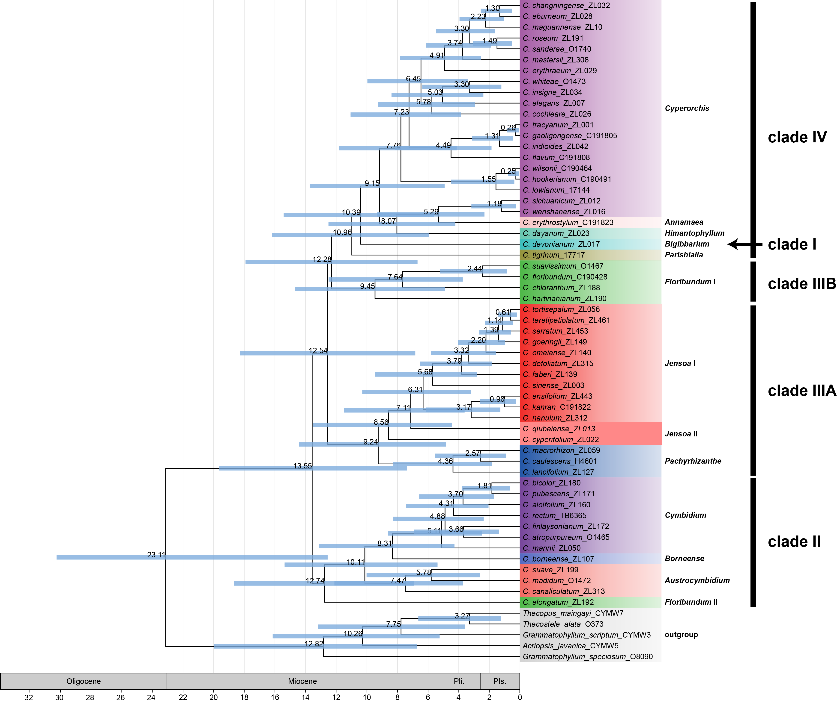

Figure S2. Chronogram of Cymbidium based on nrDNA dataset. The estimated age of each node is shown above the corresponding branch. The bule bars shows 95% Highest Posterior Density (HPD) of divergence time.

Figure S3. Mauve alignment of the whole plastome of 56 Cymbidium and five outgroup species, compared against the Cymbidium devonianum reference plastome. The colored blocks in the figure are Local Collinear Blocks (LCBs), which represent regions of conserved sequence homology and collinearity across the aligned species.

Figure S4. Ancestor state reconstruction of eleven ndh genes based on plastomes (left) and nrDNA (right) datasets. The classification criteria were established as follows: Functional (green): intact open reading frame with complete sequence; Pseudogenized (orange): premature stop codon present while retaining > 2/3 functional reference sequence length; Truncated (brown): sequence length between 90 bp and 2/3 functional reference sequence length; and Lost (white): the sequence fragment < 90 bp or complete loss.
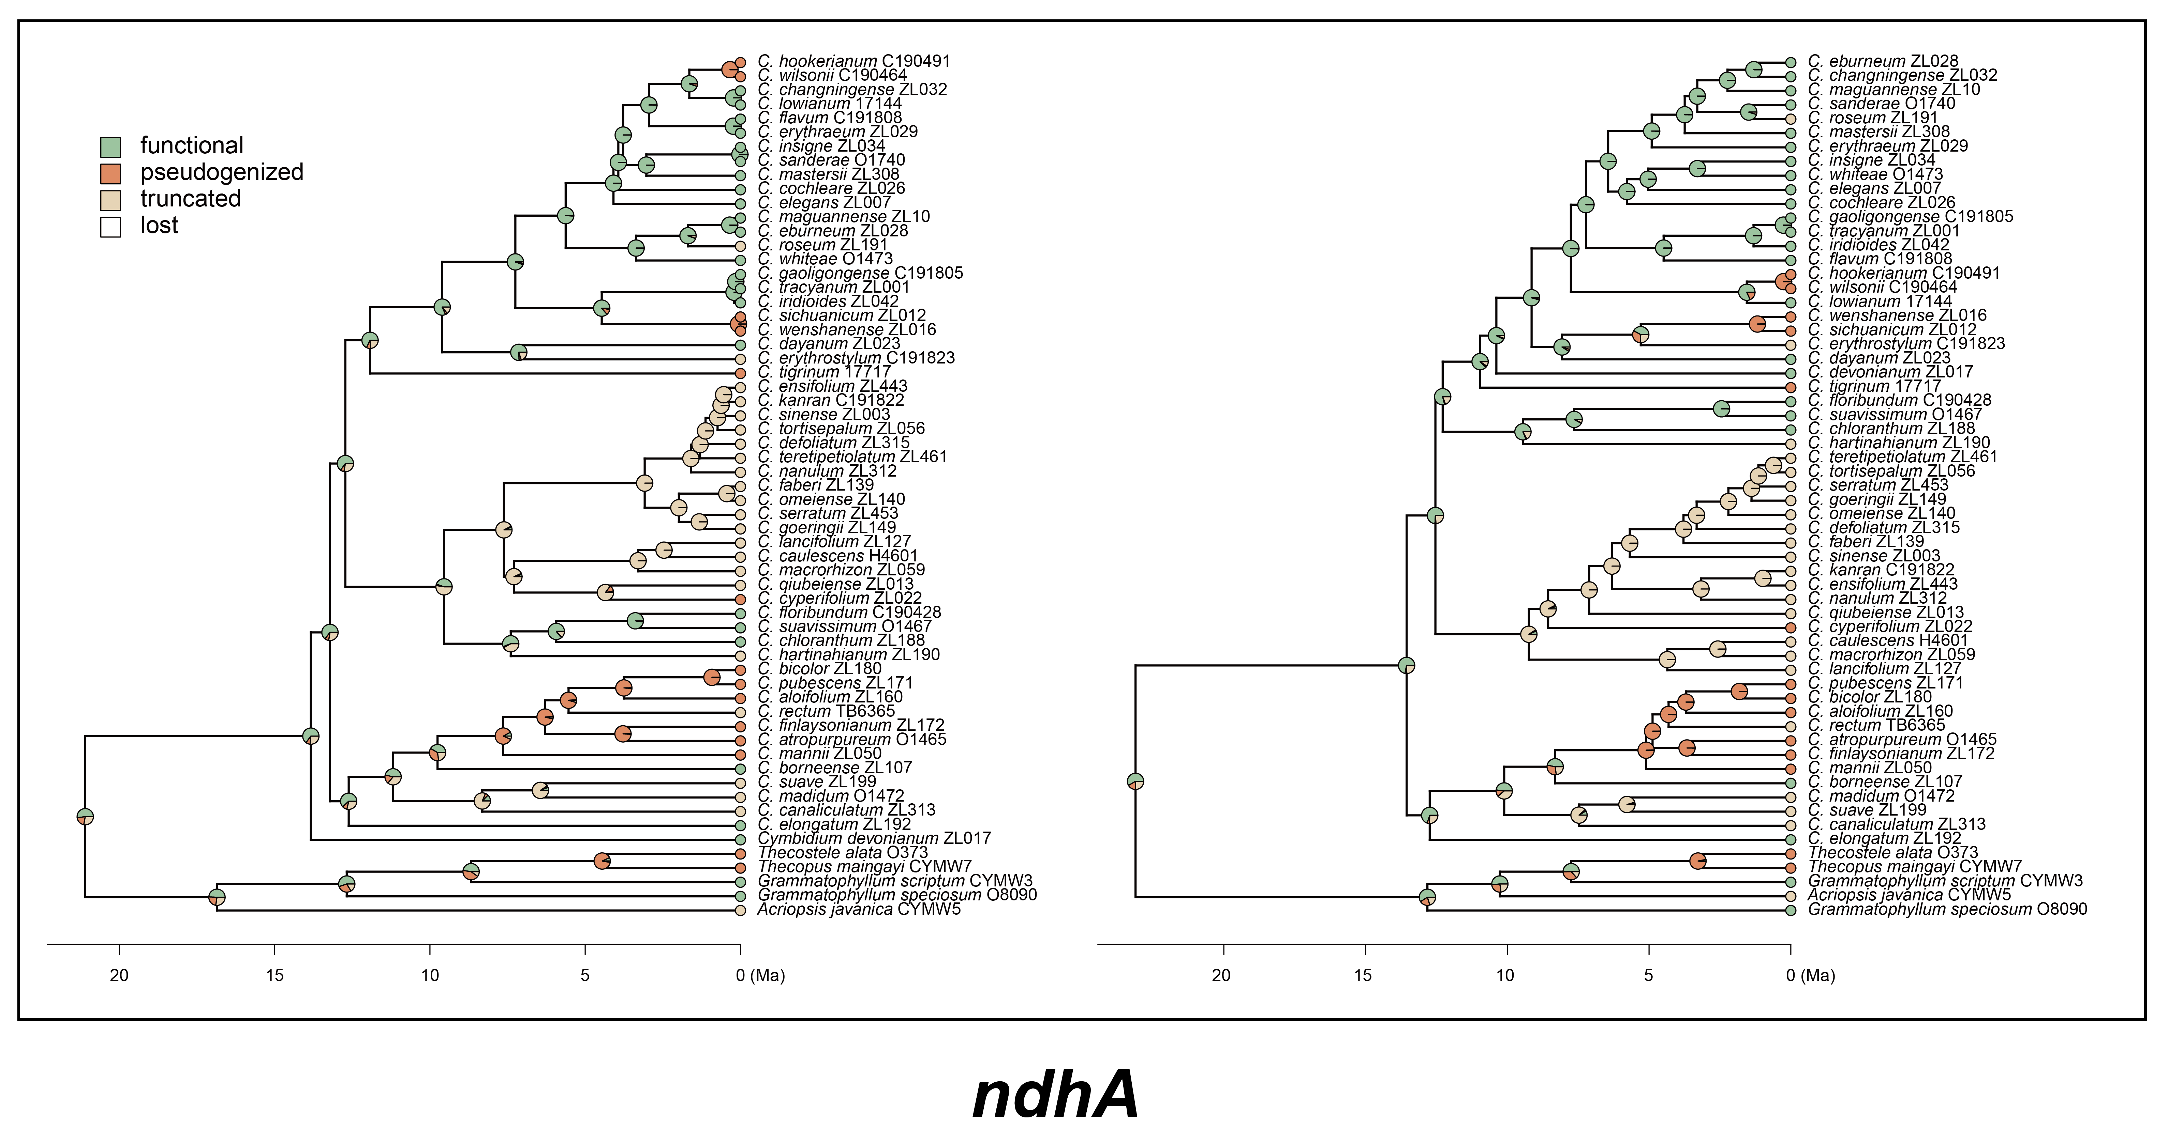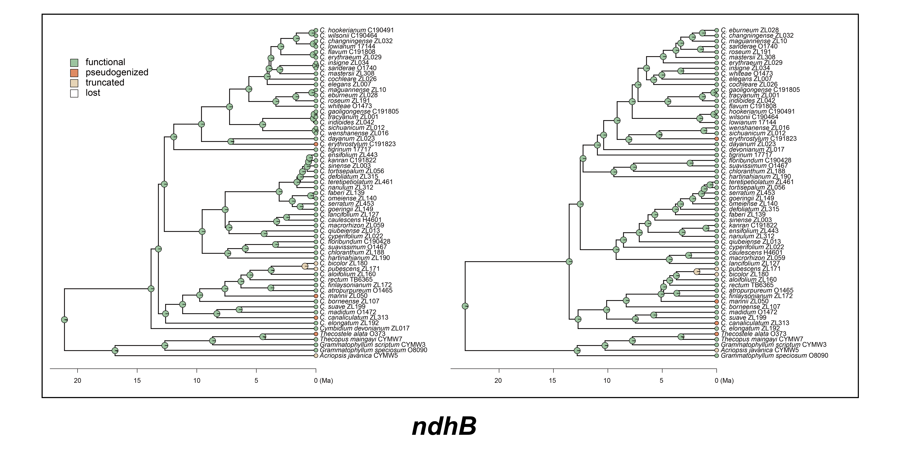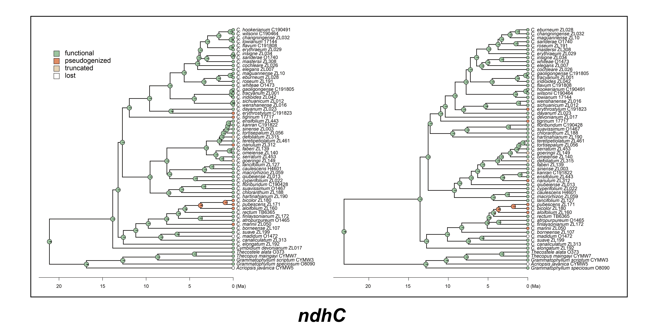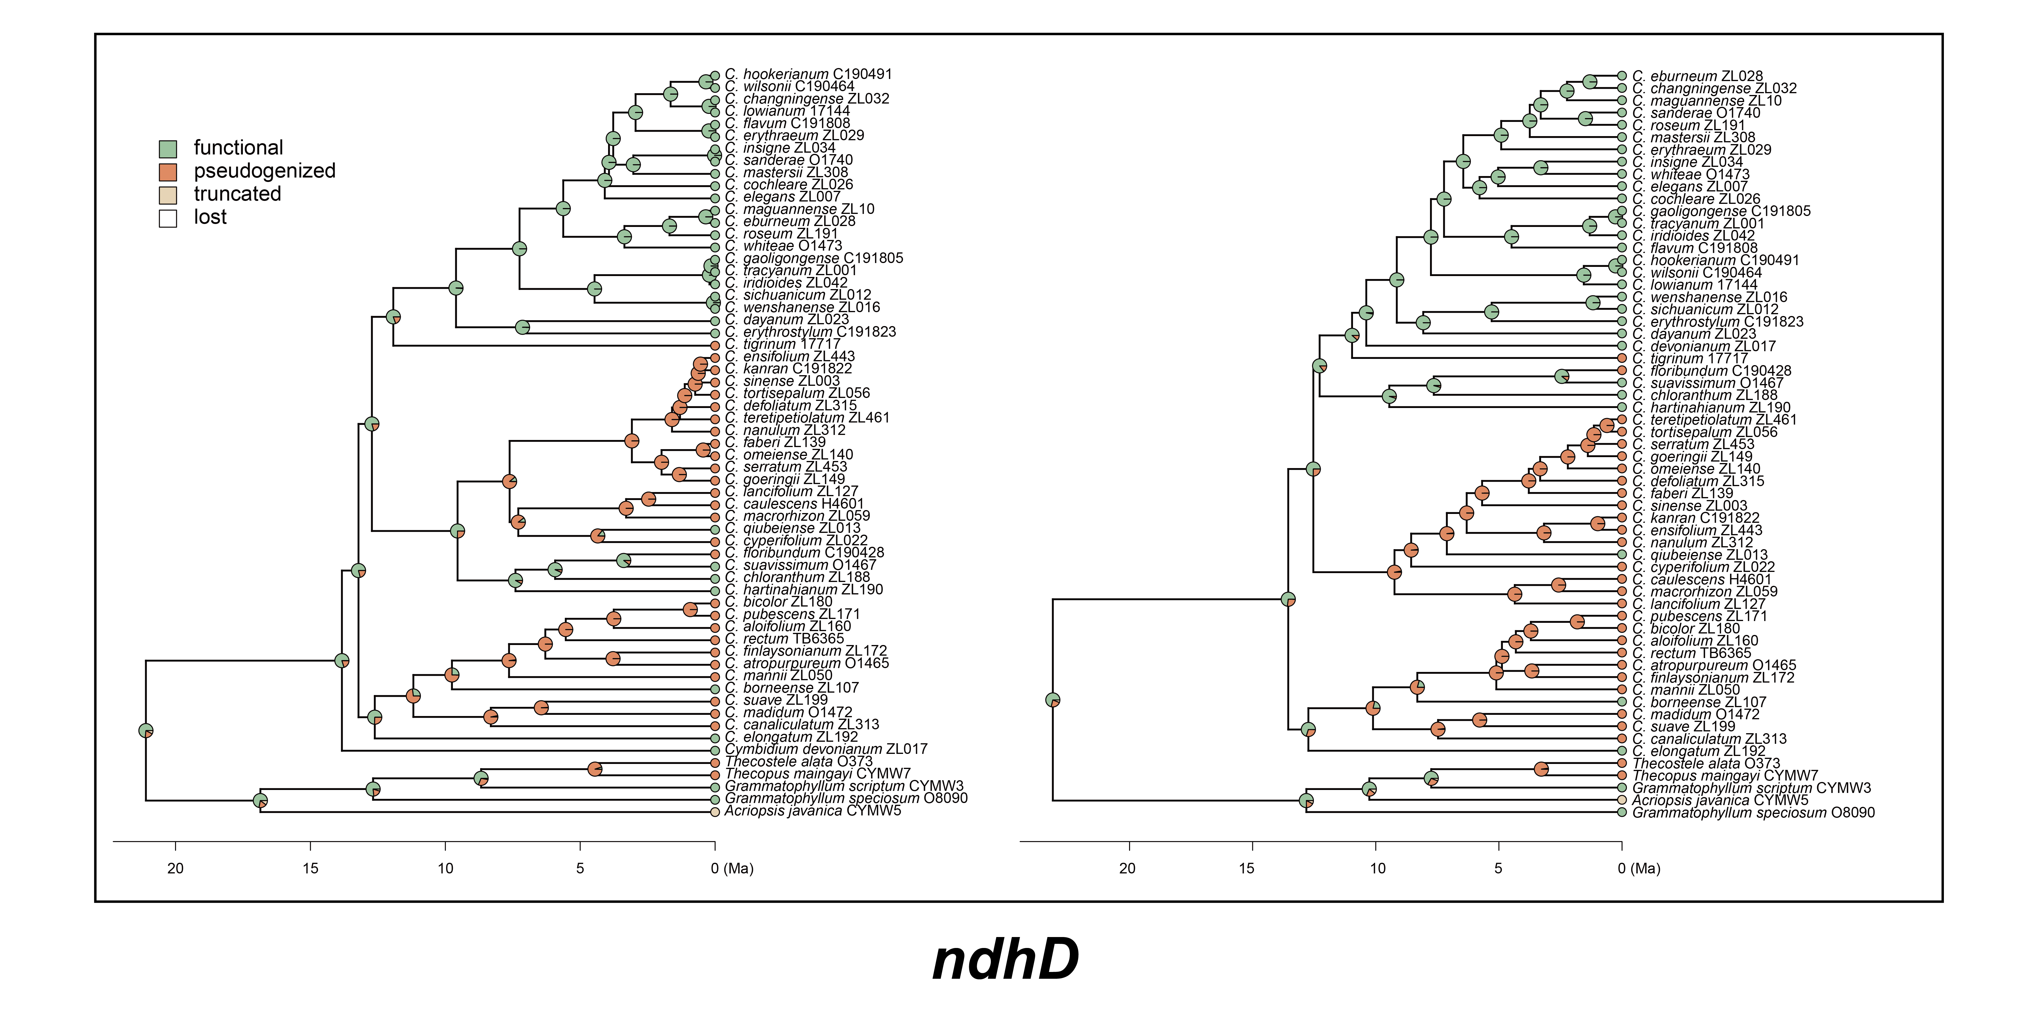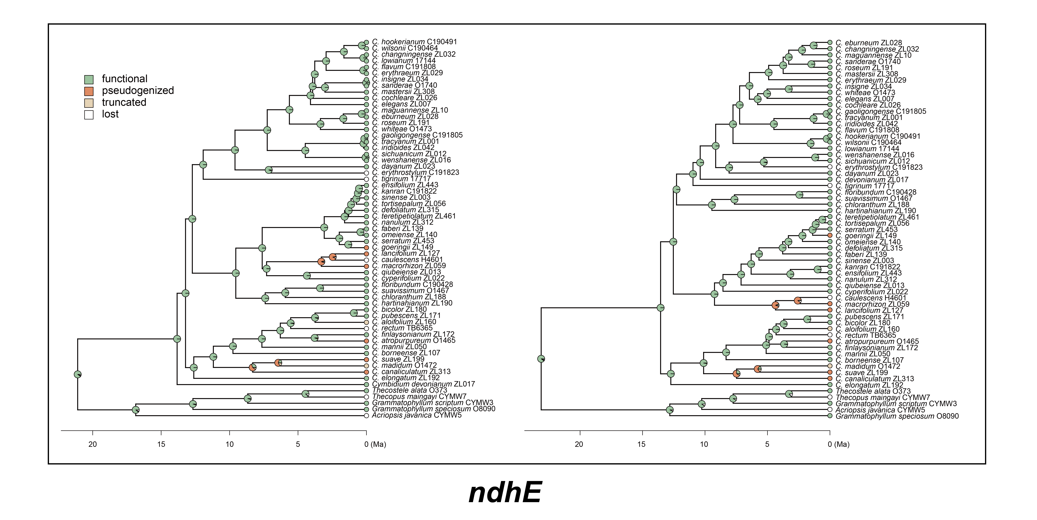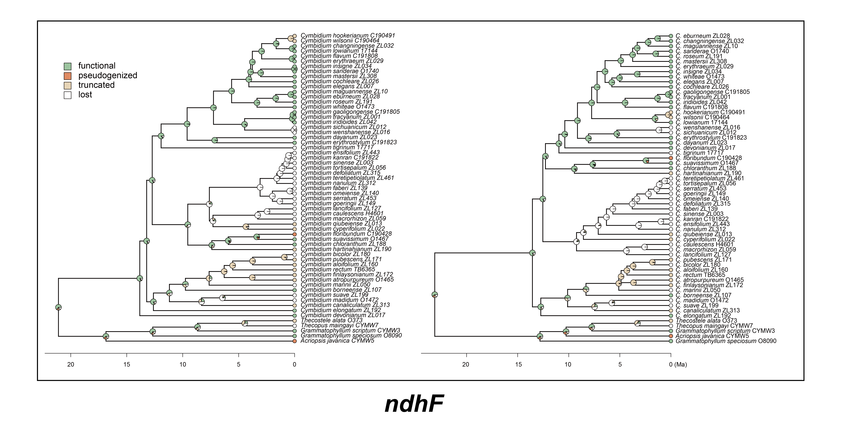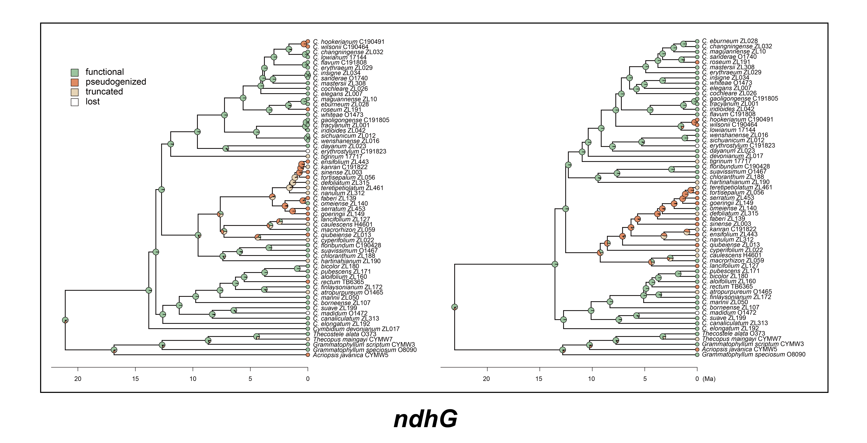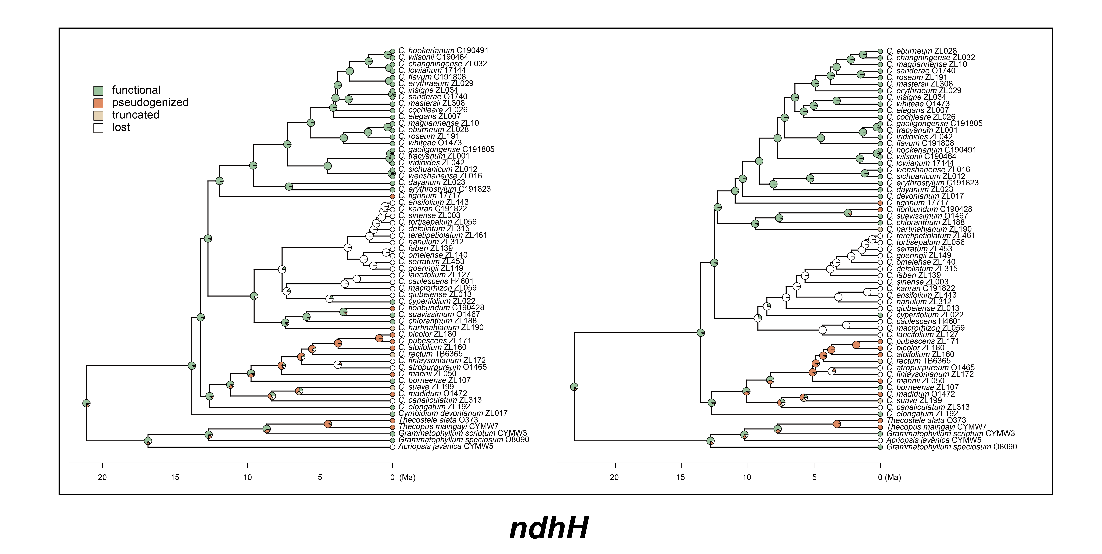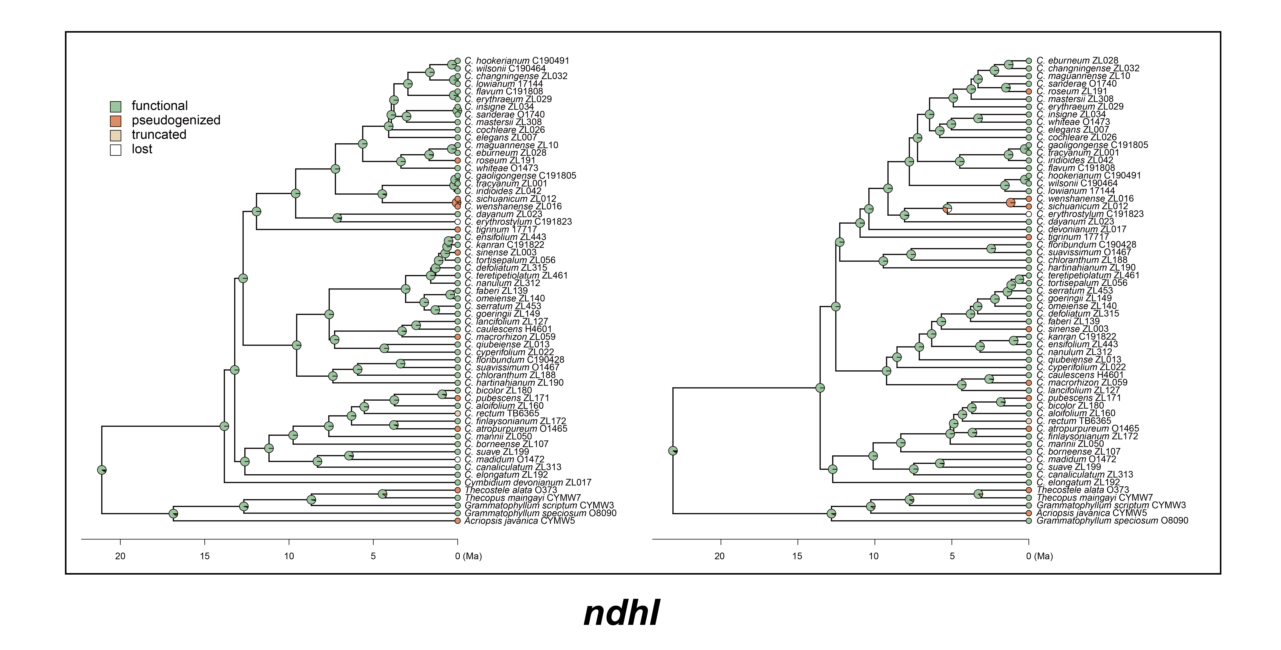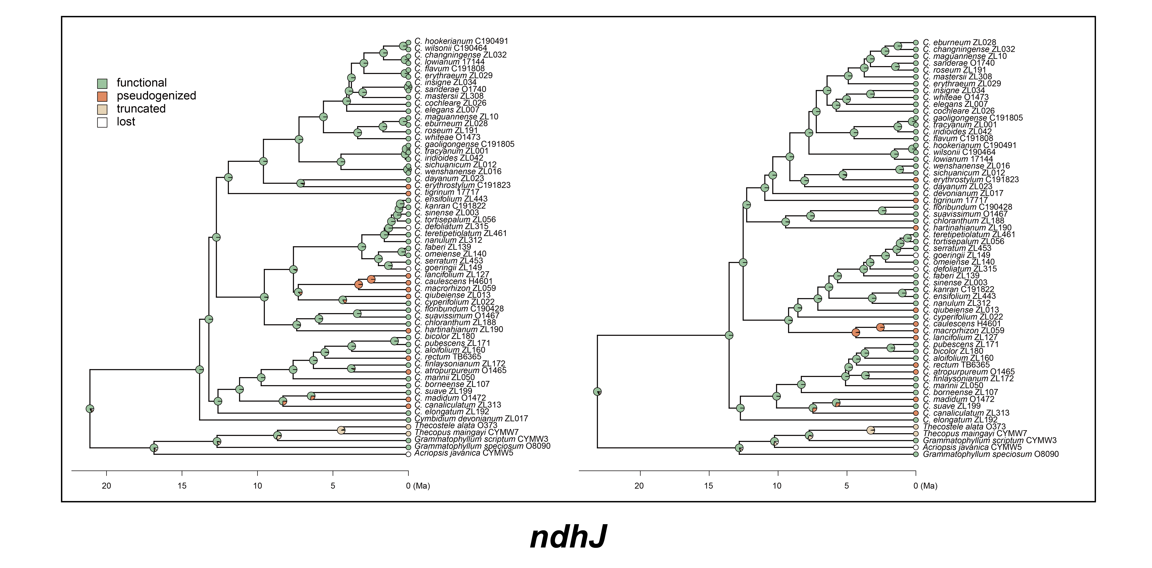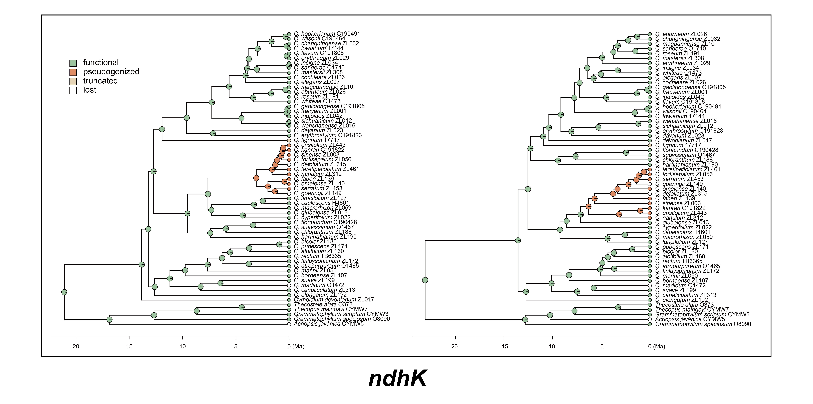

Figure S5. Comparative analysis of d_{N} and d_{S} value of ndh genes across Cymbidium species. Phylogenetic trees display non-synonymous (d_{N}, left) and synonymous (d_{S}, right) substitution rates, with horizontal bars indicating magnitude.
