Table S1 List of primers used for qRT-PCR
Gene ID | Primer name | Primer sequence(5'-3')
LOC100736524 | F | TGATAGTCGGCTCAAGGCAA
LOC100736524 | R | CGAGCCAGGGTGCATGTTTT
LOC101263532 | F | CGGGCACGGATTCCCATAAA
LOC101263532 | R | GAACGAAAACCACTCCCCGA
LOC101257776 | F | TAAGACGCGACAAGCAGGTT
LOC101257776 | R | GTCCCTTGAAGCTTTTGCTCC
LOC101253257 | F | ATCGTCGTCGTTGTATCGGG
LOC101253257 | R | TAGCAGCTTTTTCCGGCGTA
LOC101246841 | F | GCGGTGGTTTGTTTACGTGG
LOC101246841 | R | TACAACCACGGTAGCAGCAG
LOC101267548 | F | ATTACAGAGGAGTGCGGCAG
LOC101267548 | R | AGGCGGAGGAACTGTAGTAGA
LOC101267094 | F | TGCTGGTGGGTCTTTTTCGT
LOC101267094 | R | AGCACCCACCATAGCCTCTA
LOC101255592 | F | CAAGGAGGCTAGGAGGCAAA
LOC101255592 | R | AAACACCCACTGCTACGGTT
LOC101263195 | F | AGGTAAAGTACACGTGGCGA
LOC101263195 | R | ACCTCCACGGTTTGCAACTT
LOC101262303 | F | ACGTCGAAGCACACTACACA
LOC101262303 | R | AGCTTCCATCAGTTCGCACA
LOC101255394 | F | AATGCTCCTCTCTGGGTTGC
LOC101255394 | R | CCAAACCTGAAGCATTGCCC
LOC101267241 | F | TTGAGCTGGGGATACCTGGA
LOC101267241 | R | TGTTATGGCACCAGAGGACG
LOC544207 | F | GGGTATGCAGCATTCGGAGA
LOC544207 | R | GTTCGCGATGTCAAGAAGCC
LOC101267002 | F | ACTGAACTGGGGAGGCCTTA
LOC101267002 | R | CCAACTCCATCCACCGTACC
LOC101245417 | F | GCCCCTGTGGCTATGAGTTT
LOC101245417 | R | TCCGATCAACGCCATCACAA
LOC543532 | F | CATGAACCTTGCTGGGGCTA
LOC543532 | R | AAATGCAGCAACGGCTATGC
LOC101254578 | F | GGGTTTTGCTCTTGCCCTTG
LOC101254578 | R | TGTTAAGCGTCGCCCCTATG
LOC101246702 | F | CTTCTCCGCCAAGATGGGTT
LOC101246702 | R | AATGTCCCAAGCCCACGATT
LOC101267029 | F | CTGCACAGGATGATGGTGGT
LOC101267029 | R | CGCTTCTCAGCAGTTGATGC
LOC101250322 | F | TTATGTTGCACAGACGCCCT
LOC101250322 | R | TCTGTTTCTGTCCACCGCTC
LOC101248993 | F | GCGCCTTTCGGGCAAATTAT
LOC101248993 | R | TTTGTGGCAGCCTAAGCAGA
LOC101248567 | F | TTCGCCTCATTTCGGTTCCT
LOC101248567 | R | ACAGCTGATGGCTTGGTTCA
LOC101268770 | F | AGCCAGTGACACATCCACAG
LOC101268770 | R | CCAGGCTACCAGACCCATTC

Table S2 Positive seedling screening vector primer sequence
Primer name | Primer sequence(5'-3') | 产物大小
HYG-F | TTGGCGACCTCGTATTGGGAA | 519 bp
HYG-R | CAAAGATCGTTATGTTTATCGGCACT | 519 bp

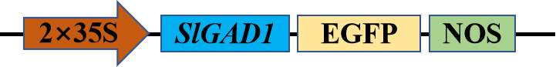

Fig. S1 Structure of SlGAD1 overexpression vector

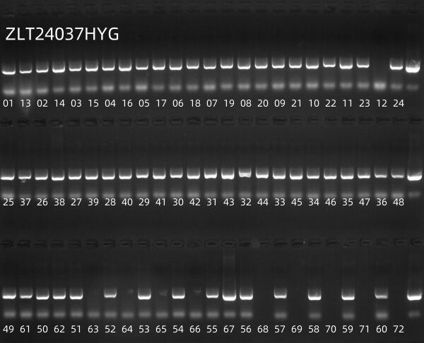
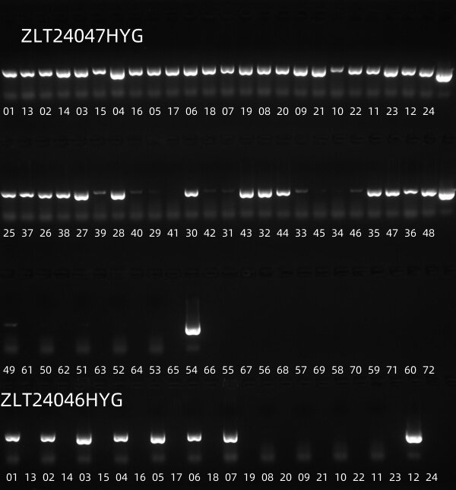
A
B
Fig. S2 Screening PCR bands for positive seedlings. A is PCR bands for SlGAD1OE # 3. B is PCR bands for SlGAD1OE # 7.

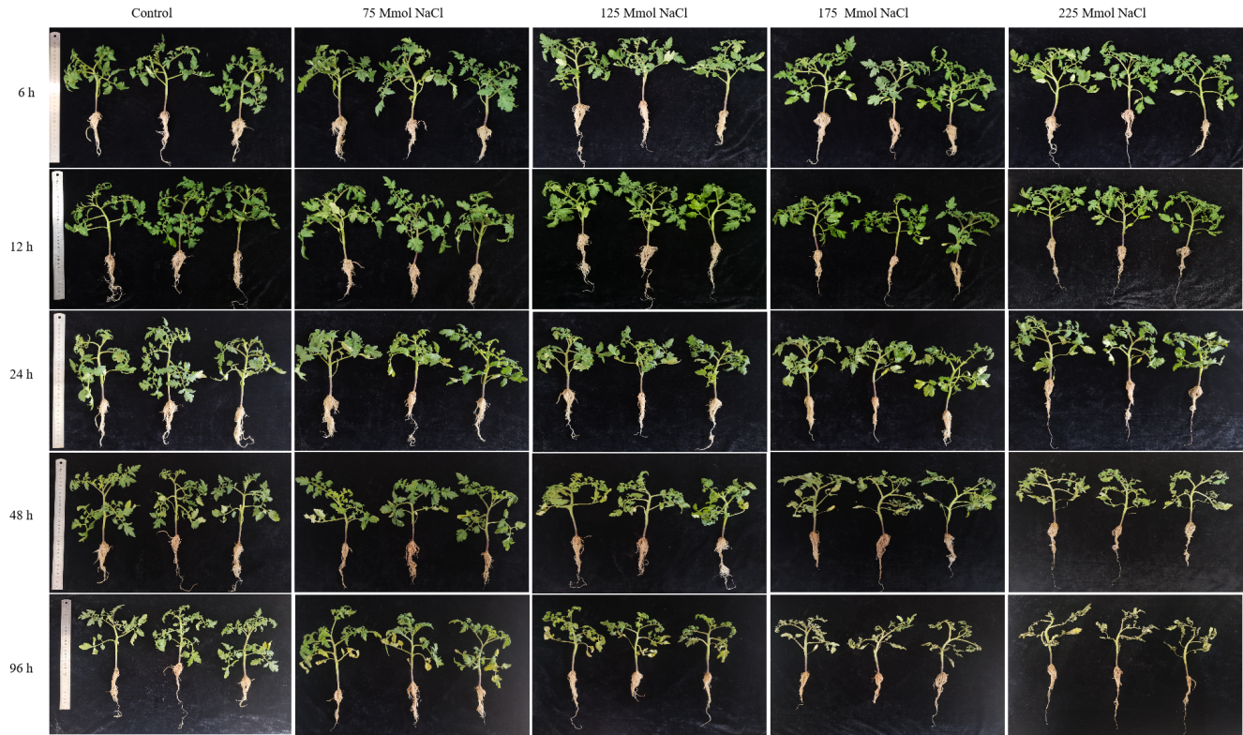
Fig. S3 Phenotypic changes of tomato seedlings under different concentrations of salt stress

Table S3 Summary of RNA-seq data for GNs and Ns treatments matched to the Solanum lycopersicum genome

Sample |  | Treated  Time  （h） | Clean  Base(G) | Error  rate | GC Content  (%) | ≥  Q30  (%) | Total  reads | Total  mapped | Mapping  Rate(%)
Control | C-1 | 0 | 6.48 | 0.03 | 42.48 | 92.88 | 43,196,444 | 39,493,023 | 91.43
Control | C-2 | 0 | 5.99 | 0.03 | 43.11 | 93.71 | 39,913,834 | 32,939,703 | 82.53
Control | C-3 | 0 | 6.35 | 0.03 | 43.08 | 94.16 | 42,302,294 | 36,838,831 | 87.08
GABA+Na treatment | GN1-1 | 6 | 7.87 | 0.03 | 42.88 | 93.43 | 52,484,686 | 50,302,004 | 95.84
GABA+Na treatment | GN1-2 | 6 | 7.59 | 0.03 | 42.66 | 94.20 | 50,602,120 | 48,244,364 | 95.34
GABA+Na treatment | GN1-3 | 6 | 8.52 | 0.02 | 42.81 | 94.47 | 56,800,656 | 54,966,598 | 96.77
GABA+Na treatment | GN2-1 | 12 | 7.33 | 0.03 | 42.55 | 89.84 | 48,668,112 | 46,464,014 | 95.47
GABA+Na treatment | GN2-2 | 12 | 7.67 | 0.03 | 42.24 | 92.65 | 47,496,968 | 45,283,740 | 95.34
GABA+Na treatment | GN2-3 | 12 | 8.30 | 0.03 | 42.49 | 93.77 | 49,086,852 | 47,347,167 | 96.46
GABA+Na treatment | GN3-1 | 24 | 7.30 | 0.03 | 42.15 | 93.86 | 48,692,790 | 47,013,173 | 96.55
GABA+Na treatment | GN3-2 | 24 | 7.48 | 0.02 | 42.52 | 94.83 | 49,877,622 | 48,330,801 | 96.90
GABA+Na treatment | GN3-3 | 24 | 7.02 | 0.02 | 42.17 | 94.80 | 46,810,282 | 45,167,395 | 96.49
GABA+Na treatment | GN4-1 | 48 | 7.88 | 0.02 | 42.64 | 94.34 | 52,553,242 | 50,671,700 | 96.42
GABA+Na treatment | GN4-2 | 48 | 7.46 | 0.02 | 42.64 | 94.36 | 49,733,240 | 47,864,102 | 96.24
GABA+Na treatment | GN4-3 | 48 | 6.97 | 0.03 | 42.69 | 92.68 | 46,474,768 | 44,839,717 | 96.48
GABA+Na treatment | GN5-1 | 96 | 8.06 | 0.02 | 42.84 | 94.25 | 53,737,214 | 51,855,089 | 96.50
GABA+Na treatment | GN5-2 | 96 | 6.70 | 0.03 | 42.44 | 94.03 | 44,634,964 | 42,942,003 | 96.21
GABA+Na treatment | GN3-3 | 96 | 8.30 | 0.02 | 42.78 | 95.32 | 55,306,258 | 53,869,547 | 97.40
Na treatment | N1-1 | 6 | 7.48 | 0.03 | 42.42 | 93.99 | 49,864,274 | 47,030,777 | 94.32
Na treatment | N1-2 | 6 | 8.28 | 0.03 | 42.35 | 93.15 | 55,205,326 | 52,762,552 | 95.58
Na treatment | N1-3 | 6 | 7.83 | 0.03 | 42.92 | 93.31 | 52,170,318 | 50,200,671 | 96.22
Na treatment | N2-1 | 12 | 7.30 | 0.02 | 41.92 | 94.33 | 48,853,270 | 45,590,338 | 93.32
Na treatment | N2-2 | 12 | 7.12 | 0.02 | 42.31 | 94.97 | 51,160,374 | 49,615,814 | 96.98
Na treatment | N2-3 | 12 | 7.36 | 0.02 | 41.75 | 94.34 | 55,331,180 | 52,979,165 | 95.75
Na treatment | N3-1 | 24 | 7.61 | 0.03 | 42.31 | 93.97 | 50,730,132 | 47,318,068 | 93.27
Na treatment | N3-2 | 24 | 8.36 | 0.03 | 42.11 | 92.67 | 55,740,976 | 53,054,131 | 95.18
Na treatment | N3-3 | 24 | 8.33 | 0.02 | 42.44 | 94.76 | 55,554,250 | 53,814,588 | 96.87
Na treatment | N4-1 | 48 | 7.39 | 0.03 | 42.64 | 92.80 | 49,264,874 | 47,280,334 | 95.97
Na treatment | N4-2 | 48 | 7.56 | 0.02 | 42.72 | 94.37 | 50,397,020 | 48,897,997 | 97.03
Na treatment | N4-3 | 48 | 7.77 | 0.03 | 42.69 | 93.78 | 51,803,328 | 50,074,694 | 96.66
Na treatment | N5-1 | 96 | 8.68 | 0.03 | 42.52 | 94.06 | 57,885,612 | 56,144,790 | 96.99
Na treatment | N5-2 | 96 | 7.52 | 0.03 | 42.78 | 93.65 | 50,131,408 | 48,647,017 | 97.04
Na treatment | N5-3 | 96 | 7.26 | 0.03 | 42.52 | 93.14 | 48,367,116 | 46,714,560 | 96.58

Table S4 Summary of alighment rates to the reference genome for GNs and Ns treatment

Sample |  | Treated  Time  （h） | Reads  unique mapped | Unique mapping  rate(%) | Multiple Mapped Reads | Reads Map  to '+' | Reads Map  to '-'
Control | C-1 | 0 | 38,640,520 | 89.45 | 852,503(1.97%) | 19,312,560(44.71%) | 19,327,960(44.74%)
Control | C-2 | 0 | 32,184,514 | 80.63 | 755,189(1.89%) | 16,086,512(40.30%) | 16,098,002(40.33%)
Control | C-3 | 0 | 35,941,229 | 84.96 | 897,602(2.12%) | 17,966,126(42.47%) | 17,975,103(42.49%)
GABA+Na treatment | GN1-1 | 6 | 49,277,896 | 93.89 | 1,024,108(1.95%) | 24,607,674(46.89%) | 24,670,222(47.00%)
GABA+Na treatment | GN1-2 | 6 | 47,331,786 | 93.54 | 912,578(1.80%) | 23,649,168(46.74%) | 23,682,618(46.80%)
GABA+Na treatment | GN1-3 | 6 | 53,871,271 | 94.84 | 1,095,327(1.93%) | 26,904,951(47.37%) | 26,966,320(47.48%)
GABA+Na treatment | GN2-1 | 12 | 45,732,507 | 93.97 | 731,507(1.50%) | 22,845,621(46.94%) | 22,886,886(47.03%)
GABA+Na treatment | GN2-2 | 12 | 44,560,823 | 93.82 | 722,917(1.52%) | 22,263,870(46.87%) | 22,296,953(46.94%)
GABA+Na treatment | GN2-3 | 12 | 46,564,119 | 94.86 | 783,048(1.60%) | 23,260,368(47.39%) | 23,303,751(47.47%)
GABA+Na treatment | GN3-1 | 24 | 46,250,848 | 94.99 | 762,325(1.57%) | 23,110,920(47.46%) | 23,139,928(47.52%)
GABA+Na treatment | GN3-2 | 24 | 47,557,636 | 95.35 | 773,165(1.55%) | 23,756,493(47.63%) | 23,801,143(47.72%)
GABA+Na treatment | GN3-3 | 24 | 44,459,968 | 94.98 | 707,427(1.51%) | 22,222,078(47.47%) | 22,237,890(47.51%)
GABA+Na treatment | GN4-1 | 48 | 49,850,166 | 94.86 | 821,534(1.56%) | 24,909,737(47.40%) | 24,940,429(47.46%)
GABA+Na treatment | GN4-2 | 48 | 47,067,736 | 94.64 | 796,366(1.60%) | 23,517,665(47.29%) | 23,550,071(47.35%)
GABA+Na treatment | GN4-3 | 48 | 44,098,739 | 94.89 | 740,978(1.59%) | 22,028,068(47.40%) | 22,070,671(47.49%)
GABA+Na treatment | GN5-1 | 96 | 50,976,838 | 94.86 | 878,251(1.63%) | 25,471,661(47.40%) | 25,505,177(47.46%)
GABA+Na treatment | GN5-2 | 96 | 42,261,485 | 94.68 | 680,518(1.52%) | 21,120,752(47.32%) | 21,140,733(47.36%)
GABA+Na treatment | GN3-3 | 96 | 52,942,531 | 95.73 | 927,016(1.68%) | 26,454,421(47.83%) | 26,488,110(47.89%)
Na treatment | N1-1 | 6 | 46,110,767 | 92.47 | 920,010(1.85%) | 23,044,767(46.21%) | 23,066,000(46.26%)
Na treatment | N1-2 | 6 | 51,756,352 | 93.75 | 1,006,200(1.82%) | 25,863,078(46.85%) | 25,893,274(46.90%)
Na treatment | N1-3 | 6 | 49,244,618 | 94.39 | 956,053(1.83%) | 24,599,021(47.15%) | 24,645,597(47.24%)
Na treatment | N2-1 | 12 | 44,748,133 | 91.60 | 842,205(1.72%) | 22,363,037(45.78%) | 22,385,096(45.82%)
Na treatment | N2-2 | 12 | 48,817,281 | 95.42 | 798,533(1.56%) | 24,395,384(47.68%) | 24,421,897(47.74%)
Na treatment | N2-3 | 12 | 52,180,530 | 94.31 | 798,635(1.44%) | 26,082,641(47.14%) | 26,097,889(47.17%)
Na treatment | N3-1 | 24 | 46,591,031 | 91.84 | 727,037(1.43%) | 23,287,134(45.90%) | 23,303,897(45.94%)
Na treatment | N3-2 | 24 | 52,162,167 | 93.58 | 891,964(1.60%) | 26,077,093(46.78%) | 26,085,074(46.80%)
Na treatment | N3-3 | 24 | 52,919,382 | 95.26 | 895,206(1.61%) | 26,443,302(47.60%) | 26,476,080(47.66%)
Na treatment | N4-1 | 48 | 46,481,316 | 94.35 | 799,018(1.62%) | 23,225,040(47.14%) | 23,256,276(47.21%)
Na treatment | N4-2 | 48 | 48,092,445 | 95.43 | 805,552(1.60%) | 24,034,543(47.69%) | 24,057,902(47.74%)
Na treatment | N4-3 | 48 | 49,193,839 | 94.96 | 880,855(1.70%) | 24,577,470(47.44%) | 24,616,369(47.52%)
Na treatment | N5-1 | 96 | 55,156,105 | 95.28 | 988,685(1.71%) | 27,561,606(47.61%) | 27,594,499(47.67%)
Na treatment | N5-2 | 96 | 47,741,427 | 95.23 | 905,590(1.81%) | 23,842,537(47.56%) | 23,898,890(47.67%)
Na treatment | N5-3 | 96 | 45,926,247 | 94.95 | 788,313(1.63%) | 22,947,545(47.44%) | 22,978,702(47.51%)

N1-3
N1-2
N1-1
N3-3
N3-2
N3-1
GN2-3
GN2-2
GN2-1
GN1-3
GN1-2
GN1-1
N5-3
N5-2
N5-1
N4-3
N4-2
N4-1
C-3
C-2
C-1
GN3-3
GN3-2
GN3-1
GN5-3
GN5-2
GN5-1
N2-3
N2-2
N2-1
GN4-3
GN4-2GN4-1

1 2 3 1 2 3 1 2 3 1 2 3 1 2 3 1 2 3 1 2 3 1 2 3 1 2 3 1 2 3 1 2 3

GN4 N2 GN5 GN3 C N4 N5 GN1 GN2 N3 N1

Fig. S4 Sample correlation heat map of transcriptome data

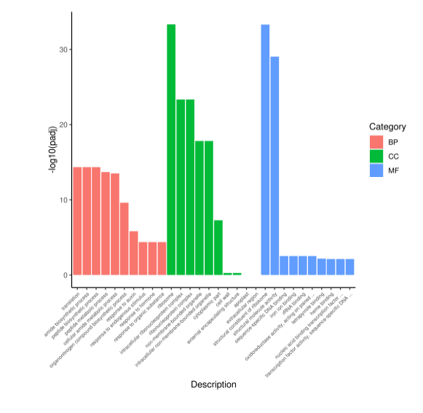
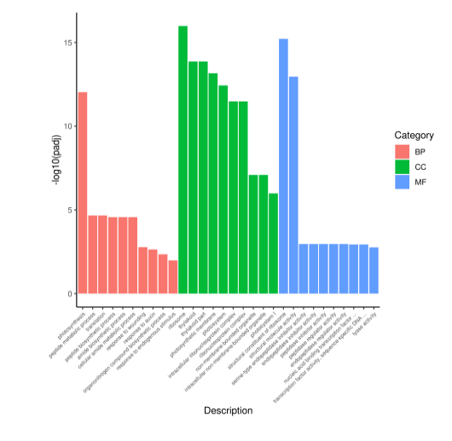
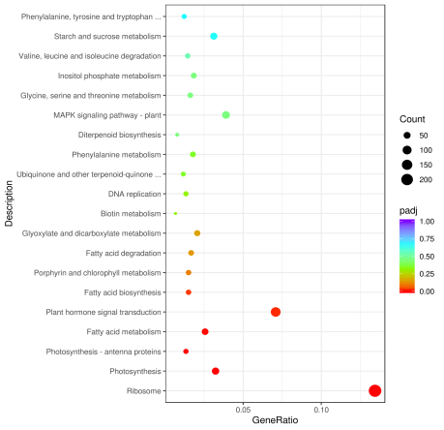
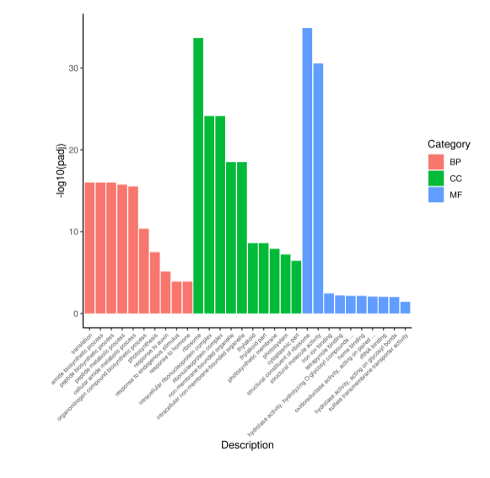
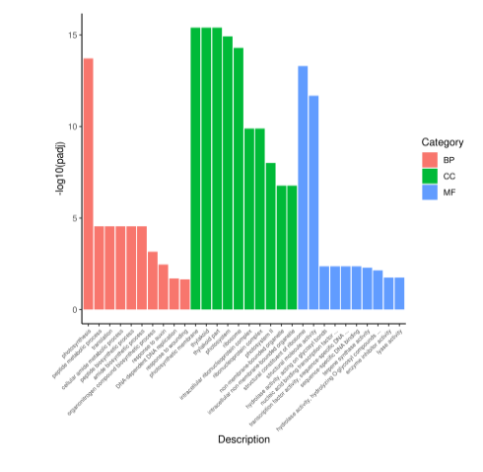
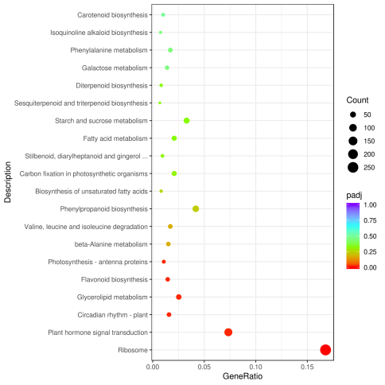
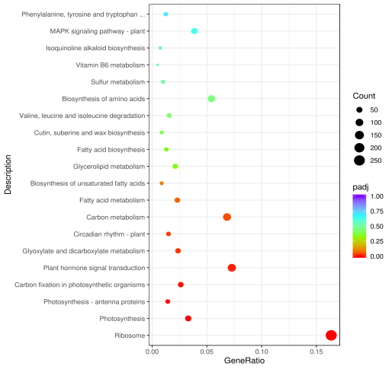
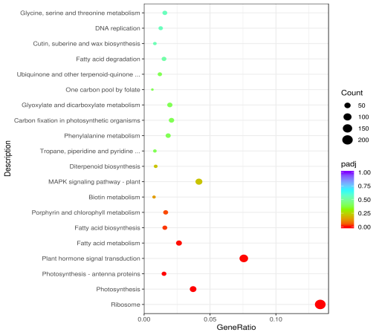
A
B
C
D
E
F
G
H

Fig.S5 GO and KEGG analysis between different treatments and control
A GO analysis of GN vs C(12h）B GO analysis of N vs C(12h）C GO analysis of GN vs C(24h）D GO analysis of N vs C(24h）E KEGG analysis of GN vs C(12h）F KEGG analysis of N vs C(12h）G KEGG analysis of GN vs C(24h）H KEGG analysis of N vs C(24h）

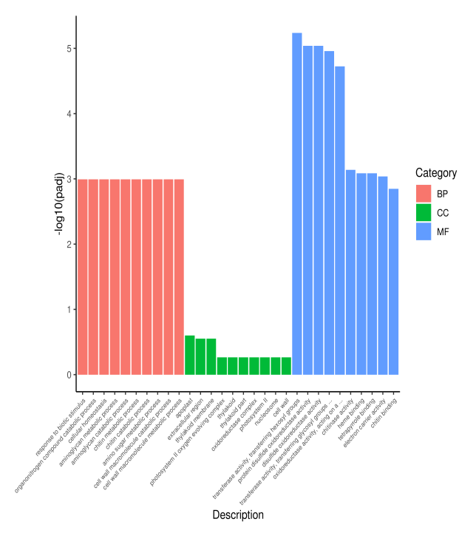
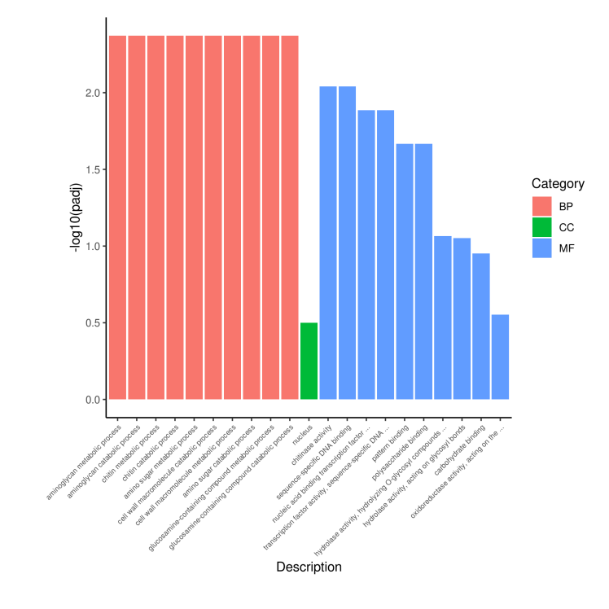
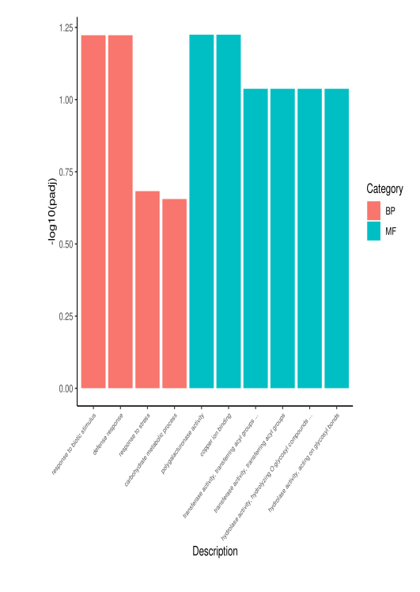
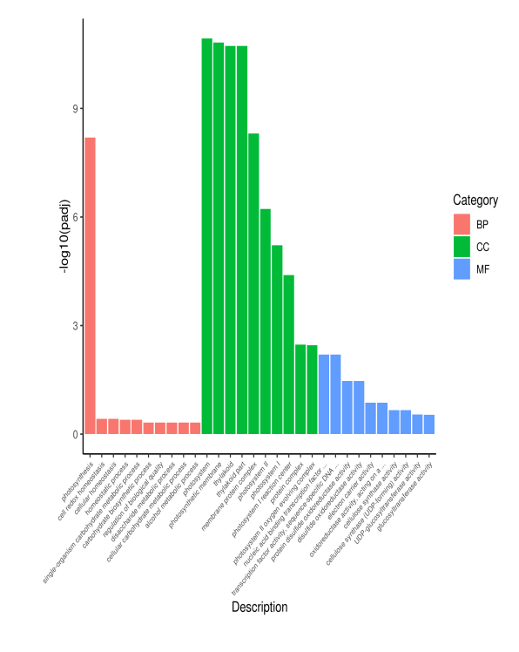
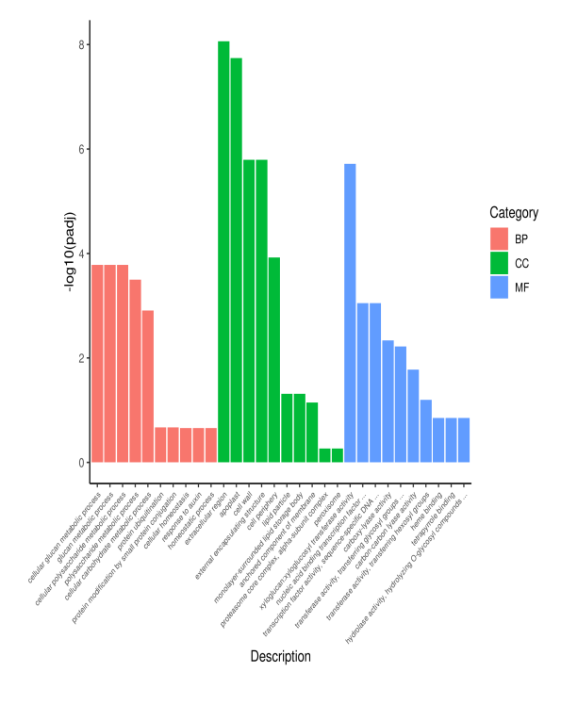
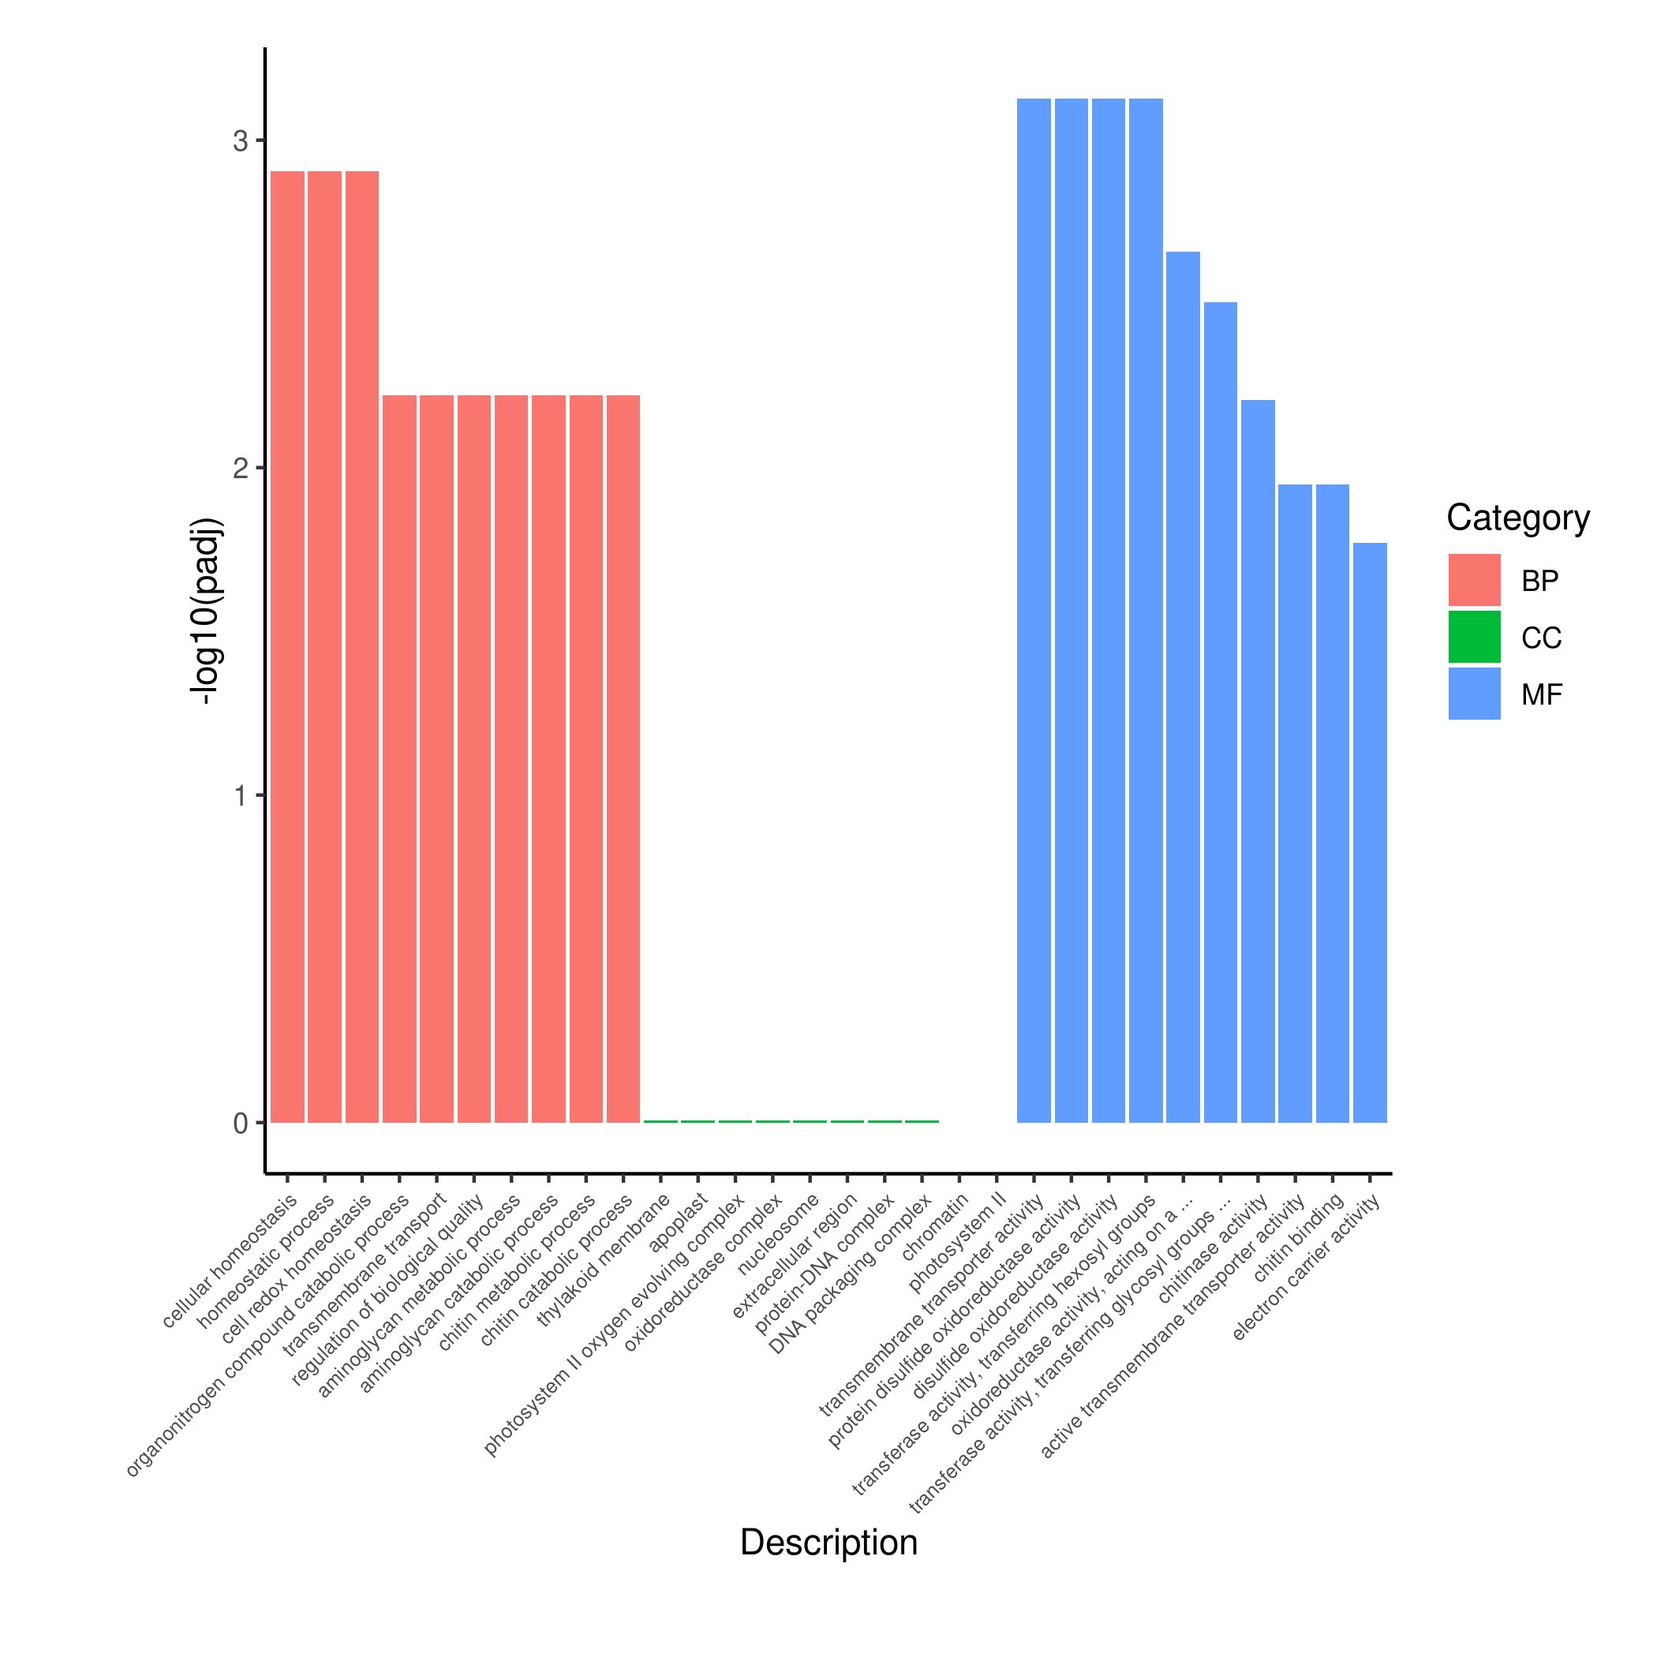
A
B
C
D
E

Fig.S6 GO analysis between different treatments at different time

A-E，each represents go analysis data of GN vs N at 6h、12h、24h、48h、96h.

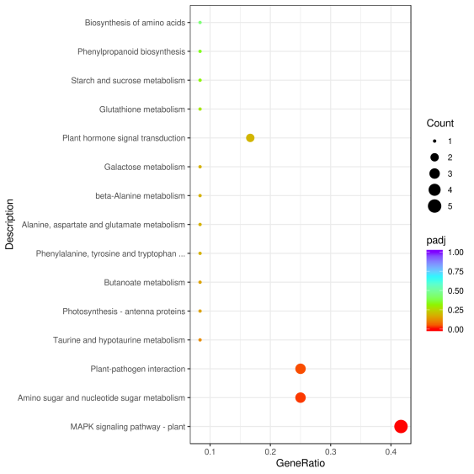
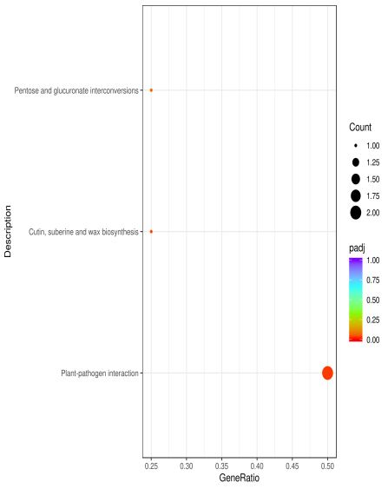
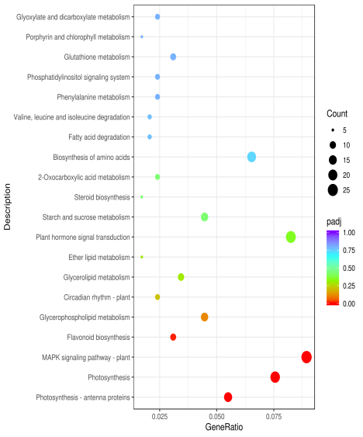
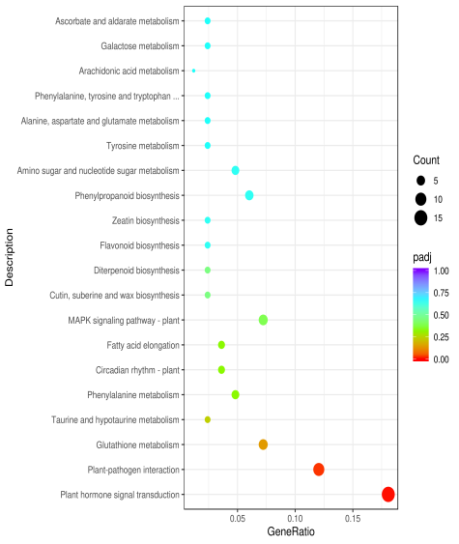
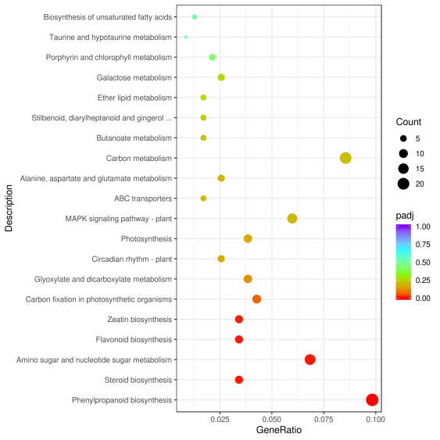
A
B
C
D
E

Fig. S7 KEGG analysis between different treatments at different time

A-E，each represents KEGG analysis data of GN vs N at 6h、12h、24h、48h、96h.
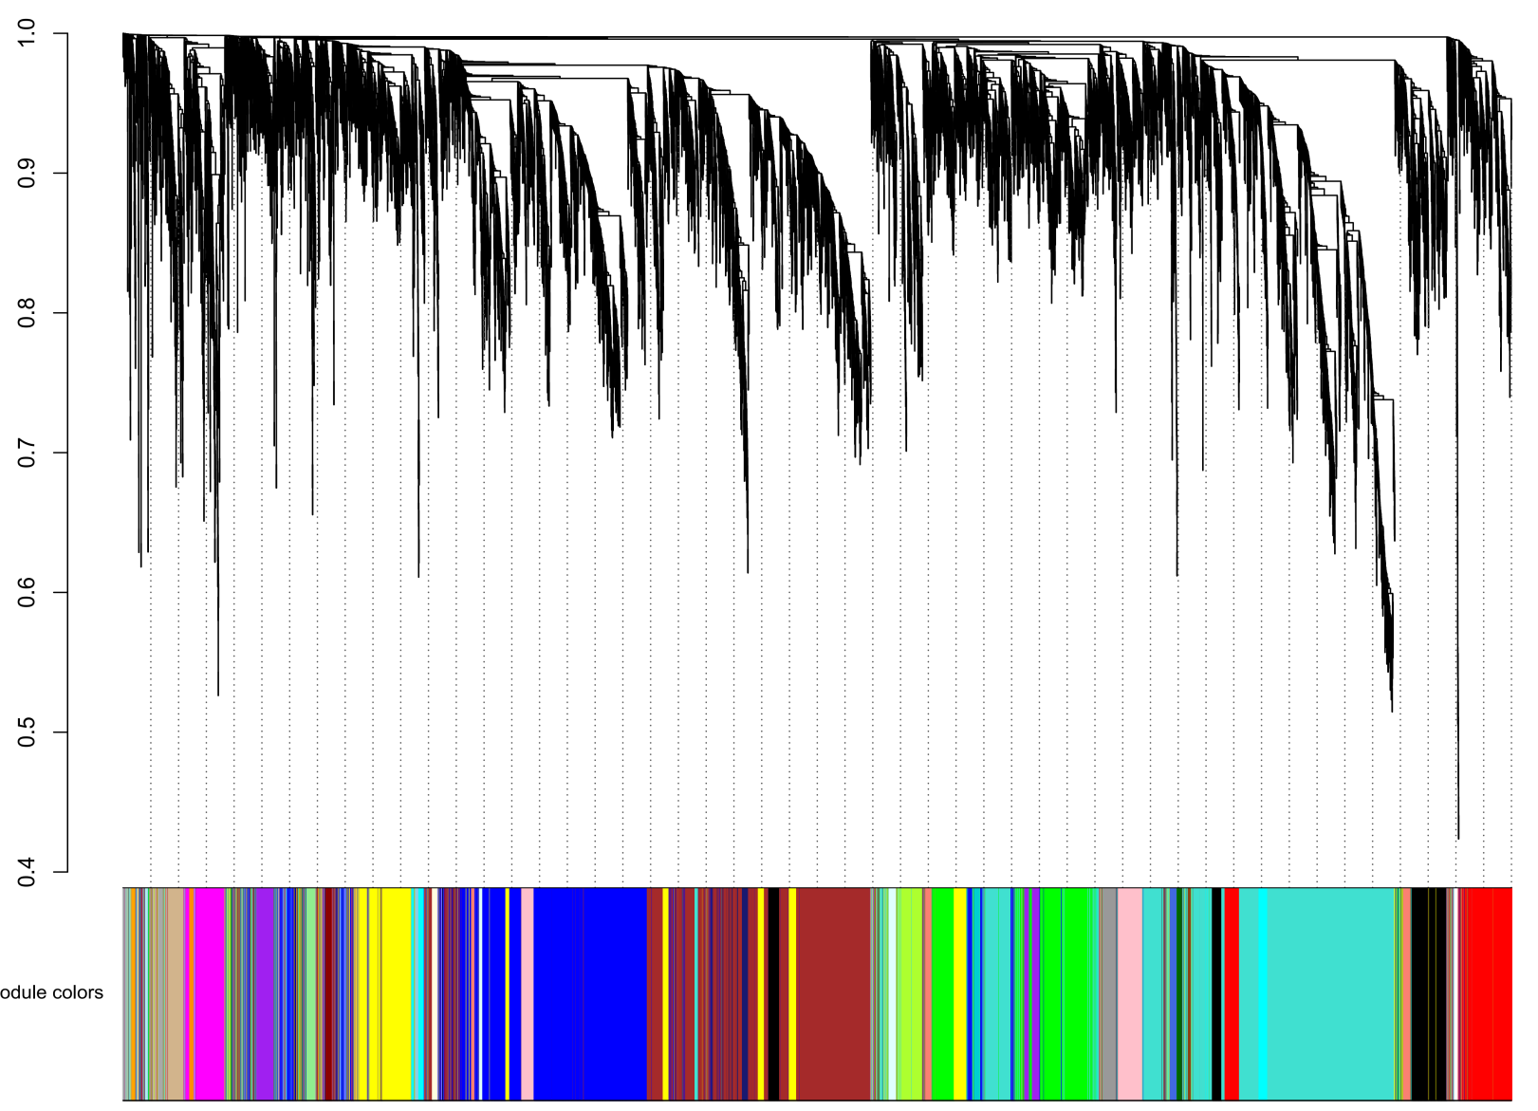
Cluster dendrogram
Height

Odule colors

Fig. S8 Gene clustering and module construction
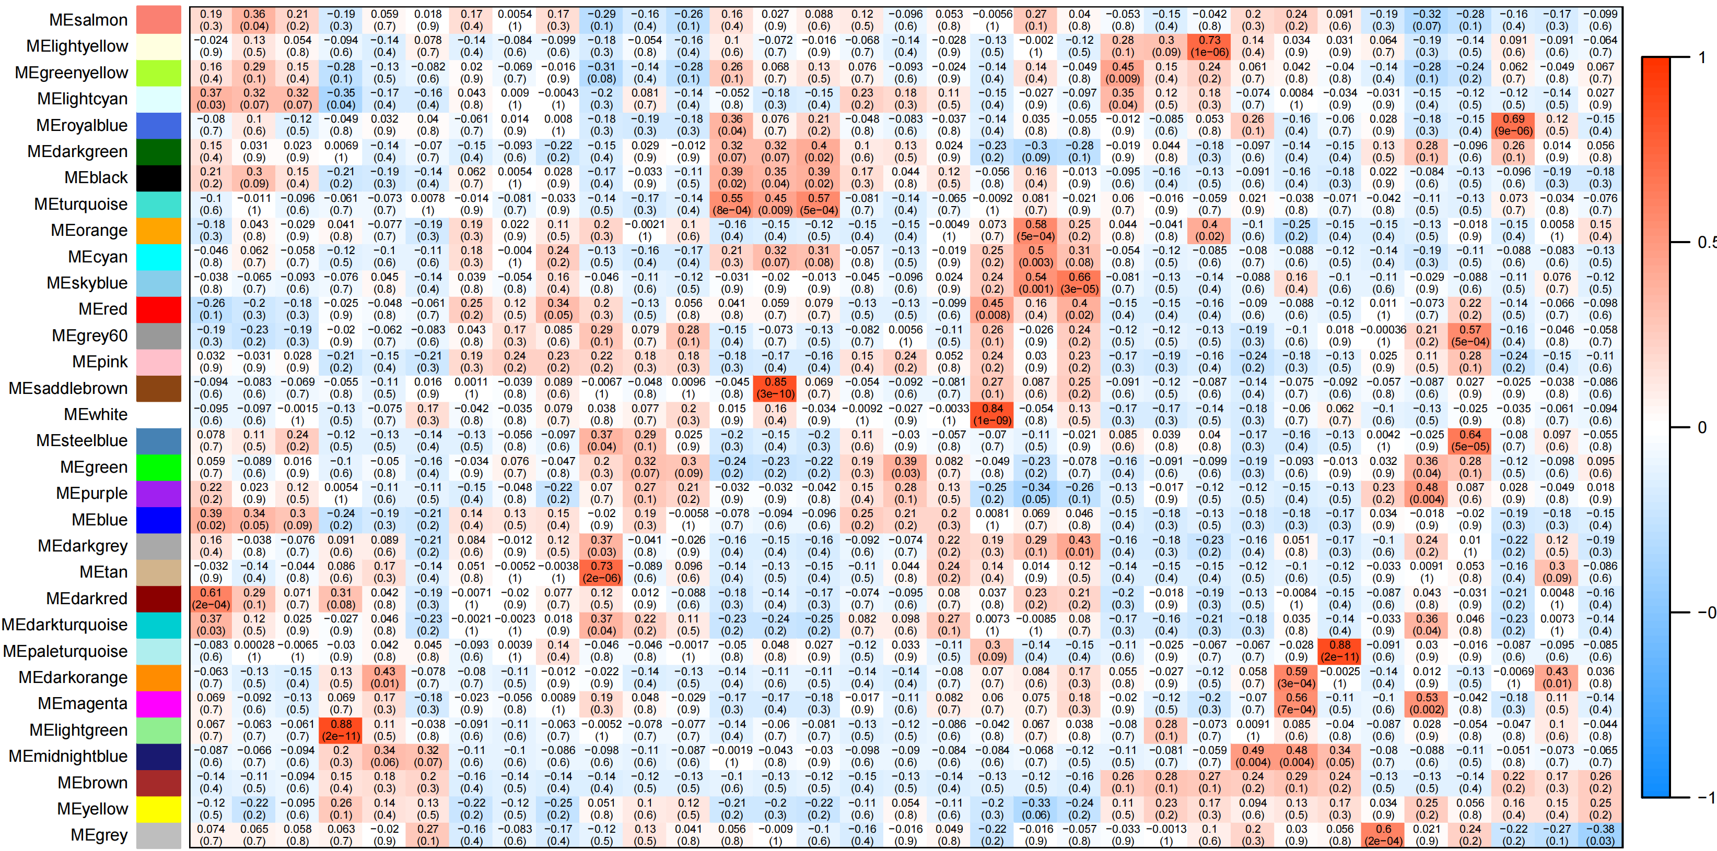
GN
4-1

GN
4-2

GN
4-3

N
2-1

N
2-2

N
2-3

GN
5-1

GN
5-2

GN
5-3

GN
3-1

GN
3-2

GN
3-3

C-1

C-2

C-3

N
4-1

N
4-2

N
4-3

N
5-1

N
5-2

N
5-3

GN
1-1

GN
1-2

GN
1-3

GN
2-1

GN
2-2

GN
2-3

N
3-1

N
3-2

N
3-3

N
1-1

N
1-2

N
1-3

Module-trait Relationship

GN4 N2 GN5 GN3 C N4 N5 GN1 GN2 N3 N1

Fig. S9 Correlation analysis between traits and modules (red grids represent positive correlation between traits and modules, blue grids represent traits and modules). The blocks have negative correlation, and the values inside and outside the parentheses in the figure are the P-value and correlation coefficient r, respectively.

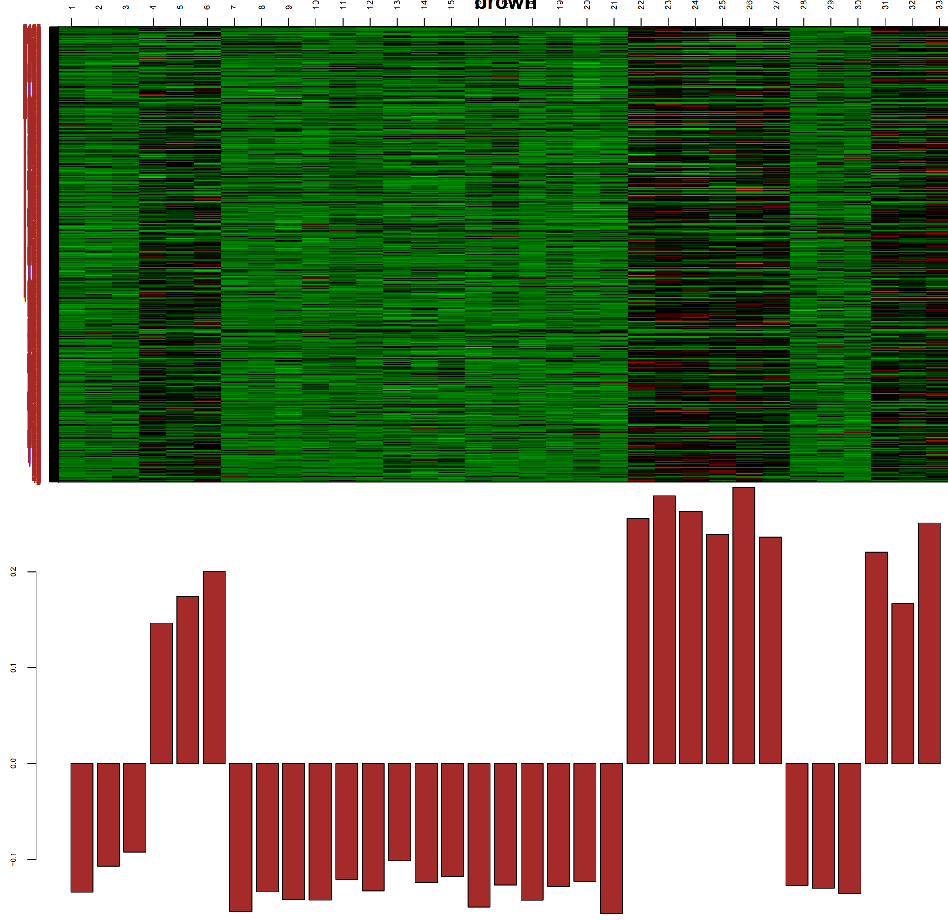

Fig. S10 Gene expression pattern diagram of MEbrown module

