Table S1. Collection site description and climate data for wild populations of Kentucky bluegrass sampled in Gansu Province, China.
Population | Habitat | Elevation (m) | Mean annual precipitation (mm) | Mean annual temperature (℃)
Sunan (SN) | Alpine meadow | 2,954.0 | 268.1 | 4.2
Qingshui (QS) | Ravine | 1,503.0 | 578.0 | 8.8
Table S2. Primer sequences for target genes in a qRT-PCR analysis.
Gene_name | Forward | Reverse
IPT1 | TAAGTGGGGCCGGACAGATA | TCGCCAACGTTGTCTCGTTA
LOG | GATGGAGGACGCCATGTGAT | CCATTTCGGCCTTCCTCTCA
LRK2 | CAGCCACTTGGTTTGTCACG | ACCCATGACACGTTGAGACC
PAP3 | ATCCCCTCGATCCTCGTCAA | CACCTTGTACCTCTCCAGCG
TaCl5-B5 | GCTCGATCATCGGTGCTACA | TGTGGTTCATGGAGTGGTCG
TaOTUB1s | CCGCGTGATGTACCTAGACC | TGCCATTGCATCATCACCCT
IPT2 | CACCACTTCCTTCCCTAGCC | CCGGGGCTACTACTCCAGC
IPT3b | GATGAGCCTCACGGCGG | CTCCAAGGCTCCGACGC
Actin | CTACGTCCCTGCCCTTTGTACA | ACACTTCACCGGACCATTCAA
Table S3. Quality assessment of newly assembled transcripts.
Type | Complete (single) | Complete (duplicated) | Fragmented | Missing
Custer | 822 (57.1%) | 66 (4.6%) | 370 (25.7%) | 182 (12.6%)
Unigene | 822 (57.1%) | 66 (4.6%) | 370 (25.7%) | 182 (12.6%)
Trinity | 222 (15.4%) | 800 (55.6%) | 307 (21.3%) | 111 (7.7%)
Table S4. Description of core genes from two WGCNA modules.
Gene_ID | Gene_name | Gene connectivity | FPKM
Gene_ID | Gene_name | Gene connectivity | SPro | SP | SAna | QPro | QP | Q&A
Cluster-47370.86765 | JAK2 | 529.10 | 9.85 | 5.75 | 36.55 | 7.43 | 6.37 | 13.47
Cluster-47370.116664 | ZIM | 79.11 | 144.74 | 4.35 | 5.22 | 157.69 | 1.88 | 32.89
Cluster-47370.108456 | SRK2A | 166.66 | 18.50 | 26.16 | 50.08 | 25.07 | 38.22 | 40.18
Cluster-47370.122987 | IAA16 | 73.13 | 13.68 | 18.27 | 22.50 | 14.69 | 23.81 | 17.45
Table S5. Description of core proteins from blue modules.
Protein_ID | Protein_name | Protein
Protein_ID | Protein_name | SPro | SP | SAna | QPro | QP | QAna
Cluster-47370_93338_orf2 | CYPRO4 | 0 | 0 | 0 | 22.86 | 36.02 | 36.39
Cluster-47370_158160_orf2 | receptor like protein kinase S_2 | 0 | 0 | 0 | 35.05 | 62.49 | 60.27
Fig.S1 Quality assessment of newly assembled transcripts. (A) Quality assessment of newly assembled transcripts. (B) Number of unigenes annotated by each of seven publicly available databases. (C) Distribution of BLAST e-values for the NCBI non-redundant protein database.
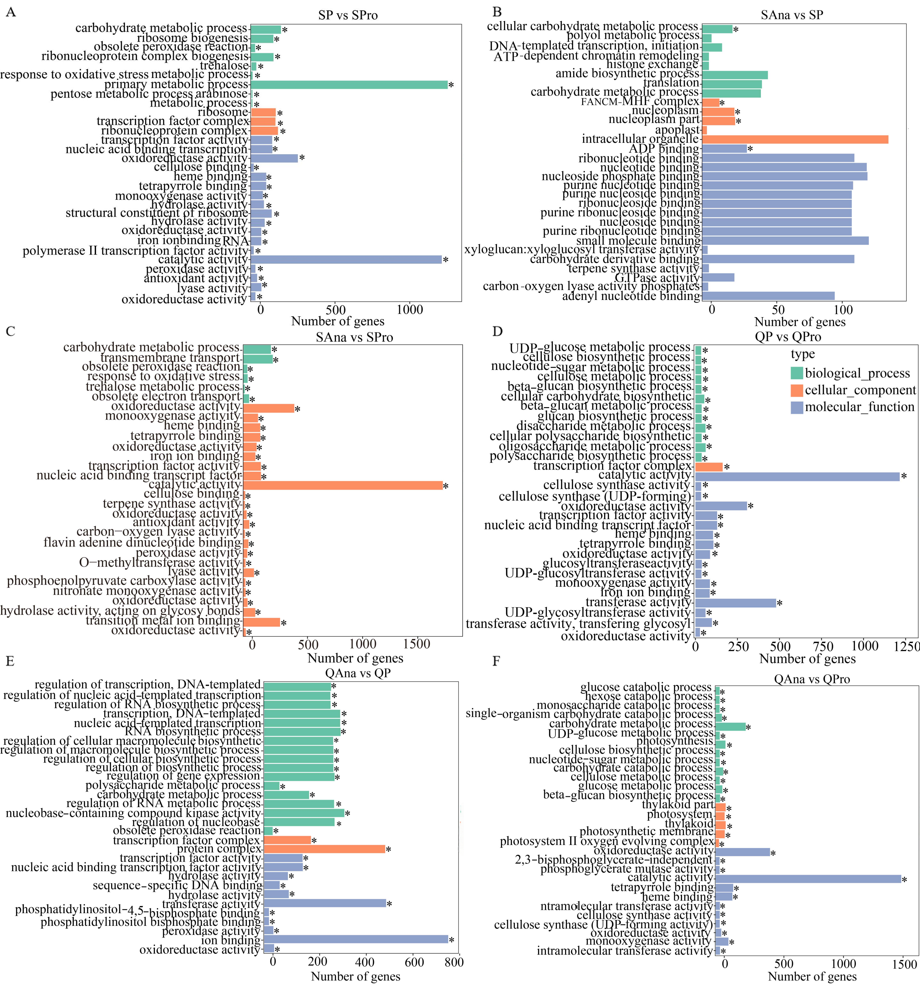
Fig.S2 Gene ontology (GO) functional annotation of differentially expressed genes (DEGs) between tillering stages. (A-C) Functional annotation of DEGs for SP vs SPro, SAna vs SP, and SAna vs SPro, respectively. (D-F) Functional annotation of DEGs for QP vs QPro, QAna vs QP, and QAna vs QPro, respectively.
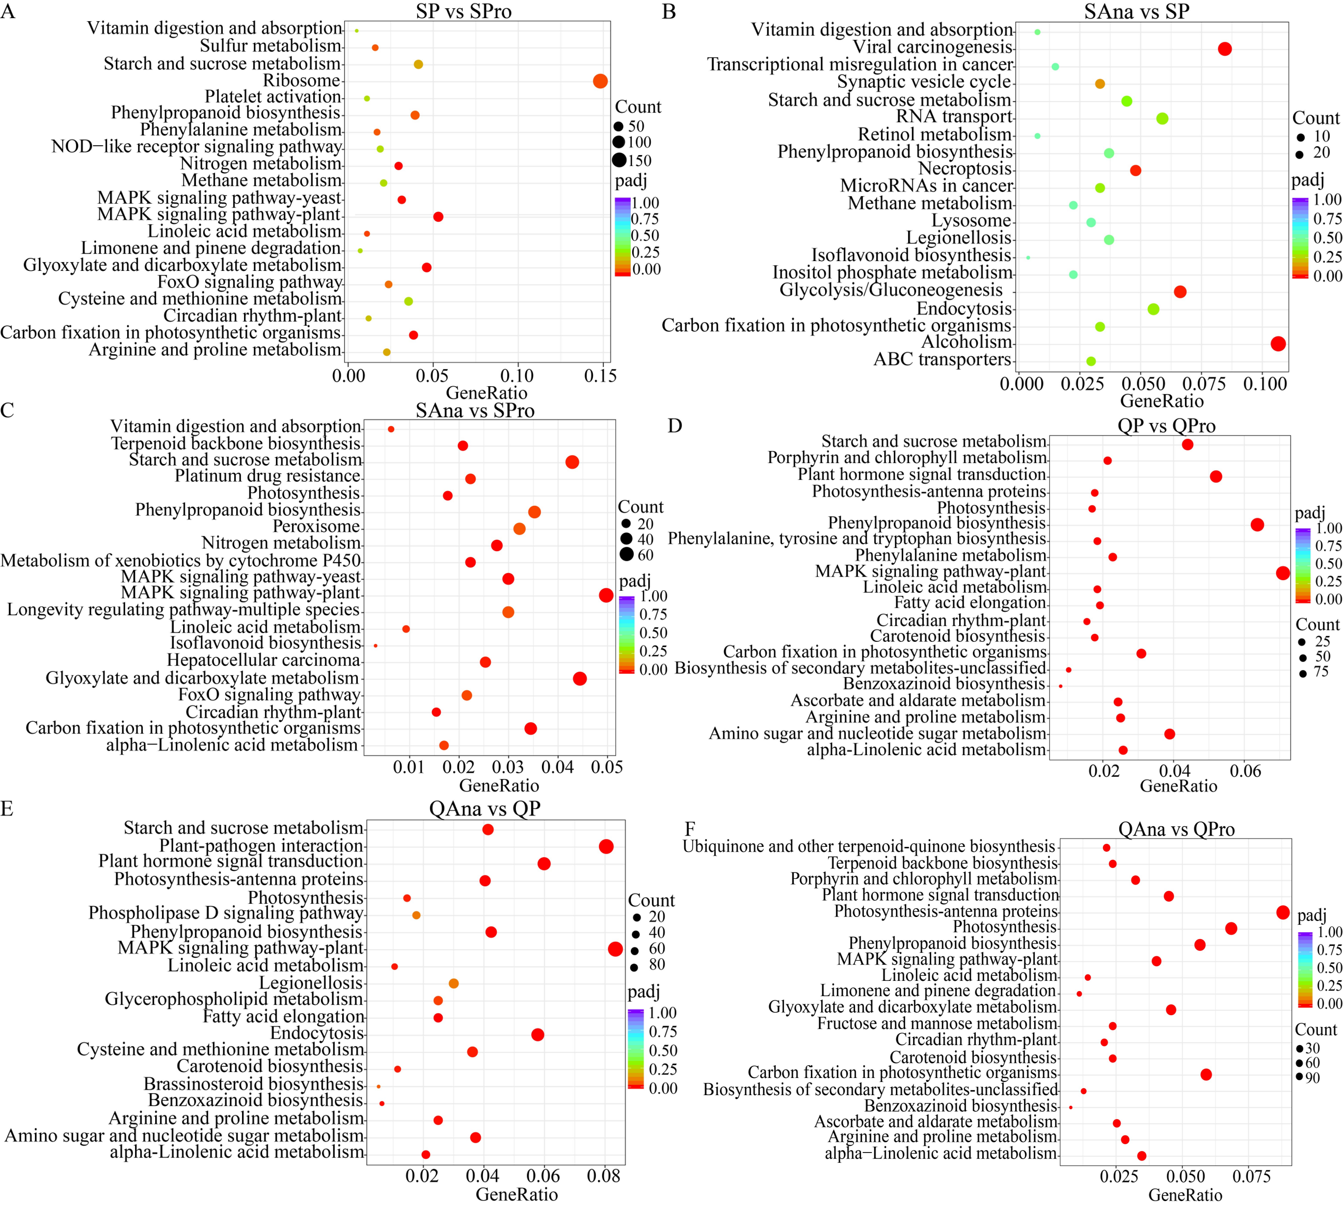
Fig.S3 KEGG enrichment analysis of differentially expressed genes (DEGs) between tillering stages in two Kentucky bluegrass varieties (SN and QS). (A-C) KEGG enrichment analysis of DEGs for SP vs SPro, SAna vs SP, and SAna vs SPro. (D-F) KEGG enrichment analysis of DEGs for QP vs QPro, QAna vs QP, and QAna vs QPro.
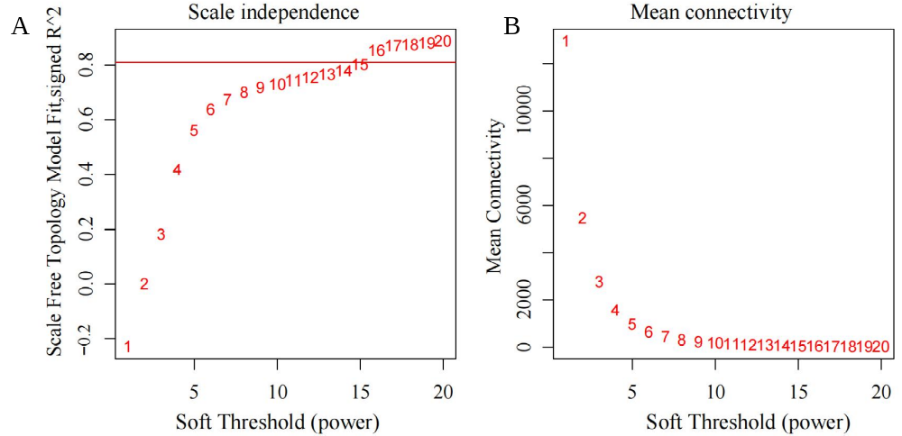
Fig.S4 Determination of the soft threshold parameter (β) for a weighted gene correlation network analysis (WGCNA) of differentially expressed genes among tillering stages. (A) Illustration of the scale-free topology model fit for different values of β; the value of red line is R² = 0.9. (B) Illustration of the mean connectivity of the co-expression network for different values of β.
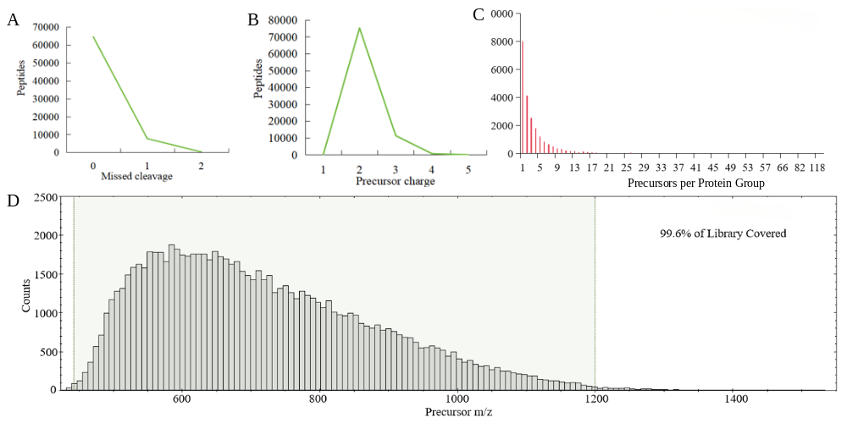
Fig.S5 Protein data quality control. (A) The number of enzyme cleavage sites versus the number of peptide ions. (B) The precursor charge number (of the parent ion) versus the number of peptide ions. (C) Distribution of the number of parent ions per protein group. (D) Distribution of the parent ion mass-to-charge ratio.
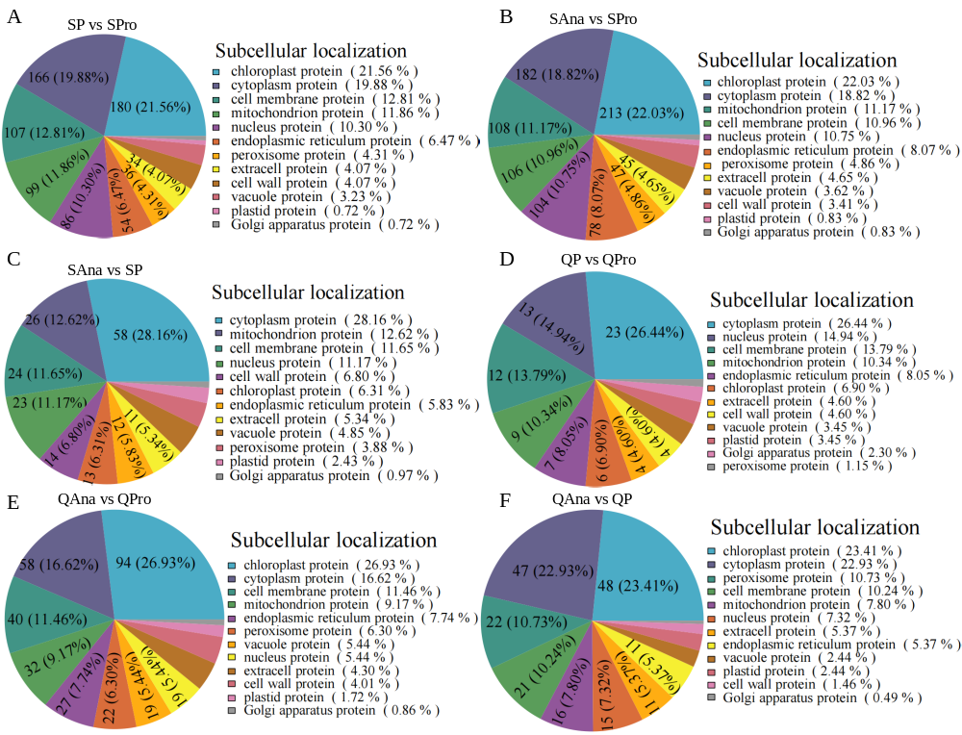
Fig.S6 Subcellular localization of proteins that were differentially expressed among tillering stages. (A-C) Subcellular localization of differentially expressed proteins (DEPs) for SP vs SPro, SAna vs Spro, and SAna vs SP, respectively. (D-F) Subcellular localization of DEPs for QP vs QPro, QAna vs QPro, and QAna vs QP, respectively.
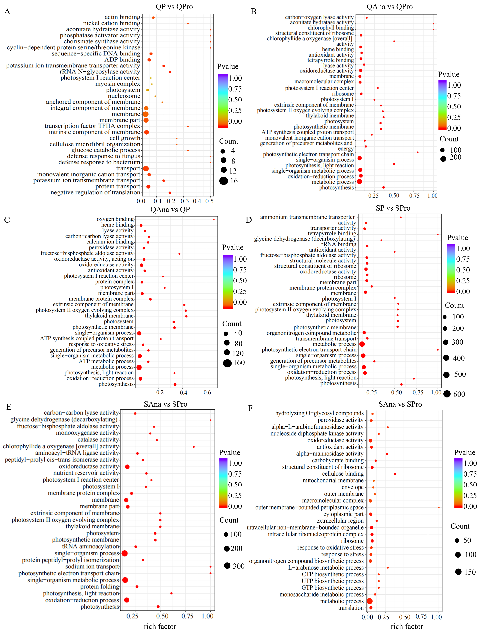
Fig.S7 GO functional annotation of differentially expressed proteins (DEPs). (A-C) GO functional annotation of DEPs for QP vs QPro, QAna vs QPro, and QAna vs QP comparisons, respectively. (D-F) GO functional annotation of DEPs for SP vs QPro, SAna vs Spro, and SAna vs SP comparisons, respectively.

Fig.S8 KEGG enrichment analysis for differentially expressed proteins (DEPs) between tillering stages. (A-C) KEGG enrichment analysis of DEPs for QP vs QPro, QAna vs QPro, and QAna vs QP, respectively. (D-F) KEGG enrichment analysis of DEPs for SP vs SPro, SAna vs Spro, and SAna vs SP, respectively.
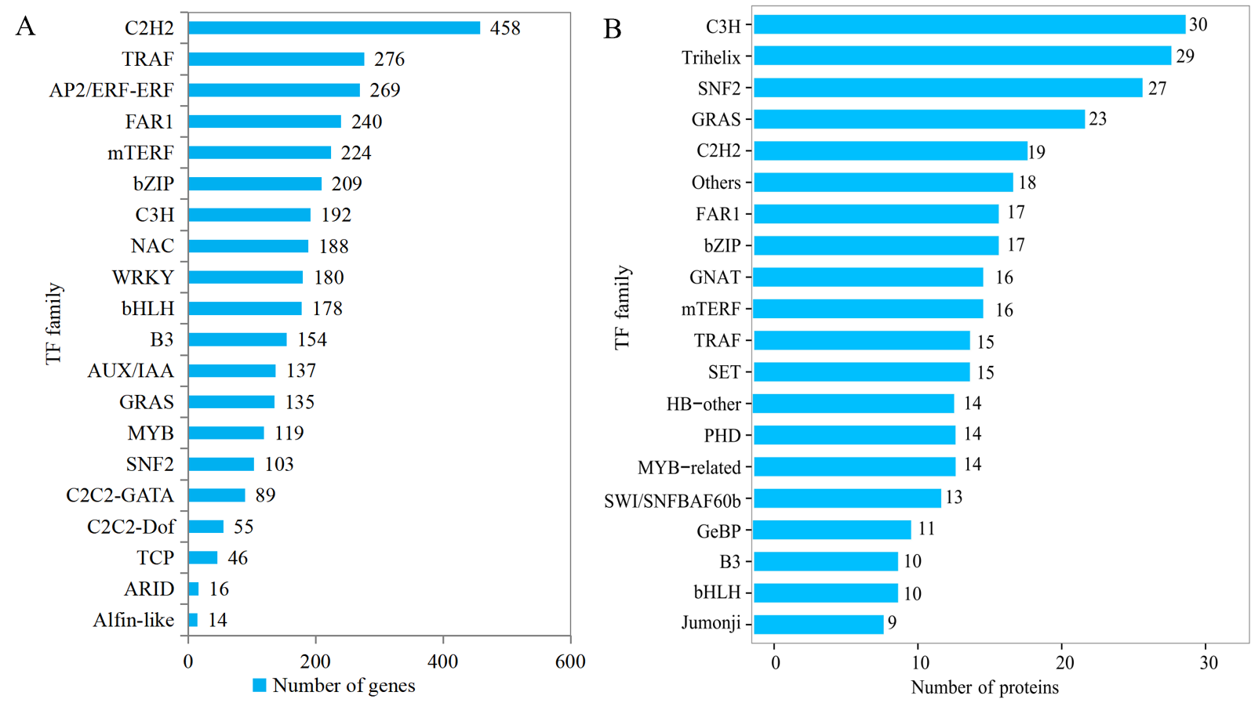
Fig.S9 Distribution statistics of gene quantity and protein quantity for different transcription factor families. (A) The distribution characteristics of the number of genes in each transcription factor (TF) family. (B) The distribution characteristics of protein numbers in each TF family.

